**Problem Statement**

Detect the roads, water, sky from image using unsupervised image segmentation.

**Solution**

Criteria of Prediction

a) Pixels of similar features are desired to be assigned the same label.

(b) Spatially continuous pixels are desired to be assigned the same label.

(c) The number of unique cluster labels is desired to be large.

**Architecture**

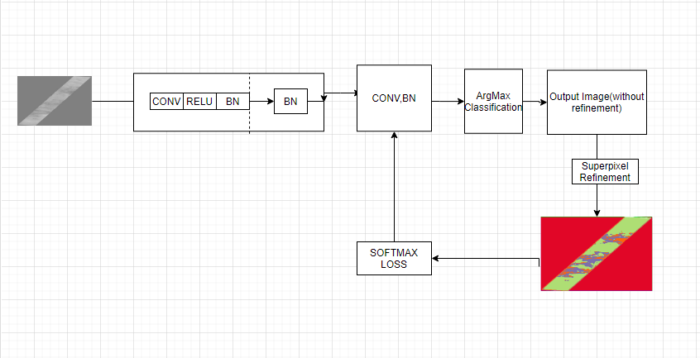

**Approach**

1. I’ve created a linear classifier using conv, relu and batch norm (feature extraction) operation

Using argmax classifier. X number of classes will be generated using argmax classifier based on

Pixel features.

1. Once pixel features generated I’m using SLIC algorithm for super-pixel refinement and to automatically get the label from output of SLIC algorithm.
2. For solving 3rd criteria I’m using backprop to generate unique cluster label

**How to run code**

1. Clone the git
2. Please use below url to convert tiff to jpg

<https://image.online-convert.com/convert/tiff-to-jpg>

as for running tiff file code was crashing because of memory issue so I’ve run the experiment on jpg image or any RGB image it will work.

1. Run below command

!python unsupervised_image_segmentation.py --input images/zebra.jpg --maxIter 15 --minLabels 4

OR

If you are running code using terminal please go to respective folder where unsupervised_image_segmentation present and run above command

**Sample Output**

