Agri-Intelligence: A Multimodal AI Decision Support System for Crop Recommendation, Disease Detection, Yield Prediction, and Resource-Aware Farm Management
B. Nagaraju
Department of Computer Science and Engineering
KLH University
Hyderabad, India
2420030614@klh.edu.in

K. Rahul
Department of Computer Science and Engineering
KLH University
Hyderabad, India
2420030011@klh.edu.in

Likith Sai
Department of Computer Science and Engineering
KLH University
Hyderabad, India
2420030066@klh.edu.in
Abstract—Agricultural decision making depends on interacting soil, climate, crop, disease, production, and market factors. Existing machine-learning studies frequently address individual tasks such as crop recommendation, yield prediction, or image-based disease recognition, while practical systems often require several of these capabilities in one workflow. This paper presents Agri-Intelligence, a software-only multimodal decision support framework designed to integrate tabular agricultural data, plant images, historical production records, weather information, and market data without requiring Internet of Things (IoT) sensors. The proposed framework separates the learning problems into specialized modules: crop recommendation as a multiclass classification task, yield prediction as a regression task, plant disease recognition as an image classification or detection task, and irrigation/resource guidance as a data-driven recommendation task. The design emphasizes reliable public datasets, leakage-aware preprocessing, cross-validation, independent testing, model comparison, explainability, and uncertainty-aware recommendations. ICRISAT district-level agricultural data and FAOSTAT crop statistics are proposed for historical and production modeling, while PlantVillage and PlantDoc provide complementary controlled and field-like imagery for disease modeling. Rather than reporting unverified performance, this paper defines an experimental protocol under which model accuracy, macro-F1, mean absolute error, root mean squared error, R-squared, calibration, and cross-domain generalization will be measured after implementation. The resulting architecture is intended to provide an extensible foundation for a web-based agricultural intelligence platform.
Keywords—agricultural artificial intelligence, crop recommendation, crop yield prediction, plant disease detection, machine learning, deep learning, decision support system, precision agriculture

I. INTRODUCTION
Agriculture is a data-intensive domain in which crop performance is affected by soil properties, weather, water availability, crop choice, disease pressure, management practices, and market conditions. Machine learning (ML) has increasingly been studied as a decision-support mechanism for agricultural prediction and classification. A systematic review by van Klompenburg et al. identified temperature, rainfall, and soil type among the most frequently used features in crop-yield prediction studies, while neural networks and convolutional neural networks were common model families [1]. More recent reviews continue to identify Random Forest, gradient-boosting methods, convolutional neural networks, and long short-term memory networks as important approaches, while emphasizing the dependence of model quality on data availability, geographic diversity, and evaluation design [2], [3].
Crop selection is similarly a multidimensional problem. Recent research on crop recommendation in India has investigated nitrogen, phosphorus, potassium, soil pH, temperature, rainfall, and humidity as predictors for selecting suitable crops [4]. However, a recommendation model trained on a small or synthetic dataset can produce misleadingly high test scores if the data do not represent the intended deployment population. Agri-Intelligence therefore treats dataset provenance and generalization as first-class components rather than optimizing only a single accuracy number.
Plant disease recognition provides a complementary computer-vision problem. Mohanty et al. demonstrated that deep convolutional networks can classify plant disease images effectively on the controlled PlantVillage benchmark, but their work also showed a substantial performance drop when models were evaluated on images collected under different real-world conditions [5]. PlantDoc was subsequently introduced to provide more field-like visual data, explicitly addressing the limited availability of non-laboratory images [6]. These findings motivate the use of both controlled and field-like data in the proposed disease module.
The main contribution of this work is an integrated software architecture that combines these specialized models into a single agricultural decision-support workflow without requiring IoT hardware. The framework is designed to support future deployment through a web application, while keeping model training, validation, and evaluation independent of the user interface.

II. PROBLEM STATEMENT AND OBJECTIVES
The central problem addressed in this work is the fragmentation of agricultural intelligence across separate prediction tasks and data sources. A farmer may need to decide which crop is suitable for a field, estimate potential yield, recognize disease symptoms, determine whether irrigation is needed, and understand market conditions. Conventional applications frequently implement one of these tasks in isolation. Agri-Intelligence aims to connect these tasks while preserving the methodological requirements of each ML problem.
The objectives are: (1) develop a crop-recommendation classifier using soil and climate variables; (2) develop a crop-yield regression model using district-level agricultural and environmental variables; (3) develop a plant-disease vision model using complementary controlled and field-like datasets; (4) derive irrigation and resource recommendations from crop, climate, soil, and evapotranspiration-related variables without physical sensors; (5) integrate weather and market information as contextual signals; (6) evaluate models using task-appropriate metrics and leakage-aware validation; and (7) expose validated models through a software architecture suitable for a web-based decision-support system.

III. RELATED WORK
A. Machine Learning for Crop Yield Prediction
Van Klompenburg et al. systematically reviewed ML and deep-learning approaches to crop-yield prediction and reported that temperature, rainfall, and soil type are frequently used predictors [1]. A 2024 review further emphasized temperature, rainfall, soil type, humidity, and vegetation indices such as NDVI, EVI, LAI, and NDWI as important information sources [2]. A 2025 systematic literature review covering studies from 2017–2024 found that linear regression, Random Forest, and gradient-boosting trees are frequently applied, while RMSE, R-squared, and MAE are common evaluation measures [3]. These findings support the proposed use of tree-based baselines and regression metrics while leaving room for deep temporal models when sufficient data are available.
B. Crop Recommendation
Crop selection depends on environmental, agronomic, economic, and regional conditions. A 2024 Heliyon study evaluated five ML models for agricultural and horticultural crop recommendations using NPK, soil pH, temperature, rainfall, and humidity variables [4]. The work demonstrates the feasibility of data-driven crop recommendation but also highlights the need to consider the origin and representativeness of the dataset. Agri-Intelligence therefore proposes using such compact soil-climate datasets as a baseline while validating the broader system against real agricultural records where possible.
C. Plant Disease Recognition
Mohanty et al. used 54,306 PlantVillage images representing 14 crop species and 26 diseases or healthy conditions and reported 99.35% held-out accuracy in their controlled benchmark [5]. Importantly, their experiments also demonstrated much lower performance on images from different conditions, highlighting the domain-shift problem. PlantDoc contains 2,598 images across 13 plant species and up to 17 disease classes and was designed to increase the availability of non-laboratory visual data [6]. Agri-Intelligence uses this distinction to design a two-stage evaluation: benchmark performance on controlled data and generalization performance on field-like data.
D. Machine Learning as a Plant Decision Tool
Singh et al. describe ML applications in plant stress phenotyping across identification, classification, quantification, and prediction [7]. This supports a modular architecture in which different agricultural questions are solved with different learning formulations rather than forcing all inputs into one model.

IV. PROPOSED AGRI-INTELLIGENCE FRAMEWORK
Fig. 1 shows the proposed software architecture. The system receives structured farmer inputs and public agricultural datasets, plant images, historical production records, weather information, and market information. These inputs are processed by specialized models and a decision layer. No physical IoT sensor is required; environmental values may be entered by the user, retrieved from public datasets, or obtained from external weather services.
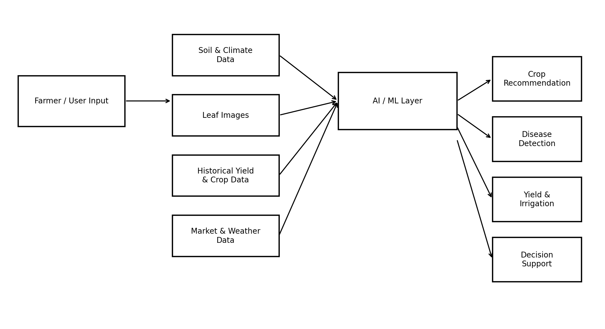
Fig. 1. Proposed multimodal software architecture for Agri-Intelligence.

A. Crop Recommendation Module
The crop recommendation module formulates crop selection as multiclass classification. The initial feature vector is defined as x = [N, P, K, pH, temperature, humidity, rainfall]. Candidate models include multinomial logistic regression as a linear baseline, Random Forest, support vector machines, gradient-boosting methods, and XGBoost/LightGBM where licensing and environment requirements permit. The final model will be selected using validation performance, stability, calibration, and interpretability rather than test-set accuracy alone.

B. Yield Prediction Module
Yield prediction is formulated as regression. The candidate input space includes crop, year, district or region, harvested area, rainfall, temperature, irrigation-related variables, fertilizer information, and other variables supported by the selected data source. The target is yield, preferably expressed in a consistent unit such as tonnes per hectare after source-specific unit conversion. Candidate models include linear regression, Random Forest regression, gradient boosting, XGBoost, and, if the time-series sample size is adequate, temporal deep-learning models.

C. Plant Disease Detection Module
The disease module accepts a leaf image and predicts a crop-disease class. Transfer learning using architectures such as EfficientNet, ResNet, or MobileNet is proposed as the initial approach because these models can provide strong image representations with practical inference cost. YOLO-based detection can be added when the objective changes from whole-image classification to localization of diseased regions. Training will use augmentation and class-balanced sampling where necessary. The evaluation will explicitly distinguish within-dataset performance from cross-dataset generalization.

D. Irrigation and Resource Intelligence
The software-only irrigation component estimates water-related recommendations from available climate and crop information rather than sensor readings. Potential features include crop type, crop growth stage, rainfall, temperature, humidity, soil characteristics, and evapotranspiration-related variables when available. The output should be expressed as a recommendation or estimated water requirement, not as a direct measurement of soil moisture. This distinction is important because the proposed system does not observe the field continuously.

E. Decision Support Layer
The decision layer combines outputs from the specialized models with contextual information. It does not replace agronomic expertise; instead, it presents predictions, confidence values, relevant input factors, and supporting context. For example, a crop recommendation can be accompanied by expected yield estimates and current weather context, while disease detection can provide a confidence score and link the result to an agronomic knowledge base.

V. DATASETS AND DATA ENGINEERING
The project will prioritize traceable public sources rather than relying exclusively on anonymous or duplicated datasets. Table I summarizes the principal data sources selected for the initial implementation.
Source | Primary use | Important variables | Role
ICRISAT District Level Database [8] | Yield and agricultural modeling | District, crop, area, production, yield, rainfall, temperature, irrigation and related variables | Primary Indian source
FAOSTAT [9] | Historical production and yield | Crop, country, year, harvested area, production, yield | Global/validation source
PlantVillage [5] | Disease classification | Leaf images, crop and disease labels | Controlled benchmark
PlantDoc [6] | Disease generalization | Field-like plant images and disease labels | External/generalization set
India Open Government Data [10] | Indian validation/context | Agricultural production and yield records | Secondary validation source
TABLE I. PROPOSED DATA SOURCES FOR AGRI-INTELLIGENCE

A. Data Preprocessing
Structured datasets will be standardized by resolving column names, units, missing values, duplicates, and inconsistent categorical labels. Continuous variables will be inspected for implausible values and outliers. Categorical variables will be encoded only after the train-test split to avoid information leakage. Image datasets will be checked for corrupted files, duplicate images, class imbalance, and near-duplicate samples.

B. Leakage Control
Data leakage is a central risk in agricultural ML. For time-dependent yield prediction, a random split can place future information into training data and produce optimistic results. The preferred evaluation will therefore use chronological holdout or grouped splits where appropriate. For disease images, duplicate or near-duplicate images will not be allowed to cross train and test partitions. Feature engineering will be fitted on training data only.

C. Dataset Integration
ICRISAT and FAOSTAT will not be merged blindly. Their geographic scales, definitions, units, temporal coverage, and collection methodologies differ. Integration will occur only after explicit harmonization of crop names, units, geography, and year. When harmonization is not defensible, the datasets will be used separately for training and external validation rather than forcing an artificial combined dataset.

VI. EXPERIMENTAL METHODOLOGY
The experimental workflow consists of baseline modeling, model comparison, hyperparameter tuning, validation, independent testing, and error analysis. A baseline is required before any advanced model is introduced. Hyperparameter tuning will be performed only on training/validation data, with the final test set locked until the end.
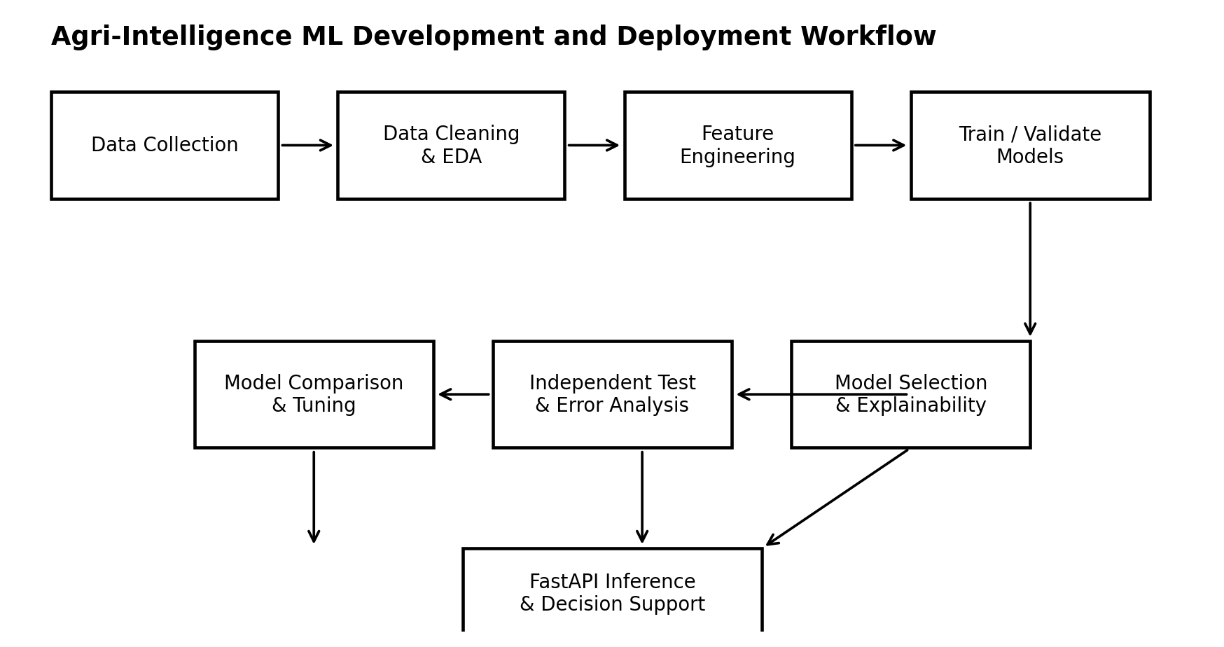
Fig. 2. Agri-Intelligence ML development and deployment workflow.
The workflow separates data preparation, model development, independent evaluation, and deployment to reduce leakage and preserve reproducibility.
For classification, the principal metrics will be accuracy, macro-precision, macro-recall, macro-F1, per-class F1, confusion matrix, and, where meaningful, calibration error. For yield regression, MAE, RMSE, and R-squared will be reported. For disease recognition, macro-F1 and per-class recall will be emphasized because class imbalance and rare diseases can make aggregate accuracy misleading.
Ablation experiments will determine the contribution of different feature groups. For example, yield prediction can be evaluated with agricultural variables alone, agricultural plus climate variables, and agricultural plus climate plus remotely sensed variables if those data are later added. Similarly, disease classification can compare training on controlled images with training that includes field-like images.
Interpretability will be investigated using feature importance and SHAP-style explanations for tabular models where appropriate. The purpose is to identify whether predictions are driven by plausible agricultural factors rather than spurious correlations.

VII. IMPLEMENTATION ARCHITECTURE
The implementation is designed as a modular Python backend with independent model artifacts. Python and scikit-learn will support tabular ML, while PyTorch or TensorFlow can support deep-learning models. FastAPI will expose inference endpoints after model validation. A React-based frontend can subsequently consume these endpoints. The separation allows models to be retrained without redesigning the user interface.
A representative inference flow is: user submits soil and climate information; the crop model returns ranked crop candidates; the yield model estimates expected productivity for compatible crops; the weather layer adds current or forecast context; the disease model analyzes an uploaded leaf image when available; and the decision layer presents the results with confidence and limitations. Model version, training-data version, and preprocessing configuration should be stored with every deployment.

VIII. EVALUATION PLAN AND EXPECTED CONTRIBUTIONS
At the current project stage, numerical model results are intentionally not reported because the final datasets have not yet been trained and evaluated. Reporting fabricated accuracy would make the research record unreliable. The planned contribution is therefore evaluated through a reproducible experimental protocol. After implementation, the results section should contain the exact dataset sizes, train-validation-test partitions, hyperparameters, metrics, confidence intervals where appropriate, confusion matrices, regression plots, and error analysis.
The expected scientific contribution is not a claim that one algorithm will universally outperform others. Recent reviews show that performance varies with crop, geography, data quality, feature availability, and prediction horizon [2], [3], [11]. The proposed contribution is instead the integration of heterogeneous agricultural intelligence with explicit attention to cross-domain generalization and data provenance.
The system is also expected to demonstrate a practical path from research models to a software decision-support application. Because the architecture does not depend on IoT hardware, it can operate with public data, user-provided measurements, and external APIs. This reduces hardware dependency but also introduces an important limitation: the system cannot directly observe field conditions that are not represented in the supplied data.

IX. LIMITATIONS AND FUTURE WORK
The proposed system has several limitations. First, public agricultural datasets can contain missing observations, inconsistent reporting practices, and changes in geographic boundaries. Second, historical yield relationships may not remain stable under climate change or changes in farming practices. Third, controlled plant-disease images can produce inflated benchmark performance relative to field conditions, as demonstrated in prior work [5]. Fourth, recommendations are only as reliable as the input variables and their provenance. Finally, market prices and weather forecasts are dynamic and require continuous data refresh.
Future work will include satellite-derived vegetation indices such as NDVI and EVI, spatial modeling, uncertainty estimation, temporal forecasting, explainable recommendations, multilingual farmer interaction, and external validation using region-specific agricultural records. A future version can also compare a software-only workflow with optional IoT inputs without making IoT a prerequisite for deployment.

X. CONCLUSION
This paper presented Agri-Intelligence, a software-only multimodal AI framework for agricultural decision support. The proposed system separates crop recommendation, yield prediction, plant disease recognition, and resource intelligence into specialized learning tasks and combines their outputs through a common decision layer. The framework is grounded in public agricultural and research datasets, including ICRISAT district-level data, FAOSTAT, PlantVillage, and PlantDoc. The methodology emphasizes leakage control, external validation, appropriate evaluation metrics, and transparent reporting rather than maximizing a single benchmark score. The next implementation stage is to construct the crop-recommendation model first, followed by yield prediction, disease recognition, and finally the integrated web application.

ACKNOWLEDGMENT
The author thanks the Department of Computer Science and Engineering, KLH University, Hyderabad, for academic support and project guidance.

REFERENCES
[1] T. van Klompenburg, A. Kassahun, and C. Catal, “Crop yield prediction using machine learning: A systematic literature review,” Computers and Electronics in Agriculture, vol. 177, 105709, 2020, doi: 10.1016/j.compag.2020.105709.
[2] A. Jabed and A. M. Murad, “Crop yield prediction in agriculture: A comprehensive review of machine learning and deep learning approaches, with insights for future research and sustainability,” Heliyon, vol. 10, no. 24, e40836, 2024, doi: 10.1016/j.heliyon.2024.e40836.
[3] “Crop yield prediction using machine learning: An extensive and systematic literature review,” Smart Agricultural Technology, vol. 10, 100718, 2025, doi: 10.1016/j.atech.2024.100718.
[4] B. Dey, J. Ferdous, R. Ahmed, et al., “Machine learning based recommendation of agricultural and horticultural crop farming in India under the regime of NPK, soil pH and three climatic variables,” Heliyon, vol. 10, no. 3, e25112, 2024, doi: 10.1016/j.heliyon.2024.e25112.
[5] S. P. Mohanty, D. P. Hughes, and M. Salathé, “Using deep learning for image-based plant disease detection,” Frontiers in Plant Science, vol. 7, 1419, 2016, doi: 10.3389/fpls.2016.01419.
[6] D. Singh, N. Jain, P. Jain, P. Kayal, S. Kumawat, and N. Batra, “PlantDoc: A dataset for visual plant disease detection,” in Proc. 7th ACM IKDD CoDS and 25th COMAD, Hyderabad, India, 2020, pp. 249–253, doi: 10.1145/3371158.3371196.
[7] A. Singh, B. Ganapathysubramanian, A. K. Singh, and S. Sarkar, “Machine learning for high-throughput stress phenotyping in plants,” Trends in Plant Science, vol. 21, no. 2, pp. 110–124, 2016, doi: 10.1016/j.tplants.2015.10.015.
[8] International Crops Research Institute for the Semi-Arid Tropics (ICRISAT), “District Level Database for Indian agriculture and allied sectors,” ICRISAT, Hyderabad, India. [Online]. Available: https://data.icrisat.org/district-level-data/
[9] Food and Agriculture Organization of the United Nations, “FAOSTAT: Crop production, yield, harvested area,” FAO, 2026. [Online]. Available: https://www.fao.org/faostat/
[10] Government of India, “Agriculture production, stock, yield,” Open Government Data Platform India. [Online]. Available: https://data.gov.in/catalog/agriculture-production-stock-yield
[11] D. De Clercq and A. Mahdi, “Modern computational approaches for rice yield prediction: A systematic review of statistical and machine learning-based methods,” Computers and Electronics in Agriculture, 2025, doi: 10.1016/j.compag.2024.109852.

