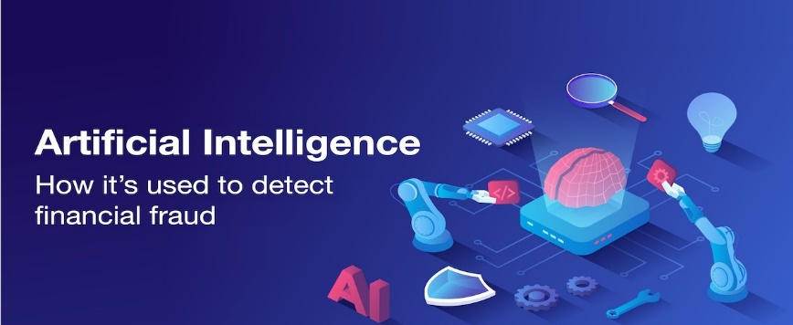

**AI-Powered Fraud Detection System for Financial Institutions**

**-RAHUL YADAV**

**DATE:- 27-04-2024**

**1. Problem Statement**

Credit card fraud is a pervasive and growing issue, causing significant financial losses to both financial institutions and their customers. Traditional fraud detection systems often rely on static rules and outdated techniques that are insufficient against increasingly sophisticated fraud tactics. The goal is to develop an advanced AI-powered fraud detection system capable of real-time analysis and identification of fraudulent transactions, thereby reducing financial losses and improving customer trust.

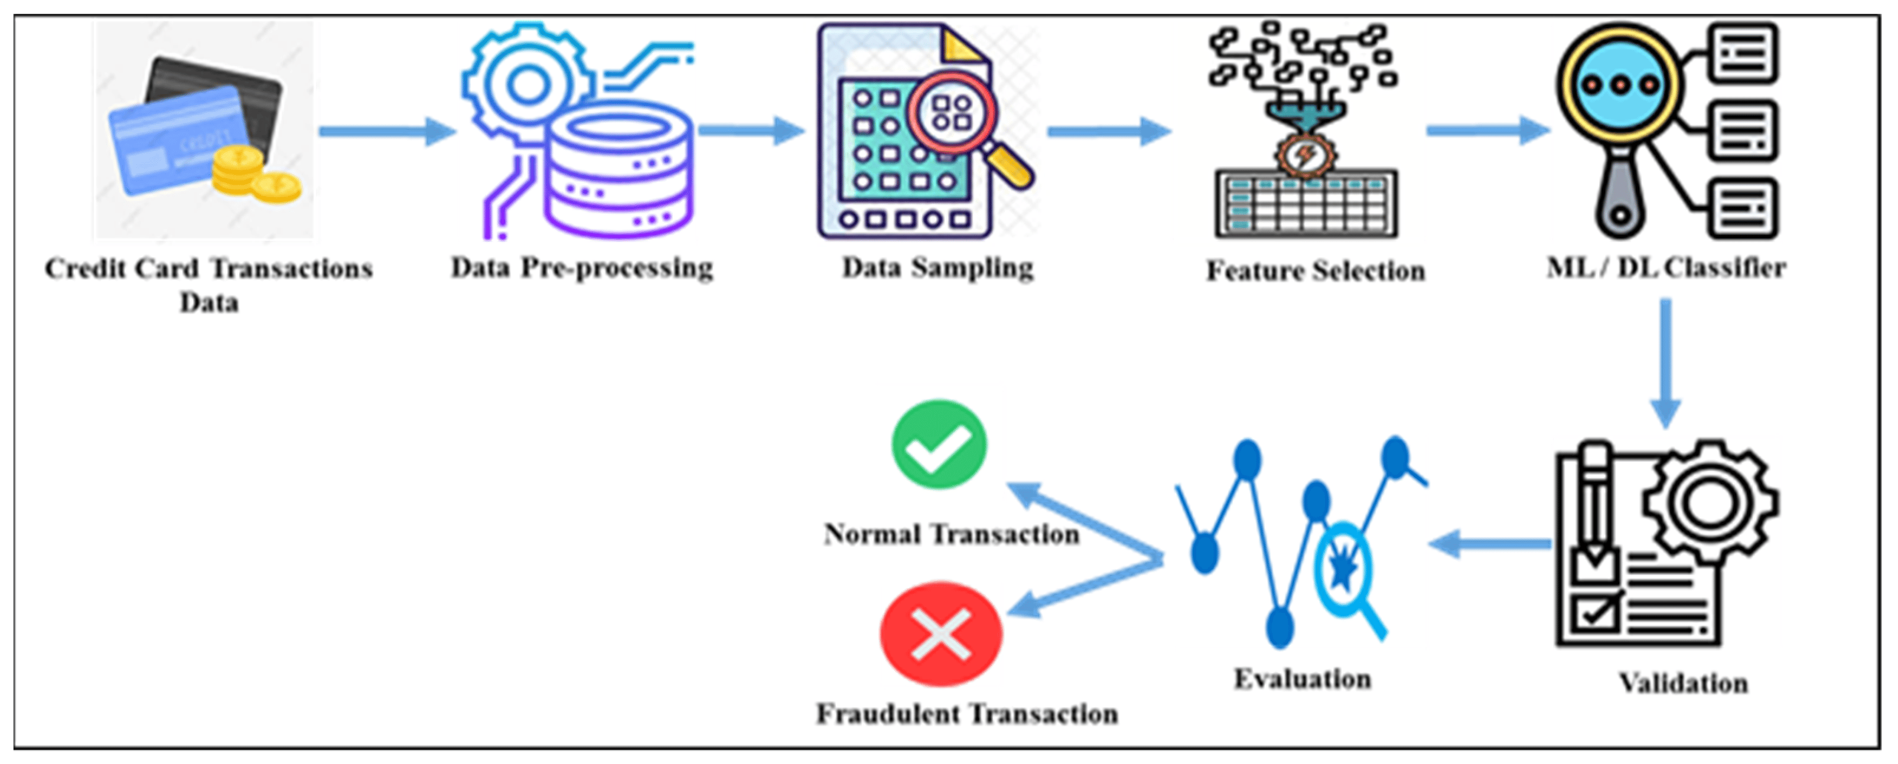

**2. Market/Customer/Business Need Assessment**

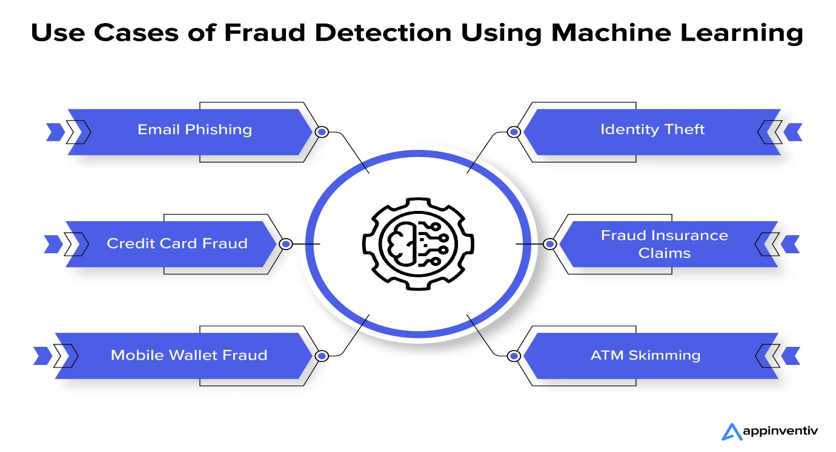

**Market Analysis**

* **Size and Growth:** The global financial fraud detection market was valued at approximately $19.5 billion in 2020 and is expected to grow at a CAGR of 15.2% from 2021 to 2028.
* **Impact of Fraud:** Credit card fraud alone caused $28.65 billion in losses in 2019 and is projected to surpass $35 billion by 2023 (Nilson Report).

**Customer Needs**

* **Real-Time Detection:** Financial institutions require systems that can detect fraud in real-time to prevent unauthorized transactions.
* **Accuracy:** High accuracy in detecting fraudulent transactions to minimize false positives and false negatives.
* **Scalability:** Solutions must be scalable to handle large volumes of transactions without compromising performance.
* **Compliance:** Systems must comply with regulatory standards to ensure data privacy and security.

**3. Target Specifications and Characterization**

**Customer Characteristics**

* **Financial Institutions:** Banks, credit unions, payment processors, and other financial service providers.
* **Transaction Volume:** Large volumes of daily transactions requiring continuous monitoring.
* **Risk Exposure:** High susceptibility to fraudulent activities necessitating robust security measures.
* **Customer Trust:** A critical need to maintain and enhance customer trust through secure transaction processes.

**Key Specifications**

* **Real-Time Processing:** Capable of analyzing transactions in real-time with minimal latency.
* **Detection Accuracy:** Achieving a high detection accuracy rate (above 95%) to ensure reliable fraud identification.
* **User Interface:** Intuitive dashboards for monitoring and managing fraud alerts.
* **Integration:** Seamless integration with existing banking systems and processes.
* **Compliance:** Adherence to regulatory requirements such as PCI DSS and GDPR.

**4. External Search**

**Online Information Sources**

* **Industry Reports**: Nilson Report, Javelin Strategy & Research, Market Watch.
* **Research Papers:** IEEE Xplore, arXiv, Google Scholar on AI and fraud detection.
* **Forums and Communities:** Reddit, LinkedIn groups discussing financial security and fraud prevention.
* **Existing Products:** Websites of competitors like FICO, ACI Worldwide, and Kount for feature comparison and market trends.

**Key References**

* **Nilson Report:** <https://www.nilsonreport.com/>
* **Javelin Strategy & Research:** <https://www.javelinstrategy.com/>
* **IEEE Xplore:** <https://ieeexplore.ieee.org/>

**5. Benchmarking Alternate Products**

**Existing Products**

* **FICO Falcon Fraud Manager:** Utilizes neural networks and machine learning to detect and prevent fraudulent activities.
* **ACI Fraud Management:** Provides real-time fraud detection with advanced analytics.
* **Kount:** AI-driven fraud prevention for e-commerce and financial services.

**6. Applicable Patents**

* System and method for fraud detection using machine learning - Describes a method using machine learning for detecting fraud in financial transactions.
* Real-time transaction fraud detection using machine learning - Focuses on real-time detection using advanced machine learning techniques.
* Artificial intelligence-driven fraud detection system - Covers a comprehensive AI-based approach for detecting and managing fraud.

**7. Applicable Regulations**

**Data Protection and Security**

* **PCI DSS:** Standards for secure handling of cardholder information to prevent data breaches.
* **GDPR:** Ensures customer data privacy and security in the European Union.
* **CCPA (California Consumer Privacy Act):** Protects consumer data privacy in California, USA.

**Financial Regulations**

* **FFIEC Guidelines:** U.S. regulations requiring financial institutions to establish robust information security programs.
* **AML (Anti-Money Laundering) Regulations:** Ensure the system can help identify and report suspicious activities related to money laundering.

**8. Applicable Constraints**

**Technical Constraints**

* **Complexity:** Development requires advanced AI and machine learning expertise.
* **Infrastructure:** Needs robust IT infrastructure for real-time data processing.

**Budget Constraints**

* **Initial Investment:** High initial costs for development, deployment, and integration.
* **Maintenance Costs:** Ongoing costs for system updates, data storage, and compliance.

**Space Constraints**

* **Server Space:** Requires significant server and storage capacity for handling large datasets.

**Regulatory Constraints**

* **Compliance:** Must adhere to strict data protection and financial regulations.

**9. Business Model**

**Monetization Strategies**

* **Subscription-Based Model:** Financial institutions pay a recurring fee based on transaction volume.
* Usage-Based Model: Fees based on the number of transactions analyzed or fraud alerts generated.
* **Licensing Model:** One-time licensing fee for software installation, with optional maintenance and support contracts.
* **Freemium Model:** Basic fraud detection features offered for free, with advanced capabilities available via paid plans.

**10. Concept Generation**

**Idea Generation Process**

* **Brainstorming Sessions:** Engaged with financial analysts, data scientists, and cybersecurity experts to identify key challenges in existing fraud detection systems.
* **Customer Feedback:** Conducted surveys and interviews with potential customers to understand their needs and pain points.
* **Industry Research:** Reviewed market reports and academic research to identify trends and emerging technologies in fraud detection.

**11. Concept Development**

**Product Concept**

The AI-Powered Fraud Detection System leverages machine learning algorithms to analyze transaction data in real-time, identifying patterns indicative of fraudulent activity. The system integrates with existing banking infrastructure and provides intuitive dashboards for monitoring and managing fraud alerts.

**12. Final Product Prototype (Abstract) with Schematic Diagram**

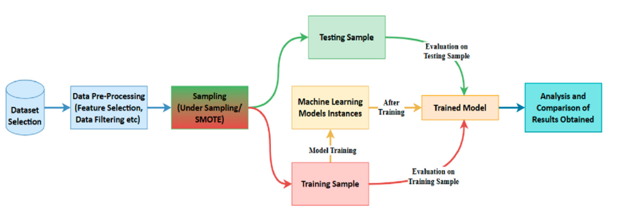

**13. Product Details**

**How Does It Work**

**1. Data Collection:** Continuously collects transaction data from the financial institution's databases.

**2. Data Preprocessing:** Cleans and preprocesses data to ensure quality and consistency.

**3. Feature Extraction:** Extracts relevant features (e.g., transaction amount, time, location) to be used by the machine learning model.

**4. Machine Learning Model:** Utilizes supervised and unsupervised learning algorithms to detect patterns indicative of fraud.

**5. Fraud Detection Alerts:** Generates real-time alerts for transactions deemed suspicious.

**6. Dashboard & Reporting:** Provides a user-friendly interface for monitoring alerts, reviewing flagged transactions, and generating reports.

**Data Sources**

* Transaction databases of financial institutions
* Historical fraud data
* Customer behavior data

**Algorithms, Frameworks, Software Needed**

* **Algorithms:** Random Forest, Gradient Boosting, Neural Networks, Anomaly Detection
* **Frameworks:** TensorFlow, Scikit-learn, PyTorch
* **Software:** Apache Kafka (for data streaming), Elasticsearch (for indexing and search), Kibana (for visualization)

**14. Code Implementation/Validation on Small Scale**

**Basic Visualizations on Real World or Augmented Data**

* **Visualization of transaction data distribution**
* **Anomaly detection visualization**

**Simple EDA**

- Exploratory Data Analysis on transaction data to identify key features and patterns

**Univariate Analysis**

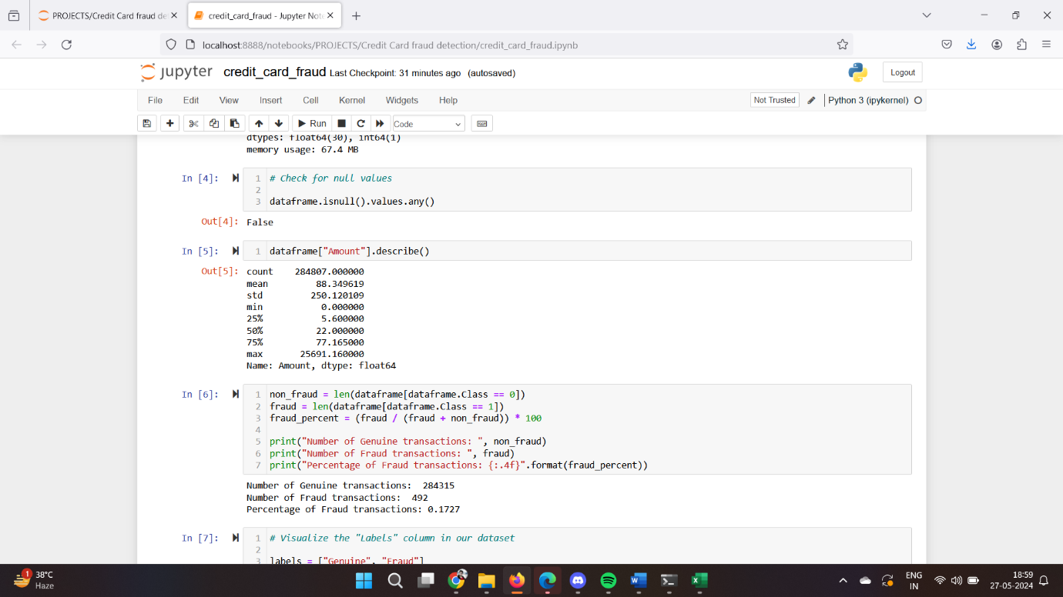

**Percentage Of Fraud Transactions**

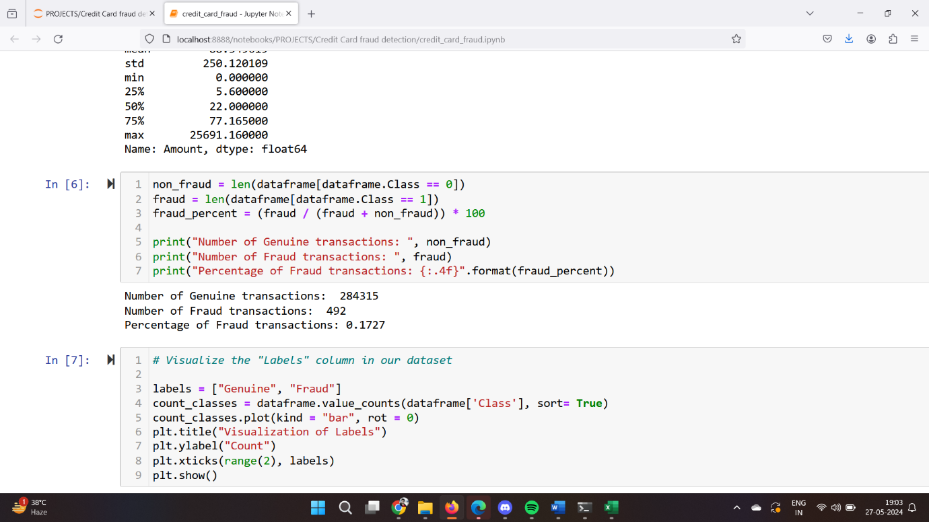

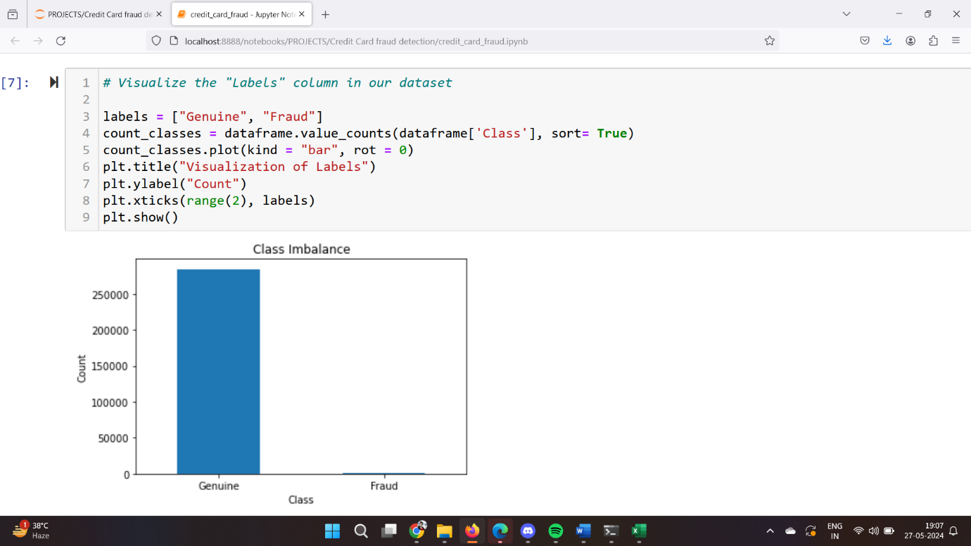**Bivariate Analysis**

**ML Modelling**

- Implementation of machine learning models to classify transactions as fraudulent or legitimate

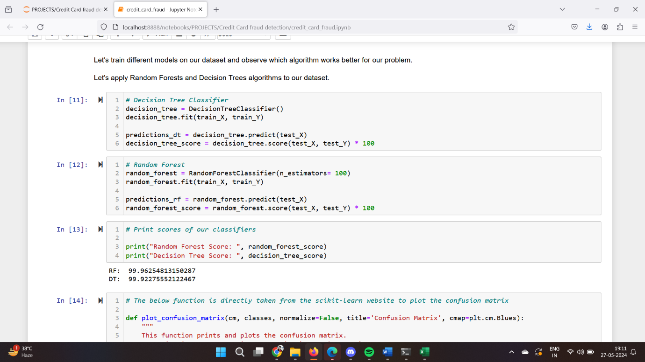

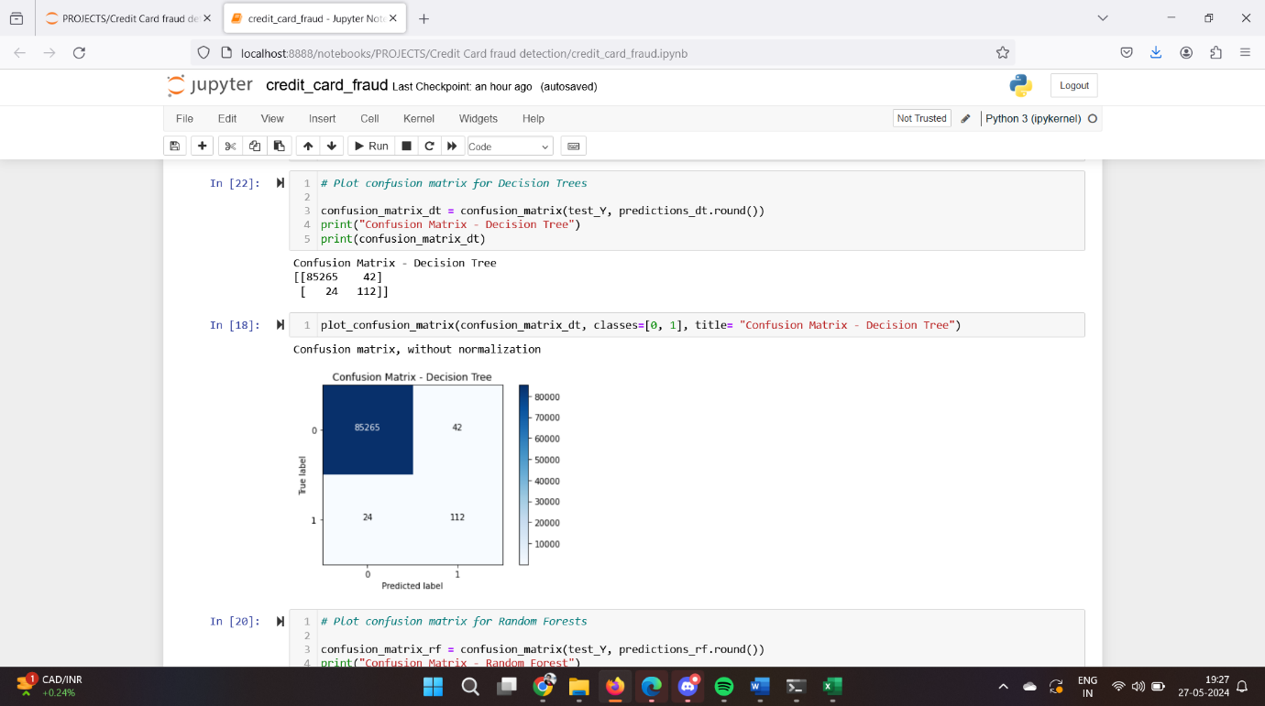

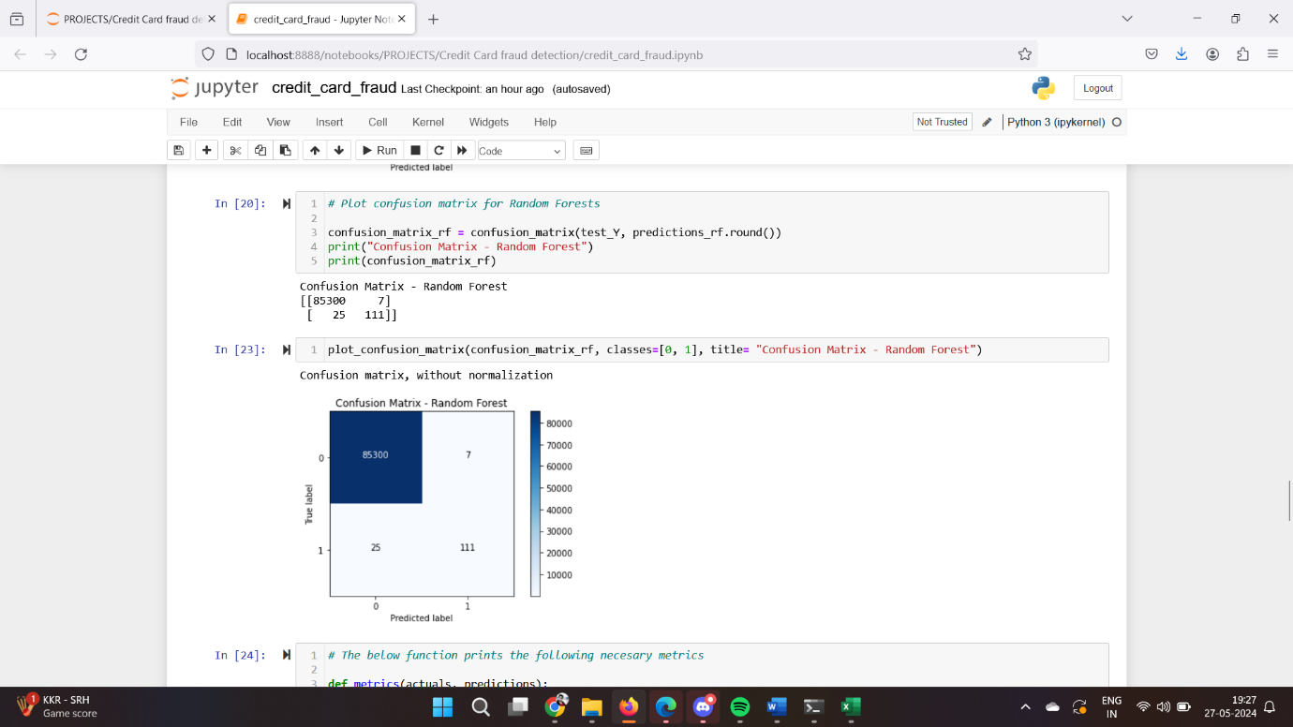

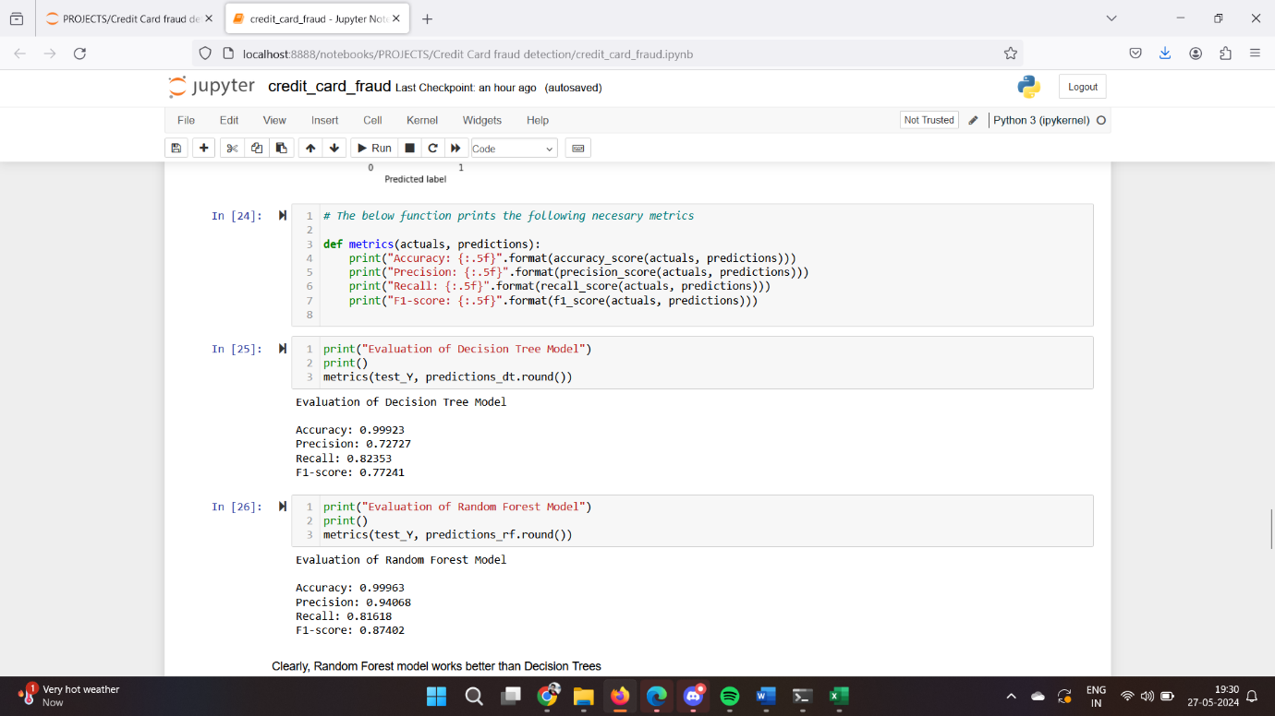

**Github Link to Code Implementation**

<https://github.com/rahul60286/Machine-Learning-Projects/tree/main/Credit_Card_Fraud_Detection_Projects>

**15. Conclusion**

The AI-Powered Fraud Detection System aims to revolutionize the way financial institutions detect and prevent credit card fraud. By leveraging advanced machine learning techniques, the system provides real-time, accurate detection of fraudulent activities, enhancing security and customer trust. The proposed solution addresses a critical need in the market and has the potential to significantly reduce financial losses due to fraud.

Clearly, Random Forest model works better than Decision Trees

But, if we clearly observe our dataset suffers a serious problem of **class imbalance**. The genuine (not fraud) transactions are more than 99% with the fraud transactions constituting of 0.17%.

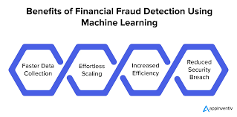

**The END**