LAB Logbook
Name: Rahul reddy
SID:2535824
Lab1
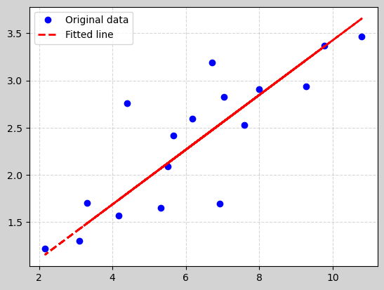

Lab2
- Test Accuracy: 0.655
2. 