Employee ID: 46185397

Name: Rahul Kumar Rajak

**Case Study 16:**

|  |  |
| --- | --- |
|  | Requirement:  Based on the inputs provided in the selection screen, fetch data from corresponding tables and display in ALV format.  Selection Screen:  1. Sales Order Number: VBELN.  Two buttons should be designed in the output screen  1. 1st button – when clicked it should generate Adobe Form with the ALV data.  2. 2nd button – when clicked i. It should ask email address with a pop-up  ii. Send email with Adobe form as attachment.  iii. Subject – Sales Order &VBELN& Details.  iv. Body     – Please find the attached PDF document. |

**Solution:**

**CODE:**

REPORT ZRK_CS_16.  
  
TABLES: vbak, vbap.  
  
TYPES: BEGIN OF ty_data,  
         vbeln TYPE vbak-vbeln,  
         erdat TYPE vbak-erdat,  
         erzet TYPE vbak-erzet,  
         ernam TYPE vbak-ernam,  
         posnr TYPE vbap-posnr,  
         matnr TYPE vbap-matnr,  
       END OF ty_data.  
  
DATA: lt_data TYPE TABLE OF ty_data,  
      ls_data TYPE ty_data,  
      lt_fcat TYPE slis_t_fieldcat_alv,  
      ls_fcat TYPE slis_fieldcat_alv.  
  
SELECTION-SCREEN BEGIN OF BLOCK b1 WITH FRAME TITLE TEXT-001.  
PARAMETERS: p_vbeln TYPE vbak-vbeln.  
SELECTION-SCREEN END OF BLOCK b1.  
  
  
START-OF-SELECTION.  
  SELECT vk~vbeln,  
           vk~erdat,  
           vk~erzet,  
           vk~ernam,  
  
           vp~posnr,  
           vp~matnr  
           FROM vbak AS vk INNER JOIN vbap AS vp  
                            ON vk~vbeln = vp~vbeln  
           INTO TABLE @lt_data WHERE vk~vbeln = @p_vbeln. "IN @s_vbeln.  
  
  IF lt_data IS NOT INITIAL.  
  
    ls_fcat-col_pos = '1' .  
    ls_fcat-fieldname = 'VBELN' .  
    ls_fcat-seltext_m = 'Sales Doc No'.  
    APPEND ls_fcat TO lt_fcat .  
    CLEAR ls_fcat .  
  
    ls_fcat-col_pos = '2' .  
    ls_fcat-fieldname = 'POSNR' .  
    ls_fcat-seltext_m = 'Sales Doc Item'.  
    APPEND ls_fcat TO lt_fcat .  
    CLEAR ls_fcat .  
  
    ls_fcat-col_pos = '3' .  
    ls_fcat-fieldname = 'ERDAT' .  
    ls_fcat-seltext_m = 'Creation Date'.  
    APPEND ls_fcat TO lt_fcat .  
    CLEAR ls_fcat .  
  
    ls_fcat-col_pos = '4' .  
    ls_fcat-fieldname = 'ERZET' .  
    ls_fcat-seltext_m = 'Sales Doc No' .  
    APPEND ls_fcat TO lt_fcat .  
    CLEAR ls_fcat .  
  
    ls_fcat-col_pos = '5' .  
    ls_fcat-fieldname = 'ERNAM' .  
    ls_fcat-seltext_m = 'Created by' .  
    APPEND ls_fcat TO lt_fcat .  
    CLEAR ls_fcat .  
  
    ls_fcat-col_pos = '6' .  
    ls_fcat-fieldname = 'MATNR' .  
    ls_fcat-seltext_m = 'Material No' .  
    APPEND ls_fcat TO lt_fcat .  
    CLEAR ls_fcat .  
  
  ENDIF.  
  
  CALL FUNCTION 'REUSE_ALV_GRID_DISPLAY'  
    EXPORTING  
      i_callback_program       = sy-repid  
      i_callback_pf_status_set = 'PF_STATUS4'  
      i_callback_user_command  = 'USER_COMMAND3'  
*     I_CALLBACK_TOP_OF_PAGE   = ' '  
*     I_CALLBACK_HTML_TOP_OF_PAGE       = ' '  
*     IS_LAYOUT                =  
      it_fieldcat              = lt_fcat  
    TABLES  
      t_outtab                 = lt_data  
    EXCEPTIONS  
      program_error            = 1  
      OTHERS                   = 2.  
  IF sy-subrc <> 0.  
* Implement suitable error handling here  
  ENDIF.  
  
FORM  pf_status4 USING rt_extab TYPE slis_t_extab.  
  SET PF-STATUS 'STATUS'.  
ENDFORM.  
  
FORM user_command3 USING r_ucomm LIKE sy-ucomm  
      rs_selfield TYPE slis_selfield.  
  IF sy-ucomm = 'ADOBE'.  
    PERFORM adobe.  
  ELSEIF sy-ucomm = 'EMAIL'.  
    PERFORM email.  
  ENDIF.  
ENDFORM.  
*&---------------------------------------------------------------------*  
*&      Form  ADOBE  
*&---------------------------------------------------------------------*  
FORM adobe .  
  DATA : lv_fname TYPE rs38l_fnam.  
  DATA : lv_outputparams TYPE sfpoutputparams.  
  DATA : lv_result TYPE sfpjoboutput.  
  lv_outputparams-preview = 'X'.  
  lv_outputparams-nodialog = 'X'.  
  lv_outputparams-device = 'PRINTER'.  
  lv_outputparams-dest  = 'LP01'.  
  
  CALL FUNCTION 'FP_JOB_OPEN'  
    CHANGING  
      ie_outputparams = lv_outputparams  
    EXCEPTIONS  
      cancel          = 1  
      usage_error     = 2  
      system_error    = 3  
      internal_error  = 4  
      OTHERS          = 5.  
  IF sy-subrc <> 0.  
  ENDIF.  
  
  CALL FUNCTION 'FP_FUNCTION_MODULE_NAME'  
    EXPORTING  
      i_name     = 'ZCS_ADOBE'  
    IMPORTING  
      e_funcname = lv_fname.  
  
  CALL FUNCTION lv_fname  
    EXPORTING  
      p_vbeln        = p_vbeln  
    IMPORTING  
      lt_data        = lt_data  
      ls_data        = ls_data  
    EXCEPTIONS  
      usage_error    = 1  
      system_error   = 2  
      internal_error = 3  
      OTHERS         = 4.  
  IF sy-subrc <> 0.  
  ENDIF.  
  
  CALL FUNCTION 'FP_JOB_CLOSE'  
    IMPORTING  
      e_result       = lv_result  
    EXCEPTIONS  
      usage_error    = 1  
      system_error   = 2  
      internal_error = 3  
      OTHERS         = 4.  
  IF sy-subrc <> 0.  
  ENDIF.  
  
ENDFORM.  
*&---------------------------------------------------------------------*  
*&      Form  EMAIL  
*&---------------------------------------------------------------------*  
  
  
FORM email.  
 DATA:gr_table TYPE REF TO cl_salv_table.  
  TRY.  
      cl_salv_table=>factory(  
      IMPORTING  
        r_salv_table = gr_table  
        CHANGING  
        t_table = lt_data ).  
    CATCH cx_salv_msg.  
  ENDTRY.  
  
  DATA:gv_xstring      TYPE xstring,  
       gv_xlen         TYPE int4,  
       gt_binary_table TYPE solix_tab,  
       gr_request      TYPE REF TO cl_bcs,  
       gv_body_text    TYPE bcsy_text,  
       gv_subject      TYPE so_obj_des,  
       gr_recipient    TYPE REF TO if_recipient_bcs,  
       gr_document     TYPE REF TO cl_document_bcs,  
       gv_size         TYPE so_obj_len.  
  
  TRY.  
      gv_xstring = gr_table->to_xml( if_salv_bs_xml=>c_type_xlsx ).  
      CALL FUNCTION 'SCMS_XSTRING_TO_BINARY'  
        EXPORTING  
          buffer        = gv_xstring  
        IMPORTING  
          output_length = gv_xlen  
        TABLES  
          binary_tab    = gt_binary_table.  
  
      gr_request = cl_bcs=>create_persistent( ).  
  
      APPEND 'Please find attached pdf document' TO gv_body_text.  
      gv_subject = 'Sales order and vbeln details'.  
  
      gr_document = cl_document_bcs=>create_document(  
      i_type = 'RAW'  
      i_text = gv_body_text  
      i_subject = gv_subject ).  
  
      gv_size = gv_xlen.  
      gr_document->add_attachment(  
      i_attachment_type = 'EXT'  
      i_attachment_subject = gv_subject && '.xlsx'  
      i_attachment_size = gv_size  
      i_att_content_hex = gt_binary_table ).  
  
      gr_request->set_document( gr_document ).  
  
      gr_recipient = cl_cam_address_bcs=>create_internet_address( 'rahul.rajak@capgemini.com' ).  
      gr_request->add_recipient( gr_recipient ).  
      gr_request->send( ).  
      MESSAGE 'Email sent.' TYPE 'S'.  
  
    CATCH cx_bcs.  
      MESSAGE 'Email not sent' TYPE 'A'.  
  ENDTRY.  
  
ENDFORM.

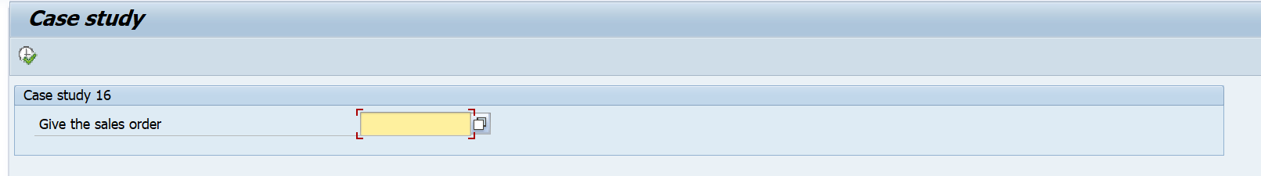OUTPUT:

After providing the sales order 11 get output

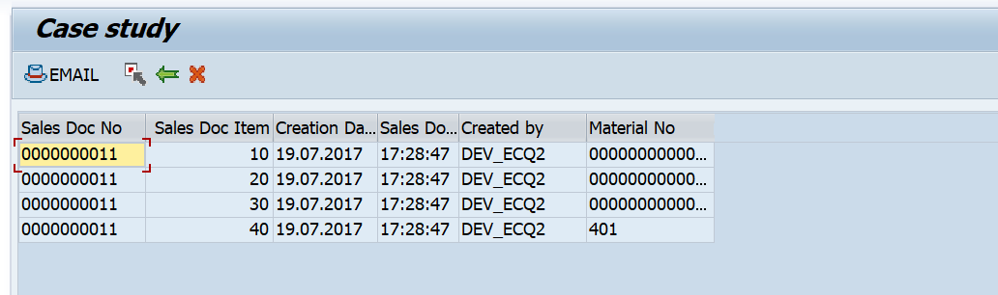Here we can see the two buttons is coming one is for email and other is for adobe.

After clicking the email button.

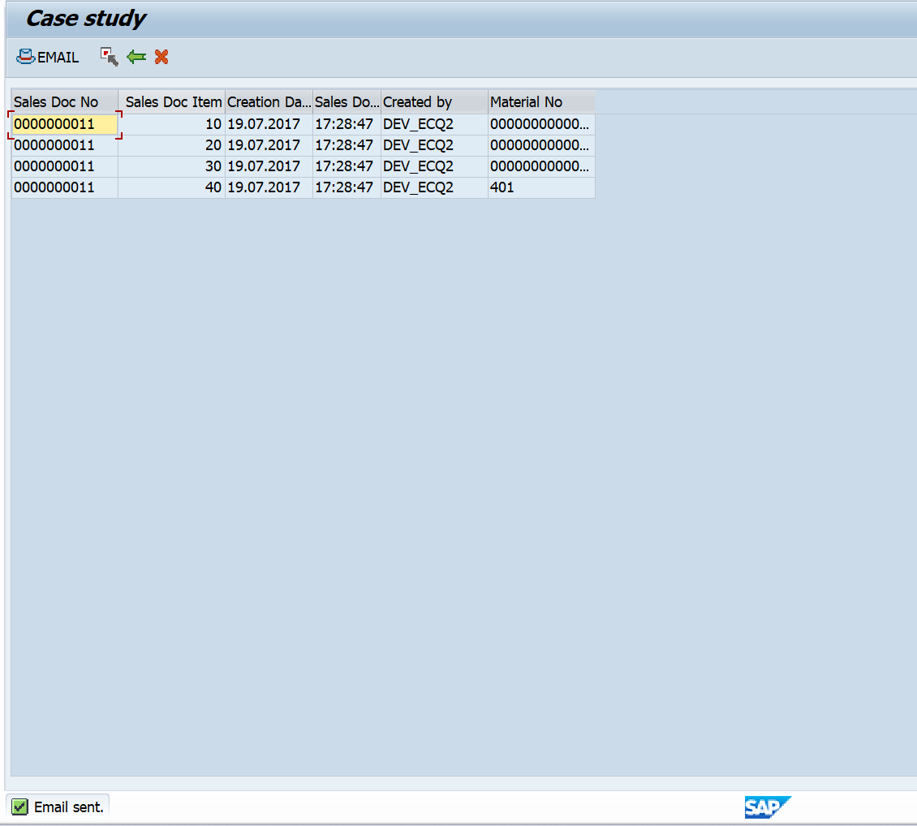

Email sent successfully.

After clicking adobe we get the output but in my case I have no adobe life cycle so I am not able to print output.