**CA-2**

**Name: - Rahul Kumar**

**Registration Number: - 12310431**

**Roll Number: - 44**

**Course Code: CAP782**

**Course Title: Responsive web design**

**Q1.**

1. You need to enhance your fluid layout (from Assessment 1) by implementing media queries and responsive image

techniques for different screen sizes.

2. Rebuild the layout using:

a. CSS Grid for the main content structure.

b. Flexbox for navigation, cards, or galleries.

3. Apply fluid spacing (em/rem units for padding/margins).

4. Define custom breakpoints based on content needs (not just device sizes).

a. Mobile (< 600px): Stack all sections vertically, hide less critical elements.

b. Tablet (600px–1024px): Sidebar moves below content, grid becomes 2-column.

c. Desktop (> 1024px): Multi-column grid with a sticky sidebar.

5. Navigation Transformation

a. Desktop: Horizontal menu.

b. Mobile: Hamburger menu

6. Use <picture> to serve cropped or different images per screen size:

a. Mobile: Close-up crop (e.g., portrait).

b. Desktop: Wide landscape crop.

7. Modern Image Optimization

a. Convert images to AVIF/WebP with JPEG fallback.

b. Use srcset with density descriptors (1x, 2x) for high-DPI screens.

**CODE**

<!DOCTYPE html>

<html lang="en">

<head>

  <meta charset="UTF-8" />

  <meta name="viewport" content="width=device-width, initial-scale=1.0" />

  <title>Travel Blog</title>

  <style>

    :root {

      --primary-color: #2c3e50;

      --secondary-color: #34495e;

      --accent-color: #3498db;

      --font-base: 1rem;

    }

    * {

      box-sizing: border-box;

      margin: 0;

      padding: 0;

    }

    body {

      font-family: Arial, sans-serif;

      line-height: 1.6;

      color: #fff;

      font-size: var(--font-base);

      background: linear-gradient(145deg, #1a1a1a, #2e2e2e, #121212);

      background-size: 400% 400%;

      animation: bgShift 15s ease infinite;

    }

    .container {

        background-color: rgba(255, 255, 255, 0.05); /* translucent for contrast */

        backdrop-filter: blur(5px);

        border-radius: 1rem;

        padding: 2rem;

        box-shadow: 0  3px rgba(0, 0, 0, 0.6);

    }

    header {

      background: var(--primary-color);

      color: white;

      padding: 2rem 0;

      text-align: center;

    }

    nav {

      background: var(--secondary-color);

    }

    .nav-wrapper {

      display: flex;

      justify-content: space-between;

      align-items: center;

      padding: 1rem;

    }

    .nav-links {

      display: flex;

      gap: 1rem;

    }

    .nav-links a {

      color: white;

      text-decoration: none;

      font-size: 1.1rem;

    }

    .hamburger {

      display: none;

      font-size: 2rem;

      color: white;

      cursor: pointer;

    }

    main {

      display: grid;

      grid-template-columns: 3fr 1fr;

      gap: 2rem;

      padding: 2rem 0;

    }

    article {

      grid-column: span 2;

    }

    .gallery {

      display: flex;

      flex-wrap: wrap;

      gap: 1rem;

    }

    .gallery-item {

      flex: 1 1 calc(50% - 1rem);

    }

    .gallery-item picture,

    .gallery-item img {

      width: 100%;

      height: auto;

      display: block;

    }

    .contact-form {

      margin-top: 2rem;

      grid-column: span 2;

    }

    .form-row {

      display: flex;

      flex-wrap: wrap;

      gap: 1rem;

      margin-bottom: 1rem;

    }

    .form-group {

      flex: 1 1 100%;

    }

    input,

    textarea {

      width: 100%;

      padding: 0.8rem;

      border: 1px solid #ccc;

      border-radius: 4px;

    }

    button {

      background: var(--accent-color);

      color: white;

      padding: 1rem 2rem;

      border: none;

      border-radius: 4px;

      cursor: pointer;

    }

    footer {

      background: var(--primary-color);

      color: white;

      text-align: center;

      padding: 2rem 0;

      margin-top: 2rem;

    }

    /* ===== Custom Breakpoints ===== */

    @media (max-width: 1024px) {

      main {

        grid-template-columns: 1fr 1fr;

      }

    }

    @media (max-width: 600px) {

      .nav-links {

        display: none;

        flex-direction: column;

        background: var(--secondary-color);

        padding: 1rem;

      }

      .nav-links.active {

        display: flex;

      }

      .hamburger {

        display: block;

      }

      main {

        grid-template-columns: 1fr;

      }

      .gallery-item {

        flex: 1 1 100%;

      }

    }

  </style>

</head>

<body>

  <header>

    <div class="container">

      <h1>Adventure Travel Blog</h1>

    </div>

  </header>

  <nav>

    <div class="container nav-wrapper">

      <div class="hamburger" onclick="toggleMenu()">☰</div>

      <ul class="nav-links" id="navLinks">

        <li><a href="#">Home</a></li>

        <li><a href="#">Destinations</a></li>

        <li><a href="#">About</a></li>

        <li><a href="#">Contact</a></li>

      </ul>

    </div>

  </nav>

  <main class="container">

    <article>

      <h2>Latest Adventure</h2>

      <p>Unlocking the world, one clever trip at a time</p>

    </article>

    <section class="gallery">

      <div class="gallery-item">

        <picture>

          <source srcset="./assets/mountain.webp" type="image/webp" />

          <img src="./assets/mountain.jpg" alt="Mountain" />

        </picture>

      </div>

      <div class="gallery-item">

        <picture>

          <source srcset="./assets/beach.webp" type="image/webp" />

          <img src="./assets/beach.jpg" alt="Beach" />

        </picture>

    </div>

        <div class="gallery-item">

            <picture>

              <source srcset="./assets/city.webp" type="image/webp" />

              <img src="./assets/mountain.jpg" alt="Mountain" />

            </picture>

          </div>

        </picture>

        <div class="gallery-item">

            <picture>

              <source srcset="./assets/forest2.jpg" type="image/webp" />

              <img src="./assets/mountain.jpg" alt="Forest" />

            </picture>

          </div>

      </div>

    </section>

    <section class="contact-form">

      <h2>Contact Us</h2>

      <form>

        <div class="form-row">

          <div class="form-group">

            <input type="text" placeholder="Name" required />

          </div>

          <div class="form-group">

            <input type="email" placeholder="Email" required />

          </div>

        </div>

        <div class="form-row">

          <div class="form-group">

            <textarea placeholder="Message" rows="5" required></textarea>

          </div>

        </div>

        <button type="submit">Send Message</button>

      </form>

    </section>

  </main>

  <footer>

    <div class="container">

      <p>&copy; 2025 Travel Blog. All rights reserved.</p>

    </div>

  </footer>

  <script>

    function toggleMenu() {

      const nav = document.getElementById("navLinks");

      nav.classList.toggle("active");

    }

  </script>

</body>

</html>

**RESULT**

1. **DESKTOP**

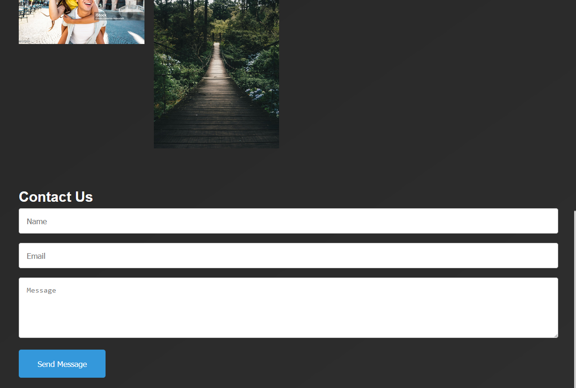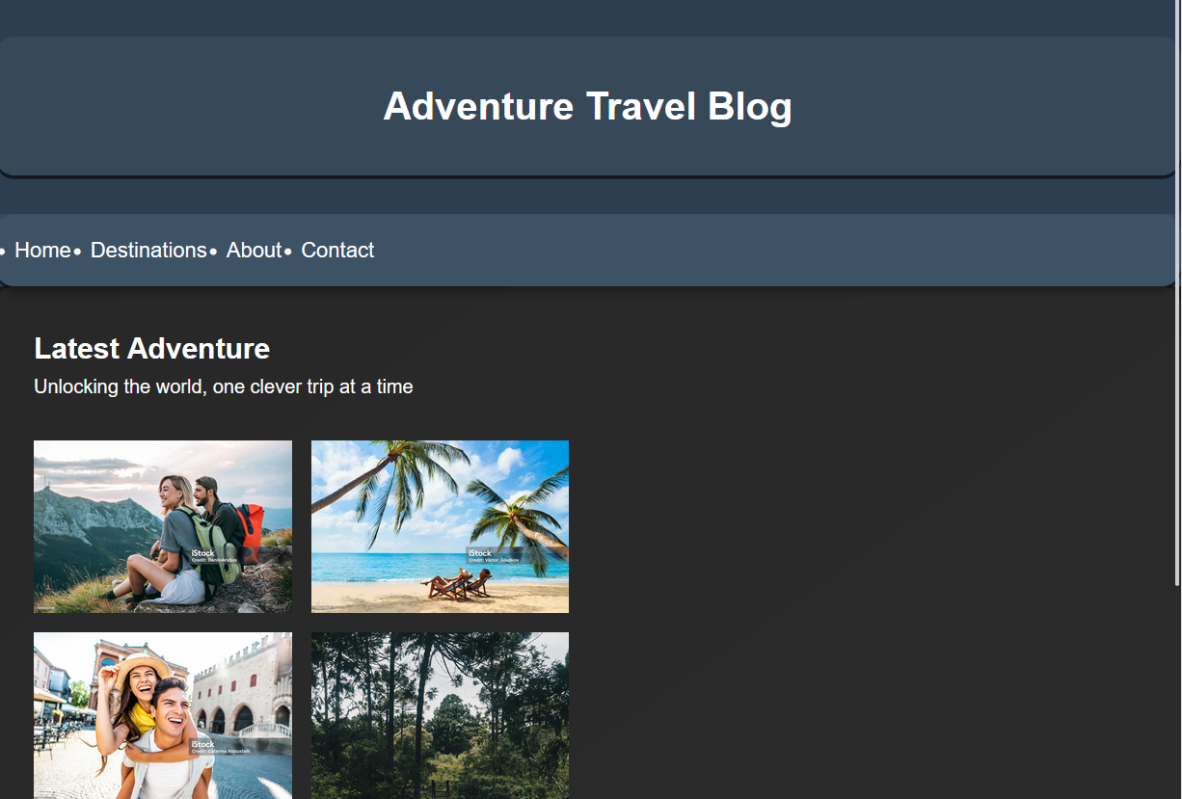

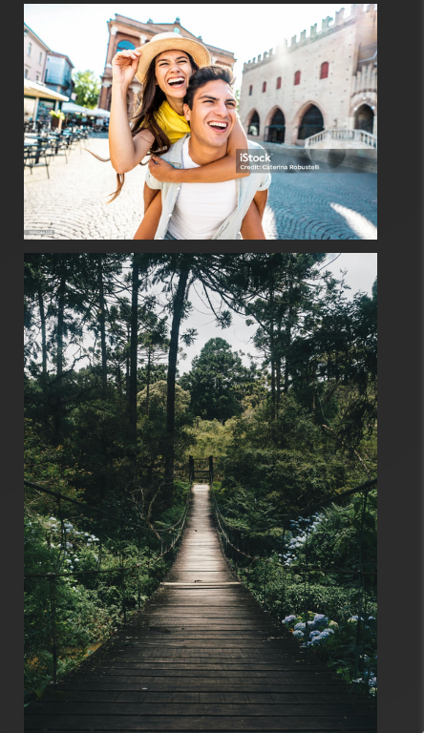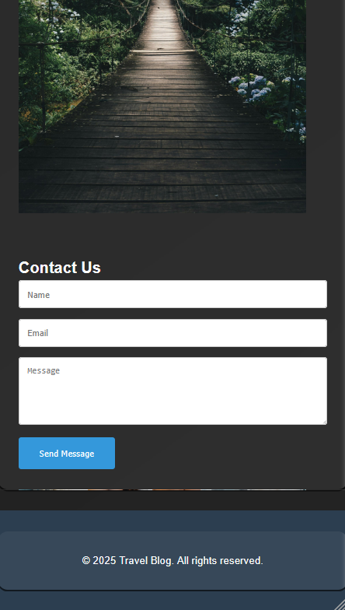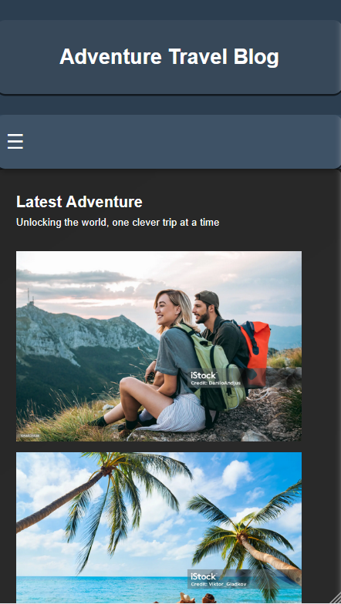**2) MOBILE**

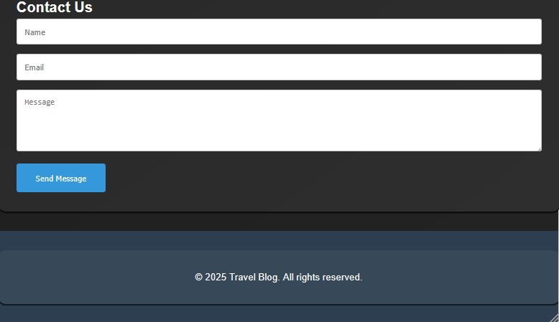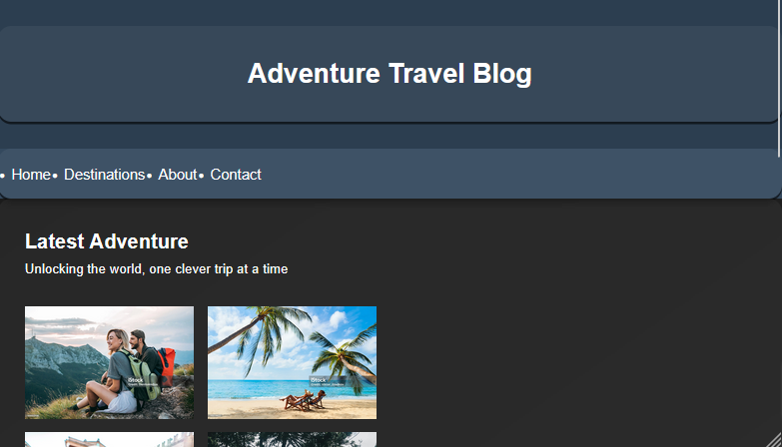**3) TABLET**