**Documentation**

**Step 1: I have created virtual environment using pipenv shell command**

**Step 2: I have install all the required library which is included in requirements.txt**

**Step 3: I have created Django project.**

1. I have created two models.
2. Custom User Model

Fields : id (primary key UUID Field), email_id (Email), first_name (str), last_name (str), is_active(boolean), admin(boolean), staff(Boolean), last_login(Date Time)

1. Books Model

Fields: id (primary key UUID Field), isbn(Integer), title (str), author(str), publication(str)

1. Then I have created Views.
2. Then I have created Serializers.

**Screenshots**

1. Signup API (Data Returned After SingUp)

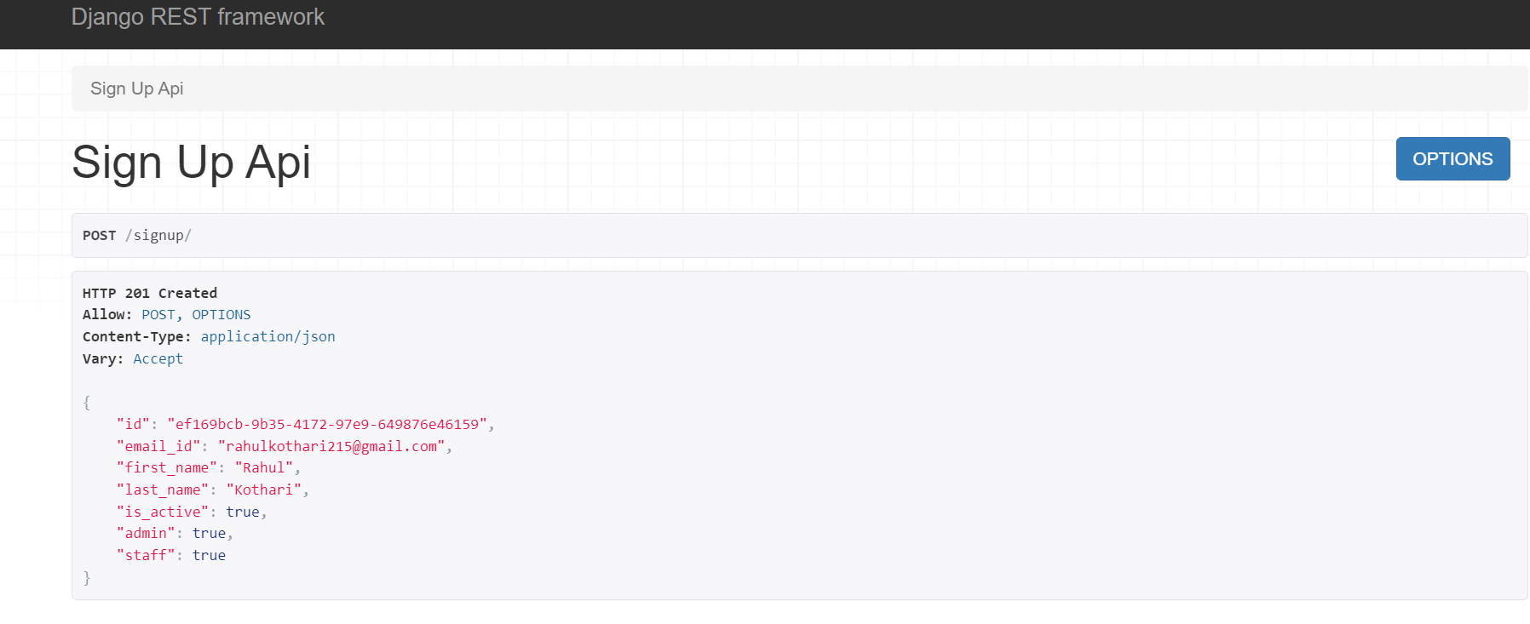

1. Login API (Data Returned After Login)

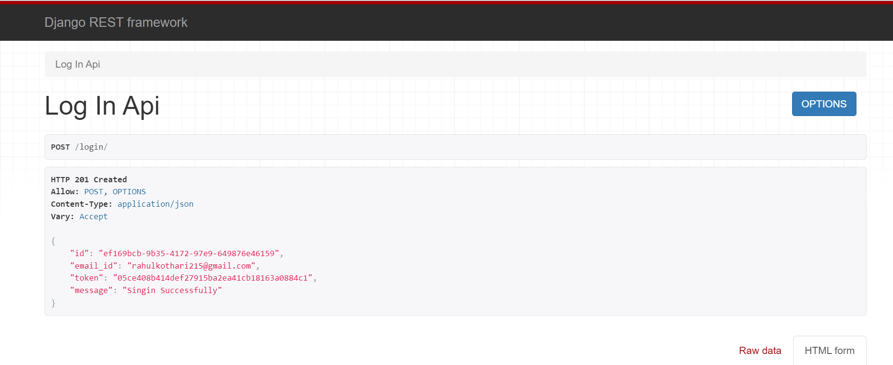

1. Data Created

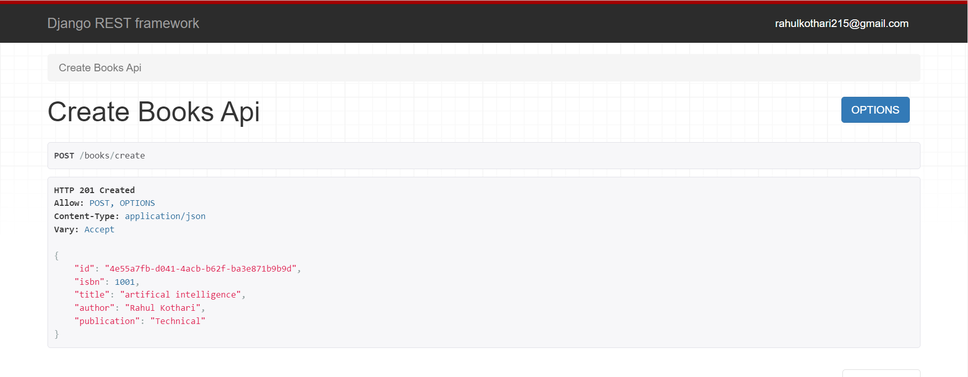

1. Retrieve all data

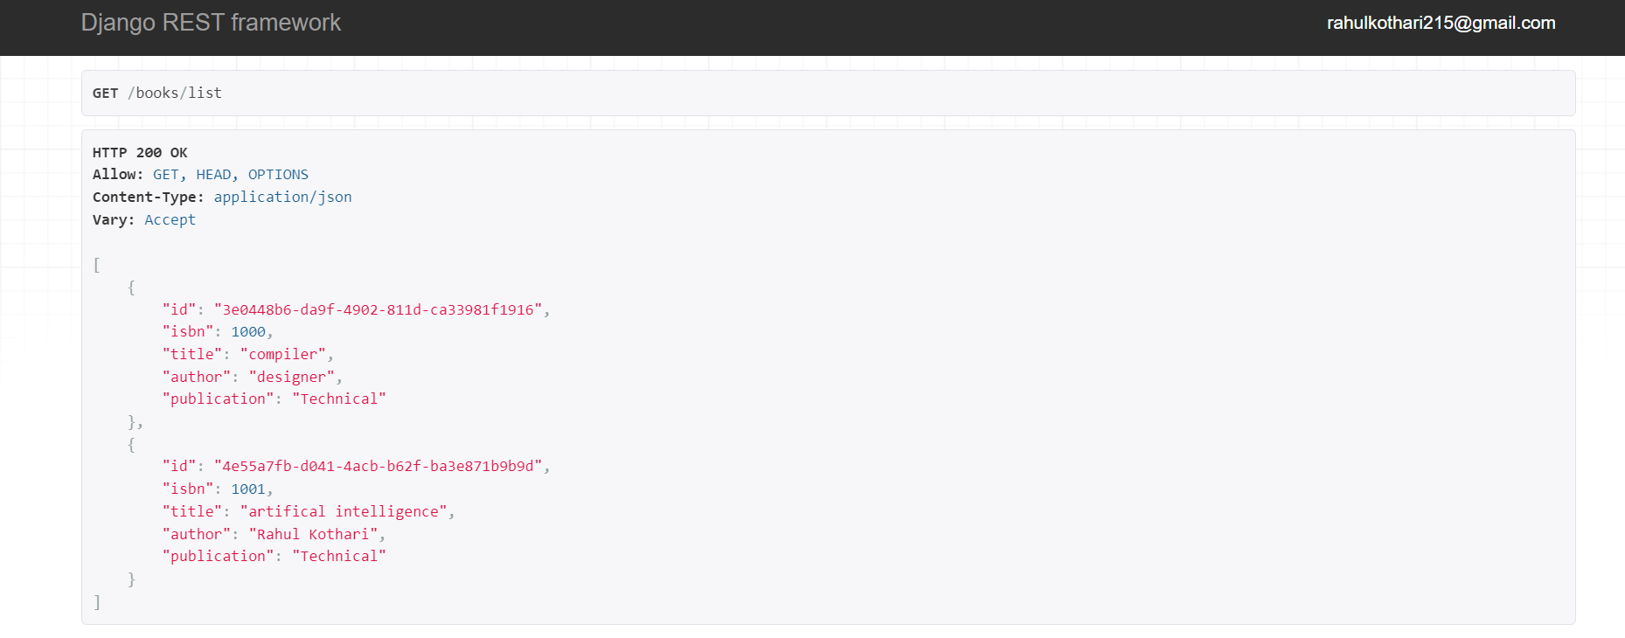

1. Update data

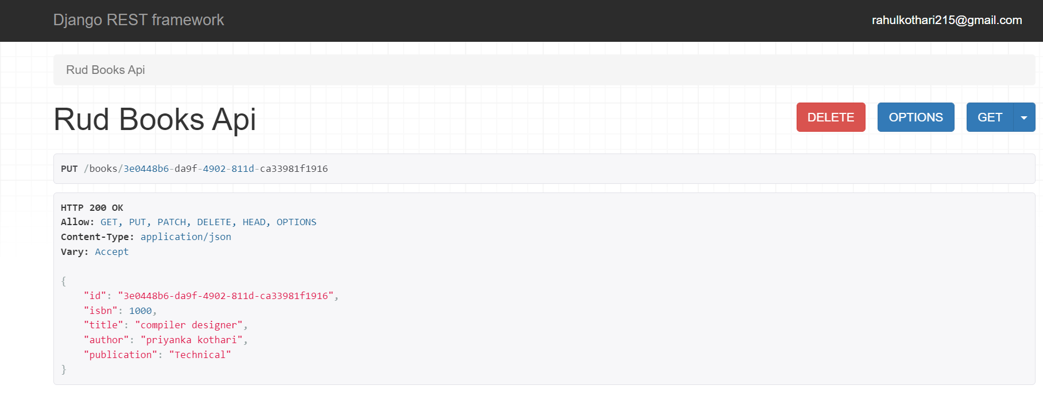

1. data after delete

