**Installing MySQL on LINUX**

* Run following commands to install MySQL Sever on Linux

1. Update package information from the MySQL APT repository with the following command (this step is mandatory):

$> sudo apt-get update -y

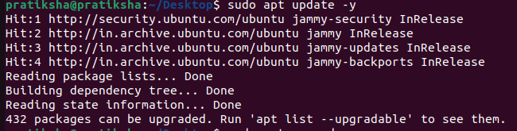

1. This installs the package for the MySQL server, as well as the packages for the client and for the database common files. During the installation, you are asked to supply a password for the root user for your MySQL installation.

$> sudo apt-get install mysql-server

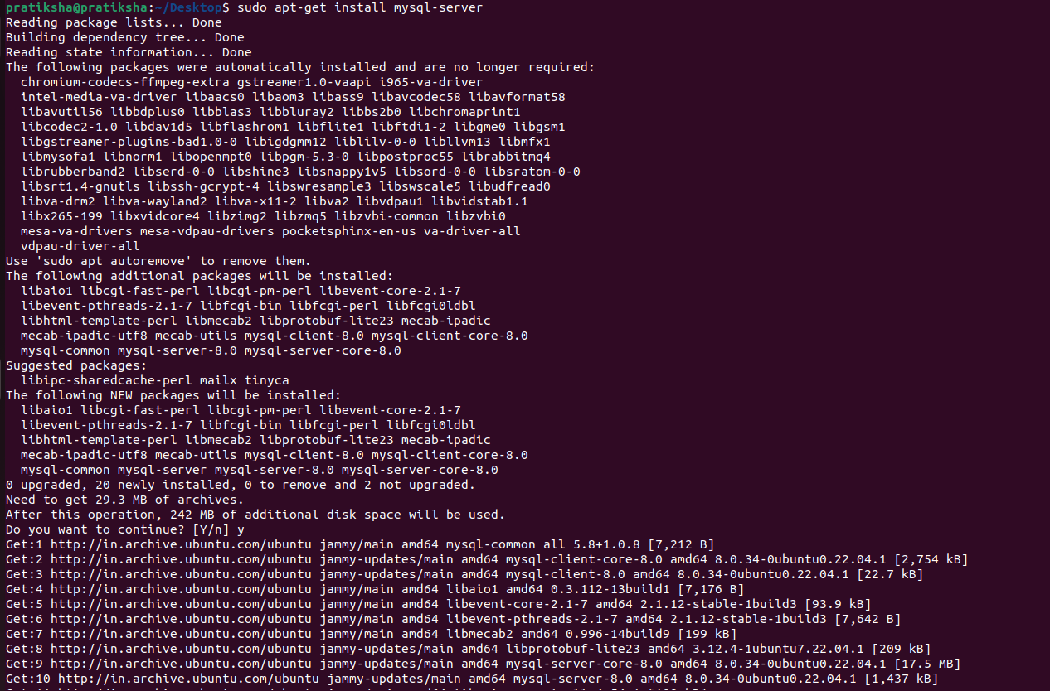

1. To know if its installed or not check the version of MySQL.



1. You can check the status of the MySQL server with the following command:

$> systemctl status mysql

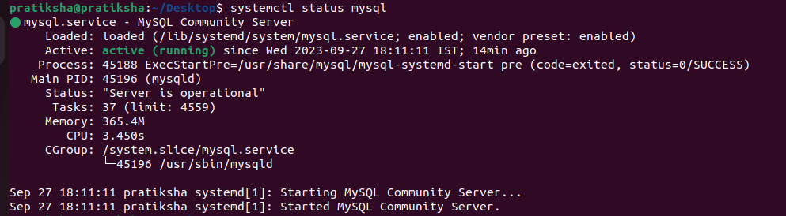

1. Login to MySQL

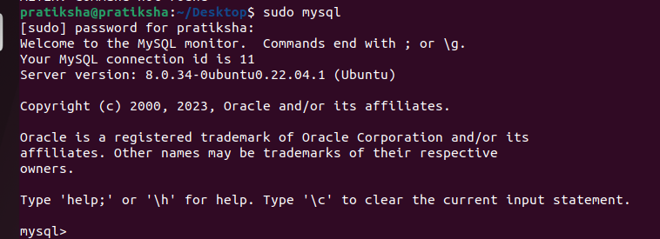

6. **If its not working, boot your PC to Windows and install MySQL by downloading it from community site .**