ONLINE MOVIE TICKET

SYSTEM

**INTRODUCTION**

This is an online movie ticket system having an admin role and a customer role where admin has access to add city, the theatres in the city, the movies each theatre will showcase and the show timings for each movie. The customer can be an unregistered user or a registered user. Unregistered user can register itself or can view movie shows without registering while the registered user can view movie shows and book tickets for the particular show by paying online. Registered users will have the option to cancel its booking in which case he will get a refund on some specific terms. Users can select the language of movie and view the seat map and choose seats for themselves.

Customer Operation:

Customer have to login into the booking system to book tickets and use the services.

USE CASE DIAGRAM

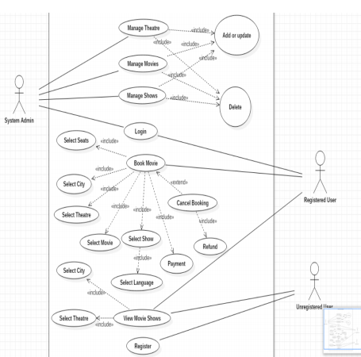

Class Diagram

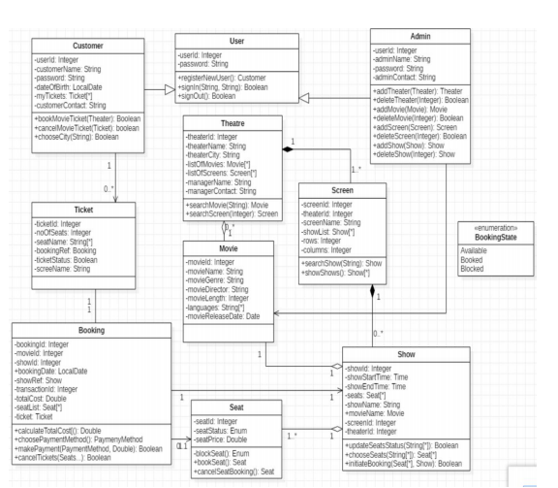

Package name in project:

1. com.capg.omts.booking.ms
2. com.capg.omts.booking.controller
3. com.capg.omts.booking.Exception
4. com.capg.omts.booking.model
5. com.capg.omts.booking.repository
6. com.capg.omts.booking.service

com.capg.omts.booking.controller

1. BookingMovieController.java
2. SeatController.java
3. TicketController.java

com.capg.omts.booking.repository

1. BookingMovieRepository.java
2. SeatRepository.java
3. TicketRepository.java

com.capg.omts.booking.model

1. Admin.java
2. Booking.java
3. BookingMovieList.java
4. BookingState.java
5. Customer.java
6. Movie.java
7. Payment.java
8. Screen.java
9. Seat.java

10.SeatStatus.java

11.Show.java

12.Theatre.java

13.Ticket.java

14.User.java

com.capg.omts.booking.Exception

1. BookingBlockedException.java
2. SeatNotFoundException.java
3. SlotNotFoundException.java
4. TicketCancellationException.java
5. TicketNotFoundException.java

com.capg.omts.booking.service

Interfaces:

1. IBookingService.java
2. ISeatService.java
3. ITicketService.java

Implementation:

1. BookingService.java
2. SeatService.java
3. TicketService.java

Methods in each implementation:

* chooseSeats(): Seat[*] For a particular show the customer chooses seats he is interested in booking. This will return a list of seats he has chosen as well as block the seats from booking.
* choosePaymentMethod(): PaymentMethod The customer now chooses the method he wants use for confirming his purchase of seats for the show.
* makePayment(PaymentMethod, Double): Boolean In this method the mode of payment user has selected is passed along with the total cost of current booking. It will invoke merchant side transaction process. For now we are considering this method only returns the confirmation of payment, later we will also consider an object will be returned containing transaction information.
* showTicket(): Ticket Upon confirmation of payment the ticket will be generated containing reference of current object and ticket parameters.
* cancelBookings(Seats…): Boolean This method will take as input the seats from the current booking session and upLocalDate their status as Available in corresponding show.

**Validation Rules**

1. All the fileds are mandatory.
2. Email id should be correct format .
3. Customer Name should contain only alphabets.
4. Contact number must be of 10 digits.