Assignment-3

Q1) List view and array adapter

Activity_main.xml

*<?***xml version="1.0" encoding="utf-8"***?>*<**RelativeLayout xmlns:android="http://schemas.android.com/apk/res/android"  
 xmlns:app="http://schemas.android.com/apk/res-auto"  
 xmlns:tools="http://schemas.android.com/tools"  
 android:layout_width="match_parent"  
 android:layout_height="match_parent"  
 tools:context=".MainActivity"**>

<**ListView  
 android:id="@+id/simplelistview"  
 android:layout_width="match_parent"  
 android:layout_height="match_parent"  
 android:divider="#000"  
 android:dividerHeight="2dp"  
 android:listSelector="@color/colorPrimary"** />  
</**RelativeLayout**>

Activity_list_view.xml

*<?***xml version="1.0" encoding="utf-8"***?>*<**LinearLayout xmlns:android="http://schemas.android.com/apk/res/android"  
 android:layout_width="match_parent"  
 android:layout_height="match_parent"  
 android:orientation="vertical"**>  
  
 <**TextView  
 android:id="@+id/textView"  
 android:layout_width="fill_parent"  
 android:layout_height="wrap_content"  
 android:layout_gravity="center"  
 android:textColor="#000"  
 android:textSize="30dp"  
 android:textStyle="italic"**/>  
  
</**LinearLayout**>

MainActivity.java  
**package** com.example.arrayadaptorlistview;

**import** androidx.appcompat.app.AppCompatActivity;  
 **import** android.os.Bundle;  
 **import** android.widget.ArrayAdapter;  
 **import** android.widget.ListView;

**public class** MainActivity **extends** AppCompatActivity {  
 ListView **simpleList**;  
 String **GameList**[] = {**"Cricket"**,**"Kho-Kho"**,**"Football"**,**"Basketball"**,**"Kabadi"**,**"Badminton"**,**"Chess"**};

@Override  
 **protected void** onCreate(Bundle savedInstanceState) {  
 **super**.onCreate(savedInstanceState);  
 setContentView(R.layout.***activity_main***);  
 **simpleList** = (ListView) findViewById(R.id.***simplelistview***);  
  
 ArrayAdapter<String> arrayAdapter = **new** ArrayAdapter<String>(**this**, R.layout.***activity_list_view***, R.id.***textView***, **GameList**);  
 **simpleList**.setAdapter(arrayAdapter);  
  
 }  
}

Output

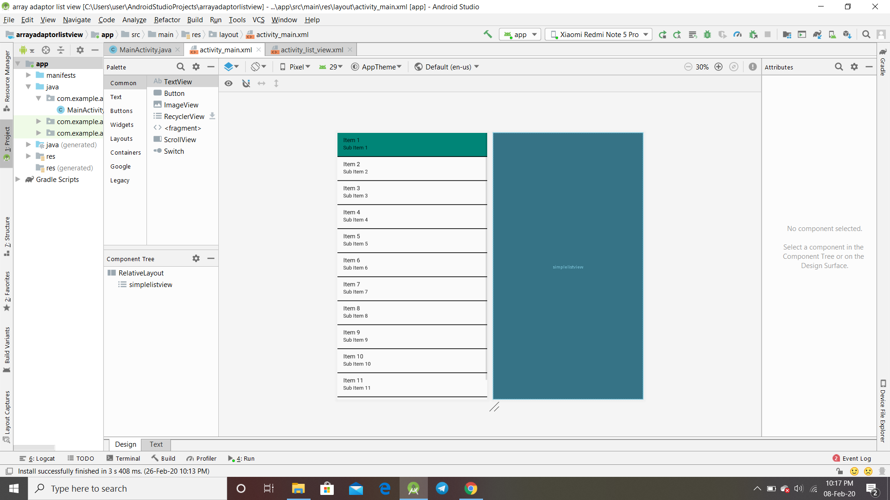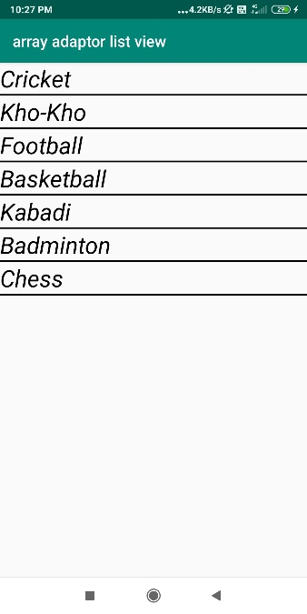 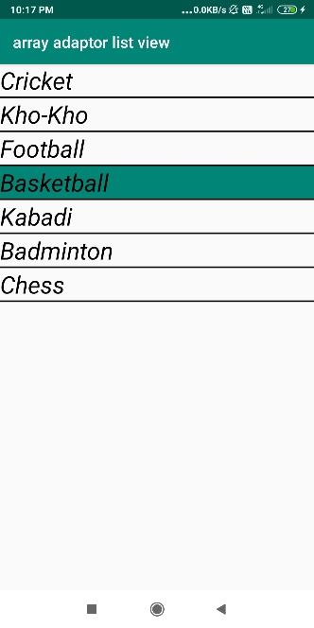

Q2) Basic from using all views

Acticity_main.xml

*<?***xml version="1.0" encoding="utf-8"***?>*<**androidx.constraintlayout.widget.ConstraintLayout xmlns:android="http://schemas.android.com/apk/res/android"  
 xmlns:app="http://schemas.android.com/apk/res-auto"  
 xmlns:tools="http://schemas.android.com/tools"  
 android:layout_width="match_parent"  
 android:layout_height="match_parent"  
 tools:context=".MainActivity"**>  
  
 <**TextView  
 android:id="@+id/textView2"  
 android:layout_width="wrap_content"  
 android:layout_height="wrap_content"  
 android:layout_marginTop="28dp"  
 android:text="Registration Form"  
 android:textColor="@android:color/background_dark"  
 android:textSize="30sp"  
 app:layout_constraintEnd_toEndOf="parent"  
 app:layout_constraintHorizontal_bias="0.497"  
 app:layout_constraintStart_toStartOf="parent"  
 app:layout_constraintTop_toTopOf="parent"** />  
  
 <**TableLayout  
 android:id="@+id/tableLayout"  
 android:layout_width="399dp"  
 android:layout_height="249dp"  
 android:layout_marginStart="2dp"  
 android:layout_marginLeft="2dp"  
 android:layout_marginTop="64dp"  
 android:layout_marginBottom="82dp"  
 app:layout_constraintBottom_toTopOf="@+id/buttonSubmit"  
 app:layout_constraintEnd_toEndOf="parent"  
 app:layout_constraintHorizontal_bias="0.4"  
 app:layout_constraintStart_toStartOf="parent"  
 app:layout_constraintTop_toBottomOf="@+id/textView2"**>  
  
 <**TableRow  
 android:layout_width="match_parent"  
 android:layout_height="match_parent"**>  
  
 <**TextView  
 android:id="@+id/name"  
 android:layout_width="158dp"  
 android:layout_height="50sp"  
 android:gravity="center|left"  
 android:text="Name:"  
 android:textColor="@android:color/background_dark"  
 android:textSize="25sp"** />  
  
 <**EditText  
 android:id="@+id/textName"  
 android:layout_width="245dp"  
 android:layout_height="50dp"  
 android:ems="10"  
 android:hint="Enter Your Name"  
 android:inputType="textPersonName"** />  
 </**TableRow**>  
  
 <**TableRow  
 android:layout_width="match_parent"  
 android:layout_height="match_parent"**>  
  
 <**TextView  
 android:id="@+id/email"  
 android:layout_width="158dp"  
 android:layout_height="50sp"  
 android:gravity="center|left"  
 android:text="Email Id:"  
 android:textColor="@android:color/background_dark"  
 android:textSize="25sp"** />  
  
 <**EditText  
 android:id="@+id/textEmail"  
 android:layout_width="wrap_content"  
 android:layout_height="wrap_content"  
 android:ems="10"  
 android:hint="gmail/yahoo"  
 android:inputType="textEmailAddress"** />  
  
 </**TableRow**>  
  
 <**TableRow  
 android:layout_width="match_parent"  
 android:layout_height="match_parent"**>  
  
 <**TextView  
 android:id="@+id/rollNumber"  
 android:layout_width="158dp"  
 android:layout_height="50sp"  
 android:gravity="center|left"  
 android:text="Roll Number:"  
 android:textColor="@android:color/background_dark"  
 android:textSize="25sp"** />  
  
 <**EditText  
 android:id="@+id/textRoll"  
 android:layout_width="wrap_content"  
 android:layout_height="wrap_content"  
 android:ems="10"  
 android:hint="AM.EN.U4XXXXXXXX"  
 android:inputType="textPersonName"** />  
  
 </**TableRow**>  
  
 <**TableRow  
 android:layout_width="match_parent"  
 android:layout_height="match_parent"**>  
  
 <**TextView  
 android:id="@+id/branch"  
 android:layout_width="158dp"  
 android:layout_height="50sp"  
 android:gravity="center|left"  
 android:text="Branch:"  
 android:textColor="@android:color/background_dark"  
 android:textSize="25sp"** />  
  
 <**EditText  
 android:id="@+id/textBranch"  
 android:layout_width="wrap_content"  
 android:layout_height="wrap_content"  
 android:ems="10"  
 android:hint="CSE/ECE/EEE/MECH"  
 android:inputType="textPersonName"** />  
  
 </**TableRow**>  
  
 <**TableRow  
 android:layout_width="match_parent"  
 android:layout_height="match_parent"**>  
  
 <**TextView  
 android:id="@+id/phone"  
 android:layout_width="158dp"  
 android:layout_height="50sp"  
 android:gravity="center|left"  
 android:text="Phone no:"  
 android:hint="+91xxxxxxxxxx"  
 android:textColor="@android:color/background_dark"  
 android:textSize="25sp"** />  
  
 <**EditText  
 android:id="@+id/textPhone"  
 android:layout_width="wrap_content"  
 android:layout_height="wrap_content"  
 android:ems="10"  
 android:inputType="phone"** />  
  
 </**TableRow**>  
  
 </**TableLayout**>  
  
 <**Button  
 android:id="@+id/buttonSubmit"  
 android:layout_width="191dp"  
 android:layout_height="62dp"  
 android:layout_marginStart="110dp"  
 android:layout_marginLeft="110dp"  
 android:layout_marginTop="82dp"  
 android:layout_marginEnd="110dp"  
 android:layout_marginRight="110dp"  
 android:text="SUBMIT"  
 android:textSize="25sp"  
 app:layout_constraintEnd_toEndOf="parent"  
 app:layout_constraintStart_toStartOf="parent"  
 app:layout_constraintTop_toBottomOf="@+id/tableLayout"** />  
  
  
</**androidx.constraintlayout.widget.ConstraintLayout**>

Acticity_main2.xml

*<?***xml version="1.0" encoding="utf-8"***?>*<**androidx.constraintlayout.widget.ConstraintLayout xmlns:android="http://schemas.android.com/apk/res/android"  
 xmlns:app="http://schemas.android.com/apk/res-auto"  
 xmlns:tools="http://schemas.android.com/tools"  
 android:layout_width="match_parent"  
 android:layout_height="match_parent"  
 tools:context=".Main2Activity"**>  
  
 <**TextView  
 android:id="@+id/receivedName"  
 android:layout_width="300dp"  
 android:layout_height="50dp"  
 android:layout_marginStart="55dp"  
 android:layout_marginLeft="55dp"  
 android:layout_marginTop="156dp"  
 android:layout_marginEnd="56dp"  
 android:layout_marginRight="56dp"  
 android:textSize="20sp"  
 android:textStyle="italic"  
 android:textColor="#C51162"  
 app:layout_constraintEnd_toEndOf="parent"  
 app:layout_constraintHorizontal_bias="0.0"  
 app:layout_constraintStart_toStartOf="parent"  
 app:layout_constraintTop_toTopOf="parent"** />  
  
 <**TextView  
 android:id="@+id/receivedMail"  
 android:layout_width="300dp"  
 android:layout_height="50dp"  
 android:layout_marginStart="55dp"  
 android:layout_marginLeft="55dp"  
 android:layout_marginEnd="56dp"  
 android:layout_marginRight="56dp"  
 android:textSize="20sp"  
 android:textStyle="italic"  
 android:textColor="#FF1694"  
 app:layout_constraintEnd_toEndOf="parent"  
 app:layout_constraintHorizontal_bias="0.0"  
 app:layout_constraintStart_toStartOf="parent"  
 app:layout_constraintTop_toBottomOf="@+id/receivedName"** />  
  
 <**TextView  
 android:id="@+id/receivedRollNo"  
 android:layout_width="300dp"  
 android:layout_height="50dp"  
 android:layout_marginStart="55dp"  
 android:layout_marginLeft="55dp"  
 android:layout_marginEnd="56dp"  
 android:layout_marginRight="56dp"  
 android:textSize="20sp"  
 android:textStyle="italic"  
 android:textColor="#00bfff"  
 app:layout_constraintEnd_toEndOf="parent"  
 app:layout_constraintHorizontal_bias="0.0"  
 app:layout_constraintStart_toStartOf="parent"  
 app:layout_constraintTop_toBottomOf="@+id/receivedMail"** />  
  
 <**TextView  
 android:id="@+id/receivedBranch"  
 android:layout_width="300dp"  
 android:layout_height="50dp"  
 android:layout_marginStart="55dp"  
 android:layout_marginLeft="55dp"  
 android:layout_marginEnd="56dp"  
 android:layout_marginRight="56dp"  
 android:textSize="20sp"  
 android:textStyle="italic"  
 android:textColor="#FFC30B"  
 app:layout_constraintEnd_toEndOf="parent"  
 app:layout_constraintHorizontal_bias="0.0"  
 app:layout_constraintStart_toStartOf="parent"  
 app:layout_constraintTop_toBottomOf="@+id/receivedRollNo"** />  
  
 <**TextView  
 android:id="@+id/receivedPhone"  
 android:layout_width="300dp"  
 android:layout_height="50dp"  
 android:layout_marginStart="55dp"  
 android:layout_marginLeft="55dp"  
 android:layout_marginEnd="56dp"  
 android:layout_marginRight="56dp"  
 android:textSize="20sp"  
 android:textStyle="italic"  
 android:textColor="#4CBB17"  
 app:layout_constraintEnd_toEndOf="parent"  
 app:layout_constraintHorizontal_bias="0.0"  
 app:layout_constraintStart_toStartOf="parent"  
 app:layout_constraintTop_toBottomOf="@+id/receivedBranch"** />  
  
 <**TextView  
 android:id="@+id/textView"  
 android:layout_width="187dp"  
 android:layout_height="55dp"  
 android:layout_marginStart="30dp"  
 android:layout_marginLeft="30dp"  
 android:layout_marginTop="104dp"  
 android:layout_marginEnd="231dp"  
 android:layout_marginRight="231dp"  
 android:text="Your Details"  
 android:textColor="#000"  
 android:textSize="25sp"  
 android:textStyle="bold"  
 app:layout_constraintEnd_toEndOf="parent"  
 app:layout_constraintHorizontal_bias="0.378"  
 app:layout_constraintStart_toStartOf="parent"  
 app:layout_constraintTop_toTopOf="parent"** />  
  
  
</**androidx.constraintlayout.widget.ConstraintLayout**>

MainActivity.java 1st activity

**package** com.example.basicform;  
  
**import** androidx.appcompat.app.AppCompatActivity;  
  
**import** android.content.Intent;  
**import** android.os.Bundle;  
**import** android.view.View;  
**import** android.widget.Button;  
**import** android.widget.EditText;  
  
**public class** MainActivity **extends** AppCompatActivity {  
  
 EditText **fullName**, **email**, **rno**, **branch**, **phoneNo**;  
  
 @Override  
 **protected void** onCreate(Bundle savedInstanceState) {  
 **super**.onCreate(savedInstanceState);  
 setContentView(R.layout.***activity_main***);  
 **fullName** = findViewById(R.id.***textName***);  
 **email** = findViewById(R.id.***textEmail***);  
 **rno** = findViewById(R.id.***textRoll***);  
 **branch** = findViewById(R.id.***textBranch***);  
 **phoneNo** = findViewById(R.id.***textPhone***);  
 Button buttonSubmit = findViewById(R.id.***buttonSubmit***);  
 buttonSubmit.setOnClickListener(**new** View.OnClickListener() {  
 @Override  
 **public void** onClick(View v) {  
 display();  
 }  
 });  
 }  
  
 **public void** display() {  
  
 String name = **fullName**.getText().toString();  
 String mail_id = **email**.getText().toString();  
 String roll_no = **rno**.getText().toString();  
 String branch_name = **branch**.getText().toString();  
 String phone_no = **phoneNo**.getText().toString();  
  
 Intent intent = **new** Intent(getApplicationContext(), Main2Activity.**class**);  
 intent.putExtra(**"f_name"**, name);  
 intent.putExtra(**"email"**, mail_id);  
 intent.putExtra(**"roll"**, roll_no);  
 intent.putExtra(**"branch"**, branch_name);  
 intent.putExtra(**"phone"**, phone_no);  
 startActivity(intent);  
  
 }  
}

MainActivity2.java 2nd acticity

**package** com.example.basicform;  
  
**import** androidx.appcompat.app.AppCompatActivity;  
  
**import** android.content.Intent;  
**import** android.os.Bundle;  
**import** android.widget.TextView;  
  
**public class** Main2Activity **extends** AppCompatActivity {  
  
 TextView **receivedName**, **receivedMail**, **receivedRoll**, **receivedBranch**, **receivedPhone**;  
  
 @Override  
 **protected void** onCreate(Bundle savedInstanceState) {  
 **super**.onCreate(savedInstanceState);  
 setContentView(R.layout.***activity_main2***);  
  
 **receivedName** = (TextView) findViewById(R.id.***receivedName***);  
 **receivedMail** = (TextView) findViewById(R.id.***receivedMail***);  
 **receivedRoll** = (TextView) findViewById(R.id.***receivedRollNo***);  
 **receivedBranch** = (TextView) findViewById(R.id.***receivedBranch***);  
 **receivedPhone** = (TextView) findViewById(R.id.***receivedPhone***);  
  
 Intent intent = getIntent();  
 String name = intent.getStringExtra(**"f_name"**);  
 String email = intent.getStringExtra(**"email"**);  
 String roll = intent.getStringExtra(**"roll"**);  
 String branch = intent.getStringExtra(**"branch"**);  
 String phone = intent.getStringExtra(**"phone"**);  
  
 **receivedName**.setText(**"Name is "** + name);  
 **receivedMail**.setText(**"Email id is "** + email);  
 **receivedRoll**.setText(**"Roll Number is "** + roll);  
 **receivedBranch**.setText(**"Branch is "** + branch);  
 **receivedPhone**.setText(**"Phone Number is "** + phone);  
  
 }  
}

Output

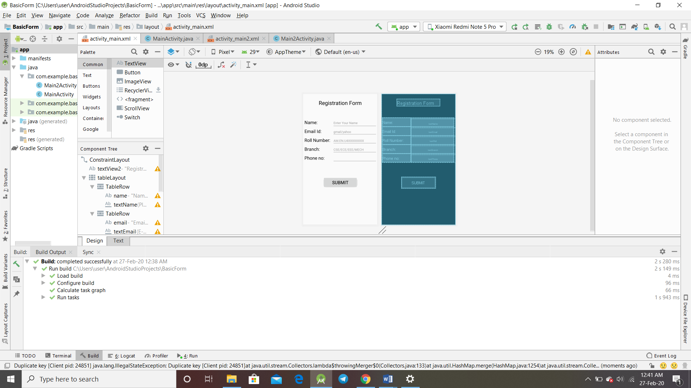

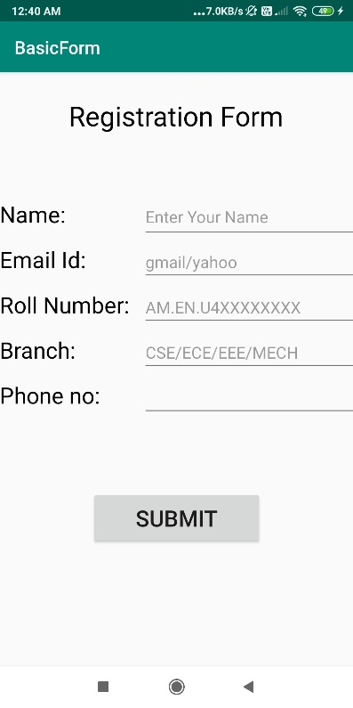 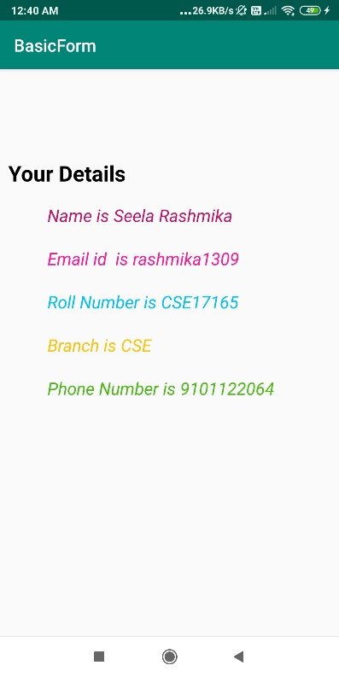

Q3) Custom array, custom list view.

Activity_main.xml

*<?***xml version="1.0" encoding="utf-8"***?>*<**RelativeLayout xmlns:a**

**ndroid="http://schemas.android.com/apk/res/android"  
 xmlns:app="http://schemas.android.com/apk/res-auto"  
 xmlns:tools="http://schemas.android.com/tools"  
 android:layout_width="match_parent"  
 android:layout_height="match_parent"  
 tools:context=".MainActivity"**>  
  
  
 <**ListView  
 android:id="@+id/simplelistview"  
 android:layout_width="match_parent"  
 android:layout_height="match_parent"** />  
</**RelativeLayout**>

activity_item.xml

*<?***xml version="1.0" encoding="utf-8"***?>*<**androidx.constraintlayout.widget.ConstraintLayout xmlns:android="http://schemas.android.com/apk/res/android"  
 xmlns:app="http://schemas.android.com/apk/res-auto"  
 xmlns:tools="http://schemas.android.com/tools"  
 android:layout_width="match_parent"  
 android:layout_height="match_parent"**>  
  
  
 <**ImageView  
 android:id="@+id/imageView"  
 android:layout_width="90dp"  
 android:layout_height="80dp"  
 android:layout_marginTop="16dp"  
 android:layout_weight="1"  
 app:layout_constraintEnd_toEndOf="parent"  
 app:layout_constraintHorizontal_bias="0.049"  
 app:layout_constraintStart_toStartOf="parent"  
 app:layout_constraintTop_toTopOf="parent"  
 tools:srcCompat="@tools:sample/avatars"** />  
  
 <**TextView  
 android:id="@+id/phone"  
 android:layout_width="303dp"  
 android:layout_height="25dp"  
 android:layout_marginStart="10dp"  
 android:layout_marginLeft="10dp"  
 android:layout_marginEnd="8dp"  
 android:layout_marginRight="8dp"  
 android:layout_weight="1"  
 android:text="TextView"  
 app:layout_constraintEnd_toEndOf="parent"  
 app:layout_constraintStart_toEndOf="@+id/imageView"  
 app:layout_constraintTop_toBottomOf="@+id/email"** />  
  
 <**TextView  
 android:id="@+id/name"  
 android:layout_width="303dp"  
 android:layout_height="30dp"  
 android:layout_marginStart="11dp"  
 android:layout_marginLeft="11dp"  
 android:layout_marginTop="16dp"  
 android:layout_marginEnd="8dp"  
 android:layout_marginRight="8dp"  
 android:layout_weight="1"  
 android:text="TextView"  
 app:layout_constraintEnd_toEndOf="parent"  
 app:layout_constraintStart_toEndOf="@+id/imageView"  
 app:layout_constraintTop_toTopOf="parent"** />  
  
 <**TextView  
 android:id="@+id/email"  
 android:layout_width="303dp"  
 android:layout_height="25dp"  
 android:layout_marginStart="10dp"  
 android:layout_marginLeft="10dp"  
 android:layout_marginEnd="8dp"  
 android:layout_marginRight="8dp"  
 android:layout_weight="1"  
 android:text="TextView"  
 app:layout_constraintEnd_toEndOf="parent"  
 app:layout_constraintStart_toEndOf="@+id/imageView"  
 app:layout_constraintTop_toBottomOf="@+id/name"** />  
</**androidx.constraintlayout.widget.ConstraintLayout**>

Activity_my_adapter.xml

*<?***xml version="1.0" encoding="utf-8"***?>*<**androidx.constraintlayout.widget.ConstraintLayout xmlns:android="http://schemas.android.com/apk/res/android"  
 xmlns:app="http://schemas.android.com/apk/res-auto"  
 xmlns:tools="http://schemas.android.com/tools"  
 android:layout_width="match_parent"  
 android:layout_height="match_parent"  
 tools:context=".MyAdapter"**>  
  
</**androidx.constraintlayout.widget.ConstraintLayout**>

MainActivity.java

**package** com.example.customarrayadapter;  
  
**import** androidx.appcompat.app.AppCompatActivity;  
  
**import** android.content.ClipData;  
**import** android.os.Bundle;  
**import** android.widget.ListView;  
  
**import** java.util.ArrayList;  
  
**public class** MainActivity **extends** AppCompatActivity {  
  
 ListView **simpleList**;  
 ArrayList<Item> **person** = **new** ArrayList<>();  
  
 @Override  
 **protected void** onCreate(Bundle savedInstanceState) {  
 **super**.onCreate(savedInstanceState);  
 setContentView(R.layout.***activity_main***);  
 **simpleList** = (ListView) findViewById(R.id.***simplelistview***);  
 **person**.add(**new** Item(**"Rashmika"**, **"rashmika1309@gmail.com"**, **"9101122064"**, R.drawable.***logo1***));  
 **person**.add(**new** Item(**"Rohith"**, **"sairohith@gmail.com"**, **"9696969696"**, R.drawable.***logo2***));  
 **person**.add(**new** Item(**"Harika"**, **"vharika@gmail.com"**, **"9876543210"**, R.drawable.***logo3***));  
 **person**.add(**new** Item(**"Rishi"**, **"rishi2004@gmail.com"**, **"1234567890"**, R.drawable.***logo4***));  
  
  
 MyAdapter myAdapter = **new** MyAdapter(**this**, android.R.layout.***simple_list_item_1***, **person**);  
 **simpleList**.setAdapter(myAdapter);  
  
 }  
}

Item.java

**package** com.example.customarrayadapter;  
  
**public class** Item {  
  
 String **first**,**email**,**phno**;  
 **int image**;  
  
 **public** Item(String first,String email,String phno,**int** image){  
 **this**.**email**=email;  
 **this**.**first**= first;  
 **this**.**phno**=phno;  
 **this**.**image**=image;  
 }  
 **public** String getEmail()  
 {  
 **return email**;  
 }  
 **public int** getImage()  
 {  
 **return image**;  
 }  
 **public** String getName()  
 {  
 **return first**;  
 }  
 **public** String getPhno()  
 {  
 **return phno**;  
 }  
}

MyAdapter.java

**package** com.example.customarrayadapter;  
  
**import** android.content.ClipData;  
**import** android.content.Context;  
**import** android.view.LayoutInflater;  
**import** android.view.View;  
**import** android.view.ViewGroup;  
**import** android.widget.ArrayAdapter;  
**import** android.widget.ImageView;  
**import** android.widget.TextView;  
  
**import** java.util.ArrayList;  
  
**public class** MyAdapter **extends** ArrayAdapter<Item> {  
  
 ArrayList<Item> **person** = **new** ArrayList<>();  
 TextView **name**,**email**,**phone**;  
 **public** MyAdapter(Context context, **int** textViewResourseId, ArrayList<Item> objects){  
 **super**(context, textViewResourseId,objects);  
 **person** = objects;  
 }  
  
 @Override  
 **public int** getCount(){  
 **return super**.getCount();  
 }  
  
 @Override  
 **public** View getView(**int** position, View convertView, ViewGroup parent){  
  
 View v = convertView;  
 LayoutInflater inflater = (LayoutInflater) getContext().getSystemService(Context.***LAYOUT_INFLATER_SERVICE***);  
 v = inflater.inflate(R.layout.***activity_item***, **null**);  
 **name** = (TextView) v.findViewById(R.id.***name***);  
 **name**.setText(**person**.get(position).getName());  
 **email** = (TextView) v.findViewById(R.id.***email***);  
 **email**.setText(**person**.get(position).getEmail());  
 **phone** = (TextView) v.findViewById(R.id.***phone***);  
 **phone**.setText(**person**.get(position).getPhno());  
 ImageView imageView = (ImageView) v.findViewById(R.id.***imageView***);  
 imageView.setImageResource(**person**.get(position).getImage());  
 **return** v;  
 }  
}

Output:

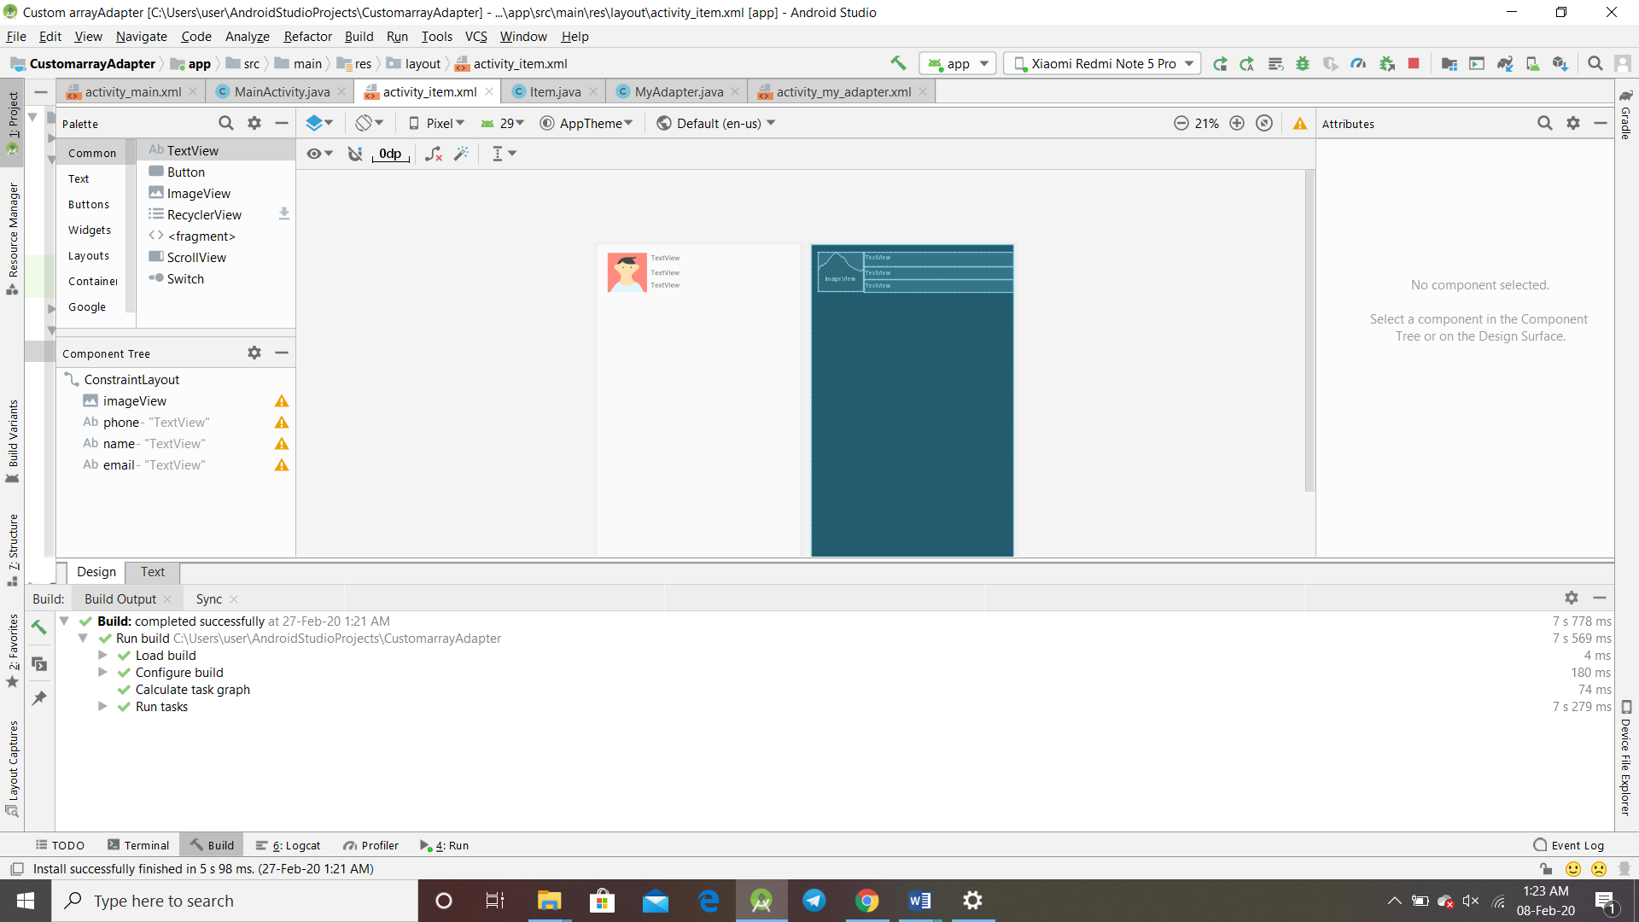

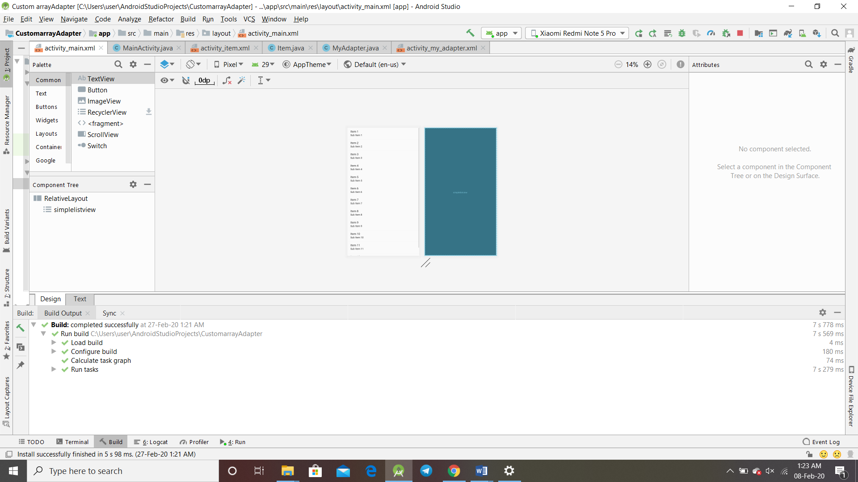

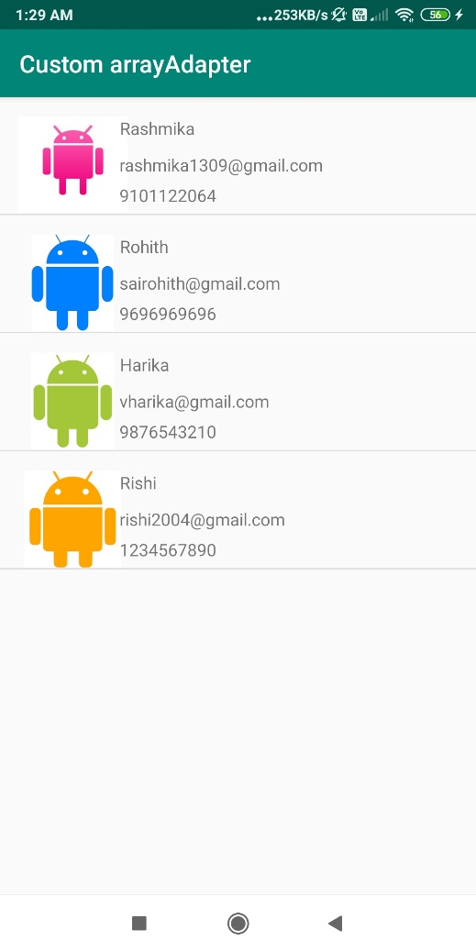

Q4) Custom list view

Acvtivity_main.xml

*<?***xml version="1.0" encoding="utf-8"***?>*<**RelativeLayout xmlns:android="http://schemas.android.com/apk/res/android"  
 xmlns:app="http://schemas.android.com/apk/res-auto"  
 xmlns:tools="http://schemas.android.com/tools"  
 android:layout_width="match_parent"  
 android:layout_height="match_parent"  
 tools:context=".MainActivity"**>  
  
  
 <**ListView  
 android:id="@+id/simplelistview"  
 android:layout_width="match_parent"  
 android:layout_height="match_parent"** />  
</**RelativeLayout**>

Activity_second.xml

*<?***xml version="1.0" encoding="utf-8"***?>*<**androidx.constraintlayout.widget.ConstraintLayout xmlns:android="http://schemas.android.com/apk/res/android"  
 xmlns:app="http://schemas.android.com/apk/res-auto"  
 xmlns:tools="http://schemas.android.com/tools"  
 android:layout_width="match_parent"  
 android:layout_height="match_parent"  
 tools:context=".secondactivity"**>  
 <**TextView  
 android:id="@+id/title"  
 android:layout_width="wrap_content"  
 android:layout_height="wrap_content"  
 android:layout_marginTop="112dp"  
 android:text="TextView"  
 app:layout_constraintEnd_toEndOf="parent"  
 app:layout_constraintStart_toStartOf="parent"  
 app:layout_constraintTop_toTopOf="parent"** />  
  
 <**ImageView  
 android:id="@+id/image"  
 android:layout_width="wrap_content"  
 android:layout_height="wrap_content"  
 android:layout_marginTop="62dp"  
 app:layout_constraintEnd_toEndOf="parent"  
 app:layout_constraintStart_toStartOf="parent"  
 app:layout_constraintTop_toBottomOf="@+id/title"  
 tools:srcCompat="@tools:sample/avatars[0]"** />  
  
 <**TextView  
 android:id="@+id/desc"  
 android:layout_width="195dp"  
 android:layout_height="106dp"  
 android:layout_marginTop="164dp"  
 android:text="TextView"  
 app:layout_constraintStart_toStartOf="@+id/image"  
 app:layout_constraintTop_toBottomOf="@+id/image"** />  
</**androidx.constraintlayout.widget.ConstraintLayout**>

Activity_item.xml

*<?***xml version="1.0" encoding="utf-8"***?>*<**androidx.constraintlayout.widget.ConstraintLayout xmlns:android="http://schemas.android.com/apk/res/android"  
 xmlns:app="http://schemas.android.com/apk/res-auto"  
 xmlns:tools="http://schemas.android.com/tools"  
 android:layout_width="match_parent"  
 android:layout_height="match_parent"**>  
  
  
 <**ImageView  
 android:id="@+id/imageView"  
 android:layout_width="90dp"  
 android:layout_height="80dp"  
 android:layout_marginTop="12dp"  
 android:layout_weight="1"  
 app:layout_constraintEnd_toEndOf="parent"  
 app:layout_constraintHorizontal_bias="0.0"  
 app:layout_constraintStart_toStartOf="parent"  
 app:layout_constraintTop_toTopOf="parent"  
 tools:srcCompat="@tools:sample/avatars"** />  
  
 <**TextView  
 android:id="@+id/phone"  
 android:layout_width="303dp"  
 android:layout_height="25dp"  
 android:layout_marginStart="10dp"  
 android:layout_marginLeft="10dp"  
 android:layout_marginTop="44dp"  
 android:layout_marginEnd="8dp"  
 android:layout_marginRight="8dp"  
 android:layout_weight="1"  
 android:text="TextView"  
 app:layout_constraintEnd_toEndOf="parent"  
 app:layout_constraintHorizontal_bias="0.0"  
 app:layout_constraintStart_toEndOf="@+id/imageView"  
 app:layout_constraintTop_toBottomOf="@+id/email"** />  
  
 <**TextView  
 android:id="@+id/name"  
 android:layout_width="303dp"  
 android:layout_height="30dp"  
 android:layout_marginStart="11dp"  
 android:layout_marginLeft="11dp"  
 android:layout_marginTop="32dp"  
 android:layout_marginEnd="8dp"  
 android:layout_marginRight="8dp"  
 android:layout_weight="1"  
 android:text="TextView"  
 app:layout_constraintEnd_toEndOf="parent"  
 app:layout_constraintHorizontal_bias="1.0"  
 app:layout_constraintStart_toEndOf="@+id/imageView"  
 app:layout_constraintTop_toTopOf="parent"** />  
  
 <**TextView  
 android:id="@+id/email"  
 android:layout_width="303dp"  
 android:layout_height="25dp"  
 android:layout_marginStart="10dp"  
 android:layout_marginLeft="10dp"  
 android:layout_marginEnd="8dp"  
 android:layout_marginRight="8dp"  
 android:layout_weight="1"  
 android:text="TextView"  
 app:layout_constraintEnd_toEndOf="parent"  
 app:layout_constraintHorizontal_bias="0.0"  
 app:layout_constraintStart_toEndOf="@+id/imageView"  
 app:layout_constraintTop_toBottomOf="@+id/title"** />  
</**androidx.constraintlayout.widget.ConstraintLayout**>

MainActivity.java

**package** com.example.customlistview;  
  
**import** androidx.appcompat.app.AppCompatActivity;  
  
**import** android.content.ClipData;  
**import** android.content.Intent;  
**import** android.os.Bundle;  
**import** android.view.View;  
**import** android.widget.AdapterView;  
**import** android.widget.ListView;  
  
**import** java.util.ArrayList;  
  
**public class** MainActivity **extends** AppCompatActivity {  
  
 ListView **simpleList**;  
 **static** ArrayList<Item> *person* = **new** ArrayList<>();  
 @Override  
 **protected void** onCreate(Bundle savedInstanceState) {  
 **super**.onCreate(savedInstanceState);  
 setContentView(R.layout.***activity_main***);  
 **simpleList** = (ListView) findViewById(R.id.***simplelistview***);  
 *person*.add(**new** Item(**"Rashmika"**,**"rashmika1309@gmail.com"**,**"9101122064"**,R.drawable.***logo1***));  
 *person*.add(**new** Item(**"Rohith"**,**"sairohith@gmail.com"**,**"9696969696"**,R.drawable.***logo2***));  
 *person*.add(**new** Item(**"Harika"**,**"vharika@gmail.com"**,**"1234567890"**,R.drawable.***logo3***));  
 *person*.add(**new** Item(**"Rishi"**,**"rishi2004@gmail.com"**,**"9087654321"**,R.drawable.***logo4***));  
  
 MyAdapter myAdapter = **new** MyAdapter(**this**,android.R.layout.***simple_list_item_1***,*person*);  
 **simpleList**.setAdapter(myAdapter);  
 **simpleList**.setOnItemClickListener(**new** AdapterView.OnItemClickListener() {  
 @Override  
 **public void** onItemClick(AdapterView<?> parent, View view, **int** position, **long** id) {  
 Intent intent = **new** Intent(getApplicationContext(),secondactivity.**class**);  
 intent.putExtra(**"description"**,*person*.get(position).getName());  
  
 startActivity(intent);  
 }  
 });  
  
 }  
 **public static** ArrayList<Item> getList(){  
 **return** *person*;  
 }  
}

secondActivity.java

**package** com.example.customlistview;  
  
**import** androidx.appcompat.app.AppCompatActivity;  
  
**import** android.content.Intent;  
**import** android.os.Bundle;  
**import** android.widget.ImageView;  
**import** android.widget.TextView;  
  
**import** java.util.ArrayList;  
  
**public class** secondactivity **extends** AppCompatActivity {  
  
 String **arr**[]= {**"Happy family"**,**"Good friends"**,**"Memorable trips"**,**"Pleasent life"**};  
 **int a**[]= {R.drawable.***logo1***,R.drawable.***logo2***,R.drawable.***logo3***,R.drawable.***logo4***};  
 **static** ArrayList<Item> *movie*= MainActivity.*getList*();  
 TextView **title**,**desc**;  
 ImageView **image**;  
 @Override  
 **protected void** onCreate(Bundle savedInstanceState) {  
 **super**.onCreate(savedInstanceState);  
 setContentView(R.layout.***activity_secondactivity***);  
 **title** = findViewById(R.id.***title***);  
 **desc** = findViewById(R.id.***desc***);  
 **image** = findViewById(R.id.***image***);  
 Intent intent = getIntent();  
 String name=intent.getStringExtra(**"description"**);  
 **for** (**int** i= 0;i<*movie*.size();i++){  
 **if**(*movie*.get(i).getName().equals(name)){  
 **title**.setText(*movie*.get(i).getName());  
 **desc**.setText(**arr**[i]);  
 **image**.setImageResource(**a**[i]);  
 }  
 }  
 }  
}

MyAdapter.java

**package** com.example.customlistview;  
  
**import** android.content.ClipData;  
**import** android.content.Context;  
**import** android.view.LayoutInflater;  
**import** android.view.View;  
**import** android.view.ViewGroup;  
**import** android.widget.ArrayAdapter;  
**import** android.widget.ImageView;  
**import** android.widget.TextView;  
  
**import** java.util.ArrayList;  
  
**public class** MyAdapter **extends** ArrayAdapter<Item> {  
  
 ArrayList<Item> **person** = **new** ArrayList<>();  
 TextView **name**,**email**,**phone**;  
 **public** MyAdapter(Context context, **int** textViewResourseId, ArrayList<Item> objects){  
 **super**(context, textViewResourseId,objects);  
 **person** = objects;  
 }  
  
 @Override  
 **public int** getCount(){  
 **return super**.getCount();  
 }  
  
 @Override  
 **public** View getView(**int** position, View convertView, ViewGroup parent){  
  
 View v = convertView;  
 LayoutInflater inflater = (LayoutInflater) getContext().getSystemService(Context.***LAYOUT_INFLATER_SERVICE***);  
 v = inflater.inflate(R.layout.***activity_item***, **null**);  
 **name** = (TextView) v.findViewById(R.id.***name***);  
 **name**.setText(**person**.get(position).getName());  
 **email** = (TextView) v.findViewById(R.id.***email***);  
 **email**.setText(**person**.get(position).getEmail());  
 **phone** = (TextView) v.findViewById(R.id.***phone***);  
 **phone**.setText(**person**.get(position).getPhno());  
 ImageView imageView = (ImageView) v.findViewById(R.id.***imageView***);  
 imageView.setImageResource(**person**.get(position).getImage());  
 **return** v;  
 }  
}

Item.java

**package** com.example.customlistview;  
  
**public class** Item {  
  
 String **first**,**email**,**phno**;  
 **int image**;  
  
 **public** Item(String first,String email,String phno,**int** image){  
 **this**.**email**=email;  
 **this**.**first**= first;  
 **this**.**phno**=phno;  
 **this**.**image**=image;  
 }  
 **public** String getEmail()  
 {  
 **return email**;  
 }  
 **public int** getImage()  
 {  
 **return image**;  
 }  
 **public** String getName()  
 {  
 **return first**;  
 }  
 **public** String getPhno()  
 {  
 **return phno**;  
 }  
}

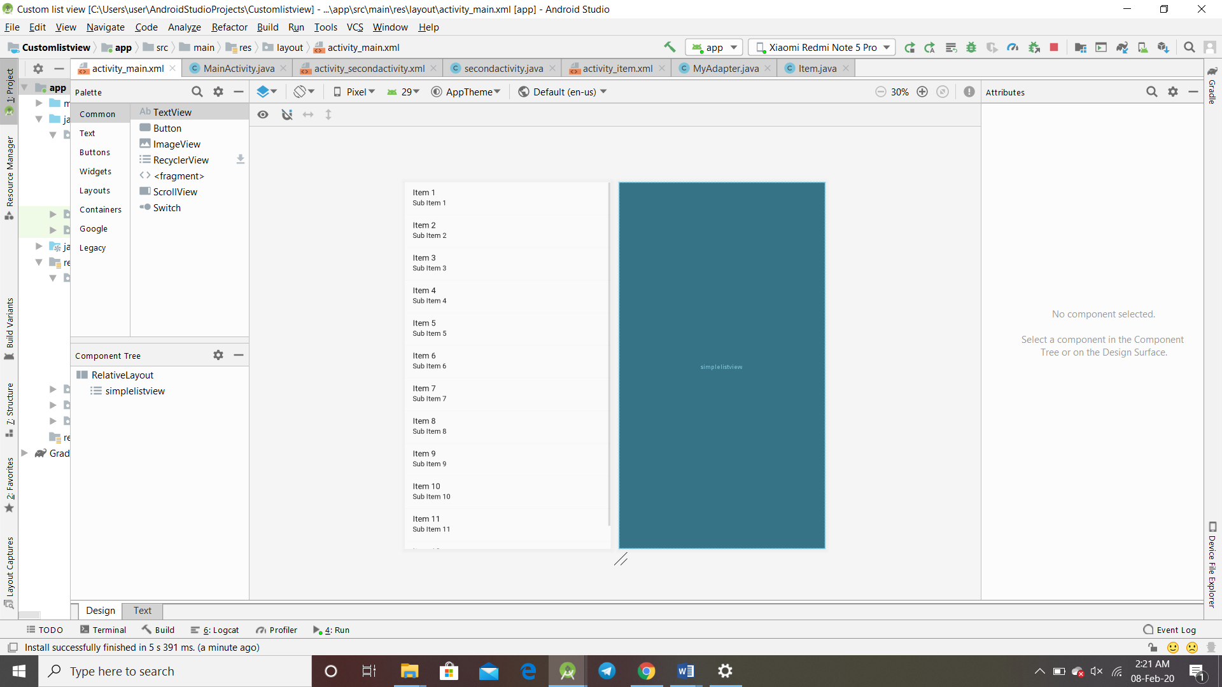

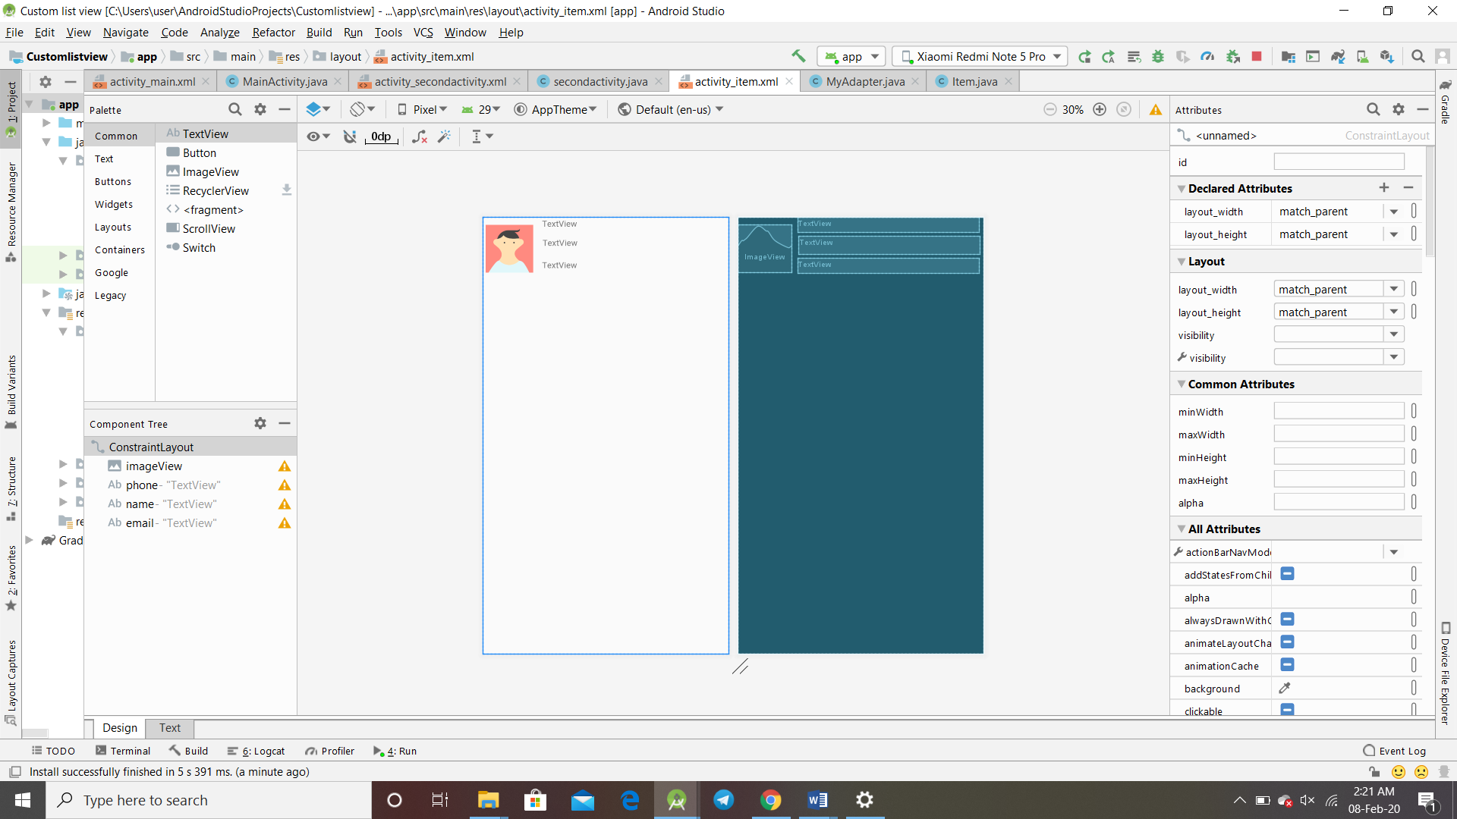

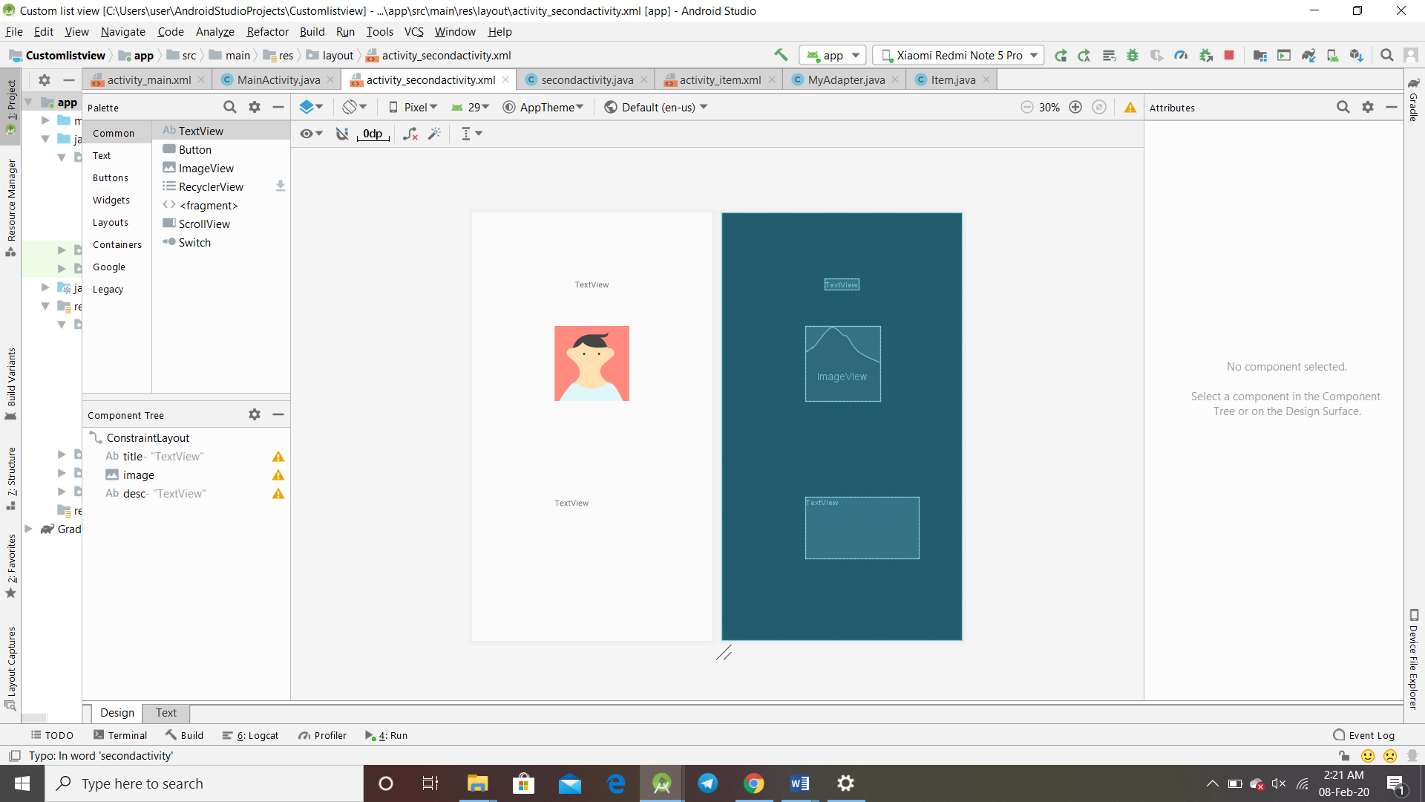

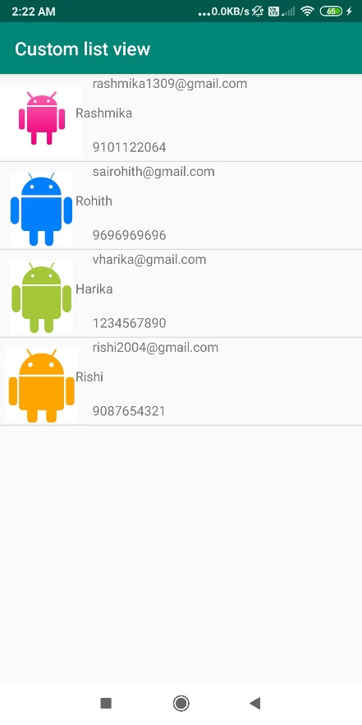 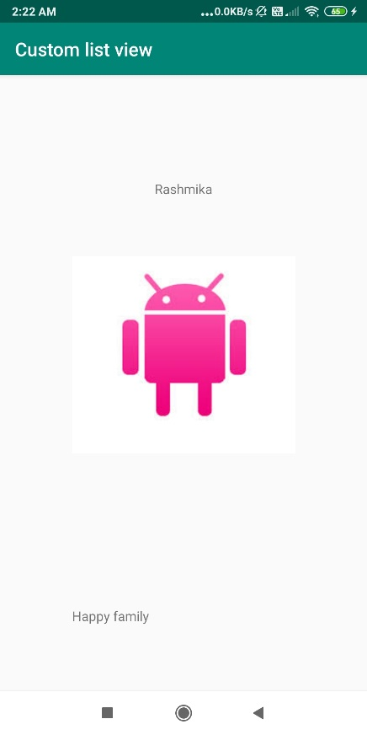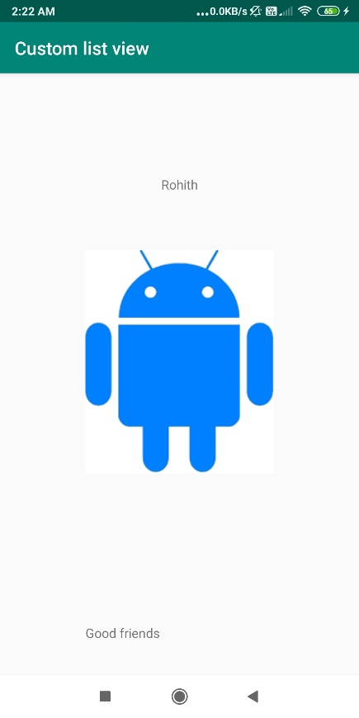

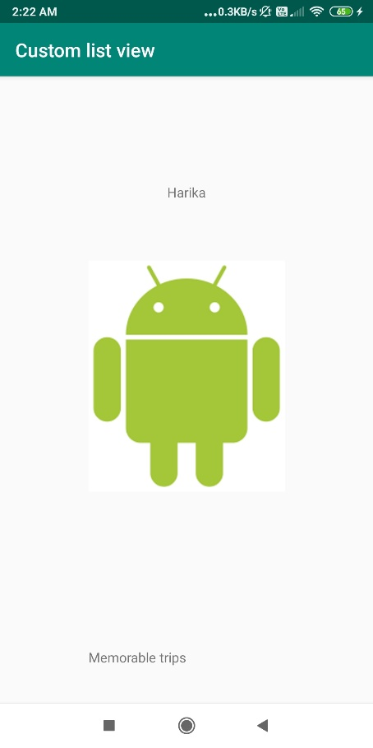 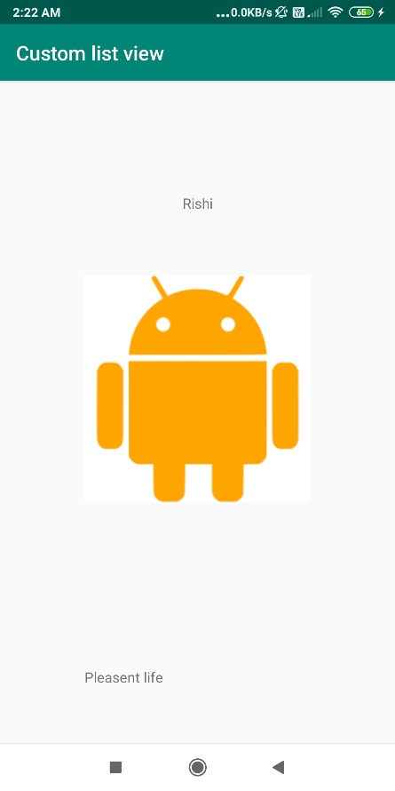

Q5) Grid view

Activity_main.xml

*<?***xml version="1.0" encoding="utf-8"***?>*<**LinearLayout xmlns:android="http://schemas.android.com/apk/res/android"  
 android:layout_width="match_parent"  
 android:layout_height="match_parent"  
 android:orientation="vertical"**>  
 *<!--  
 GridView with 3 value for numColumns attribute  
 -->* <**GridView  
 android:id="@+id/simpleGridView"  
 android:layout_width="fill_parent"  
 android:layout_height="wrap_content"  
 android:footerDividersEnabled="false"  
 android:padding="1dp"  
 android:numColumns="3"** />  
</**LinearLayout**>

Activity_second.xml

*<?***xml version="1.0" encoding="utf-8"***?>*<**RelativeLayout xmlns:android="http://schemas.android.com/apk/res/android"  
 xmlns:tools="http://schemas.android.com/tools"  
 android:layout_width="match_parent"  
 android:layout_height="match_parent"  
 android:background="#fff"  
 tools:context="com.example.gridview.SecondActivity"**>  
 <**ImageView  
 android:id="@+id/selectedImage"  
 android:layout_width="match_parent"  
 android:layout_height="wrap_content"  
 android:layout_centerInParent="true"  
 android:scaleType="fitXY"** />  
</**RelativeLayout**>

Activity_custom_adapter.xml

*<?***xml version="1.0" encoding="utf-8"***?>*<**LinearLayout xmlns:android="http://schemas.android.com/apk/res/android"  
 android:layout_width="match_parent"  
 android:layout_height="wrap_content"  
 android:padding="1dp"  
 android:orientation="vertical"**>  
  
 <**ImageView  
 android:id="@+id/icon"  
 android:layout_width="match_parent"  
 android:layout_height="328dp"  
 android:layout_gravity="center_horizontal"  
 android:scaleType="fitXY"  
 android:src="@drawable/logo1"** />  
</**LinearLayout**>

MainActivity.java

**package** com.example.gridview;  
  
**import** android.content.Intent;  
**import** android.os.Bundle;  
**import** android.view.View;  
**import** android.widget.AdapterView;  
**import** android.widget.GridView;  
  
**import** androidx.appcompat.app.AppCompatActivity;  
  
**public class** MainActivity **extends** AppCompatActivity {  
 GridView **simpleGrid**;  
 **int logos**[] = {R.drawable.***logo1***, R.drawable.***logo2***, R.drawable.***logo3***, R.drawable.***logo4***,  
 R.drawable.***logo5***, R.drawable.***logo6***, R.drawable.***logo7***, R.drawable.***logo8***, R.drawable.***logo9***,  
 R.drawable.***logo10***, R.drawable.***logo11***, R.drawable.***logo12***, R.drawable.***logo13***};  
 @Override  
 **protected void** onCreate(Bundle savedInstanceState) {  
 **super**.onCreate(savedInstanceState);  
 setContentView(R.layout.***activity_main***);  
 **simpleGrid** = (GridView) findViewById(R.id.***simpleGridView***); *// init GridView  
 // Create an object of CustomAdapter and set Adapter to GirdView* CustomAdapter customAdapter = **new** CustomAdapter(getApplicationContext(), **logos**);  
 **simpleGrid**.setAdapter(customAdapter);  
 *// implement setOnItemClickListener event on GridView* **simpleGrid**.setOnItemClickListener(**new** AdapterView.OnItemClickListener() {  
 @Override  
 **public void** onItemClick(AdapterView<?> parent, View view, **int** position, **long** id) {  
 *// set an Intent to Another Activity* Intent intent = **new** Intent(MainActivity.**this**, SecondActivity.**class**);  
 intent.putExtra(**"image"**, **logos**[position]); *// put image data in Intent* startActivity(intent); *// start Intent* }  
 });  
 }  
}

SecondActivity.java

**package** com.example.gridview;  
  
**import** android.content.Intent;  
**import** android.os.Bundle;  
**import** android.widget.ImageView;  
  
**import** androidx.appcompat.app.AppCompatActivity;  
  
**public class** SecondActivity **extends** AppCompatActivity {  
 ImageView **selectedImage**;  
 @Override  
 **protected void** onCreate(Bundle savedInstanceState) {  
 **super**.onCreate(savedInstanceState);  
 setContentView(R.layout.***activity_second***);  
 **selectedImage** = (ImageView) findViewById(R.id.***selectedImage***); *// init a ImageView* Intent intent = getIntent(); *// get Intent which we set from Previous Activity* **selectedImage**.setImageResource(intent.getIntExtra(**"image"**, 0)); *// get image from Intent and set it in ImageView* }  
}

CustomAdapter.java

**package** com.example.gridview;  
  
**import** android.content.Context;  
**import** android.view.LayoutInflater;  
**import** android.view.View;  
**import** android.view.ViewGroup;  
**import** android.widget.BaseAdapter;  
**import** android.widget.ImageView;  
**public class** CustomAdapter **extends** BaseAdapter {  
 Context **context**;  
 **int logos**[];  
 LayoutInflater **inflter**;  
 **public** CustomAdapter(Context applicationContext, **int**[] logos) {  
 **this**.**context** = applicationContext;  
 **this**.**logos** = logos;  
 **inflter** = (LayoutInflater.*from*(applicationContext));  
 }  
 @Override  
 **public int** getCount() {  
 **return logos**.**length**;  
 }  
 @Override  
 **public** Object getItem(**int** i) {  
 **return null**;  
 }  
 @Override  
 **public long** getItemId(**int** i) {  
 **return** 0;  
 }  
 @Override  
 **public** View getView(**int** i, View view, ViewGroup viewGroup) {  
 view = **inflter**.inflate(R.layout.***activity_custom_adapter***, **null**); *// inflate the layout* ImageView icon = (ImageView) view.findViewById(R.id.***icon***); *// get the reference of ImageView* icon.setImageResource(**logos**[i]); *// set logo images* **return** view;  
 }  
}

Output

