LabSheet: Understand how DHCP works with the Packet Tracer
- Create a router of type 2811 and then create three PCs – PC0, PC1, PC2
- Create a switch of type 2960
- Connect FastEthernet 0/0 interface of the switch to the router FastEthernet 0/0.
- Connect all the PCs using Copper Cross over cables t. Make sure at the switch you select FastEthernet 0/1, FastEthernet 0/2, FastEthernet 0/3 for three PCs and for each PCs select FastEthernet interface
- Now to turn ON the router, click on the router icon so that configuration menu comes up. Select CLI tab and give ‘n’ to the question, “Would you like to enter the original configuration dialog?”
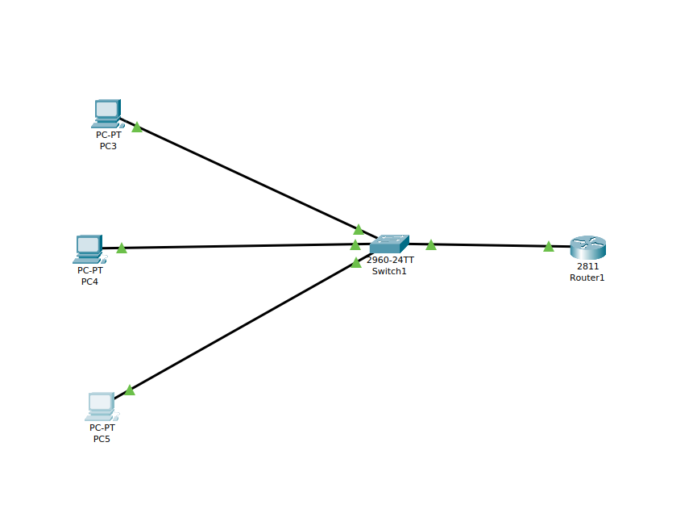
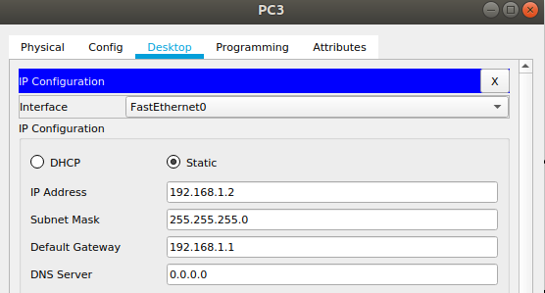

- Press RETURN to start the session
- Type enable to activate privileged mode (this gives you more options in configuring the router)
- Type config terminal (or config t for short) to access the configuration menu.
- Type interface fastethernet0/0 to access Ethernet0/0.
- Type IP address 192.168.1.1 255.255.255.0 to assign an IP address and subnet mask to the interface.
- Type no shutdown to finish

You should see all the link state to up.
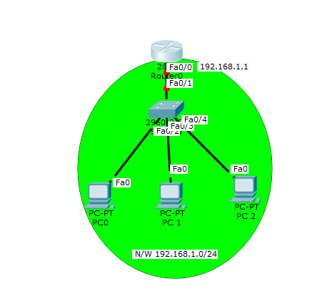
We still need to configure the router and three PCs for dynamic IP allocation.
.
Configure DHCP server on the Router. In the server we will define a DHCP pool of IP addresses to be assigned to hosts, a Default gateway for the LAN and a DNS Server. Type the following on the router
Router(config)#

Router(config)#ip dhcp pool MY_LAN

Router(dhcp-config)#network 192.168.1.0 255.255.255.0

Router(dhcp-config)#default-router 192.168.1.1

Router(dhcp-config)#dns-server 192.168.1.10

At each of the PCs, do the following: PC1->Desktop->IP configuration. Then enable DHCP

Then the experiment is over. You can check the dynamic IP allocated to each of the PCs by clicking on the settings. Three PCs are assigned IP address starting from 192.168.1.2 and the default gateway is 192.168.1.1 with the DNS server as 192.168.1.10.
Then open a command prompt and try to ping from one PC to another PC.
