Ftp Server Configuration and file transfer
- Launch Packet Tracer and use desktop icons to create three machines. Give their names as ftpserver, ftp client1, ftp client2. Let the IP address be 192.168.1.100, 192.168.1.2 and 192.168.1.3.
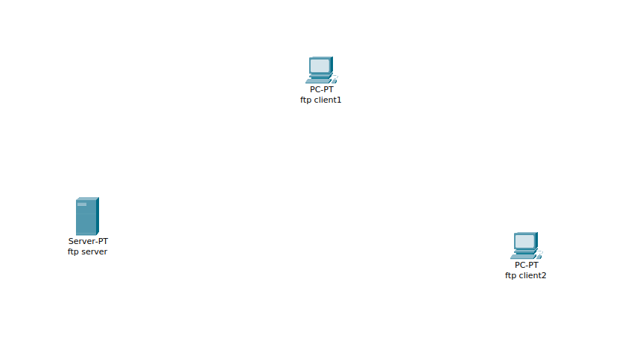
- Create another desktop with name DNS server and configure the IP to be 192.168.1.1
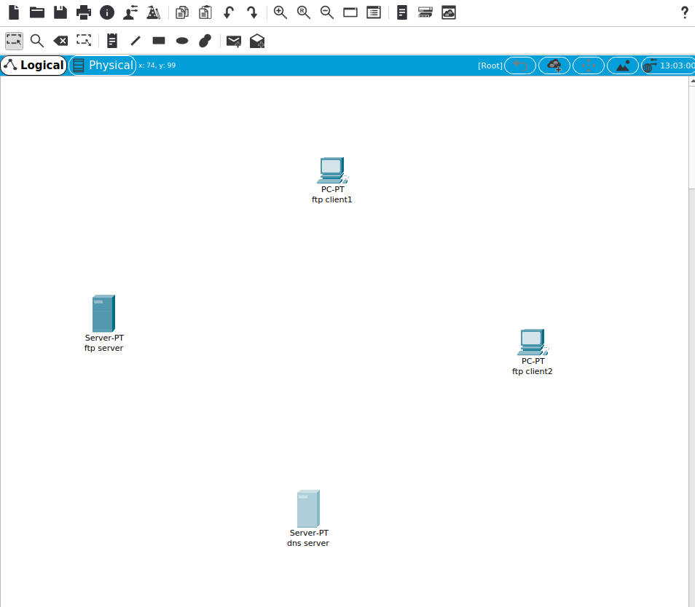
- Using the Desktop tab, configure the IP address for the server and clients as Static address and make their subnet mask as 255.255.255.0 and DNS server as 192.168.1.100
- Make a switch connecting these four desktops and enable the links. Your network configuration should look similar to diagram given below.
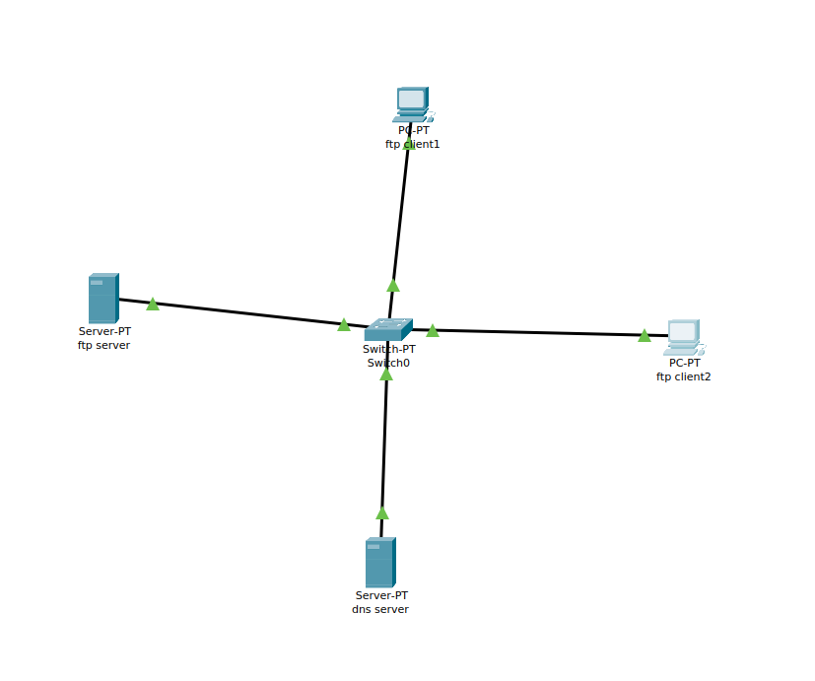
- Configure ftp server using drop down menu as ftp server and create a user login and password

- Create a text file in ftp client 1 machine by using a Text Editor.
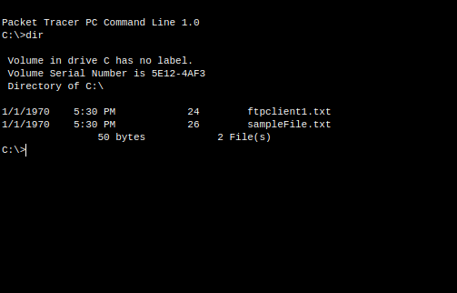
- Make an entry in the DNS server for the ftp server and give its name and IP address.
- Then open a command prompt at ftp client 1 and invoke the command “ftp ftpserver”
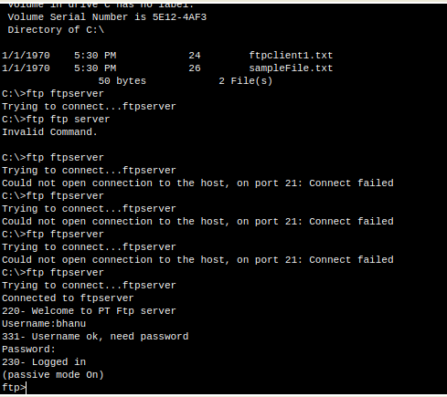
- It’ll ask for login and password, provide the username and password you created on the ftp server.
- Then type put textfile on the ftp command prompt. It’ll upload the file to the ftpserver. Verify by running dir command that the file is actually uploaded.
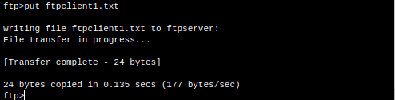
- Next from the ftp client 2 machine, access the ftp server in the same way and download the file using get textfile. Verify by running dir command that the file is actually downloaded.
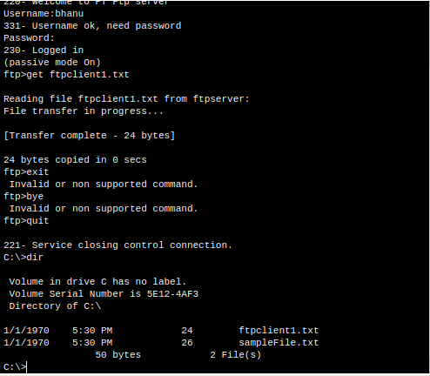
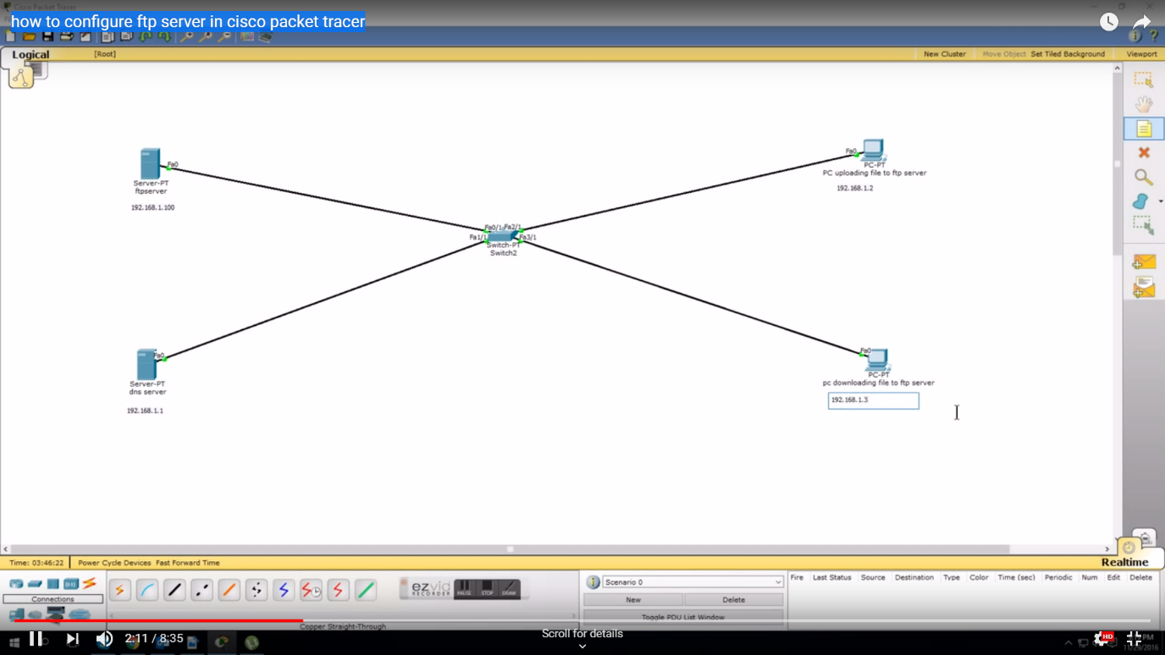
Network 1

