TECHNICAL PROJECT REPORT

# **Bluetooth-Controlled Car**

# Team Members / Inventors:

|  |  |  |  |  |  |
| --- | --- | --- | --- | --- | --- |
| **S.No.** | **Name** | **Department** | **Designation** | **Mobile** | **E-Mail** |
| 1. | RAHUL KUMAR | ECE | Student | 9610375459 | kumarrahulverma1000@gmail.com |
| 2. | VINAYAK SHARMA | ECE | Student | 9882802083 | [v.707s.harma@gmail.com](mailto:v.707s.harma@gmail.com) |
| 3. |  |  |  |  |  |
| 4. |  |  |  |  |  |
| 5. | Khushal Thakur | ECE | Mentor | 9646030764 | [khushal.thakur@cumail.in](mailto:khushal.thakur@cumail.in) |
| 6. | Anshul Sharma | ECE | Mentor | 9478697475 | anshulsharma.ece@cumail.in |
| 7. | Kiran Jot Singh | ECE | Mentor | 9463909689 | kiranjotsingh.ece@cumal.in |
| 8. | Divneet Singh Kapoor | ECE | Mentor | 9878422653 | [divneet.ece@cumail.in](mailto:divneet.ece@cumail.in) |

Section – 1 (IPR Related)

# Brief Abstract (500 words):

* Problem my project is solving.
* It is mainly sloving two problems first one is for carreing thing and the second one as an entertainment for children as a toy which can be controlled by the smartphone.
* In brief I want to say that it can reduce the work of person which work in various public offices for carreing documents for one office pace to to other instead of that staff we can use robo car that can be controlled via smartphone and for an extra freature we can use camera in it to see in which direction that car is going. Also that car can be used in the restaurants for servng food also can be used to carry dirty plates.
* How are you solving that (solution)?
* Additional modifications that can cater to improvedsolution

# Existing state-of-the-art and Drawbacks in existing state-of-the-art

(*Brief background of the existing knowledge*)

|  |  |  |
| --- | --- | --- |
| **S. No.** | **Existing state of art** | **Drawbacks in existing state of art** |
| 1 | It is able to carry normal things in the from place to other hence replacing workers. | It can only carry upto 0.5 kg weight. |
| 2 | We are using rechargeable batteries. | Battery life is not so good for working for long time. |

# Novel/Additional modifications that you can propose to improve upon drawbacks

* We can connect this model to GPS,Searvor and compass to follow our mobile so that it can use in laugagge.
* We can use an fringeprint lock in it so that it can be secure from robbery and with the help GPS we find our device.
* Improvement can be done in motors and its capacity so that it store more thing and mainely in battery so it can able to move motor and weigh of the lauggage.

# Advantages

(*List down the advantages, if each feature is incorporated)*

* Compact.
* Easy to operate and use.
* Can be used for entertainment for childrens.

# Block Diagram

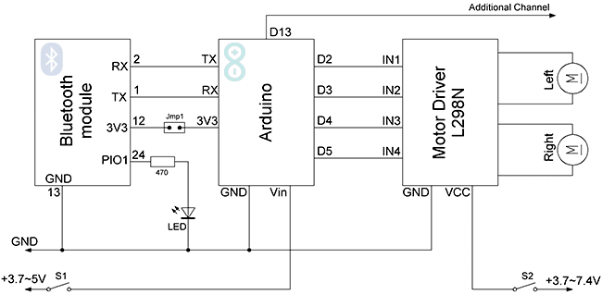

Section – 2 (Real Project)

# Materials

Hello! In this project I will show you how to make a Bluetooth-controlled car which can be controlled through your Android smartphone!

Before starting, make sure that you have:

* Arduino Uno board (Rs. 450)
* L298N motor driver (Rs. 170)
* HC-05 Bluetooth module (Rs. 299)
* An RC car that can fit all the above! (Rs. 350)

Wheel are with it.

Optionally, you will need:

* 1M & 100K resistor for battery level (optional) (Rs. 2)
* Jumper wires (Rs. 20 for 10 pieces)

For power, you can use the existing batteries (4x 1.5V AA), or replace them with a LiOn rechargeable battery pack.

At the time I build mine I use 4 rechargeble battery. If you are using havey power motors for extera load then you can use other battery. So best of luck for the project.

# Circuit Diagram

*Fully functional circuit diagram with exact connections.*

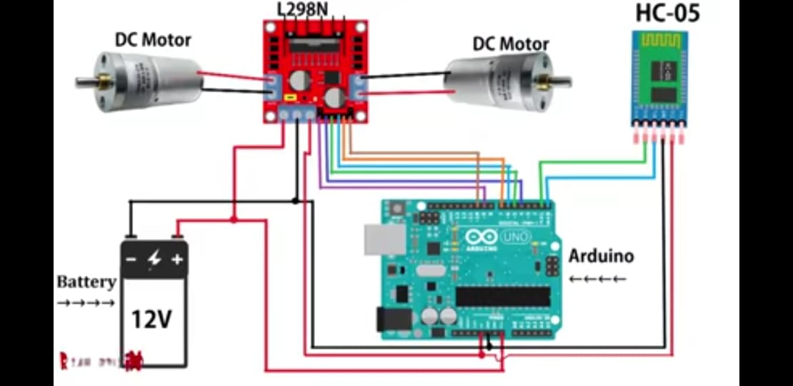

# Steps of Circuit Completion

## STEP 1 CONNECT BLUETOOTH MODULE HC-05 TO ARDUINO ​

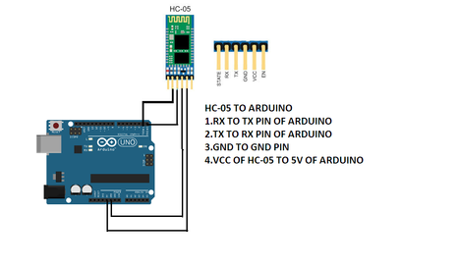

**CONNECTION OF HC-05 TO ARDUINO**1. CONNECT RX PIN OF HC-05 TO TX PIN OF ARDUINO  
2.CONNECT TX PIN OF HC-05 TO RX PIN OF ARDUINO  
3.CONNECT GND PIN OF HC-05 TO GND PIN OF ARDUINO  
4.CONNECT VCC PIN OF HC-05 TO 5V PIN OF ARDUINO  
  
STEP 2 CONNECTION OF MOTOR DRIVER L298N TO ARDUINO  
​

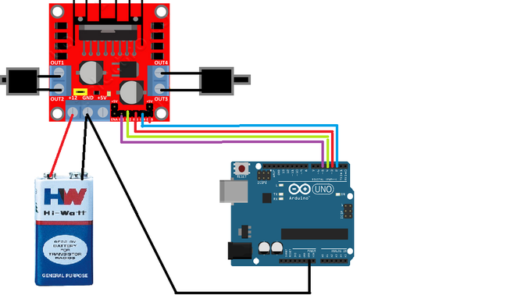

**connection of l298n motor driver to arduino  
1.connect n1 pin of motor to arduino 4 pin  
2.connect n2 pin of motor to arduino 5 pin  
3.connect n3 pin of motor to arduino 6 pin  
4 connect n4 pin of motor to arduino 7 pin  
5.connect en1 pin 0f motor to arduino 9 pin  
6.connect en2 pin 0f motor to arduino 10 pin**

**positive terminal of battery connect to motor as well as negative terminal of battery AND CONNECT TO MOTOR**

**THATS ALL YOU HAVE TO DO**

Make sure that all the connections are tight.

### Tips

* First enable Bluetooth and establish connection with BT module (ex. HC-05, password 1234). If you are unable to upload your program.
* Accelerometer function is under development, use with caution!

Please share your innovative ideas.

"Learning and innovation go hand in hand. The arrogance of success is to think that what you did yesterday will be sufficient for tomorrow."

# Program Code

(*Link of your Github project*)