PROJECT REPORT
Seasonal Agriculture Performance
Data Analytics
An Exploratory Data Analysis of Crop Yield, Seasonal Trends and Farm Economics

Dataset: seasonal_agriculture_performance_dataset.csv
4,000 farm records • 28 variables • 8 states • 8 crops • 3 seasons
Tools: Python, Pandas, NumPy, Matplotlib, Seaborn
Date: September 2026

Table of Contents

1. Executive Summary
This report presents an exploratory data analysis of a seasonal agriculture performance dataset covering 4,000 farm records across 8 Indian states, 10 districts, 8 crop types and 3 growing seasons (Kharif, Rabi and Zaid). The analysis examines crop yield, environmental conditions, input usage, irrigation efficiency, and farm economics (cost, revenue and profit) to identify the drivers of agricultural performance and profitability.
The dataset was inspected for structural integrity, missing values, duplicate records and invalid or out-of-range entries. Minor gaps were found in Rainfall, Soil Moisture and Yield (under 1.2% each), and no duplicate rows or invalid percentage values were present. Statistical outlier screening flagged Sugarcane's very high per-hectare yield and profit figures as natural extreme values rather than data errors.
Key findings show that the Kharif season delivers the strongest overall performance — the highest mean yield (5.64 t/ha), highest mean profit (₹178,915) and highest rainfall and humidity — while the Zaid season is the weakest, with the lowest mean yield (4.67 t/ha) and a negative average profit (–₹24,805). Water efficiency (tonnes of yield per 1,000 m³ of water) is the single strongest driver of both yield (r = 0.92) and profit (r = 0.49), well ahead of rainfall, soil nutrients or pesticide use. Drip irrigation delivers the best yield, water efficiency and profit outcomes of all four irrigation methods, while Flood irrigation is the least efficient despite being the most widely used method. Sugarcane is by far the most productive and profitable crop studied, while Wheat, Rice and Pulses show negative average profit across most seasons.
These findings suggest that shifting irrigation practice toward drip/sprinkler systems, prioritising Kharif-season planning, and monitoring water efficiency as a leading indicator would meaningfully improve both yield and farm profitability.

2. Introduction

2.1 Background
Agricultural output is shaped by a complex interaction of seasonal weather, soil conditions, irrigation practices, input usage and market economics. Understanding how these factors combine across different growing seasons and crop types is essential for farm planning, resource allocation and policy design.

2.2 Objective of the Study
The objective of this project is to analyse a farm-level agricultural dataset in order to:
- Understand the structure, quality and completeness of the data.
- Compare crop yield, environmental conditions and economic performance across the Kharif, Rabi and Zaid seasons.
- Evaluate the effect of irrigation method on water efficiency, yield and profitability.
- Identify the variables most strongly correlated with yield and profit.
- Highlight top- and bottom-performing farms, and assess risk from disease/pest pressure by season and crop.
- Translate the findings into practical, data-backed recommendations.

2.3 Tools and Libraries Used
The analysis was carried out in a Jupyter Notebook using Python, with the following libraries:
- Pandas and NumPy – data loading, cleaning and aggregation
- Matplotlib and Seaborn – statistical visualisation (histograms, bar charts, box plots, heatmaps, scatter plots)

3. Dataset Overview
The dataset (seasonal_agriculture_performance_dataset.csv) contains 4,000 rows and 28 columns, with each row representing one farm's performance in a given season.

3.1 Key Variables
Category | Variables
Identifiers / Location | Farm_ID, State, District
Crop & Season | Crop, Season, Irrigation_Method
Farm & Environment | Farm_Area_Hectares, Rainfall_mm, Avg_Temperature_C, Humidity_pct, Sunlight_Hours_Day, Soil_pH, Soil_Moisture_pct
Inputs | Nitrogen_kg_ha, Phosphorus_kg_ha, Potassium_kg_ha, Fertilizer_kg_ha, Pesticide_Litre_ha, Seed_Quality_Score
Output / Risk | Yield_Tonnes_Ha, Production_Tonnes, Disease_Pest_Risk_pct
Economics | Market_Price_INR_Tonne, Total_Cost_INR, Revenue_INR, Profit_INR
Water Use | Water_Used_m3, Water_Efficiency_t_per_1000m3
Table 3.1 – Variable categories in the dataset

3.2 Coverage
- 8 states, including Andhra Pradesh, Maharashtra, Telangana, Karnataka, Gujarat, Madhya Pradesh and Punjab, spanning 10 districts.
- 8 crops: Rice (690 records), Wheat (614), Maize (551), Cotton (508), Pulses (496), Groundnut (424), Chilli (412) and Sugarcane (305).
- 3 seasons: Kharif (1,779 records, 44.5%), Rabi (1,627, 40.7%) and Zaid (594, 14.9%).
- 4 irrigation methods: Flood (1,310), Rainfed (1,041), Drip (915) and Sprinkler (734).

4. Data Cleaning & Quality Checks

4.1 Missing Values
Three columns contained missing values, all below 1.2% of records — low enough that they do not materially affect aggregate statistics:
Column | Missing Values | Missing %
Rainfall_mm | 48 | 1.2%
Soil_Moisture_pct | 40 | 1.0%
Yield_Tonnes_Ha | 32 | 0.8%
Table 4.1 – Missing value summary

4.2 Duplicate Records
No duplicate rows were found in the dataset (0 duplicates across 4,000 records), confirming each row represents a unique farm-season observation.

4.3 Range & Validity Checks
All percentage-based fields (Humidity, Soil Moisture, Disease/Pest Risk) were confirmed to fall within the valid 0–100% range, and none of the 13 core numeric fields checked (farm area, rainfall, temperature, nutrients, fertilizer, pesticide, yield, production, cost, revenue, water use) contained negative values. A cross-check of Profit_INR against Revenue_INR − Total_Cost_INR showed zero mismatches, confirming the profit figures are internally consistent.

4.4 Outlier Screening
An IQR-based outlier scan (1.5× IQR beyond Q1/Q3) was run across all numeric columns. The highest outlier rates were in the economic and yield fields:
Column | Outlier Count | Outlier %
Profit_INR | 404 | 10.10%
Production_Tonnes | 333 | 8.33%
Water_Efficiency_t_per_1000m3 | 322 | 8.05%
Yield_Tonnes_Ha | 302 | 7.55%
Water_Used_m3 | 276 | 6.90%
Revenue_INR | 240 | 6.00%
Table 4.2 – Top outlier fields (IQR method)
These outliers are concentrated in Sugarcane records, which legitimately produce far higher yield and revenue per hectare than other crops — they were therefore treated as genuine extreme values rather than data errors and retained in the analysis.

5. Exploratory Data Analysis

5.1 Distribution of Numeric Variables
A full-grid histogram of all numeric columns was generated to inspect distribution shape and detect skew.
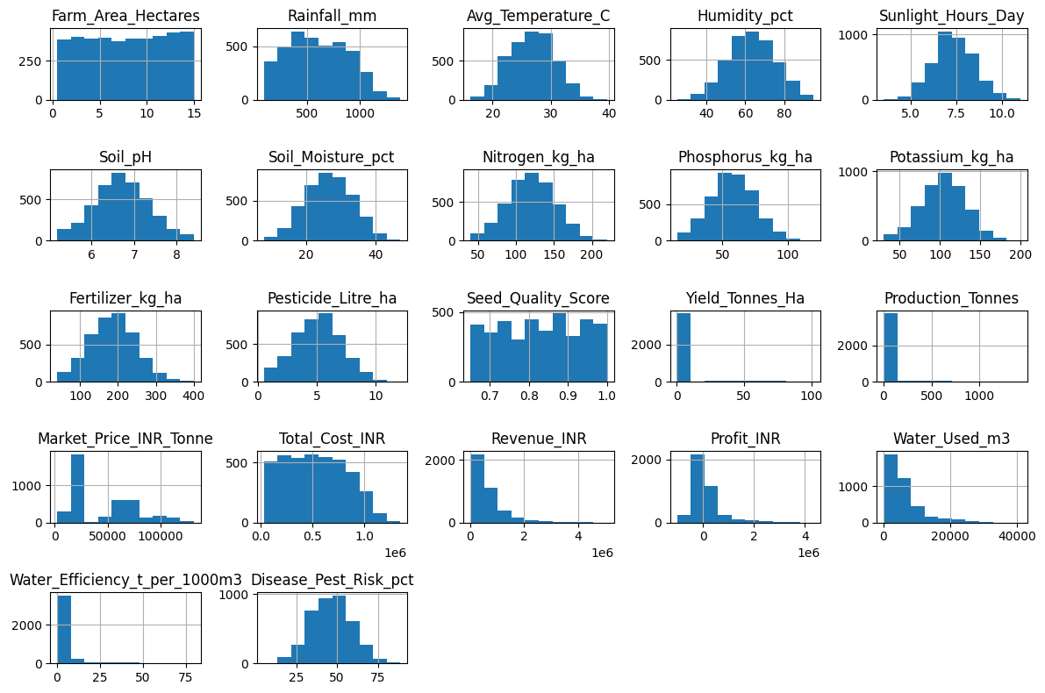
Figure 5.1 – Distribution of all numeric variables

5.2 Overall Yield Distribution
Crop yield (Yield_Tonnes_Ha) is heavily right-skewed: the median farm yields 1.74 t/ha, but the mean is pulled up to 5.27 t/ha by a small number of very high-yield Sugarcane farms (maximum 101.44 t/ha).
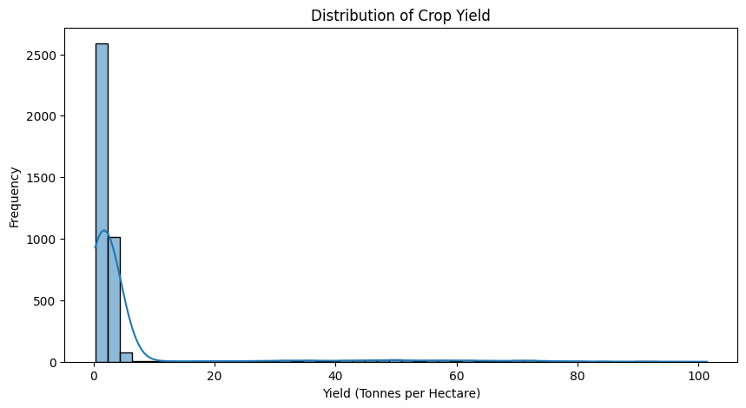
Figure 5.2 – Distribution of crop yield across all farms

6. Seasonal Agricultural Performance

6.1 Seasonal Yield Summary
Season | Farms | Mean Yield (t/ha) | Median Yield | Mean Production (t) | Mean Revenue (₹) | Mean Cost (₹) | Mean Profit (₹)
Kharif | 1,779 | 5.64 | 1.95 | 46.31 | 710,719 | 531,804 | 178,915
Rabi | 1,627 | 5.08 | 1.66 | 41.49 | 601,526 | 513,837 | 87,689
Zaid | 594 | 4.67 | 1.45 | 38.89 | 519,172 | 543,977 | –24,805
Table 6.1 – Seasonal performance summary
Kharif is the strongest season on every dimension — highest yield, production and profit — while Zaid is the only season with a negative average profit, indicating that Zaid-season farming is economically marginal on average.
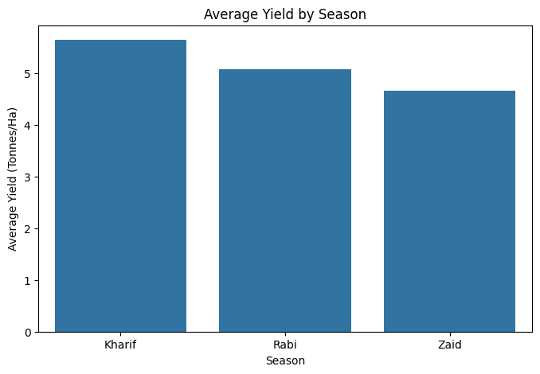
Figure 6.1 – Average yield by season
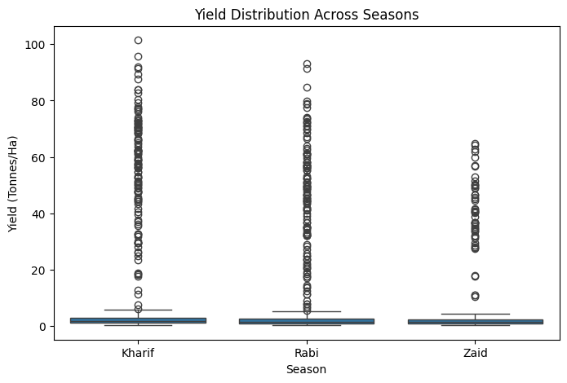
Figure 6.2 – Yield distribution (spread and outliers) across seasons

6.2 Crop × Season Yield Matrix
Average yield per hectare varies enormously by crop, with Sugarcane far outstripping every other crop in every season:
Crop | Kharif | Rabi | Zaid
Chilli | 1.73 | 1.46 | 1.18
Cotton | 1.37 | 1.19 | 0.95
Groundnut | 1.48 | 1.22 | 1.04
Maize | 2.97 | 2.61 | 2.30
Pulses | 1.04 | 0.87 | 0.65
Rice | 2.71 | 2.33 | 1.90
Sugarcane | 53.46 | 43.94 | 38.42
Wheat | 2.26 | 2.06 | 1.75
Table 6.2 – Mean yield (t/ha) by crop and season
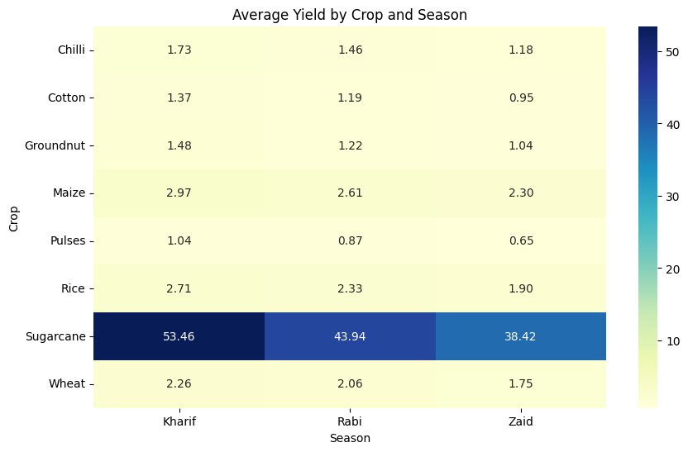
Figure 6.3 – Heatmap of average yield by crop and season
Every crop follows the same ranking — Kharif > Rabi > Zaid — confirming that the seasonal effect on yield is consistent across crop types, not driven by any single crop.

7. Environmental Conditions by Season
Season | Rainfall (mm) | Temperature (°C) | Humidity (%) | Sunlight (hrs/day) | Soil Moisture (%)
Kharif | 852.08 | 28.45 | 71.81 | 6.79 | 31.20
Rabi | 436.00 | 23.49 | 57.89 | 7.59 | 24.05
Zaid | 299.42 | 31.04 | 52.01 | 8.18 | 19.17
Table 7.1 – Mean environmental conditions by season
Kharif is the monsoon season — it receives nearly double the rainfall of Rabi and almost three times that of Zaid, with correspondingly higher humidity and soil moisture. Zaid is the hottest and driest season, with the highest temperature and sunlight hours but the lowest soil moisture, which likely explains its weaker yield and profit performance.
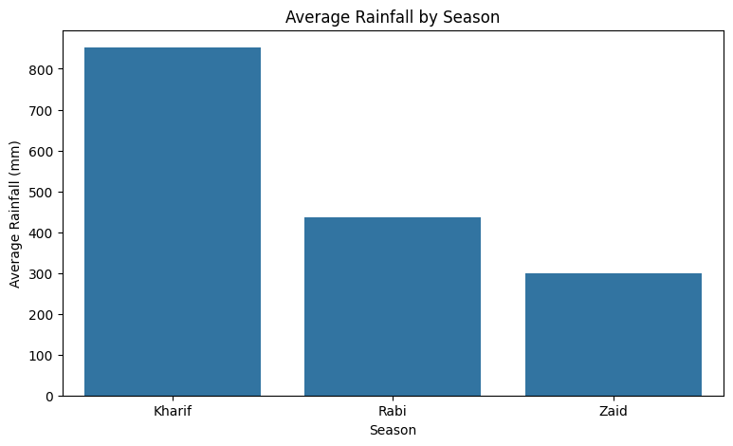
Figure 7.1 – Average rainfall by season
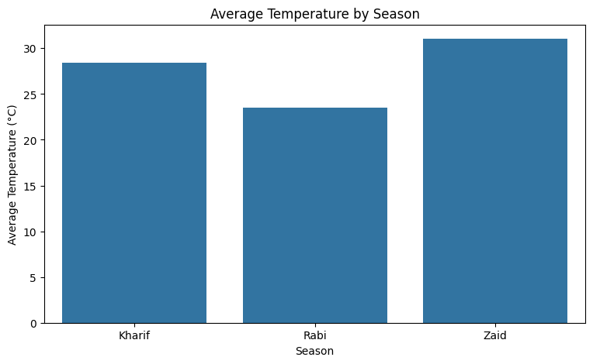
Figure 7.2 – Average temperature by season

8. Seasonal Economic Performance
Season | Mean Revenue (₹) | Median Revenue (₹) | Mean Cost (₹) | Median Cost (₹) | Mean Profit (₹) | Median Profit (₹)
Kharif | 710,719 | 520,196 | 531,804 | 524,840 | 178,915 | 38,808
Rabi | 601,526 | 438,156 | 513,837 | 506,733 | 87,689 | –3,187
Zaid | 519,172 | 373,701 | 543,977 | 534,833 | –24,805 | –62,144
Table 8.1 – Seasonal economic summary
Median profit turns negative in both Rabi and Zaid, meaning more than half of farms in those seasons operate at a loss, while production costs stay broadly flat (₹513,800–₹544,000) across all three seasons. Kharif's profit advantage is driven almost entirely by higher revenue rather than lower cost, which traces back to the yield gains supported by monsoon rainfall.
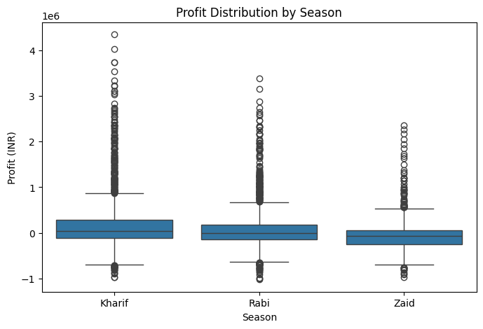
Figure 8.1 – Profit distribution by season, showing losses concentrated in Rabi and Zaid

9. Irrigation Method & Water Efficiency
Irrigation Method | Farms | Mean Yield (t/ha) | Mean Water Used (m³) | Mean Water Efficiency | Mean Profit (₹)
Drip | 915 | 6.62 | 5,918.75 | 6.27 | 219,626
Flood | 1,310 | 4.90 | 8,026.47 | 3.44 | 73,354
Rainfed | 1,041 | 4.61 | 3,549.55 | 7.56 | 79,050
Sprinkler | 734 | 5.19 | 6,208.26 | 4.67 | 91,121
Table 9.1 – Performance by irrigation method
Drip irrigation delivers the highest yield (6.62 t/ha) and the highest profit (₹219,626) of any method, using less water than Flood irrigation while producing more. Flood irrigation — the most widely used method (33% of farms) — is the least water-efficient, consuming the most water per farm for the lowest yield and profit. Rainfed farms achieve strong water efficiency by definition (no active water input) but with lower absolute yield.
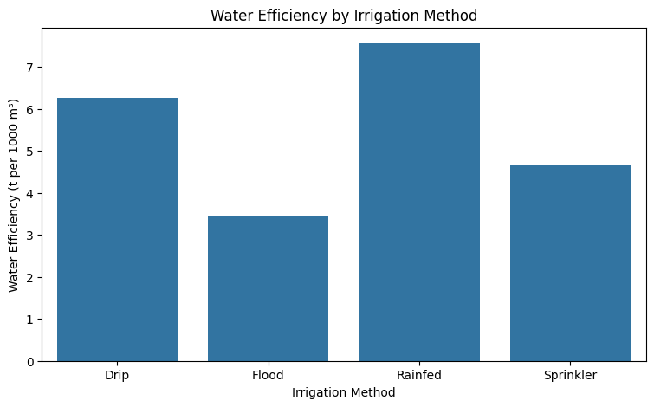
Figure 9.1 – Water efficiency by irrigation method

10. Correlation Analysis
A correlation matrix was built across 17 numeric variables to identify which factors move together with yield and profit.
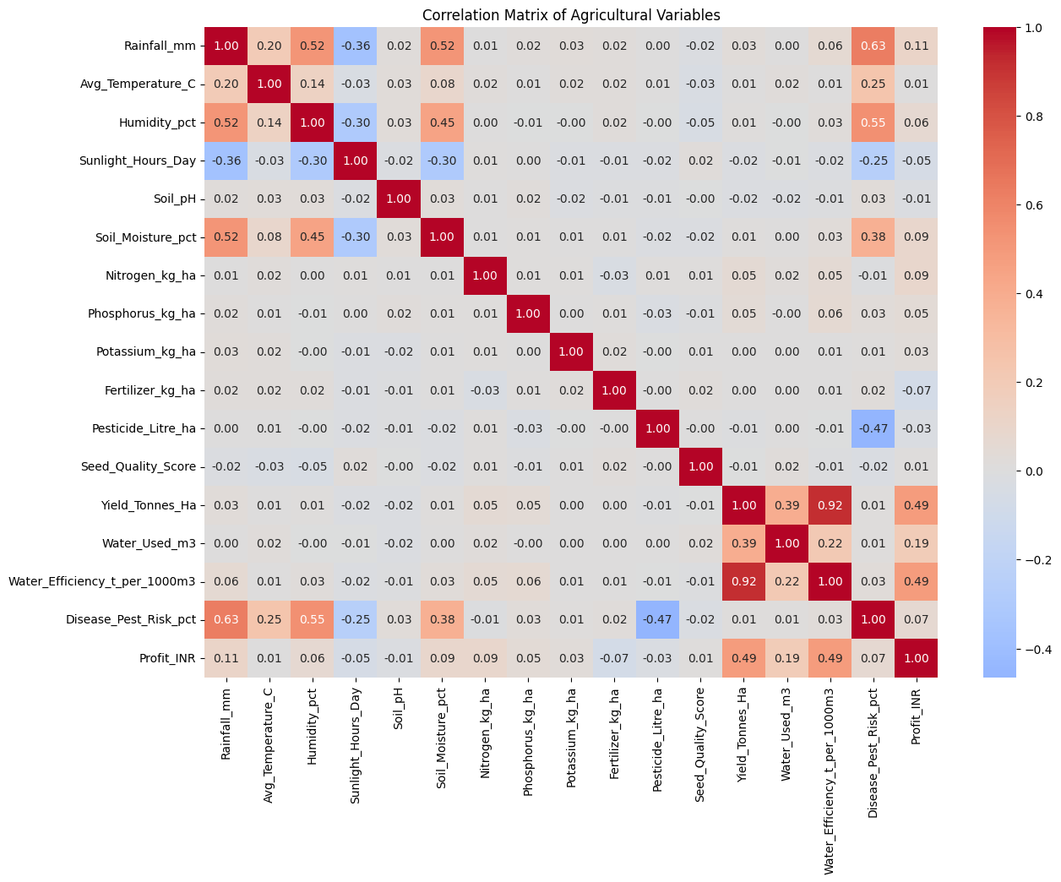
Figure 10.1 – Correlation matrix of agricultural variables

10.1 Strongest Correlations with Yield
Variable | Correlation with Yield
Water_Efficiency_t_per_1000m3 | 0.915
Profit_INR | 0.490
Water_Used_m3 | 0.389
Nitrogen_kg_ha | 0.054
Phosphorus_kg_ha | 0.048
Rainfall_mm | 0.031
Table 10.1 – Top correlations with Yield_Tonnes_Ha

10.2 Strongest Correlations with Profit
Variable | Correlation with Profit
Yield_Tonnes_Ha | 0.490
Water_Efficiency_t_per_1000m3 | 0.489
Water_Used_m3 | 0.190
Rainfall_mm | 0.108
Soil_Moisture_pct | 0.092
Nitrogen_kg_ha | 0.085
Table 10.2 – Top correlations with Profit_INR
Water efficiency stands out as the dominant driver of both yield and profit, far ahead of soil nutrients (Nitrogen, Phosphorus, Potassium), pesticide use or seed quality — all of which show near-zero correlation with yield. This reinforces the irrigation findings in Section 9: how efficiently water is used matters far more than how much fertilizer or pesticide is applied.

10.3 Rainfall and Soil Moisture vs. Yield
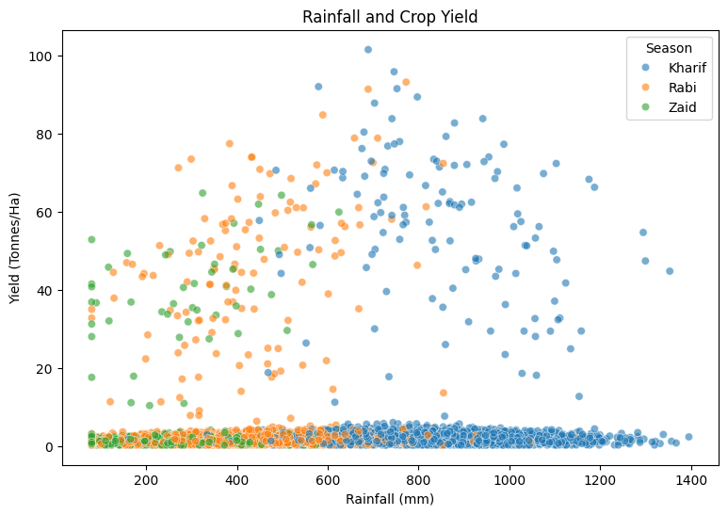
Figure 10.2 – Rainfall vs. crop yield, coloured by season
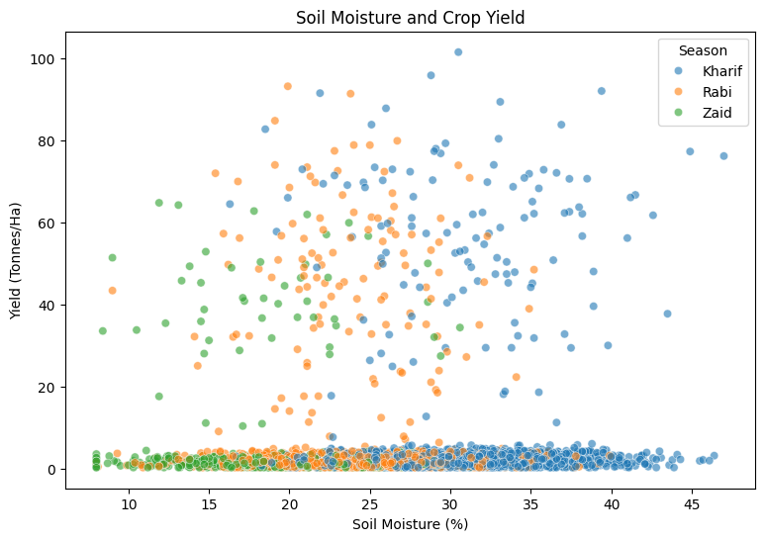
Figure 10.3 – Soil moisture vs. crop yield, coloured by season
Both scatter plots show that most farms cluster at modest yields regardless of rainfall or soil moisture level, with the handful of very high-yield points almost entirely attributable to Sugarcane rather than to weather conditions — consistent with the low direct correlation between rainfall/soil moisture and yield reported above.

11. Top and Bottom Performing Farms

11.1 Highest-Yielding Farms
All of the top 10 yield records are Sugarcane farms grown in the Kharif or Rabi season, led by a Gujarat farm (SF11716) at 101.44 t/ha, followed by an Andhra Pradesh farm (SF13424) at 95.79 t/ha and a Rabi-season Andhra Pradesh farm (SF13526) at 93.13 t/ha.

11.2 Lowest-Yielding Farms
The bottom 10 yield records all sit at the dataset floor of 0.30 t/ha, spread across Maize, Wheat, Pulses and Groundnut in various states — indicating a cluster of near-total crop failures rather than a single problem crop or region.

11.3 Most Profitable Farms
The highest-profit farms are concentrated in Chilli and Sugarcane, led by two Chilli farms in Punjab (SF12237, ₹5.06M revenue) and Maharashtra (SF10627, ₹5.08M revenue), reflecting Chilli's high market price per tonne despite its modest per-hectare yield.

11.4 Largest Losses
The largest losses appear across Groundnut, Wheat, Maize and Rice, mostly in the Rabi season, with revenue as low as ₹102,497 (a Wheat farm in Andhra Pradesh) against much higher production costs — consistent with Rabi/Zaid's weaker overall profit profile documented in Section 8.

12. Crop × Season Profitability Ranking
Ranking all 24 crop-season combinations by mean yield reveals a stark split: Sugarcane dominates every season, followed by Maize and Rice, while Wheat, Rice and Pulses are loss-making in most seasons despite reasonable yields.
Crop | Season | Farms | Mean Yield (t/ha) | Mean Profit (₹)
Sugarcane | Kharif | 125 | 53.46 | 1,000,791
Sugarcane | Rabi | 129 | 43.94 | 731,613
Sugarcane | Zaid | 51 | 38.42 | 583,636
Chilli | Kharif | 185 | 1.73 | 954,380
Chilli | Rabi | 163 | 1.46 | 638,573
Maize | Kharif | 234 | 2.97 | –39,333
Rice | Kharif | 314 | 2.71 | –64,903
Wheat | Kharif | 292 | 2.26 | –105,872
Rice | Zaid | 102 | 1.90 | –227,239
Table 12.1 – Selected crop×season combinations, ranked by yield (highest and lowest profit examples shown)
Notably, high yield does not guarantee high profit: Maize and Rice post respectable yields (2.3–3.0 t/ha) but negative average profit in most seasons, while Chilli achieves strong profit from a comparatively low yield (1.2–1.7 t/ha) due to its high market price. This highlights that market price and cost structure matter as much as physical yield to farm profitability.

13. Disease and Pest Risk Analysis

13.1 Risk by Season
Season | Mean Risk (%) | Median Risk (%)
Kharif | 54.47 | 54.5
Rabi | 40.48 | 40.6
Zaid | 38.22 | 37.9
Table 13.1 – Disease/pest risk by season
Kharif carries the highest disease and pest risk (54.5% on average) — consistent with its higher rainfall and humidity, which favour pest and pathogen activity — yet it still delivers the best yield and profit outcomes overall, suggesting the yield benefits of monsoon conditions outweigh the added risk.

13.2 Risk by Crop
Crop | Mean Risk (%) | Mean Yield (t/ha) | Mean Profit (₹)
Wheat | 47.85 | 2.11 | –123,398
Pulses | 46.57 | 0.92 | –4,238
Rice | 46.50 | 2.44 | –102,214
Groundnut | 46.29 | 1.32 | 44,858
Chilli | 46.06 | 1.54 | 750,878
Cotton | 45.97 | 1.23 | 124,547
Maize | 45.54 | 2.72 | –83,978
Sugarcane | 45.40 | 46.94 | 817,188
Table 13.2 – Disease/pest risk by crop
Disease and pest risk is fairly uniform across crops (45–48%), so it does not explain the large profitability gap between crops — Wheat and Sugarcane carry almost identical risk levels but sit at opposite ends of the profit spectrum.

14. Key Insights & Recommendations

14.1 Key Insights
- Kharif is the best-performing season overall — highest yield, production, revenue and profit — driven by monsoon rainfall and soil moisture, despite carrying the highest pest/disease risk.
- Zaid is the weakest season, with the lowest yield and the only negative mean profit, linked to its low rainfall and low soil moisture.
- Water efficiency (yield per 1,000 m³ of water) is the strongest predictor of both yield (r = 0.92) and profit (r = 0.49) — far stronger than rainfall, soil nutrients, or pesticide use.
- Drip irrigation outperforms Flood, Sprinkler and Rainfed methods on yield, water efficiency and profit, while Flood — the most common method — is the least efficient.
- Sugarcane is the standout crop, with yields and profits an order of magnitude above all others; Chilli achieves high profit from comparatively low yield due to its market price.
- Yield and profit are not the same thing: Maize, Rice and Wheat post decent yields but negative average profit in most seasons, showing that cost and price structure drive profitability as much as physical output.
- Data quality is strong — minimal missing data (<1.2%), zero duplicate rows, and internally consistent profit calculations — giving confidence in the findings above.

14.2 Recommendations
- Prioritise Kharif-season planning and investment, while building targeted pest/disease management (biological controls, resistant seed varieties) to offset its higher risk.
- Expand drip and sprinkler irrigation coverage, particularly in Flood-irrigated farms, to lift both water efficiency and profit without necessarily increasing water usage.
- Treat water efficiency as a leading KPI for farm performance monitoring, given its outsized correlation with both yield and profit.
- For loss-making crop-season combinations (e.g. Wheat and Rice in Rabi/Zaid), review input cost structures and market pricing rather than focusing solely on yield improvement.
- Investigate Zaid-season economics further — potentially through supplemental irrigation or shifting toward higher-margin crops such as Chilli — to turn its average loss into a profit.

15. Conclusion
This analysis of 4,000 farm records demonstrates that seasonal timing, irrigation method and water-use efficiency are far stronger determinants of agricultural yield and profitability than soil nutrients, pesticide application or seed quality alone. The Kharif monsoon season and Sugarcane cultivation stand out as the top performers in the dataset, while Zaid-season and Flood-irrigated farming represent the weakest economic outcomes. These patterns offer clear, data-driven levers — irrigation modernisation, seasonal planning and crop/market alignment — for improving farm-level performance in the regions covered by this dataset.
Prepared from: Seasonal_Agriculture_Performance_Data_Analytics.ipynb

