First Come First Serve (FCFS) CPU Scheduling | Operating System – M02 P03

This is a multipart blog article series, and in this series I am going to explain you the concepts of operating system. This article series is divided into multiple modules and this is the second module which consists of 11 articles.

In this article we will try to understand the concept of first come first serve CPU scheduling with the help of an example.

**FCFS:**

* Criteria for FCFS is “arrival time” which means that the process come first will be executed first.
* Mode is “non pre-emptive” which means that, if a process comes into “running state” from “ready state”, it will not be sent back to “ready state” it will be executed completely and terminated.

This is a table we will solve this question with the help of Gantt chart.

|  |  |  |  |  |  |  |
| --- | --- | --- | --- | --- | --- | --- |
| Process | Arrival time | Burst time | Completion time | TAT | Waiting time | Response time |
| P1 | 0 | 2 |  |  |  |  |
| P2 | 1 | 2 |  |  |  |  |
| P3 | 5 | 3 |  |  |  |  |
| P4 | 6 | 4 |  |  |  |  |

We have given the arrival time and burst time of the process.

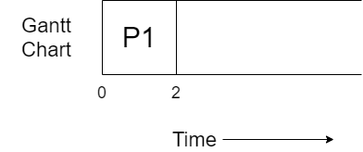

P1 arrives to CPU at 0 and we start executing it for 2 time duration. And after executing for 2 time durations the process will get terminated.

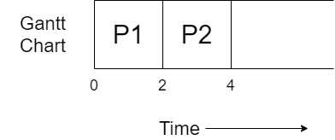

The process P2 has already at time duration 1, but because another process was getting execute P2 was in ready queue.

Now, we will take the process P2 form ready queue and start executing it. It will execute for 2 unit of time and after that it will get terminated.

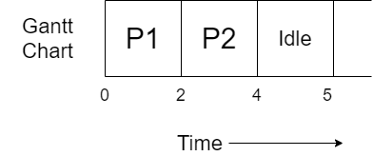

Now, a special situation is happed, that the current time unit is 4 while the next process which is P3 will arrive on time unit 5, that’s why CPU will remain idle for 1 unit of time.

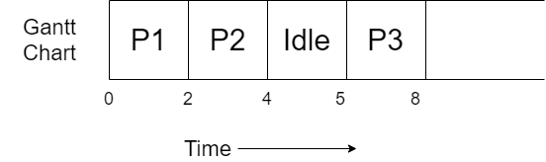

At time unit 5 process P3 will arrive and as the CPU is free it will start executing it. It get executed for 3 time units and got terminated.

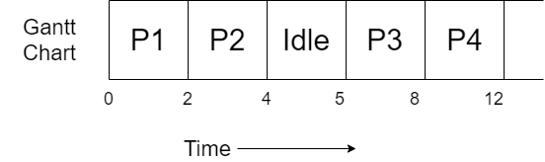

The last process P4 had arrived at 6, but as the CPU was busy in executing process P3 the process was in ready queue. It got chance to get executed at time unit 8 and got executed for 4 time unit and then terminated.

All the process got completely executed. Now we will complete the table, but for it you need to know some formulas.

* Completion time: The time at which process completes its execution.
* Turnaround time = Completion time – arrival time.
* Waiting time = turnaround time – burst time.
* Response time: In case of non pre-emptive process response time is equal to waiting time.

So, the final table obtained will be.

|  |  |  |  |  |  |  |
| --- | --- | --- | --- | --- | --- | --- |
| Process | Arrival time | Burst time | Completion time | TAT | Waiting time | Response time |
| P1 | 0 | 2 | 2 | 2 | 0 | 0 |
| P2 | 1 | 2 | 4 | 3 | 1 | 1 |
| P3 | 5 | 3 | 8 | 3 | 0 | 0 |
| P4 | 6 | 4 | 12 | 6 | 2 | 2 |

So, this was all about First Come First Serve (FCFS), hope you like it and learned something new from it.

If you have any doubt, question, queries related to this topic or just want to share something with me, then please feel free to contact me.