Question on Shortest Job First | Operating System – M02 P06

This is a multipart blog article series, and in this series I am going to explain you the concepts of operating system. This article series is divided into multiple modules and this is the second module which consists of 11 articles.

In this article we will see a question on shortest job first and try to understand the concepts of SJF operation in an operating system.

**Question:** The gant chart for pre-emptive shortest job first scheduling algorithm will be?

|  |  |  |
| --- | --- | --- |
| Process No. | Arrival time | Burst time |
| P1 | 0 | 7 |
| P2 | 1 | 4 |
| P3 | 2 | 8 |

1. 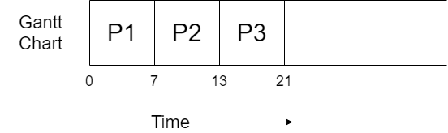
2. 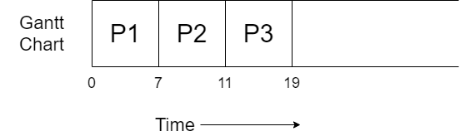
3. 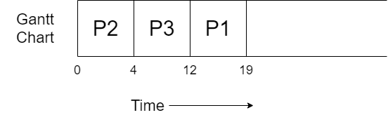
4. 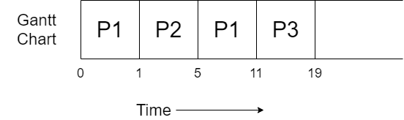

**Answer:** (iv)

**Explanation:**

* Pre-emptive shortest job first (SJF) is also known as shortest remaining time first.
* Gantt chart always starts from zero.
* The process P1 arrives at CPU at time unit 0 with burst time of 7 units, it get executed for 1 unit of time. Now the remaining burst time of process P1 is 6.
* At time unit 2 process P2 also arrives at the CPU with burst time of 4 units less than the burst time of P1, so P1 will be preempt and P2 will start executing, it will get executed completely and terminated because no other process have less burst time then it.
* Process P3 has already arrived to CPU at time unit 2.
* If we check the time units of the both the processes present in the ready queue, we see that P1 have burst time of 6 unit left and P3 have 8 units of burst time. So, P1 will again start its execution till it ends.
* P1 ends at time unit 11 and then P3 start its execution and get terminate at time unit 19.

So, this was all about pre-emptive shortest job first CPU scheduling algorithm in an operating system. Hope you liked it and learned something from it.

If you have any doubt, question, queries related to this topic or just want to share something with me, then please feel free to contact me.