Memory Management and Degree of Multiprogramming | Operating System – M05 P01

This is a multipart blog article series, and in this series I am going to explain you the concepts of operating system. This article series is divided into multiple modules and this is the fifth module which consists of 26 articles.

In this article we are going to know about memory management in operating system and degree of multiprogramming.

**Memory management**

* Memory management in operating system means that it is a method/ functionality to manage different types of memory.
* Mainly memory management is method of managing primary memory or RAM.

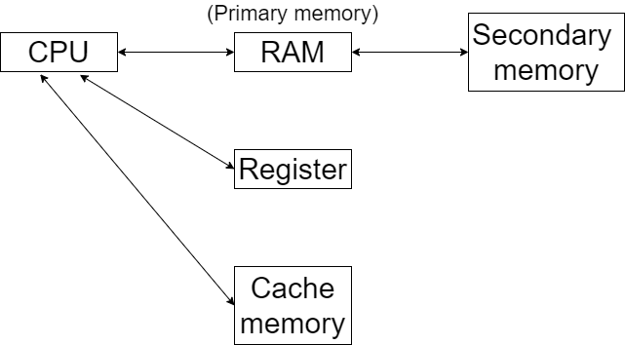

**Degree of multiprogramming**

* CPU is not connected with secondary memory directly because the speed of secondary memory is very low in comparison of CPU.
* All the process/ programs are present in secondary memory, in order to execute them we have to load them in RAM
* From RAM they will be sent to CPU and get executed.
* This is called degree of multiprogramming.
* Multiprogramming means, try to place more and more processes from secondary memory to primary memory. Because then only the utilization of CPU will be at satisfactory level.
* If we increase the number of process in RAM than CPU utilization will be more and degree of multiprogramming will be also high.

So this was a brief explanation of memory management and degree of multiprogramming in an operating system. Hope you liked it and learned something new from it.

If you have any doubt, question, quires related to this topic or just want to share something with me, than please feel free to contact me.