Memory Management Techniques | Operating System – M05 P02

This is a multipart blog article series, and in this series I am going to explain you the concepts of operating system. This article series is divided into multiple modules and this is the fifth module which consists of 26 articles.

In this article you will get a basic understanding about memory management techniques and why memory management techniques are required in an operating system.

**Memory management technique**

* The main motive of memory management technique is to place maximum number of process in RAM (ready state).
* By that the degree of multiprogramming will increase.
* We try to keep degree of multiprogramming high, because whenever CPU tends to become idle then we have a lot of process available in ready state to get executed.
* By this we try to maximize the utilization of the CPU.

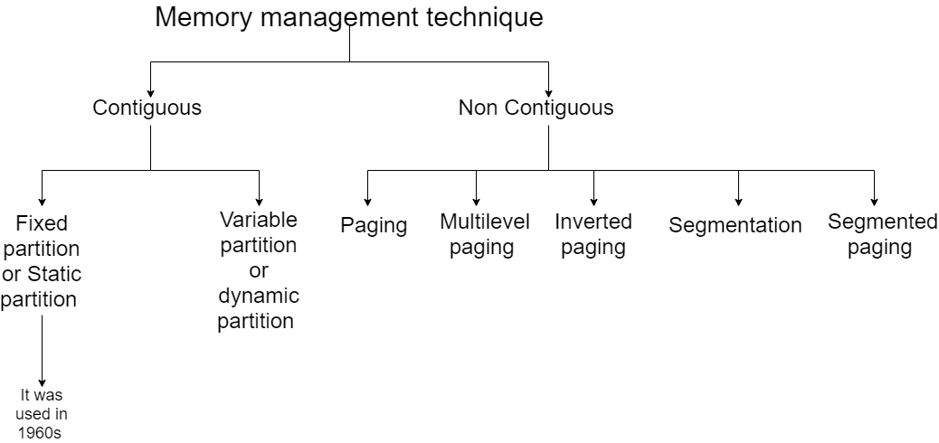

* In contiguous allocation the processes are allocated in memory in contiguous manner.
* In non contiguous allocation the processes are allocated in memory in non-contiguous manner.

So this was a brief explanation about memory management techniques, we will see about each topic in dept in next few articles. Hope you liked it and learned something new form it.

If you have any doubt, question, quires related to this topic or just want to share something with me, than please feel free to contact me.