Question on Contiguous Memory Management | Operating System – M05 P07

This is a multipart blog article series, and in this series I am going to explain you the concepts of operating system. This article series is divided into multiple modules and this is the fifth module which consists of 26 articles.

In this article we will see a question on contiguous memory management and will try to understand its concepts.

**Question:** Calculate the time at which J7 will be completed. (Algorithm is best-fit)

|  |  |  |  |  |  |  |  |  |
| --- | --- | --- | --- | --- | --- | --- | --- | --- |
| Request No. | J1 | J2 | J3 | J4 | J5 | J6 | J7 | J8 |
| Request size | 2 KB | 14 KB | 3 KB | 6 KB | 6 KB | 10 KB | 7 KB | 20 KB |
| Usage time | 4 | 10 | 2 | 8 | 4 | 1 | 8 | 6 |

1. 17
2. 19
3. 20
4. 37

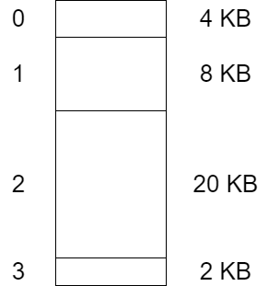

**Answer:**

* (ii) 19
* We will put J1 at location 3 in memory, the internal fragmentation is zero. It will execute for 4 unit of time.

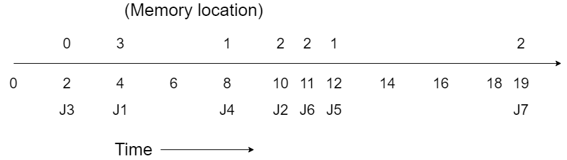

* Now, we will put J2 in memory at location 2, where it will get execute for 10 units of time. At present the internal fragmentation at memory location 2 is of 6 KB.
* Now, we put J3 in memory location 0, where it will get executed for 2 unit of time. At present the internal fragmentation at memory location at o is 1 KB.
* Then J4 will arrive, we put it in memory location 1, where it will get executed for 8 units of time. At present the internal fragmentation at memory location 1 is 2 KB.
* We want to put J5 in memory but there is no empty slot. So, we will wait until J4 gets terminated and then we will place J5 at memory location 1, where it will get executed for 4 units of time.
* Now we want to put mJ6 in memory but there is no empty slot that can accommodate J6. So we will wait till J2 gets completed and then we will place J6 at memory location 2. Where it will be executed for 1 unit of time.
* We want to put J7 in memory but again there is no empty slot which can accommodate J7. So we will wait till J6 gets completed and then place J7 at memory location 2, where it will get executed for 8 unit of time.
* Therefore J7 will be completed at time unit 19 and time at which J7 enters RAM is 11.

So this was a simple question of contiguous memory management. Hope you liked it and learned something new from it.

If you have any doubt, question, quires related to this topic or just want to share something with me, than please feel free to contact me.