SUPPLY CHAIN VISIBILITY & OPTIMIZATION
Milestone 1, Milestone 2, Milestone 3 & Milestone 4 Project Report
Inventory KPI Dashboard
Advanced Inventory & Supplier Performance Analytics
Transportation & Supplier Performance Dashboard
Warehouse Analytics & Executive Supply Chain Overview
Prepared By
Rahul Gowda

1. Project Title
Supply Chain Visibility & Optimization

2. Project Objectives
- Monitor total inventory, inventory value, demand, and inventory turnover.
- Compare inventory performance across products/minerals and warehouses.
- Analyze inventory trends over time and stock-status distribution.
- Provide interactive filtering using Mineral, Warehouse, Year, and Stock Status.
- Evaluate supplier capacity, performance, tier distribution, and risk scores.
- Identify slow-moving products and support inventory optimization through turnover analysis.
- Compare current and previous period performance through trend and variance analysis.
- Analyze transportation cost across carriers and routes.
- Measure fulfillment performance and on-time delivery rate.
- Compare supplier shipment volumes and average supplier ratings.
- Provide interactive filtering by supplier, carrier, region, and route.
- Use drill-down analysis to move from mineral groups to specific product levels.

3. Project Description
Supply Chain Visibility & Optimization is a Power BI-based analytics project focused on transforming supply-chain data into interactive dashboards for inventory, supplier, transportation, and performance analysis. Milestone 1 establishes the reporting foundation through inventory data preparation, data modeling, KPI definition, DAX measures, and the Inventory KPI Dashboard. Milestone 2 extends this foundation with Inventory Analysis, Supplier Performance Evaluation, and Trend & Variance Analysis. Milestone 3 adds Transportation & Supplier Performance Analysis using transportation, delivery, carrier, route, supplier, orders, warehouse, and date data.
The solution supports analysis of inventory levels and value, demand, turnover, supplier performance, supplier risk, slow-moving products, period-to-period changes, transportation cost, shipment cost, fulfillment rate, on-time rate, supplier shipment volume, supplier rating, carrier cost, and route cost. Interactive slicers allow users to examine performance by supplier, carrier, region, and route.

4. Tools Used
Tool / Source | Purpose
Power BI | Dashboard development, interactive visualizations, KPI cards, slicers, drill-downs, and analytical reporting.
DAX | Dynamic measures including inventory, turnover, slow-moving products, variance, and supplier risk metrics.
Supply Chain Optimization Workbook | Primary source of project data.
Inventory and Supporting Tables | Inventory, Product_Mineral, Warehouse, Date, Supplier and related supply-chain data.

5. Milestone 1 – Dashboard Explanation

5.1 Overview
Milestone 1 establishes the foundation of the project by preparing the inventory dataset, organizing the data model, defining core KPIs, creating DAX measures, and building the Inventory KPI Dashboard in Power BI.

5.2 Data Preparation and Model
The supply chain optimization workbook contains Product_Mineral, Supplier, Warehouse, Carrier, Route, Orders, Delivery, Transportation, Inventory, Critical_Mineral_Risk, Date and Supplier_Scorecard tables. The Inventory table is the main source for Milestone 1. Key fields include Snapshot_Date, Warehouse_ID, Product_ID, Opening_Inventory_Tonnes, Receipts_Tonnes, Demand_Issued_Tonnes, Closing_Inventory_Tonnes, Average_Inventory_Tonnes, Inventory_Value_USD, Warehouse_Capacity_Tonnes, Utilization_Pct and Stock_Status.
Data preparation included reviewing imported tables, standardizing data types, preparing date fields for time analysis, reviewing categorical values for filters, excluding unnecessary reporting fields where appropriate, and validating the prepared data.

5.3 Dashboard Components
- Slicers: Mineral, Warehouse, Year, and Stock Status.
- KPI Cards: Total Inventory, Inventory Value, Total Demand, Inventory Turnover, Total Products, and Total Warehouses.
- Top Visuals: Inventory by Product, Inventory by Warehouse, and Inventory Value by Mineral.
- Bottom Visuals: Inventory Trend Over Time, Inventory Summary by Minerals, and Inventory Stock Status.
- Summary/detail table for inventory metrics.
Core DAX measures use Closing_Inventory_Tonnes for Total Inventory, Inventory_Value_USD for Inventory Value, Demand_Issued_Tonnes for Total Demand, Demand divided by Average Inventory for Inventory Turnover, and distinct counts of Product_ID and Warehouse_ID for Total Products and Total Warehouses.

6. Milestone 1 – Output Screenshots

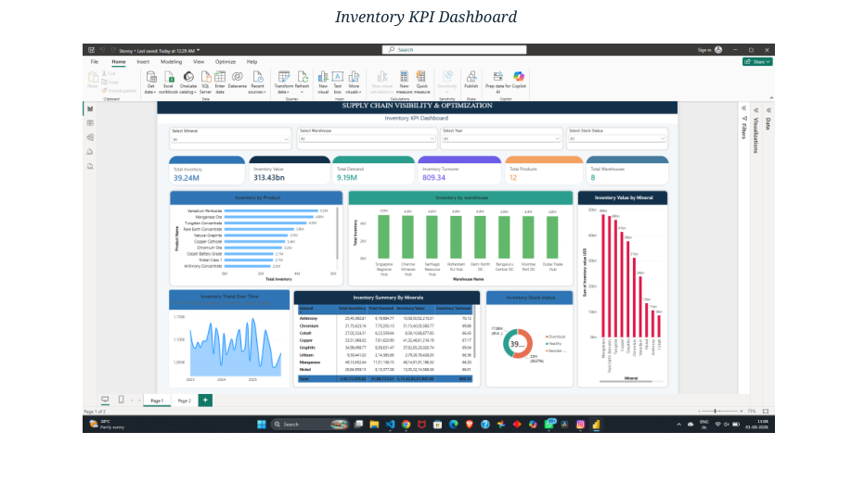
Figure 1. Milestone 1 – Inventory KPI Dashboard

7. Milestone 2 – Dashboard Explanation

7.1 Overview
Milestone 2 advances the project by introducing deeper analytical layers: Inventory Analysis, Supplier Performance Evaluation, and Trend & Variance Analysis. This phase focuses on identifying supply risks, optimizing stock levels through turnover metrics, and understanding seasonal variances.

7.2 Inventory Analysis
- KPI Cards: Total Inventory, Inventory Turnover, Total Products, and Slow-Moving Products.
- Bar Chart: Product Category vs. Inventory.
- Column Chart: Warehouse vs. Inventory.
- Line Chart: Inventory Trend over Time.
- Summary Table: Product-level detail for Inventory and Turnover.

7.3 Supplier Analysis
- Donut Chart: Supplier Tier Distribution and On-Time vs. Delayed Performance.
- Bar Chart: Region vs. Supplier Performance.
- Line Chart: Supply Trend over Time.
- Supplier Details: Capacity, rating, and risk scores.

7.4 Trend & Variance Analysis
- Line Chart: Trend analysis of inventory levels.
- Column Chart: Variance comparison between current and previous periods.
- KPI Card: Critical differences in inventory variance percentage.

7.5 DAX & Analytical Enhancements
Measure | Analytical Logic
Inventory Turnover | Measures how often inventory is sold and replaced over a period.
Slow-Moving Products | Counts products with turnover rates below a defined efficiency threshold.
Inventory Variance | Current Period Inventory − Previous Period Inventory.
Variance % | Inventory Variance ÷ Previous Period Inventory.
Supplier Risk Score | Weighted average of delivery performance, quality, and financial stability.

8. Milestone 2 – Output Screenshots

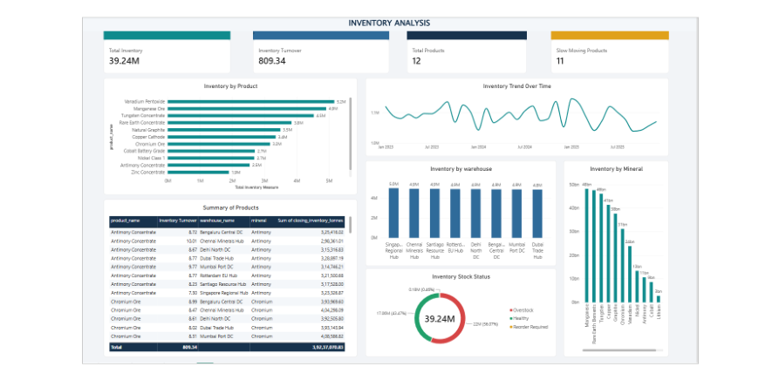
Figure 2. Milestone 2 – Inventory Analysis Dashboard

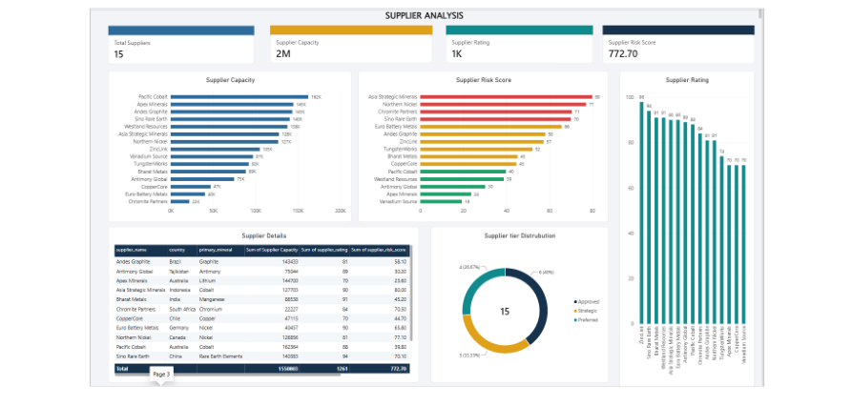
Figure 3. Milestone 2 – Supplier Performance and Risk Analysis
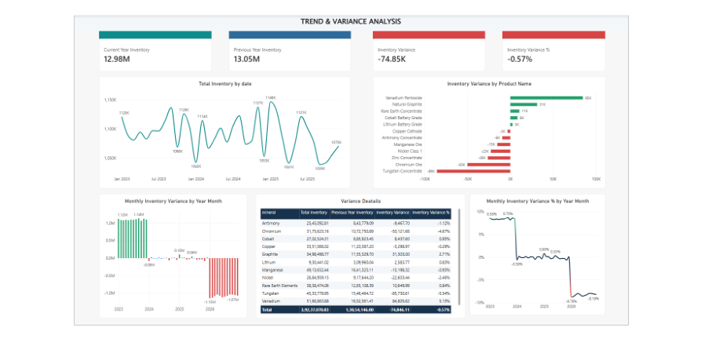
Figure 4. Milestone 2 – Trend & Variance Analysis

9. Milestone 3 – Dashboard Explanation

9.1 Overview
Milestone 3 extends the Supply Chain Visibility & Optimization project from inventory and supplier analytics into transportation and supplier performance analysis. The dashboard is designed to provide a consolidated view of transportation spending, shipment cost, order fulfillment, delivery timeliness, supplier shipment volume, supplier rating, carrier transportation cost, and route transportation cost. The page uses interactive slicers so that users can examine performance by Supplier Name, Carrier ID, Region, and Route ID.

9.2 KPI Cards
The Milestone 3 dashboard contains four KPI cards. Total Transportation Cost summarizes the transportation expenditure in the selected filter context. Average Shipment Cost represents the average transportation cost per transportation record. Fulfillment Rate measures the proportion of orders with Completed status. On-Time Rate measures the proportion of deliveries recorded as on time. In the captured dashboard view, the Region slicer is set to Middle East, so the displayed values are filter-responsive: Total Transportation Cost = 51.48M, Average Shipment Cost = 106.81K, Fulfillment Rate = 69.92%, and On-Time Rate = 23.44%. Changing or clearing the slicers will update these values dynamically.

9.3 Dashboard Visuals
The dashboard contains four analytical visuals. Supplier-wise Shipment Count compares shipment volume across suppliers using supplier name and delivery count. Average Supplier Rating compares the average supplier rating for each supplier rather than counting rating records. Carrier-wise Transportation Cost compares total transportation cost across carrier IDs. Route-wise Transportation Cost compares total transportation cost across route IDs. These visuals help identify differences in supplier activity and transportation expenditure.

9.4 Interactive Slicers
Four slicers are provided: Supplier Name, Carrier ID, Region, and Route ID. These controls allow users to filter the KPI cards and charts interactively. The slicers support focused analysis of individual suppliers, carriers, regions, or routes while preserving the overall dashboard structure.

9.5 Analytical Purpose
Milestone 3 improves supply-chain visibility by connecting supplier activity with transportation performance. The dashboard enables users to monitor transportation spending, review shipment cost, evaluate fulfillment and on-time delivery performance, compare supplier shipment activity and ratings, and identify carriers and routes associated with higher transportation costs. The results provide a visual foundation for operational monitoring and further supply-chain optimization.

10. Milestone 3 – Output Screenshots

Figure 5. Milestone 3 – T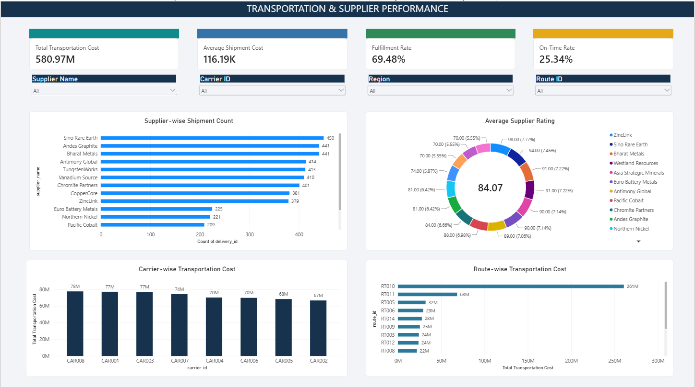

Figure 5. Milestone 3 – Transportation & Supplier Performance Dashboard (final captured output)

11. Milestone 4 – Warehouse Analytics & Final Dashboard

11.1 Overview
Milestone 4 completes the analytical phase of the Supply Chain Visibility & Optimization project. The milestone focuses on warehouse efficiency analysis, an executive-level supply chain overview, dashboard performance review, final validation, documentation, and deployment readiness. The completed Power BI pages provide a focused warehouse view and a consolidated executive view.

11.2 Warehouse Analytics & Efficiency
The Warehouse Analytics & Efficiency dashboard provides a dedicated view of warehouse inventory and operational utilization. It uses warehouse, regional, manager, and time-based analysis to support warehouse-level monitoring and comparison.
- KPI Cards: Total Warehouses, Inventory Value, Total Transportation Cost, and Average Warehouse Utilization.
- Inventory Value by Warehouse ID: compares inventory value across individual warehouses.
- Inventory Value by Region: compares inventory value across operating regions.
- Inventory Value by Warehouse Manager: provides manager-level inventory visibility.
- Inventory Trend Over Time: shows changes in inventory levels across the available time period.
- Interactive slicers: Warehouse ID, Region, Year, and Stock Status.
In the captured dashboard view, the KPI cards display 8 Total Warehouses, Inventory Value of 313.43bn, Total Transportation Cost of 580.97M, and Average Warehouse Utilization of 76.68.

11.3 Executive Supply Chain Overview
The Executive Supply Chain Overview consolidates the major supply-chain indicators from the earlier milestones into a single management-oriented dashboard. It provides a quick view of inventory, transportation, fulfillment, delivery timeliness, supplier rating, and route cost.
- KPI Cards: Total Inventory, Inventory Value, Total Transportation Cost, Fulfillment Rate, and On-Time Rate.
- Total Inventory by Warehouse: compares inventory levels across warehouse locations.
- Total Transportation Cost by Region: compares transportation expenditure across regions.
- Average Supplier Rating: compares suppliers using average supplier rating.
- Inventory Trend Over Time: monitors inventory movement across the reporting period.
- Route-wise Transportation Cost: compares transportation expenditure across routes.
In the captured executive dashboard view, the KPI cards display Total Inventory of 39.24M, Inventory Value of 313.43bn, Total Transportation Cost of 580.97M, Fulfillment Rate of 69.48%, and On-Time Rate of 25.34%.

11.4 Dashboard Performance Optimization
Dashboard performance is treated as a final quality requirement. The final dashboard is kept focused on essential KPI cards, analytical visuals, and relevant slicers. Power BI Performance Analyzer should be used to identify visuals with high DAX query or display time before final deployment.
- Review visual query and display time using Performance Analyzer.
- Prefer reusable DAX measures for KPI calculations.
- Keep the number of visuals and slicers focused on the analytical requirements.
- Avoid unnecessary fields, legends, labels, and duplicate visuals.
- Confirm dashboard responsiveness when slicers and filters are changed.

11.5 Final Testing & Validation
Final testing validates that the dashboard produces consistent results and that interactive controls work as intended. Testing covers KPI calculations, slicers, charts, filters, visual layout, and data refresh.
- KPI validation: verify that each KPI uses the intended measure and aggregation.
- Warehouse ID testing: confirm that warehouse selection updates relevant visuals.
- Region testing: confirm that regional filtering updates the dashboard consistently.
- Year testing: verify that time-based visuals respond correctly to year selections.
- Stock Status testing: verify Healthy, Overstock, and Reorder Required selections.
- Executive dashboard testing: verify inventory, transportation, supplier, fulfillment, and route visuals.
- Visual testing: check for blank visuals, incorrect titles, overlapping objects, truncated labels, or unintended filters.
- Refresh testing: confirm that the report refreshes successfully before deployment.

11.6 Documentation & Deployment
The final documentation combines the work completed across all four milestones. It records the project objectives, data sources, dashboard development, analytical measures, output dashboards, testing activities, and deployment readiness. The final Power BI file should be saved as the controlled project version and published to Power BI Service after validation.

12. Milestone 4 – Output Screenshots
Figure 6. Milestone 4 – Warehouse Analytics & Efficiency Dashboard
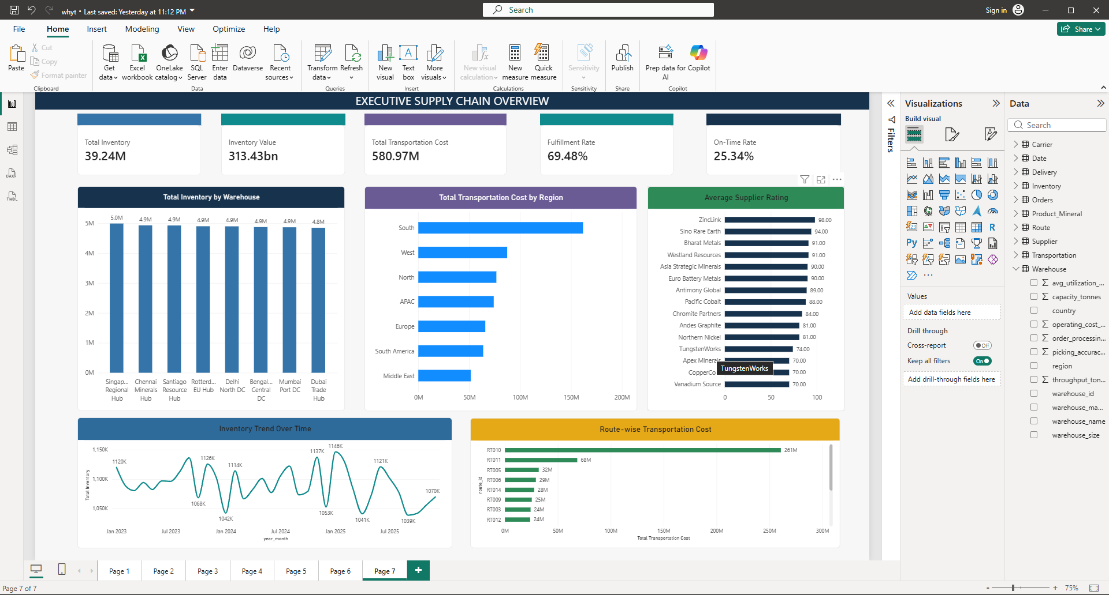

Figure 7. Milestone 4 – Executive Supply Chain Overview Dashboard
