*You are provided with the following data from PayBuddy –*

1. ***Credit data:*** *Data about credit application, approved/declined decision, repayment details and more at the customer level.*
2. ***Marketing data:*** *Transaction level data with details like merchant industry, price, chosen funding instrument and more.*
3. ***AB Testing data:*** *AB testing data for 3 months for transactions with random recommendation (nudge) of Funding Instrument as default (control group) and data-based recommendation (nudge) of Funding Instrument as default (test group). The test/control group tag for every transaction is provided.*

*Using the provided data, answer questions 1 to 9. Support your answers by pasting the necessary graphs and tables as pictures (when mentioned in the question). In addition to this document, submit the excel file, where you have performed the analysis.*

1. ***Visualize and identify the topmost reason of decline for a credit card application being declined.***

***Hint: Use the decline reason column in the Credit data excel sheet and identify the most frequently used reason. Also, plot a histogram of the distribution of different types of decline reasons.***

With the declined transactions histogram, it’s clear that the “Compliance” is top reason for declining the credit card applications.

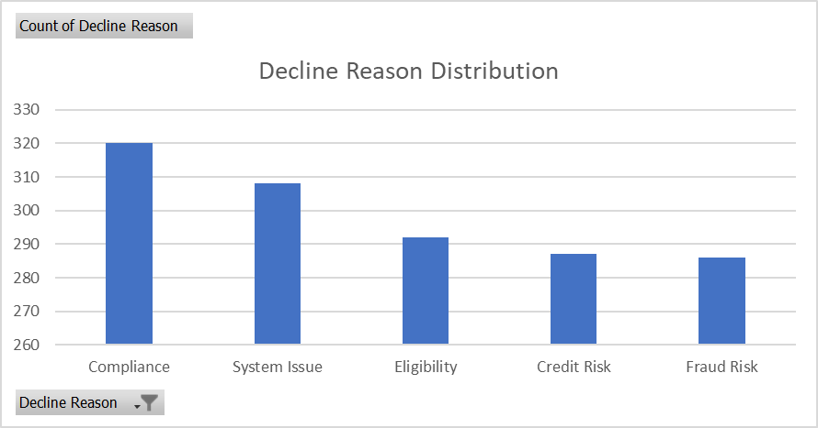

1. ***Identify the following from the data –*** 
   1. ***the month with the lowest credit score cutoff for approval***
   2. ***the month with the highest default rate***
   3. ***the month with the highest approval rate***

***Also identify the trend for each credit score, default rate and approval rate as to whether increasing or decreasing or fluctuating (increase/decrease) month over month.***

***Hint: Create a pivot table for every month with approval rate, default rate and average credit score.***

a. The month with lowest credit score cut-off for approval is “March”

b. The month with highest default rate is "January"

c. The month with highest approval rate is "March"



1. ***Plot average transaction amount, approval rate for every month. Identify the following from the plot*** 
   1. ***the month with highest transaction amount***
   2. ***the month with highest approval rate***

***Also identify if average transaction amount is increasing or decreasing with respect to approval rate? (for e.g. if approval rate increases, average transaction amount decreases or if approval rate increases, average transaction amount increases or vice versa).***

***Hint: Create a pivot table with average transaction month and approval rate for every month. Compare it with the approval rate for every month and check if the average application amount is increasing or decreasing with respect to the approval rate.***

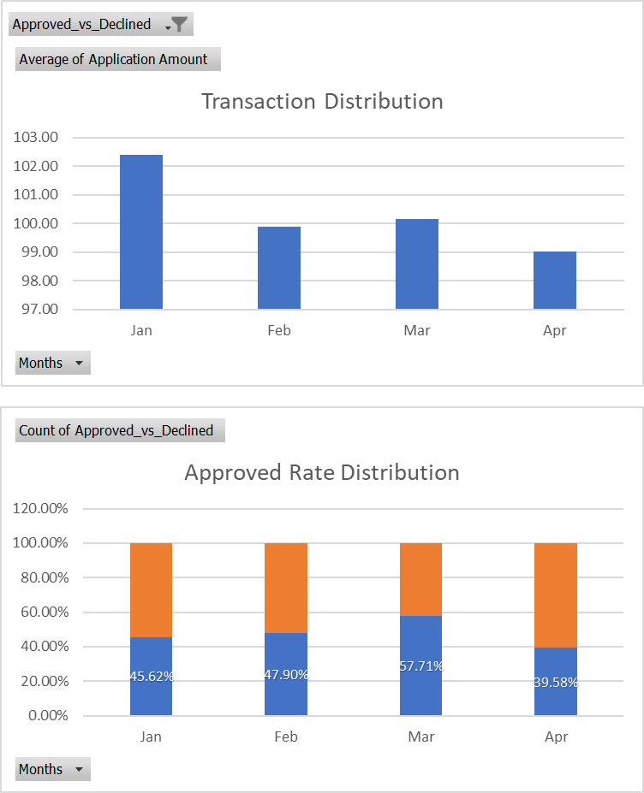

Average transaction amount is decreasing with increase in the approval rate, with exception in the month of April due to less data.

a. The month with highest transaction amount is “March”

b. The month with highest approval rate is "March"

1. ***Report the net revenue for PayBuddy for every month. Do you think the company is making a profit or loss overall?***

***Hint: Assume that PayBuddy takes a commission of 3.5% on every transaction. The revenue for PayBuddy per transaction is (0.035 * amount – loss). The loss is 0 if the customer did not default. The sum of this for all customers will be the net revenue for PayBuddy. Compute this value for every month and write your insights.***





It seems that the approvals with each month has no strong upward or downward trend however the percentage of defaults within the approved amount is increasing which suggests something is not going well. Overall impression seems that the company is moving towards losses.

1. ***What is the impact of the data-based nudge on customer engagement? Plot the old customer segment and new customer segment engagement distribution for the test and control group.***

***Hint: Use AB testing data to identify how many customers have moved to higher engagement segments. Identify if more customers migrated to higher segments or lower segments in treatment group.***



With the percentage share of the customer engagement it seems that the “About to churn” category has completely gone in both control and treatment groups, in the Control and Treatment the “About to churn” and “High” categories have almost identical results.

However, when the Low and Medium Categories are compared, they have gone to higher categories much more in the Treatment group when compared to Control group.

1. ***What is the impact of the data-based nudge on customer spending (credit vs debit card)? Calculate the percentage change in credit and debit spending between the test and control group. Identify if credit spending is increased or decreased after introducing data-based nudges (treatment group).***

***Hint: Use AB testing data to identify total credit spending (sum_3_mnth_credit_txn) and total debit card spending (sum_3_mnth_debit_txn). Write your insights.***

It seems that after data-based nudge the spending the credit spending has increased by approx. 5% however there is a steep decline in debit spending





1. ***Which Funding Instrument is the most preferred for mobile transactions?***

***Hint: Use a pivot table to find the count of Funding Instruments for different modes of transaction. Find the highest used Funding Instrument for mobile transactions.***

Most preferred funding instrument for Mobile transactions is **PayPal_Pay_Later.**



1. ***Find the most frequently used merchant segment for each funding instrument.***

***Hint: Use a pivot table to find the sum of credit/debit card transaction amount for customers (in 12 months) using the Funding Instrument. Group the Funding Instrument as a credit or debit card based on a maximum of this amount.***





1. ***Which FI is preferred by customers with many premium cards?***

***Hint: Use a pivot table to find the count of the average number of premium cards per customer for each Funding Instrument. Find the Funding Instrument with the maximum average number of premium cards.***

Maximum average number of premium cards is 5.98 for **PayPal_Cobrand_Card**

