Connecting AI with LinkedIn Safely
A Guardrail Architecture for Claude & Antigravity (Without Account Restrictions)
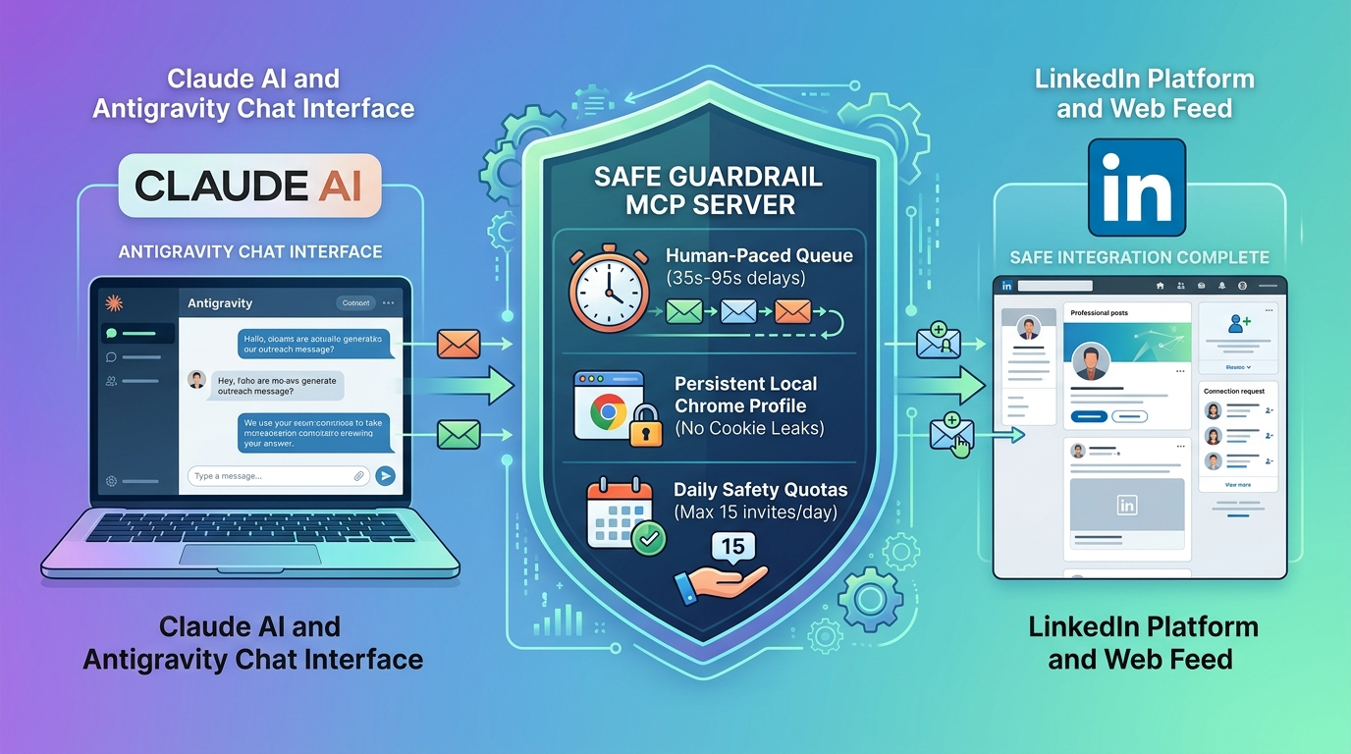
Figure 1: How the Safe Guardrail MCP Server protects accounts with human pacing and persistent profiles.
1. The Dilemma with Existing LinkedIn Tools
When professionals connect an AI assistant like Claude or Antigravity to LinkedIn, they immediately hit a wall: there is no official LinkedIn connector available. As a result, users are forced to choose between two flawed alternatives:
- The Official API Tools: Safe from bans, but very limited. You can publish a basic text post, but you cannot search jobs, read user profiles, or send messages.
- The Raw Scraper Tools: Can do everything, but act like high-speed bots. They demand your private session cookies, blast requests all at once, and quickly trigger LinkedIn's automated security flags and account bans.
We built this custom connector so nobody has to compromise between 'safe but useless' and 'powerful but banned'.
2. What We Actually Built
We designed a custom connector (Model Context Protocol / MCP server) that runs locally on your machine. Instead of blasting LinkedIn with rapid-fire commands, it behaves like a careful human assistant sitting in front of a real browser:
- Persistent Browser Profile: Uses a standard local Chrome profile that stays logged in naturally, avoiding suspicious re-logins.
- Human-Paced Action Queue: Any outbound networking request (message, connection request) enters a waiting queue with randomized pauses (35 to 95 seconds apart).
- Hard Daily Safety Limits: Monitors your daily activity and stops automatically before reaching spam thresholds.
3. Why This Is Better & Safer Than Typical 3rd-Party Tools
- No Leaked or Pasted Cookies: Typical third-party tools require you to open developer tools, extract secret cookies (li_at), and paste them into configuration files. Our solution opens a clean browser window once; you log in naturally with your password and 2FA, and the session stays securely on your machine.
- Human Rhythm (Anti-Burst Protection): When standard automation sends 5 connection requests, it fires all 5 within 2 seconds. Our queue spaces each request with natural, randomized human delays so it never looks like robotic spam.
- Built-in Speed Governors: If an AI accidentally loops or repeats a command, our server has strict daily ceilings (maximum 15 invites, 15 messages, and 50 profile views per day). Once reached, it politely pauses until the next day.
- Universal AI Compatibility: Works out-of-the-box with Claude Desktop, Antigravity, Cursor, or any platform supporting the MCP standard.
4. Core Features Included
- Job Search: Search job listings by title, keywords, and location (e.g., 'Senior AI Engineer in Remote').
- Profile Reader: Inspect public profile headlines, summaries, and career backgrounds before meetings.
- Post Drafting & Scheduling: Draft and schedule posts directly to your LinkedIn feed without manual copying and pasting.
- Paced Direct Messaging: Queue messages to contacts that send smoothly at human intervals.
- Connection Requests with Notes: Send personalized invitation notes paced safely one by one.
- Safety Dashboard: Ask the AI at any time to report how much daily quota has been used and what remains.
5. The Honest Truth About Safety (No False Claims)
We believe in complete transparency, so here is what you should honestly know:
- Not Officially Endorsed: This is not an official LinkedIn product. LinkedIn does not officially support automated browser tools on personal accounts.
- No 100% Zero-Risk Guarantee: No automation software can claim absolute zero risk, because LinkedIn continually updates its anti-bot algorithms.
- The Safest Practical Choice: By keeping your login local, using realistic human delays, and enforcing strict daily quotas, this architecture reduces risk to the absolute minimum feasible level.

