**Fall**

14

**ECE 313**

Final Project

Nicholas Foss, Rahul Joshi, Lawrence Fung

Binary Hypothesis Testing for Real-time Patient Monitoring

08

**Fall**

**Task 1.1**

a) Calculate the prior probabilities of P(H1) and P(H0).

We calculated the prior probability P(H1) by counting the samples where there was a 1 in the set then dividing that number by the total of alarms.

P(H0) was calculated similarly by counting the samples where there was a 0 in the set and then dividing that number by the total number of alarms.

P(H0)=num of 0 in alarm set/total num of alarms

P(H1)=num of 1 in alarm set/total num of alarms

b) Construct the likelihood matrices for each of the 7 features*.*

In order to construct the likelihood matrices, we needed to find the pmfs of the features given there was an alarm and given there was no alarm. We did this by using the tabulate function on a feature set given alarms and tabulated another feature set given no alarms.

c) Show your results by generating a separate figure for each patient, consisting

of 7 *subplots* corresponding to the 7 features. In each subplot of each figure,

plot the conditional pmf under each of the hypotheses *H0* and *H1.* Use *legend*

function in MATLAB to distinguish between the two pmf’s in the subplot.

Subplots at end of report

d) Calculate the ML and MAP decision rule vectors

We formed the ML decision rule vectors by going through the H0 and H1 pmfs and marking a 1 in the ML decision rule vector when the pmf of H1 was greater than or equal to the pmf of H0.

The MAP decision rule vector was done in a similar way. We multiplied the H0 pmf with the prior probability P(H0) and the H1 pmf with the prior probability P(H1). After doing this multiplication we iterated through the multiplied H0 and H1 pmfs and compared these pmfs. Marking a 1 if pmf H1 was greater than or equal to pmf H0 in the MAP decision rule vector.

*H1_pmf(i) ≥ H0_pmf(i)* then *ML_vector(i) = 1*.

*P(H1)*H1_pmf(i) ≥P(H0) H0_pmf(i)* then *MAP_vector(i) = 1*.

**Task 1.2**

a) Use the *HT_table_array* calculated in Task 1.1 part e, to generate alarms based on

each of the ML and MAP decision rules for the *testing* data set.

We generated our set of alarms by using a hash table to map our ML and MAP rule to each value in the feature set which was contained in HT table. We then looped through the testing data set and used the previously created hash table to determined the alarms for each value in this data set.

b) Use *label_testing* golden alarms to evaluate each of the ML and MAP decision

rules, by calculating:

1. The conditional probability of false alarm

To calculate the probability of false alarm we calculate the probability the decision rule declares and alarm given that that the test alarm declares no abnormality

*P(False Alarm) = P(Decision rule declares an alarm | Physician indicates no abnormality)*

We calculate the probability that the decision rule declares a 1 and the physician golden alarms generates a 0. Then we divided this by the probability that the physician declares a 0.

P(False Alarm) = *P(Decision rule declares an alarm AND Physician indicates no abnormality)/P(physician indicates no abnormality)*

*P(Decision rule declares an alarm AND Physician indicates no abnormality)*

*=(num where decision rule=1 and golden alarm=0)/total num of alarms*

*P(physician indicates no abnormality)*

*=(num of golden alarm=0)/total num of alarms*

2. The conditional probability of missed detection

To calculate the probability of missed detection we calculate the probability that the decision rule does not declare and alarm give the test alarms declares and abnormality.

*P(Missed Detection) = P(Decision rule declares no alarm | Physician indicates an abnormality)*

We calculate the probability that the decision rule declares a 0 and the physician declares a 1. And divide this by the probability the physician declares a 1

P(Missed Detection) = *P(Decision rule declares no alarm AND Physician indicates an abnormality)/P(physician indicates an abnormality)*

*P(Decision rule declares no alarm AND Physician indicates an abnormality)*

*=(num where decision rule=0 and golden alarm=1)/total num of alarms*

*P(physician indicates no abnormality)*

*=(num of golden alarm=1)/total num of alarms*

3. The probability of error

The probability of error is calculated by calculating the probability decision rule declares and alarm(indicate 1) and golden alarms declares no alarm(indicate 0) and then we added this with the probability decision rule declares no alarm(indicate 0) and golden alarms declares alarm(indicate 1).

*P(Error) = P(Decision rule declares an alarm AND Physician indicates no abnormality)+*

*P(Decision rule declares no alarm AND Physician indicates an abnormality)*

*P(Error)=(num decision rule alarm=1 and golden alarm=0+num decision rule alarm =0 and golden alarm =1)/total num of alarms*

**Task 2**

For this task we tried to find the lowest probability of error using option 1, where we find the top two features with the lowest ML and MAP errors. To minimize these two probabilities we need to minimize the number of disagreements between alarms and physician alarms. We minimized these error probabilities by looking at the sum of mismatches for the top two features and chose those features as our pair for each patient.

For our second technique we used option 3 where we determine the correlation between different pairs of features. We try to find the pairs that are most uncorrelated because we need low correlation to calculate the error probability, because if the correlation is between pairs is high we cannot use this information.

Results:

ML rule patient 3(features 3 and 5) patient 4(features 2 and 7) patient 8(features 2 and 3)

MAP rule patient 2(features 1 and 6) patient 3(features 5 and 7) patient 5(features 1 and 2)

**Task 1.1c plots**

**Patient 1**

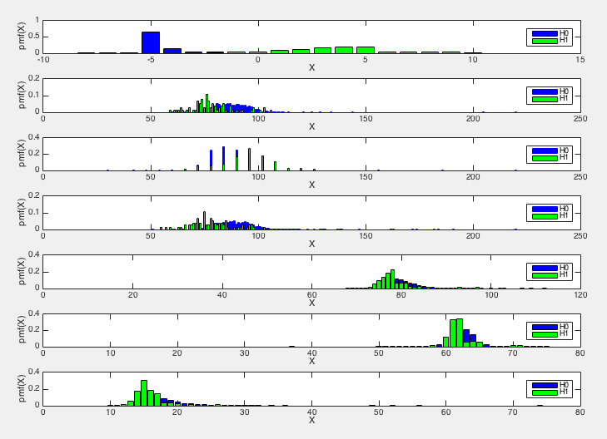

**Patient 2**

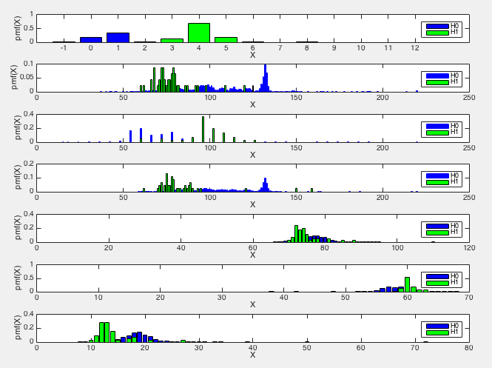

**Patient 3**

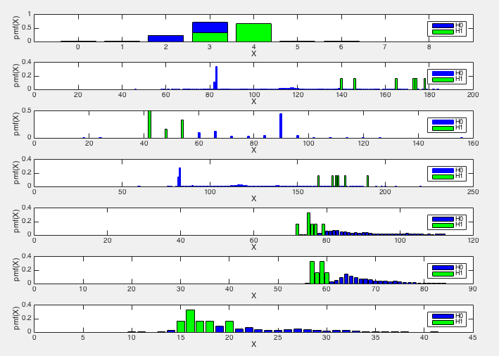

**Patient 4**

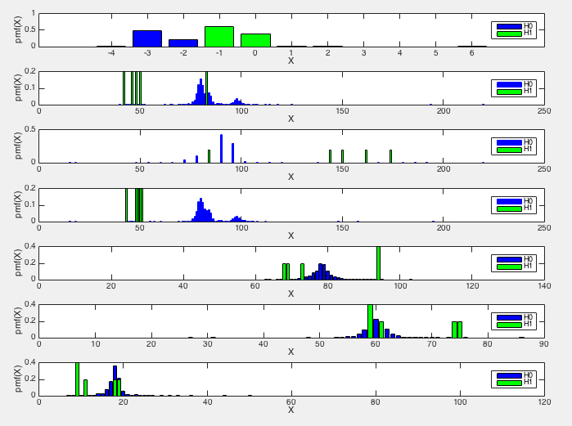

**Patient 5**

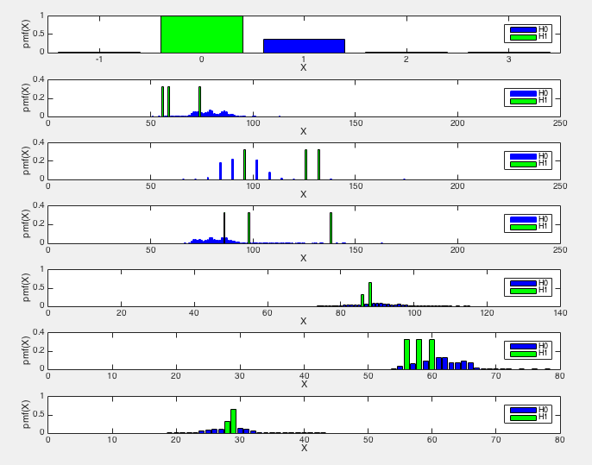

**Patient 6**

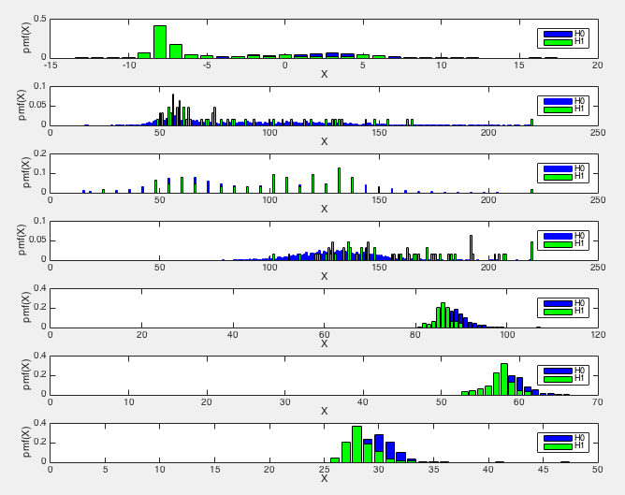

**Patient 7**

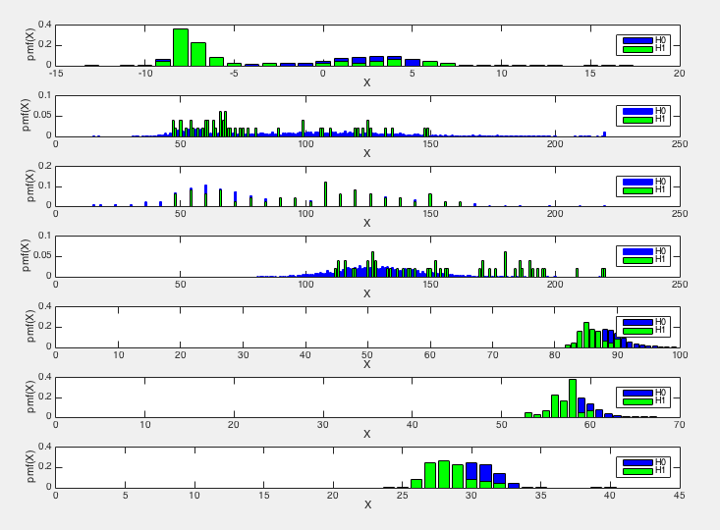

**Patient 8**

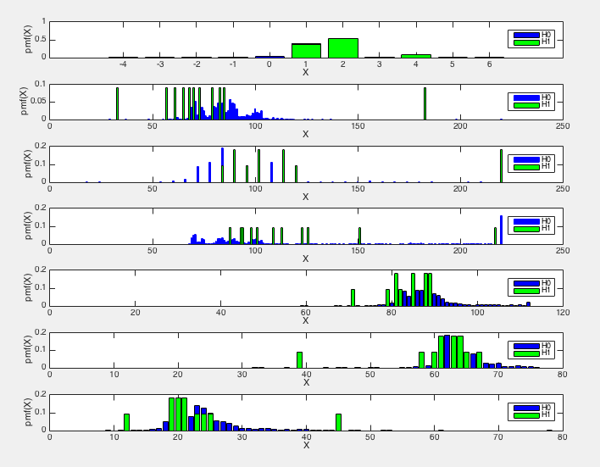

**Patient 9**

