Mid 1 Question 4

By

**Rahul Anand Sharma**

**201203002**

Report can be viewed online at <http://web.iiit.ac.in/~rahul.anand/cv/report.pdf>.

Q4 a)

Camera Calibration

Usage

[P, K, R, t] = camcalib (Filename, Numpts)

Ex: [P, K, R, t] = camcalib (‘ImageDetails.tx’, 100)

Input is given in the form of file “ImageDetails.txt” which contains image to world point correspondences

Implementation:

If x is image point and X is world point

x = P*X

Step 1: Normalization of the Points.

Step 2: Apply SVD (Singular Value Decomposition)

Step 3: Get Last singular vector as P

Step 4: Denormalize P

Decompose the camera projection matrix P into intrinsic matrix K, rotation matrix R, and translation vector t.

P: 3x4 camera projection matrix

K: 3x3 intrinsic matrix

R: 3x3 rotation matrix

t: 3x1 translation vector

We can specify number of points to use for camera calibration.

Example:

Using all point correspondences i.e. points=4727

K = 42.4215 51.0905 -228.1953

0 12.7389 100.6149

0 0 1.0000

R = 0.4471 -0.8828 0.1442

0.2456 0.2762 0.9292

-0.8601 -0.3800 0.3403

t = 21.4646

-4.3678

4.6878

Q4 b)

Optimal Seam Detection

1. Take user input to select common region.
2. Get Difference image using watershed function.
3. Generate a graph in which each node represents one of the watershed regions, and the edges are the grey-value of the image in between the regions.
4. Compute max-flow/min-cut of this Graph.
5. The matrix L contains 0 or 1 for each vertex, indicating whether it is connected to the source or the sink.
6. Assign each region in the image with the correct label ID.
7. Apply blurring followed by Stitching.

Example:

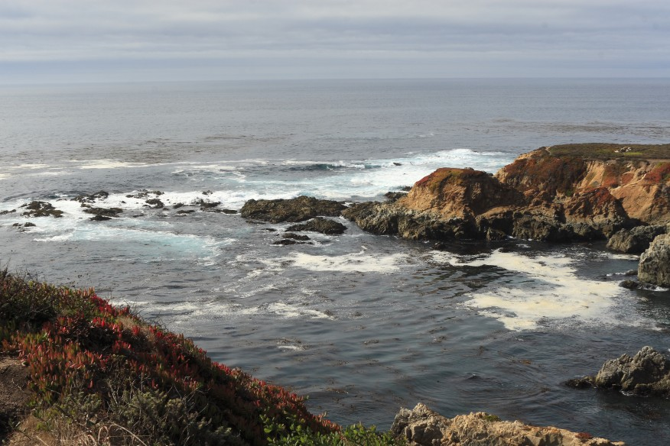

Image 1

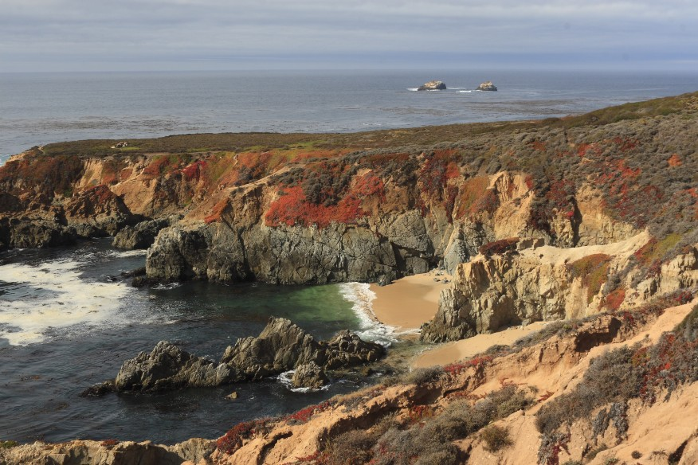

Image 2

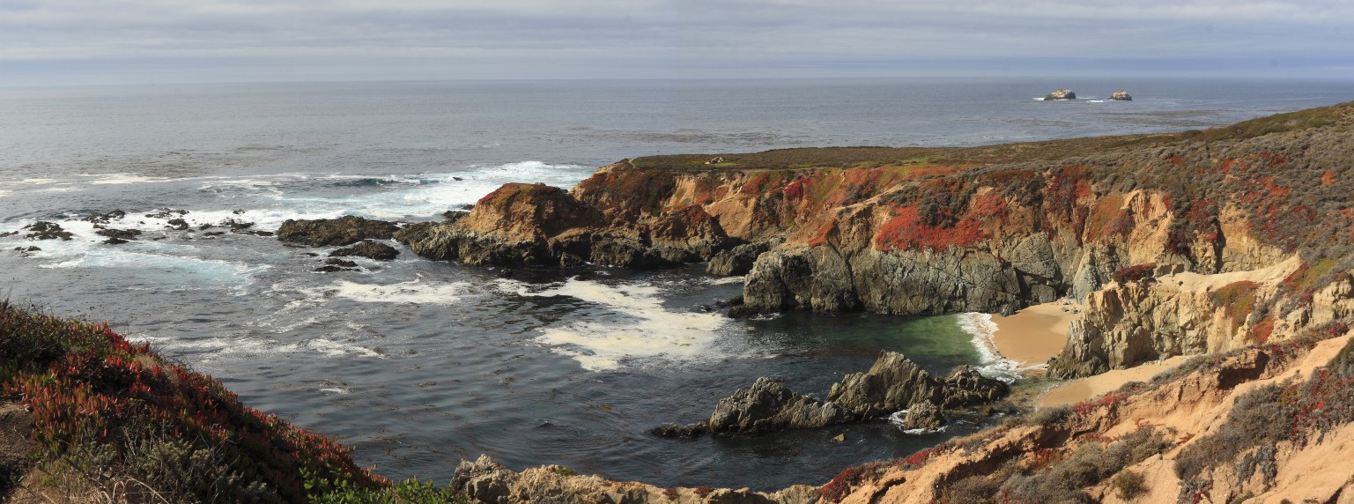

Stitched Image