Part A : Questions

A1(a) Ans.
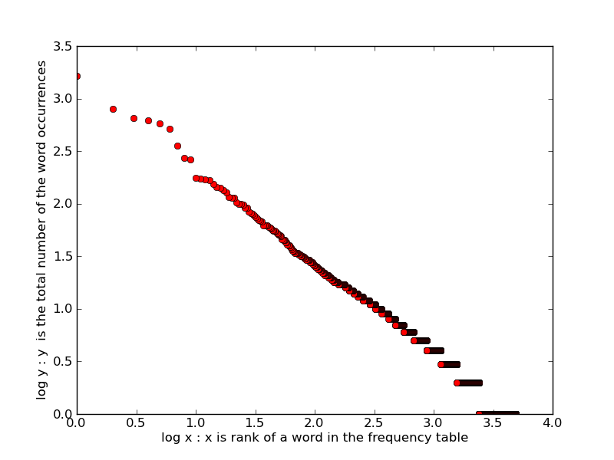

A1(b) Ans.
Vocabulary items for 1/4 of the total number of word occurrences : 12
Vocabulary items for 1/4 of the total number of word occurrences : 146
Vocabulary items for 1/4 of the total number of word occurrences : 802

A2 Ans.
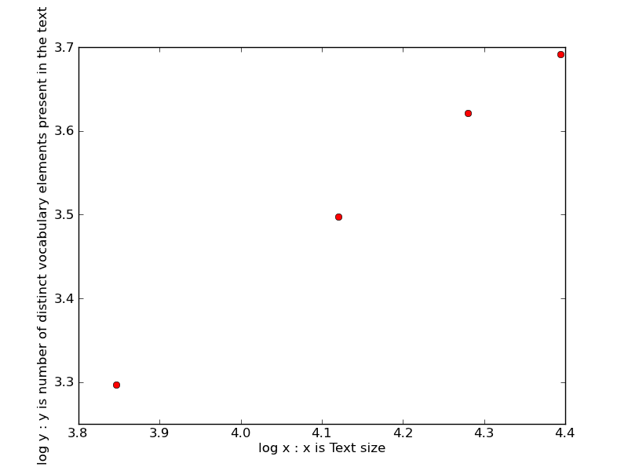
Here, b = (y2-y1)/(x2-x1)
b = (3.497-3.297)/(4.120-3.846)
b = 0.2/0.274
b = 0.73

A3 Ans.
StopList = 'and', 'is', 'it', 'an', 'as', 'are', 'have', 'in', 'their', 'said', 'from', 'for', 'also', 'by', 'to', 'other', 'which', 'new', 'has', 'was', 'more', 'be', 'we', 'that', 'but', 'they', 'not', 'with', 'than', 'a', 'on', 'these', 'of', 'could', 'this', 'so', 'can', 'at', 'the', 'or', 'first'

Part B : Program

The inverted file system is built in python.

Required dependencies :
Python Interpreter version 2.7.2
matplotlib version 1.1.0

To access the test interface for search queries:
>> python invert.py
To display generated web-data from 40docs:
>> python invert.py displaywebdata
To check answers of QA1a:
>> python invert.py A1a
To check answers of QA1b:
>> python invert.py A1b
To check answers of QA2:
>> python invert.py A2
To check answers of QA3:
>> python invert.py A3

Data Structure
The data structure is of the form { word, {filename, {pos1,pos2,pos3} }} i.e. Dict(Dict(Set))

The objective of the inverted file system is to allow fast text searches. Dict and set are used instead of lists as we have to perform a lot of lookups.

Lookup time for Dict is nearly O(1) [In this case it is nearly O(1) due to the unique (key,value) pairing of the Outer Dict containing word as keys]. The same goes for Inner Dict containing filename as keys. For the positions in the posting list, I preferred sets instead of lists because lookup time for sets [O(1)] is very less than for lists [which tends to O(n)].

How program works?
main() calls traverseDataSet() which generates the posting list data structure, while taking in consideration that the token starts with an alphabet.

searchTerm() is responsible for searching through the data structure. If flag is set to 0, it performs search for single query, else it performs search for multiple query.

For single query, the program display list of postings that contain the term with tf, idf and tf.idf. It also contains file id in which the query is, and position of the token in the file. It also shows ten words from the document that include the term in its context within the document. For multiple word query, I have used cosine similarity and calculated scores for every term. The file ids are displayed in decreasing order along-with their normalized similarity score between query and document.

B1a.txt is of the form <word> <document freq for that word>
for e.g.
ability 5

B1b.txt is of the form <word no> <word> <fileid>:<word occurrence in the file> <fileid>:<word occurrence in the file> <fileid>:<word occurrence in the file> ..... [[ sum of total word occurances ]]
for e.g
7 ability 11 : 1 14 : 1 17 : 1 19 : 1 38 : 1 [[5]]

