Rahul Bekal

Mrs. Harris

AP Chemistry

12 October 2014

Lab Report - Silver Oxide : Empirical Formula

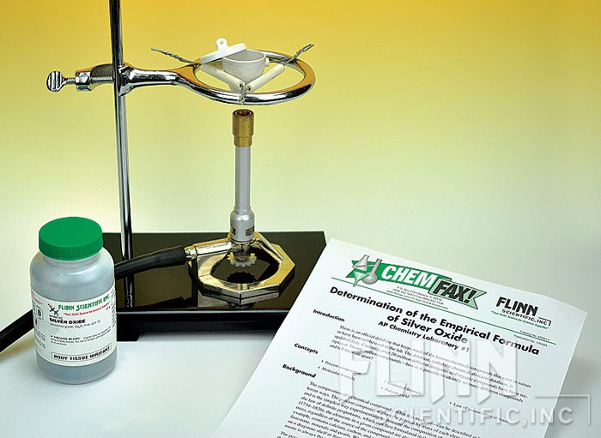

Table of Contents:

1. Purpose
2. Procedure
3. Experimental Data
4. Calculations and Graphs
5. Conclusions
6. Discussion of Theory
7. Error Analysis
8. Questions

**Purpose:**

The purpose of this lab was to find the empirical formula of silver oxide. It could be determined by decomposing the silver oxide. By then stoichiometry can be applied to solve for the empirical formula. A real life implication of this lab could be used to determine the empirical formula for other compounds.

**Procedure:**

1. Heat a crucible on a ring clamp 1 cm above a bunsen burner for 1 minute. Then measure the mass of the crucible and the lid.
2. Add 0.5 grams of Silver Oxide to the crucible. Then measure the mass of the crucible and lid after the Silver Oxide sample was added.
3. Place the crucible on the clay triangle and place the lid covering half of the crucible opening. Then heat the bottom of the crucible by brushing the bunsen burner’s flame slowly under it.
4. Then continue to gently heat the crucible with a smaller flame for 10 minutes.
5. Finish heating the crucible at maximum heat on the bunsen burner for 10 more minutes.
6. After 10 minutes, put the crucible on wire gauze and let it cool for 10 minutes.
7. Measure the mass of the crucible, lid, and silver metal product.
8. Remove all contents of crucible and dump in waste container.

**Experimental Data:**

|  |  |  |
| --- | --- | --- |
|  | Trial #1 | Trial #2 (Starter) |
| Mass of Crucible and Lid (g) | 21.660 grams | 20.8 grams |
| Mass of Crucible, Lid and Silver Oxide (g) | 22.116 grams | 21.307 grams |
| Mass of Crucible, Lid, and Silver Metal (g) | 22.084 grams | 21.269 grams |
| Mass of Silver Oxide (g) | .456 grams | .507 grams |
| Mass of Silver Metal(g) | .424 grams | .469 grams |
| Mass of Oxygen(g) | .032 grams | .038 grams |

**Calculations and Graphs:**

Trial 1 -

0.424 g Ag • $\frac{1 mole}{107.87 g Ag}$ = .00393 moles= $\frac{.00393moles}{.002moles}$ =1.965 moles Ag

0.032 g O • $\frac{1 mole}{16 g of Ag}$ = .002 moles= $\frac{.002moles}{.002moles}$ =1.0 moles O

1.965 moles Ag = 2 moles Ag

1.0 moles O = 1 moles O

**=Ag2O**

Trial 2 -

0.469 g Ag • $\frac{1 mole}{107.87 g Ag}$ = .00435 moles= $\frac{.00435moles}{.00238moles}$ =1.83 moles of Ag

0.038 g O • $\frac{1 mole}{16 g of Ag}$ = .00238 moles= $\frac{.00238moles}{.00238moles}$ =1 moles O

1.83 moles Ag = 2 moles Ag

1 moles O = 1 moles O

**=Ag2O**

**Conclusion:**

In the experiment, the empirical formula of Silver Oxide can be found by using the law of conservation of mass and applying it to the decomposition reaction. By using the amount of Oxygen formed and Silver formed, one can use the empirical formula to find the moles of Oxygen and Silver in the Silver Oxide sample. We found that, for every 2 moles of Silver there was one mole of Oxygen. So the final empirical formula, found by using the decomposition reaction and stoichiometry, is Ag2O.

**Discussion of Theory:**

The theory demonstrated in this experiment is the Law of Conservation and use of stoichiometry to find the empirical formula of a compound. By subtracting the amount of Silver made by the reaction by the original amount of Silver Oxide added, one is able to find the amount of Oxygen made. Now using stoichiometry one is able to find moles of Silver Oxide used from each product. Finally one is able to find the empirical formula. The calculations above support the theory as it uses the Law of Conservation to find the amount of products made. Then the calculation finds the empirical formula by using stoichiometry.

**Error Analysis:**

A couple errors may have slightly affected the experiment such as the oil from skin affecting the mass measured on the crucible. This may have accounted for a mistake in calculations of mass of oxygen or silver in the crucible. It is also possible that the crucible had to be heated longer to make sure all the oxygen left the crucible, before it was weighed. This may have affected our percentage yield to be under a 100%. Also when the silver metal was cooling and being moved to the scale it may have absorbed some oxygen also causing the percentage yield to be under a 100%. Based on our results this most likely was caused by the product reabsorbing oxygen while it was cooling.

**Relative Error:**

Trial 1- .425g-.424g = .001 g

$\frac{.001}{.425}$ =.00235 Relative Error

Trial 2- .472-.469 = .003g

$\frac{.003}{.472}$ =.00636 Relative Error

(Relative Error was calculated from Percentage Error Data in Questions Section Below.)

**Questions:**

Trial 1

**Masses**

1. 22.116g - 21.660g = .456 g of Silver Oxide

22.084g - 21.660g = .424 g of Silver Metal

22.116g - 22.084g = .032g of Oxygen

**Percent Composition**

1. $\frac{.032g of Oxygen}{.456g of Silver Oxide}$ $∙$ 100= 7.02% of Oxygen

$\frac{.424g of Silver}{.456g of Silver Oxide}$ $∙$ 100= 92.98% of Silver

**Moles of Product**

1. 0.424 g Ag • $\frac{1 mole}{107.87 g Ag}$ = .00393 moles of Silver

0.032 g O • $\frac{1 mole}{16 g of Ag}$ = .002 moles of Oxygen

**Empirical Formula**

1. $\frac{.00393moles}{.002moles}$ =1.965 moles of Ag

$\frac{.002moles}{.002moles}$ =1.0 moles O

1.965 moles Ag = 2 moles Ag

1.0 moles O = 1 moles O

**=Ag2O**

**Balanced Decomposition Equation**

1. 2Ag2O 4Ag + O2

**Theoretical Yield of Silver Metal**

1. .456 g Silver Oxide $∙$ $\frac{1 mole Silver Oxide}{231.74}∙\frac{4 moles Silver}{2 moles Silver Oxide}∙\frac{107.87g of Silver}{1 mole Silver}$

**=.425 g of Silver**

**Percentage Yield of Silver Metal**

1. $\frac{.424g of Silver}{.425 g of Silver}∙100$ =99.76%.