PES UNIVERSITY, BANGALORE
Department of Computer Science and Engineering
Software Engineering Mini-Project

Software Architecture and Design Specification
Online Internship and Placement Preparation Portal

Group: Team 16
Version: 1.0
Date: 05-10-2026
Status: Draft

Team Members
Rahul Bellary: PES1UG24CS357
Dhoni Satwik: PES1UG24CS321
Prateek Hachadad: PES1UG24CS340

Revision History
Version | Date | Author | Change Summary
1.0 | 06-10-2026 | Rahul Bellary | Initial version for Part-1 submission

Approvals
Role | Name | Signature / Date
Team Member | Rahul Bellary
Team Member | Dhoni Satwik
Team Member | Prateek Hachadad
Course Instructor

1. Introduction

1.1 Purpose
This document specifies the architecture and design of the Online Internship and Placement Preparation Portal.

1.2 Scope
Covers Student, Recruiter and Admin services: authentication, internship listings, applications, aptitude tests, analytics, notifications and administration.

1.3 Audience
Developers, testers, security reviewers, course instructors and maintainers.

1.4 Definitions
MERN, JWT, RBAC, REST, ADR, TLS, STRIDE. See SRS Appendix A.

2. Document Overview

2.1 How to use this document
Section 3 describes the architecture (components, pattern, technology, risks, traceability, security). Section 4 describes the detailed design (sequence diagrams, APIs, error handling, UX).

2.2 Related Documents
SRS.docz, Test-Plan.docx, Requirement_List.docx

3. Architecture

3.1 Goals & Constraints
Goals: secure handling of personal data and test integrity, responsive search, 99.5% availability, maintainable modules, support for 5,000 users.
Constraints: MERN stack plus Python analytics, free/open-source tools, one-semester timeline, team of three.

3.2 Stakeholders & Concerns
Stakeholder | Concerns
Students | Usability, fair and reliable tests, privacy of resume and scores
Recruiters | Reaching suitable candidates, easy applicant review
Admin / Placement cell | Moderation, reports, auditability
Developers | Modularity, testability, simple deployment
Instructors | Conformance to the deliverables and quality of design

3.3 Component (UML) Diagram
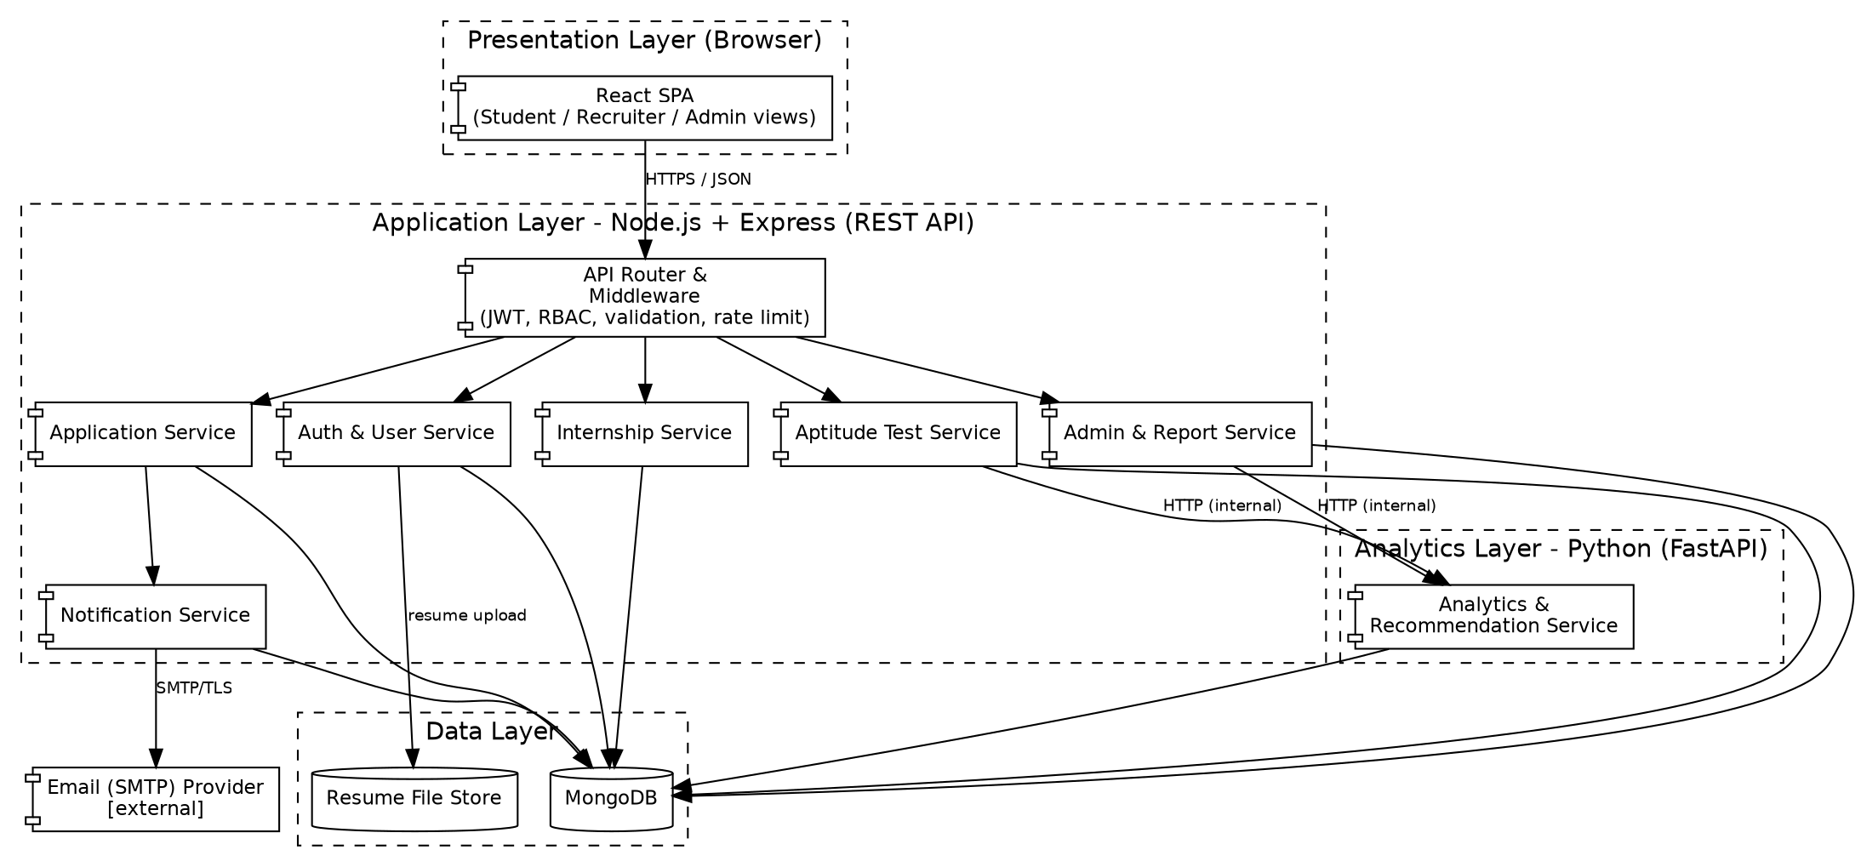
Figure 1: Component diagram of the Portal

3.4 Component Descriptions
Component | Responsibility
React SPA | Role-based UI for Students, Recruiters and Admins; calls REST API over HTTPS.
API Router & Middleware | Single entry point: JWT verification, RBAC, input validation/sanitisation, rate limiting, central error handler.
Auth & User Service | Registration, login, lockout, profile and resume upload, user (de)activation.
Internship Service | Listing CRUD, moderation workflow, search and filtering.
Application Service | Apply, duplicate/deadline checks, status updates, applicant review.
Aptitude Test Service | Question bank, attempt lifecycle, timer, autosave, grading, review.
Notification Service | In-app notifications and email via SMTP; asynchronous dispatch.
Admin & Report Service | Audit log, CSV export, aggregate queries.
Analytics & Recommendation Service (Python) | Computes score trends, weak categories, recommendations and aggregates.
MongoDB / Resume store | Persistent data and uploaded PDF resumes.

3.5 Chosen Architecture Pattern and Rationale
Pattern: layered architecture (presentation, application, data) with a modular monolith for the Node.js backend and one separate Python analytics service. Rationale: clear separation of concerns, simple deployment for a three-member team, and independent evolution of the analytics logic in Python where data libraries are strong. Full microservices were rejected as over-complex for the expected scale (5,000 users); a single monolith without the analytics split was rejected because the analytics requirement is naturally implemented in Python (ADR-1, ADR-2).
ADR | Decision | Alternatives considered
ADR-1 | Layered modular monolith for core API | Microservices (operational overhead too high)
ADR-2 | Separate Python FastAPI analytics service | Analytics in Node.js (weaker data tooling)
ADR-3 | MongoDB document store | Relational DB (schema flexibility for questions/attempts preferred)
ADR-4 | Stateless JWT sessions | Server-side sessions (harder to scale horizontally)

3.6 Technology Stack & Data Stores
Layer | Technology
Client | React, React Router, Chart.js
API | Node.js 20, Express, Mongoose, JWT, bcrypt, helmet, express-rate-limit, express-validator
Analytics | Python 3.11, FastAPI, pandas
Data | MongoDB 7; resume files on a protected storage volume
Transport | TLS 1.2+ (HTTPS), SMTP over TLS
DevOps | Docker, GitHub Actions, Jest, pytest, Cypress

3.7 Risks & Mitigations
Risk | Mitigation
Analytics service failure | Core flows (apply, test grading) do not depend on it; dashboard shows cached values and a notice
Database failure or data loss | Daily backups; restore procedure tested
Test answer leakage | Answer key never sent during an active attempt; grading only on the server
SMTP failure | Queued retry; in-app notification remains
Performance degradation under load | Database indexes, pagination, stateless API for horizontal scaling

3.8 Traceability to Requirements
Requirement | Component
PIP-F-001 to PIP-F-003, PIP-F-021 | Auth & User Service
PIP-F-004 to PIP-F-007 | Internship Service
PIP-F-008 to PIP-F-010 | Application Service
PIP-F-011 | Notification Service
PIP-F-012 to PIP-F-016 | Aptitude Test Service
PIP-F-017 to PIP-F-019 | Analytics Service, Admin & Report Service
PIP-F-020, PIP-F-022 | Admin & Report Service
PIP-NF-001, 002, 006 | Layered stateless API, indexes, pagination
PIP-NF-003, 008 | Deployment, backup (SAD 3.7)
PIP-NF-004, 005 | React SPA (UX, SAD 4.5)
PIP-S-001 to PIP-S-007 | API Router & Middleware, Security Architecture (SAD 3.9)

3.9 Security Architecture
Threat modelling (STRIDE):
Threat | Example | Mitigation | Requirement
Spoofing | Stolen or guessed credentials | bcrypt, lockout after 5 failures, short-lived JWT | PIP-F-002, PIP-S-002
Tampering | Modifying application status or scores through the API | RBAC, server-side validation, grading only on server | PIP-S-003, PIP-S-004
Repudiation | Denying an approval or status change | Append-only audit log | PIP-S-007, PIP-F-022
Information disclosure | Resume or answer key leakage | TLS, ownership checks, answers withheld during attempt | PIP-S-001, PIP-S-006, PIP-F-015
Denial of service | Request flooding | Rate limiting (HTTP 429), pagination | PIP-S-005
Elevation of privilege | Student calling Admin endpoints | RBAC middleware on every route | PIP-S-003

4. Design

4.1 Design Overview
Each backend module follows route -> controller -> service -> model layering. Middleware handles authentication, authorisation, validation and error formatting. The React client uses role-based routes and a shared API client.

4.2 UML Sequence Diagrams
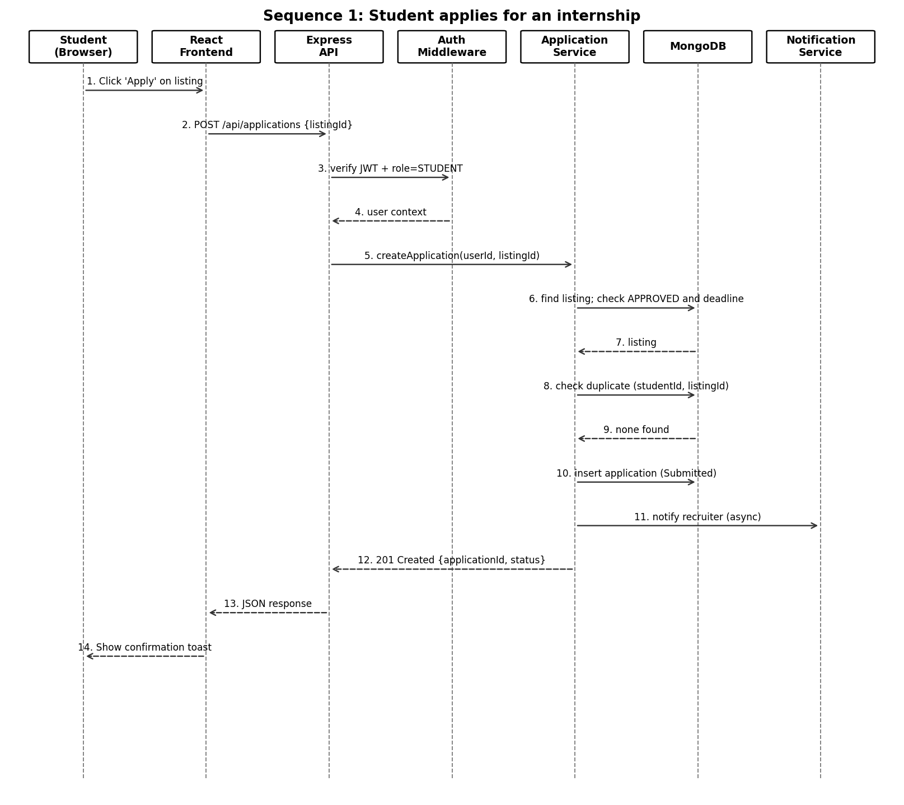
Figure 2: Sequence diagram - student applies for an internship
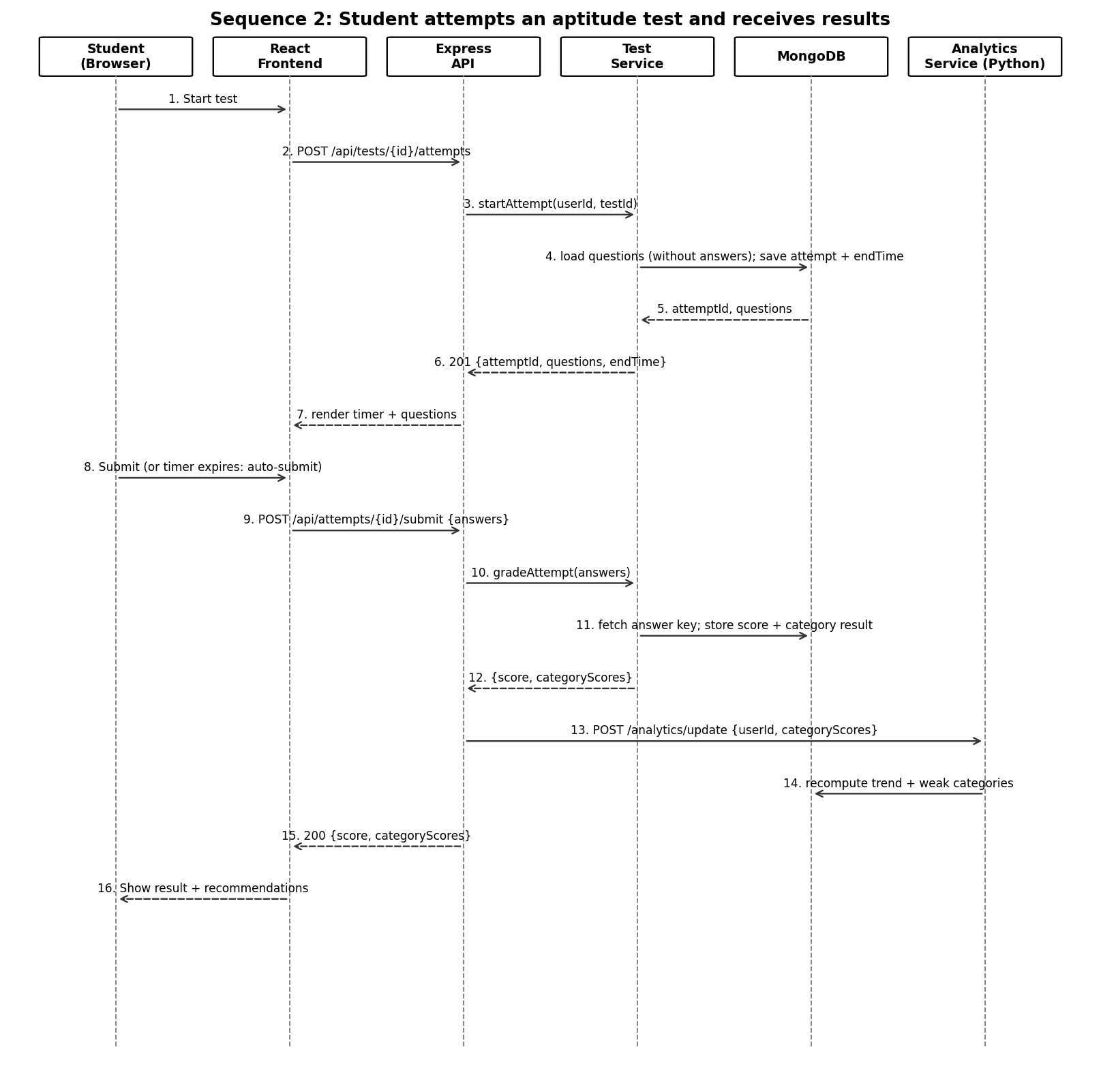
Figure 3: Sequence diagram - aptitude test attempt and results

4.3 API Design
All endpoints use JSON over HTTPS and (except register/login) require the header Authorization: Bearer <JWT>.

Auth API
Endpoint | Method | Request | Response | Errors
/api/auth/register | POST | {name, email, password, role} | 201 {userId} | 400 invalid input, 409 email exists
/api/auth/login | POST | {email, password} | 200 {token, role, expiresIn} | 401 invalid credentials, 423 account locked

Internship API
Endpoint | Method | Request | Response | Errors
/api/internships | GET | query: q, skill, location, mode, minStipend, maxStipend, page | 200 {items[], page, total} | 400 invalid filter
/api/internships | POST (Recruiter) | {title, company, description, skills, stipend, location, mode, deadline} | 201 {id, status: Pending} | 400, 403
/api/internships/{id}/review | PATCH (Admin) | {decision, remark} | 200 {id, status} | 403, 404

Application API
Endpoint | Method | Request | Response | Errors
/api/applications | POST (Student) | {listingId} | 201 {applicationId, status: Submitted} | 400 no resume, 403, 404, 409 duplicate, 410 deadline passed
/api/applications/mine | GET (Student) | - | 200 {items[]} | 401
/api/applications/{id}/status | PATCH (Recruiter) | {status} | 200 {id, status} | 403, 404, 422 invalid transition

Test API
Endpoint | Method | Request | Response | Errors
/api/tests/{id}/attempts | POST (Student) | - | 201 {attemptId, questions[], endTime} | 403, 404, 409 active attempt exists
/api/attempts/{id}/answers | PUT | {answers[]} | 204 | 403, 410 attempt closed
/api/attempts/{id}/submit | POST | {answers[]} | 200 {score, categoryScores} | 403, 404, 409 already submitted

Analytics API (internal, Python)
Endpoint | Method | Request | Response | Errors
/analytics/update | POST | {userId, categoryScores} | 202 accepted | 422 invalid body
/analytics/students/{id}/summary | GET | - | 200 {trend[], categoryScores, recommendations[]} | 404

4.4 Error Handling, Logging & Monitoring
- Standard error body: {error: {code, message, details?}} with correct HTTP status (400, 401, 403, 404, 409, 410, 422, 423, 429, 500).
- Central Express error handler; no stack traces or internal details returned to clients.
- Logs (winston/pino) in structured JSON with request ID; passwords, tokens and resume content are never logged.
- Audit log for security-relevant events (PIP-S-007, PIP-F-022).
- Monitoring: API latency percentiles, error rate, analytics service health check, uptime checks and alerts.

4.5 UX Design
- Responsive layout from 360 px; accessible contrast and labelled form fields.
- Role-based dashboards; search with clear filters; application status shown as coloured badges with text.
- Test screen: countdown timer, question navigator, autosave indicator, confirmation before submit.

4.6 Open Issues & Next Steps
- Choice of file storage (local volume vs object storage) to be finalised.
- Future enhancements: resume parsing and scoring, interview scheduling,
- Creating the application further on.

5. Appendices
5.1 Glossary: MERN, JWT, RBAC, REST, ADR, TLS, STRIDE (see SRS Appendix A).
5.2 References: IEEE 42010, OWASP ASVS, NIST SP 800-160.
5.3 Tools: draw.io / PlantUML for diagrams, Postman / Swagger for API documentation.

