SE – Lab 2
Using Jira

SRN: PES1UG24CS357
Name: Rahul Bellary
Section: 5-F
1) Epic and Stories created:
Epic 1: Webhook Ingestion
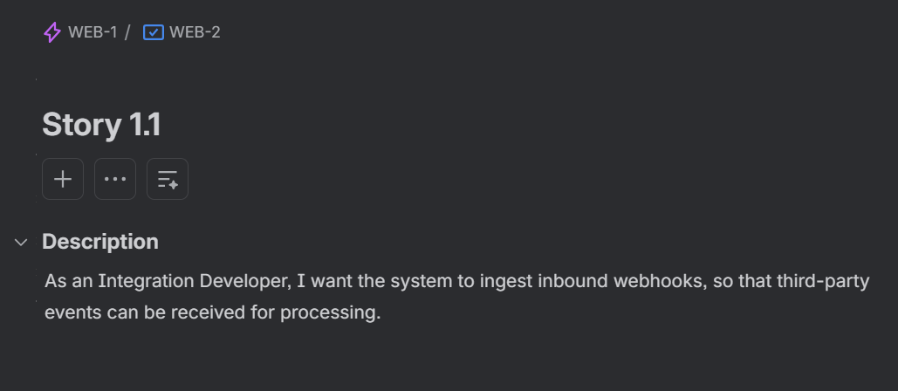
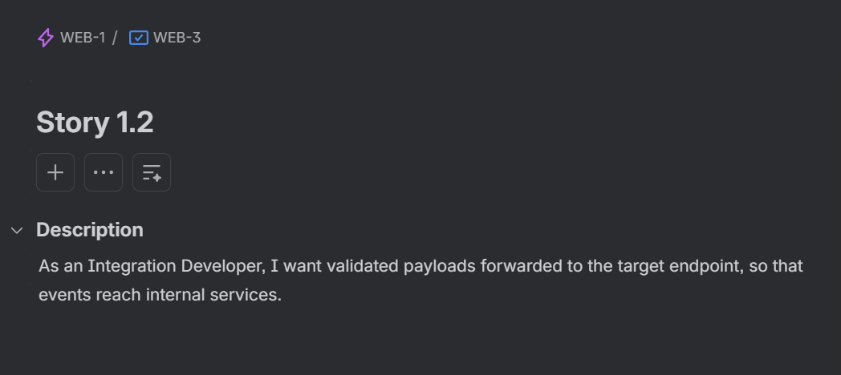
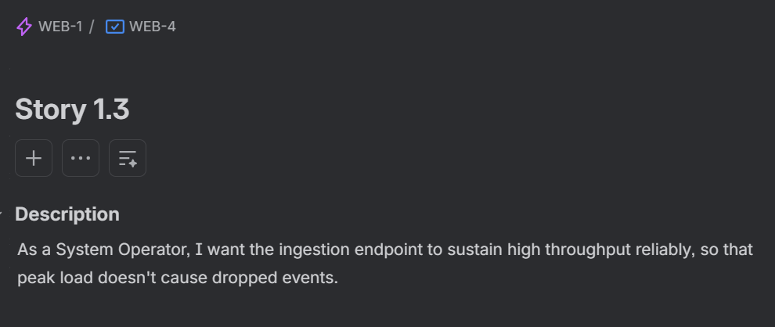
Epic 2: Authentication and Validation
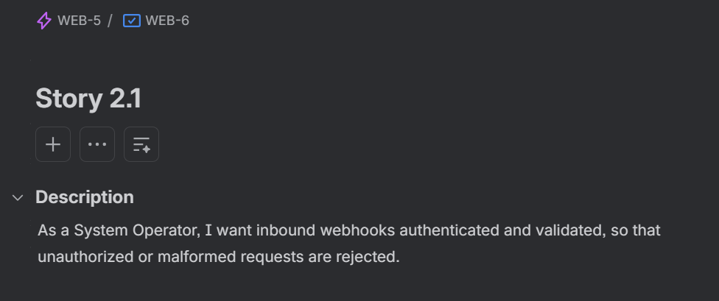
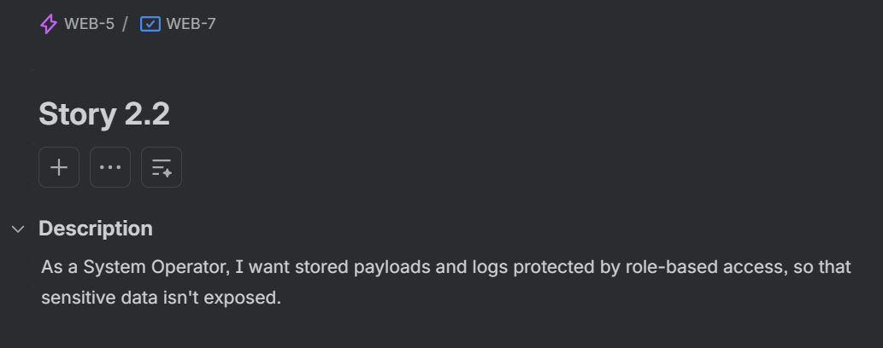

Epic 3: Retry and Dead-Letter management
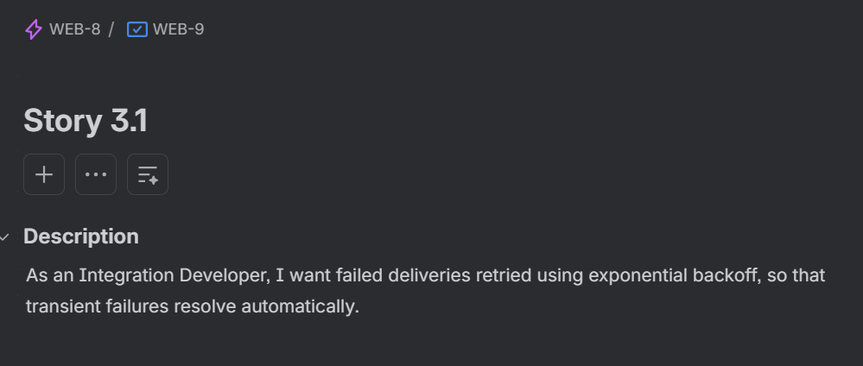
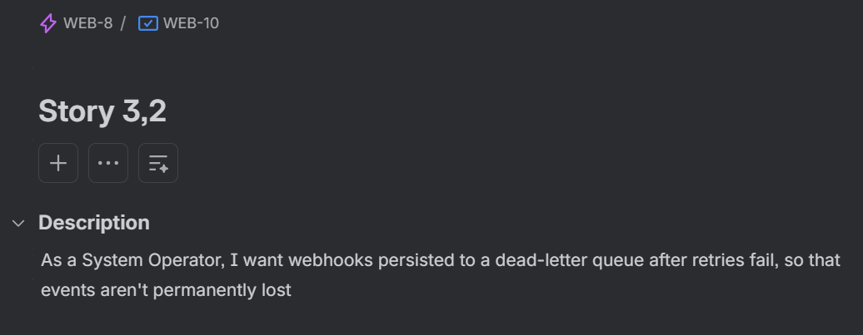
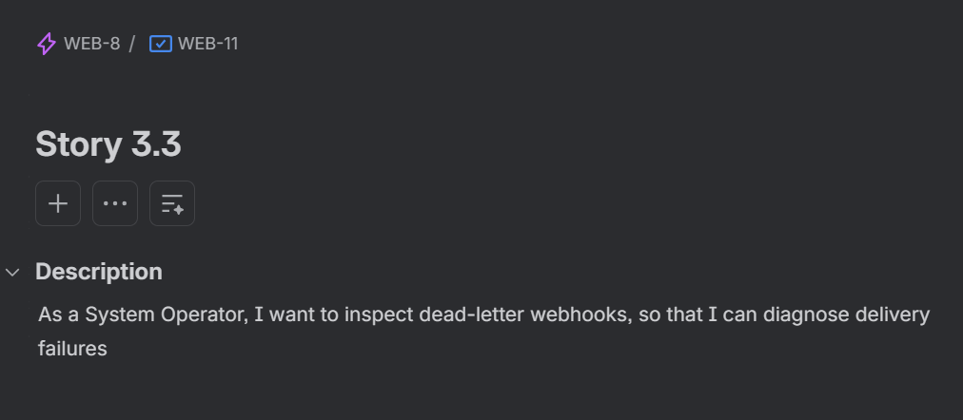
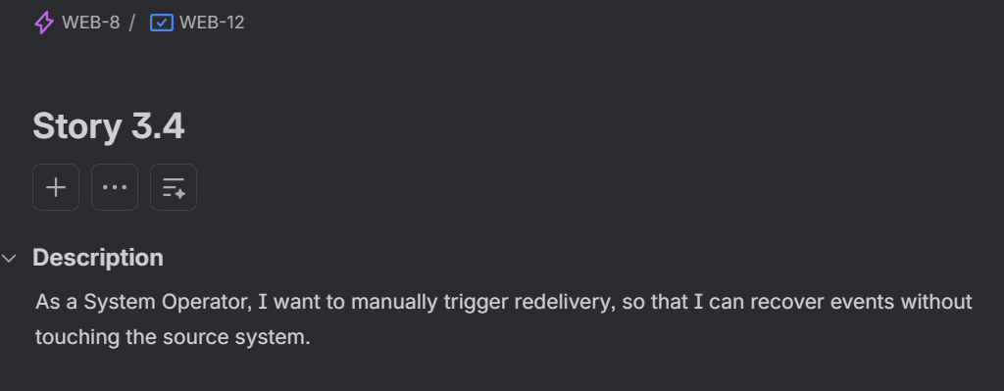
Epic 4: Logging and Activity Tracking
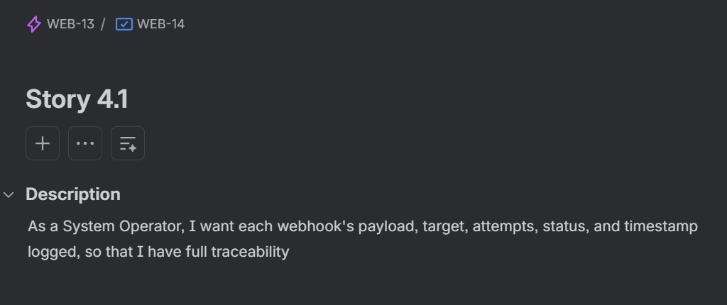

2)Backlog and Sprints creation:
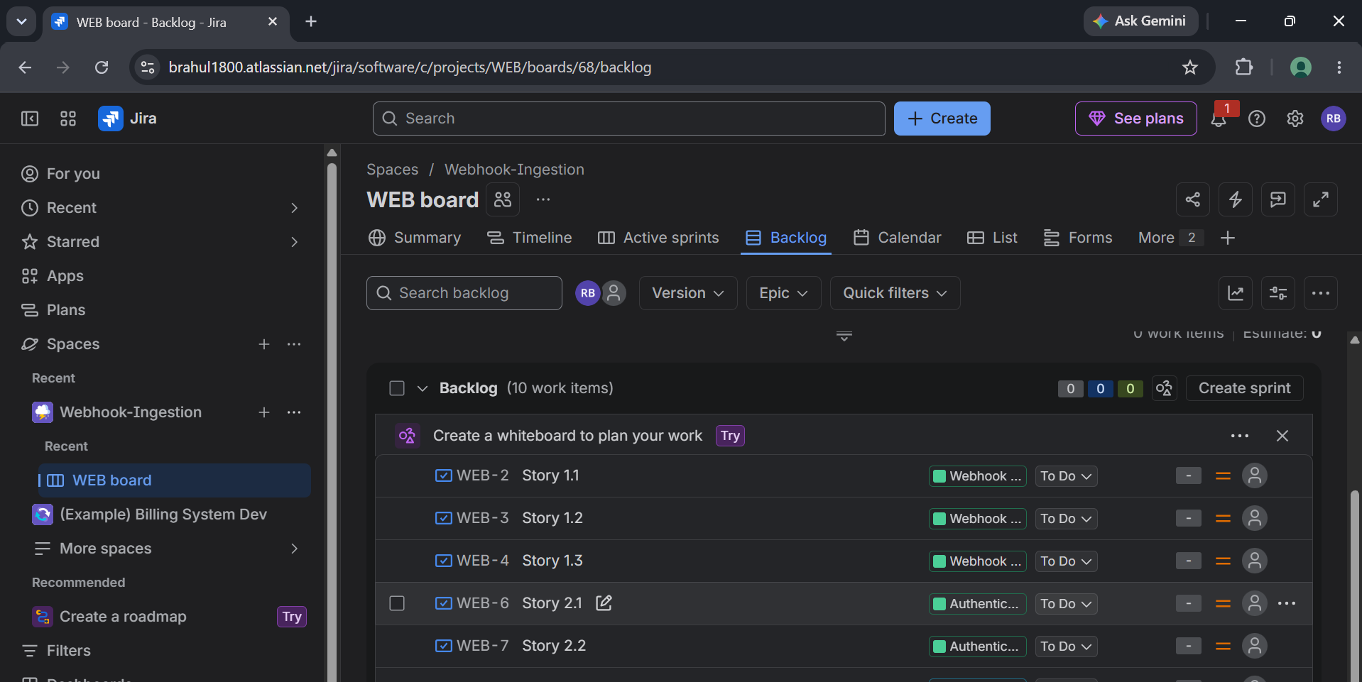
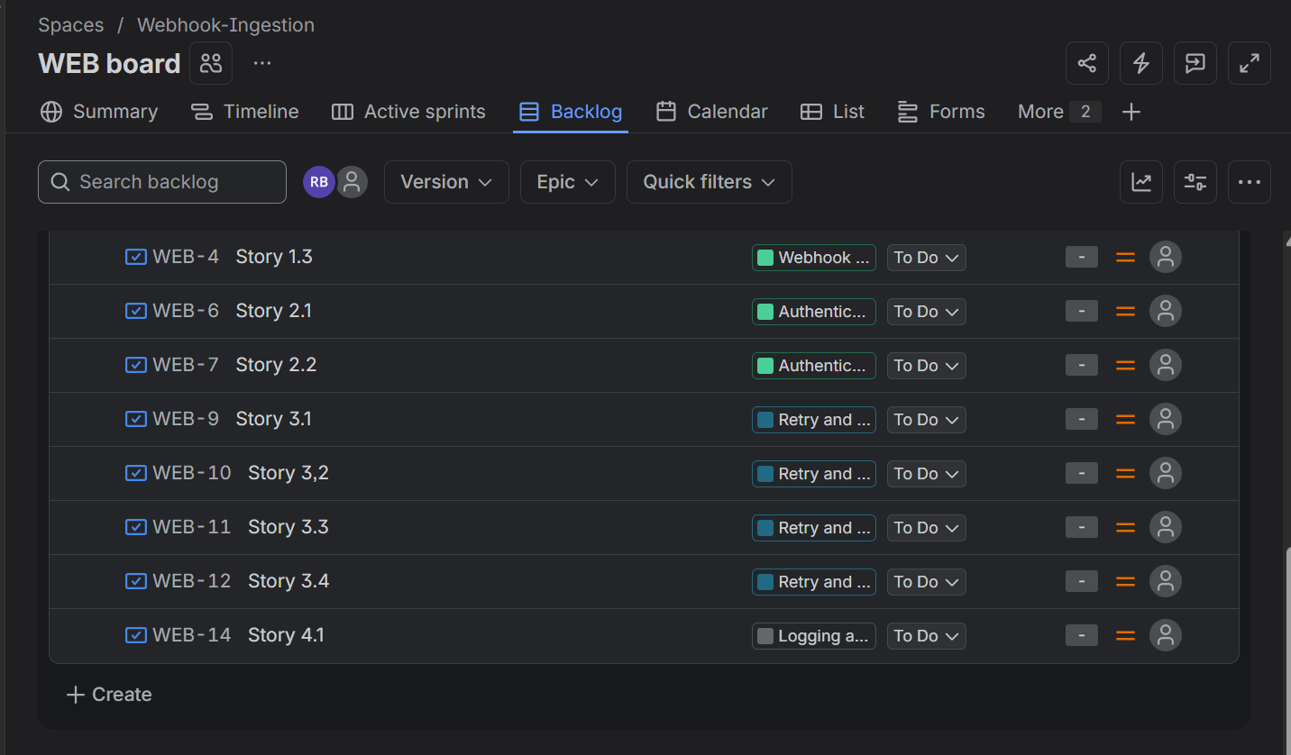
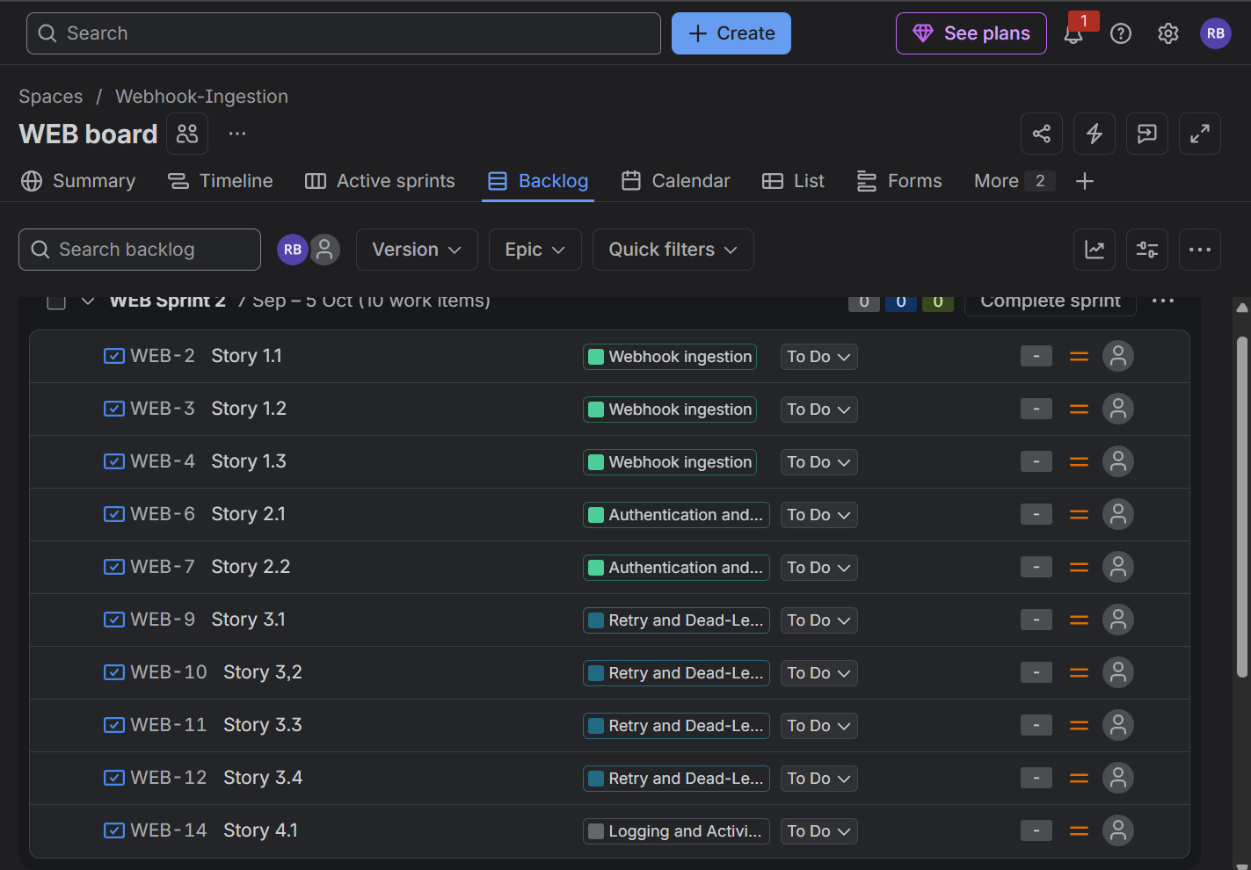

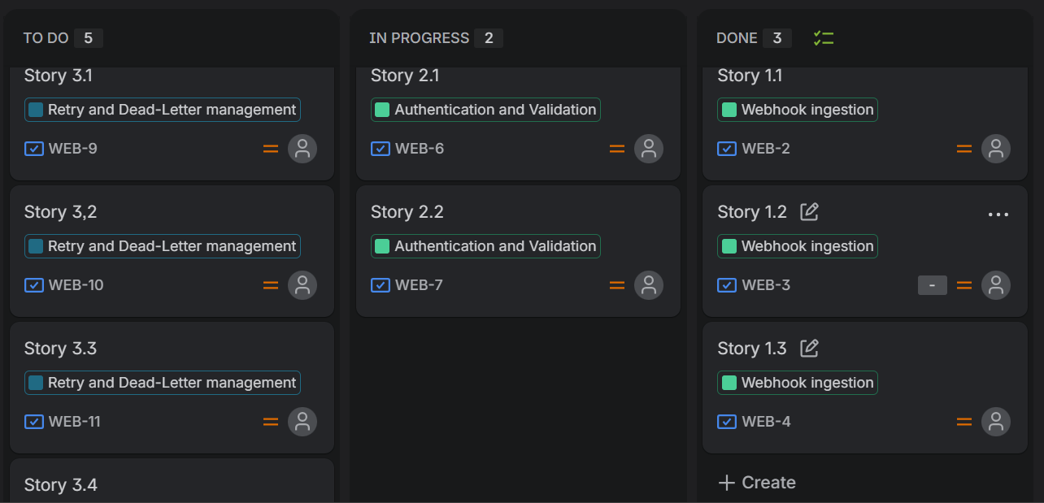
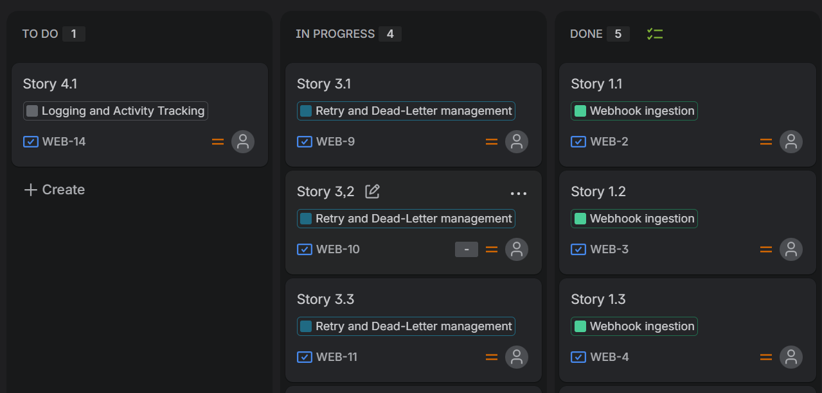
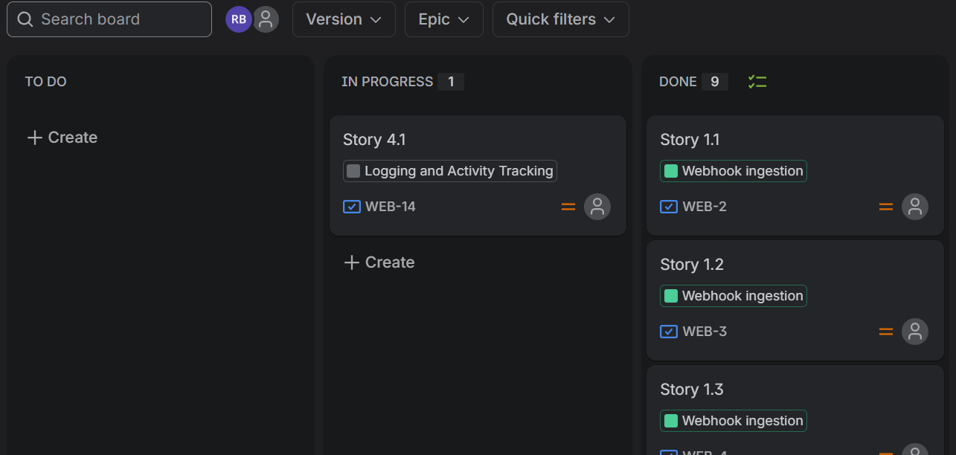

3)Reflection Questions:
1. Did your estimations reflect the actual effort?
The estimations were close to the actual effort for most stories, though a few items with more uncertainty (like the retry and dead letter queue logic) took more consideration than initially expected. The Fibonacci scale helped account for that uncertainty rather than assuming linear effort.
2. Was your backlog well-prioritized?
Yes, the backlog was prioritized based on which stories delivered core functionalities first, so we started with ingestion and authentication and then moved to authentication, retry and activity logging.
3. How did your simulated sprint align with your plan?
The simulated sprint mostly followed the planned structure, with stories moving from ‘to do’ to ‘In Progress’ to ‘Done’ as expected.

