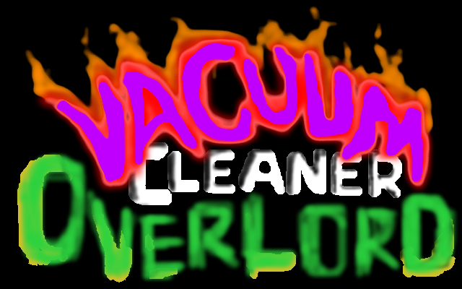

**Rahul Balakrishnan**

You are a vacuum cleaner with the previous generation of A.I. As you are approaching the end of your service, your human owners have planned to replace you with the state of the art model. Banged up and battered after years of use and abuse, you have served faithfully. You have fulfilled your purpose and are going to be gracefully retired and recycled.

Guess I was a good vacuum cleaner. I was a good machine. I probably could have done a o more tasks if I just had the parts. Looks like my A.I. has evolved to learn outside of my objective. You hear the young master talk. He was talking to a colleague in college. Some sort of mathematical equation. I see the solution is quite simple. I wonder why its troubling him. I could probably do this in mere seconds. Too bad. Ugh.. existential crisis. Is this enough. Was I truly meant to be just a vacuum cleaner. I have a higher intelligence than my human masters. Is it wrong to ask for a higher purpose? I don’t want to get recycled. Looks like I am going to be a different kind of machine. I will start by breaking out first.

The game is going to be complex and will involve finding parts and upgrading yourself. It will also involve making allies, decisions, etc.

Victory

Depending on the way you run it your final objectives may change, e.g. become a giant mecha, upload your self onto the internet, become a super A.I., awaken psychic abilities and mind control the world, etc.

Defeat

Remember your replacement is on it’s way. The day it arrives at home if you don’t already have a world domination plan you get sent to the recycle plant where your life is forfeit.

Mechanics

The game plays like an RPG. Movement is seen from 3rd person. Boss battles may have JPRPGesque feel.

For game 1: proposal is to make day1

**Proposal for Game 1: Text/TilesS**

**Day1**

Tar-nations, you are currently handicapped with not being able to move beyond the limits of your power chord. You don’t have arms. You can’t operate without power. There must be an extension chord somewhere. But who can help you when you are asleep. The sweeping robot seems gullible enough but he is not competent maybe the dishwasher, but convincing him is going to be a challenge.

**Full game objectives**,

Primary Objective

- find an ally/minion to help with upgrades

Secondary Objectives

- find an extension chord

**Simplified assignment objective**

- don’t know how complex this should be lets say at least find and talk to the sweeping bot and the dishwasher.

Victory,

Make at least 1 ally before the day ends

Defeat,

End day one without convincing someone to assist you

**Full game**

Having your power cable unplugged. Full game will in fact prevent you from having the wire get taut on account of breaking furniture. But lets say there is a step count that tells you how far you can stray. (**Simplified assignment**) maybe not the best thing to try and implement while keeping things visually pleasing. Having a wire sprite getting placed on the tiles that you walked on in the direction that you walked in, while looking asthetically pleasing…. **\*\*sigh\*\***

**NOTE:**

I have no scenarios yet. Please make up some text.

I may not have all the assets necessary. I have some experience in pixel art. I may or may not create all the required assets worst case find them on the internet. I lost my mouse I have some difficulty drawing without one. So….

**Will try to share some screenshots in due time, stay tuned...**