Nike Sales Dashboard
Data Summary & Insights
Prepared from the supplied Excel dataset and dashboard screenshots

1. Data Summary
The source workbook contains 2,500 rows and 13 columns. The cleaned workbook retains all rows and original business fields, standardizes inconsistent region labels, normalizes text spacing/capitalization, converts Order_Date to a date field, and keeps missing values blank rather than filling them with assumptions.
- Total recorded Revenue: 687,184.29.
- Total recorded Profit: 3,440,032.12; this should be validated because profit is unusually large compared with revenue.
- Recorded Units_Sold sum: 1,875, but 1,235 rows have no units value, so this is not a complete total.
- Missing values: Size 510; Units_Sold 1,235; MRP 1,254; Discount_Applied 1,668; Order_Date 616.
- Region labels were consolidated to 6 standard regions; for example, Bangalore/Bengaluru and Hyd/Hyderabad/Hyderbad were merged.
- No exact duplicate rows were found in the source data.

2. Key Insights
- Online is the largest revenue channel at 378,183.10 (55.0% of recorded revenue), compared with Retail at 309,001.19 (45.0%).
- Men is the highest-revenue gender category at 261,454.48, followed by Women at 232,600.58 and Kids at 193,129.23.
- After region cleanup, the data contains 6 consistent region labels. The dashboard’s original region chart uses inconsistent labels, so it should be refreshed from the cleaned data before making regional comparisons.
- The monthly revenue screenshot suggests a period of higher revenue around late 2024 to mid-2025, but the trend should be rebuilt after checking missing dates and confirming the date hierarchy and aggregation.
- The screenshot’s chart title mentions both Revenue and Count of Profit, while the visible series appears to show Revenue only. Correct the visual title/field setup so it accurately describes what is plotted.
- Units sold and date-based insights are limited by missing data. Avoid treating the current units chart or monthly trend as complete until these gaps are reviewed.
- Validate the Profit field and its definition: the dataset’s total recorded Profit is much larger than total Revenue, which may reflect a data-definition issue or incorrect values.

3. Dashboard Screenshots and Interpretation

Dashboard 1 — Revenue by Sales Channel
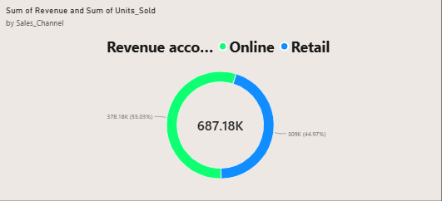
Online contributes approximately 378.18K (55.03%) and Retail approximately 309.00K (44.97%) of the 687.18K total shown. This indicates Online is the larger revenue channel in the current dataset.

Dashboard 2 — Revenue Trend by Date
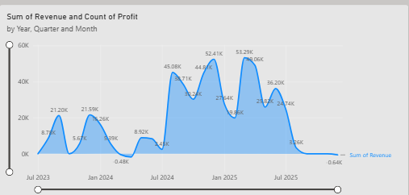
The chart shows uneven monthly revenue with visible peaks around late 2024 and early 2025. Confirm date completeness, monthly grouping, and the series/title configuration before using this as a final trend finding.

Dashboard 3 — Units Sold by Region
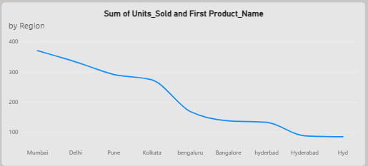
The original visual lists duplicate spellings for Bengaluru/Bangalore and Hyderabad/Hyd/Hyderbad. Standardize these labels and rebuild the chart. Units_Sold has many missing values, so comparisons are partial.

Dashboard 4 — Revenue by Gender Category
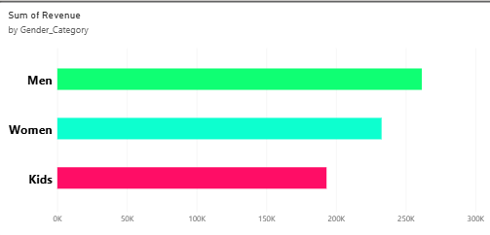
Men has the highest recorded revenue (about 261.45K), followed by Women (about 232.60K) and Kids (about 193.13K). This can guide category-level sales review, but does not explain profitability or customer-level demand.
4. Key insights included in the report
- Sales channel: Online revenue is 378.18K (55.03%), while Retail revenue is 309.00K (44.97%).
- Gender category: Men generates the highest recorded revenue at approximately 261.45K, followed by Women at 232.60K and Kids at 193.13K.
- Regional data: Inconsistent names such as Bangalore/Bengaluru and Hyd/Hyderabad/Hyderbad need to be standardized before comparing regional performance.
- Monthly trend: The revenue chart shows fluctuations and several peaks, but missing dates should be investigated before drawing firm conclusions.
- Data quality: Missing Units_Sold, MRP, discounts, dates, and sizes may affect analysis. Profit values also require validation.
.

