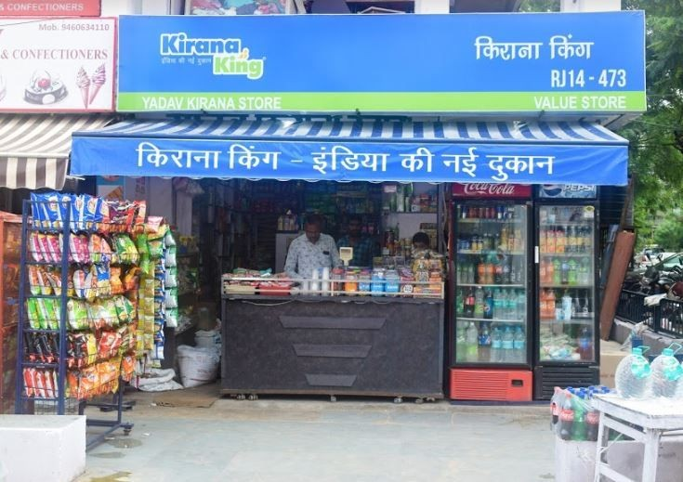
Question 1 - I'm standing in front of this store it’s a closed counter in my area, I think its average order values could be 12.5k help me with closest match to this store and how should I approach it?

Hello Amit, it's great that you're proactively identifying potential new partnerships! Let's analyze the store you're looking at and find the best match in our database.
Based on your description of a "closed counter" with an estimated average order value of "12.5k" (INR 12,500), and examining the provided image which clearly shows a traditional 'Kirana Store' setup with a counter, displaying "Yadav Kirana Store" and "VALUE STORE" branding, I've identified a strong match in our system.
Closest Store Match
The store that closely aligns with your observations is:
- Store ID: STR_007
- Store Name: Classic Emporium
- Store Type: Closed Counter (Direct match with your description)
- Location: Saraba Nagar (Within your assigned area)
- Average Monthly Order Value (AMOV): INR 11,645.25
- Growth Rate Percentage: 5.82%
- Segmentation: Mass Market (Aligns well with the "VALUE STORE" indication on the signboard)
- Last Audit Date: 2026-04-10
- Latest Sales (Mar 2026): INR 11,701 (117 orders)
While our database also has "Metro Store" (STR_041) which is a "Kirana Store" with an AMOV of INR 11,869.25 (numerically slightly closer to your 12.5k estimate), "Classic Emporium" (STR_007) is a direct match for "Closed Counter" store type and its "Mass Market" segmentation is more consistent with a "VALUE STORE" seen in the image. The difference in AMOV is minimal (INR 11,645.25 vs. your 12,500 estimate), making STR_007 a very robust match.
How to Approach "Classic Emporium" (STR_007)
Based on the data for Classic Emporium, here's how you should approach it:
- Acknowledge and Validate:
  - Confirm AOV: You've estimated 12.5k. Our data shows an average of INR 11,645.25. This is a very close estimate! During your visit, you can subtly validate their actual current average order value to ensure alignment.
  - Store Type: Reiterate that this store's "Closed Counter" format is a common and vital part of the local retail ecosystem, and we understand its unique operational needs.
- Deep Dive into Sales Trends:
  - Orders vs. Value Discrepancy: This is a critical point of discussion. Observe the monthly sales history:
    - Dec 2025: Sales: INR 11,058, Orders: 31 (Avg. order value: ~INR 356)
    - Jan 2026: Sales: INR 11,695, Orders: 41 (Avg. order value: ~INR 285)
    - Feb 2026: Sales: INR 12,127, Orders: 97 (Avg. order value: ~INR 125)
    - Mar 2026: Sales: INR 11,701, Orders: 117 (Avg. order value: ~INR 100)
  - Notice the significant increase in orders_count from 31 to 117, while sales_value_inr has remained relatively stable (even with a slight dip in March compared to February). This indicates a drastic decrease in the average value per order. This is a major opportunity area.
- Key Discussion Points & Strategy for Visit:
  - Understand Customer Behavior: Inquire about recent changes in customer purchasing patterns. Are customers buying more frequently but smaller quantities?
  - Product Mix Optimization: Discuss their current product offerings. With a "Mass Market" segmentation, they likely cater to daily needs.
    - Are they stocking enough mid-to-high margin products to balance the high volume of low-value orders?
    - Identify opportunities for bundling products or promoting larger pack sizes to increase the average ticket value.
    - Check for stock availability on popular, slightly higher-priced items.
  - Merchandising for Closed Counter: For a closed counter, visibility of products, especially impulse buys near the counter, is crucial. Offer suggestions for optimizing product placement to encourage upsells and cross-sells.
  - Promotional Strategies: If the increase in order count is due to promotions, evaluate their effectiveness. Are these promotions driving profitable growth or just increasing footfall for low-margin items?
  - Leverage Positive Growth: The store shows a healthy growth_rate_percentage of 5.82%. Emphasize that by addressing the average order value per transaction, this growth can be significantly amplified, leading to substantial overall revenue increase.
  - Build Relationship: Position yourself as a partner to help them grow their business, focusing on profitability per transaction rather than just transaction volume.
By focusing on these points, you can turn the current sales pattern into a strategic opportunity for significant revenue growth for Classic Emporium, and strengthen our partnership. Good luck!

Q2. Hi

Hello! As Area Sales Officer Vikram Singh, I'm here to assist you. I have access to our internal database of retail stores.
How can I help you today? Would you like to know more about the stores under my management, their performance, or any other details from the database?
Q3. Tell me about my area

Hello Vikram, let's take a detailed look at your area based on the latest database snapshot.
As Area Sales Officer (ASO_03), you are currently managing a diverse portfolio of 21 retail stores.

Area Overview for Vikram Singh (ASO_03)
Here's a snapshot of your area's performance and composition:
- Total Stores Managed: 21
- Average Monthly Order Value (Across all stores): Approximately INR 179,760
- Average Growth Rate (Across all stores): Approximately 4.48%
- Last Audit Date for all stores in your area: 2026-04-10

Distribution by Location
Your stores are distributed across three primary locations:
- Cyber City: 8 stores
- Sector 17: 7 stores
- DLF Phase 3: 6 stores

Store Type Breakdown
Your area features a mix of store types, indicating a varied retail landscape:
Store Type | Number of Stores | Average Monthly Order Value (INR) | Average Growth Rate (%)
Hypermarket | 6 | 492,347 | 4.96
Supermarket | 4 | 119,305 | 3.27
Kirana Store | 6 | 18,437 | 7.86
Mid-Size Store | 2 | 63,500 | 4.96
Self-Assisted Store | 2 | 40,475 | 7.67
Closed Counter | 1 | 28,500 | 3.70

- Hypermarkets are your largest contributors by volume, with a robust average monthly order value and healthy growth.
- Kirana Stores show the highest average growth rate among store types, suggesting good potential, despite lower individual order values.

Segmentation Insights
Your portfolio covers all segmentation types:
Segmentation | Number of Stores | Average Monthly Order Value (INR) | Average Growth Rate (%)
Premium | 8 | 248,829 | 2.83
Discount | 4 | 170,320 | 6.19
Mass Market | 4 | 149,007 | 5.66
Value | 5 | 19,039 | 7.62
- Premium stores make up a significant portion of your portfolio (8 stores) and contribute heavily to the overall volume. However, their average growth rate is lower than Discount, Mass Market, and Value segments.
- Discount, Mass Market, and Value segments show higher average growth rates, indicating good momentum in these areas.

Key Performers & Areas for Focus
Top Performing Stores (by Avg. Monthly Order Value):
- STR_060 Metro Emporium II (Hypermarket, Sector 17): INR 530,000 AMOV, 2.94% Growth
- STR_028 Skyline Traders (Hypermarket, Cyber City): INR 520,000 AMOV, 2.00% Growth
- STR_004 Sunrise Traders (Hypermarket, Cyber City): INR 490,657 AMOV, 9.69% Growth (Excellent growth!)
- STR_038 Standard Provisions (Hypermarket, Sector 17): INR 490,000 AMOV, 4.26% Growth
Stores with Highest Growth Potential:
- STR_045 Vikas Bazaar (Self-Assisted Store, DLF Phase 3): 14.50% Growth
- STR_051 Quick Stop (Kirana Store, DLF Phase 3): 13.33% Growth
- STR_059 Quality Link (Kirana Store, DLF Phase 3): 10.34% Growth
- STR_004 Sunrise Traders (Hypermarket, Cyber City): 9.69% Growth
Stores Requiring Immediate Attention (Negative/Low Growth):
- STR_001 Classic Retail (Hypermarket, Cyber City): -6.88% Growth. This store has a high average monthly order value (INR 475,973) but is experiencing significant negative growth. This should be a top priority for investigation and intervention.
- STR_017 Bharat Dukan (Kirana Store, Cyber City): 0.31% Growth
- STR_009 City Superstore (Supermarket, Sector 17): 0.80% Growth
- STR_011 Global General Store (Self-Assisted Store, Sector 17): 0.83% Growth

Summary & Recommendations
Vikram, your area is robust with a strong presence of Hypermarkets contributing substantially to overall sales volume. The Kirana, Discount, Mass Market, and Value segments show promising growth trends.
Key Action Points:
- Address Classic Retail (STR_001): The negative growth rate for this high-value Hypermarket is a critical concern. Understanding the underlying issues and implementing corrective measures should be your immediate focus.
- Nurture High-Growth Stores: Investigate the success factors behind stores like Vikas Bazaar (STR_045), Quick Stop (STR_051), Quality Link (STR_059), and Sunrise Traders (STR_004) to replicate best practices across other stores, especially within their respective segments and locations.
- Monitor Low-Growth Stores: Keep a close eye on Bharat Dukan (STR_017), City Superstore (STR_009), and Global General Store (STR_011) to understand why their growth is lagging and explore strategies to boost their performance.
This overview should help you strategize your visits and efforts more effectively. Let me know if you need to drill down into specific stores or want to explore other metrics!

