1. **Introduction**

Route optimization is a critical aspect of transportation, logistics, and delivery systems. Several studies have explored different algorithms and techniques for optimizing routes, but there are still gaps that need further research. This gap analysis identifies the limitations in existing research and suggests possible areas for improvement.

**2. Literature Survey Summary (Existing Research)**

A detailed literature review on route optimization reveals that various methods have been used:

✅ Graph-Based Algorithms

**🚧 1. Dijkstra’s Algorithm : 🗺️**

📌**Working**:

It works step by step, always picking the next closest node and updating

distances until it finds the shortest route to the destination..  
📌 **Advantages**:

Guarantees the absolute shortest path in graphs

📌**Limitations**:

Doesn’t account for real-time factors like traffic or weather

📌 **Example**:

GPS systems.

**🚧 2. *A*\* Algorithm : 🎯**

📌**Working**:

A* builds on Dijkstra’s approach but adds a smart guess (heuristic function) to

prioritize nodes that seem more promising. This makes it faster.

📌 **Advantages**:-

More efficient than Dijkstra’s for large graphs.

📌**Limitations**:-

The effectiveness depends on the heuristic function

📌 **Example**:

Used in video games for pathfinding

✅ Metaheuristic Approaches

**🚧 1. Genetic Algorithm (GA) : 🧬**

📌**Working**:

Inspired by natural selection, GA starts with multiple possible solutions

(routes), then improves them through processes like crossover (mixing solutions) and

mutation (random changes) to evolve towards an optimal route.

📌 **Advantages**:-

Self-Improving Over Time

Adapts to Changing Conditions(like traffic or demand)

📌**Limitations**:-

Computationally expensive for large datasets.

📌 **Example**:

Used in logistics to optimize delivery routes.

**🚧 2. Ant Colony Optimization (ACO) : 🐜**

📌**Working**:

Based on how ants find food, ACO uses simulated "pheromones" that guide the search

for the best routes. Over time, the shortest path becomes the most attractive.

📌 **Advantages**:-

Works Well for Large Search Spaces

Finds Near-Optimal Solutions

📌**Limitations**:-

Can be slow for large problems.

Requires careful tuning of parameters (like how fast pheromones evaporate).

📌 **Example**:

Used in network routing problems..

✅ Artificial Intelligence & Machine Learning

🚧 **1. Neural Networks (NNs): 🧠**  
 📌 **Working:**

Learn from past data to predict optimal routes. They identify

patterns and can adapt to real-world conditions like traffic, weather, and delivery

schedules.  
 📌 **Advantages:**

Suitable for real-time predictions in dynamic environments.

📌 **Limitations:**

Requires large datasets for training.

Computationally expensive to train and deploy.

📌 **Example:** Used in predictive routing for delivery systems.

🚧 **2. Reinforcement Learning (RL): 🎮**  
 📌 **Working:**

RL learns optimal routing strategies through trial and error. An agent interacts

with an environment, receives rewards or penalties, and gradually improves decision-

making.  
 📌 **Advantages:**

Adapts to dynamic and uncertain environments.

📌 **Limitations:**

Requires significant computational resources and time to train.

May struggle with environments that have sparse rewards.

📌 **Example:** Used in autonomous vehicles

✅ Real-World Applications & APIs

🚧 **1.** **Google Maps API: 🚗**  
 📌 **Working:**

Google Maps API provides real-time traffic data, route planning, and

navigation using a combination of algorithms (like Dijkstra’s, A*) and live data.  
 📌 **Advantages:**

Provides real-time traffic and route updates.

Easy to integrate into applications with robust documentation.  
 📌 **Limitations:**

Limited customization for specific logistics needs.

Requires an internet connection and API usage fees.

📌 **Example:** Used in ride-sharing apps like Uber

🚧 **2. OpenStreetMap (OSM): 🌐**  
 📌 **Working:**

OpenStreetMap is an open-source mapping platform that provides map data for

route optimization. Algorithms like Dijkstra’s or A* can be applied to OSM data for

navigation.  
 📌 **Advantages:**

Free and open-source, with no API costs.

Highly customizable for specific applications.

📌 **Limitations:**

Data quality and coverage may vary by region.

Requires additional development to integrate real-time data.

📌 **Example:** Helps in ride-sharing services and also Supports offline navigation 🚀

.

**

**Neural Networks**

**Google Maps API**

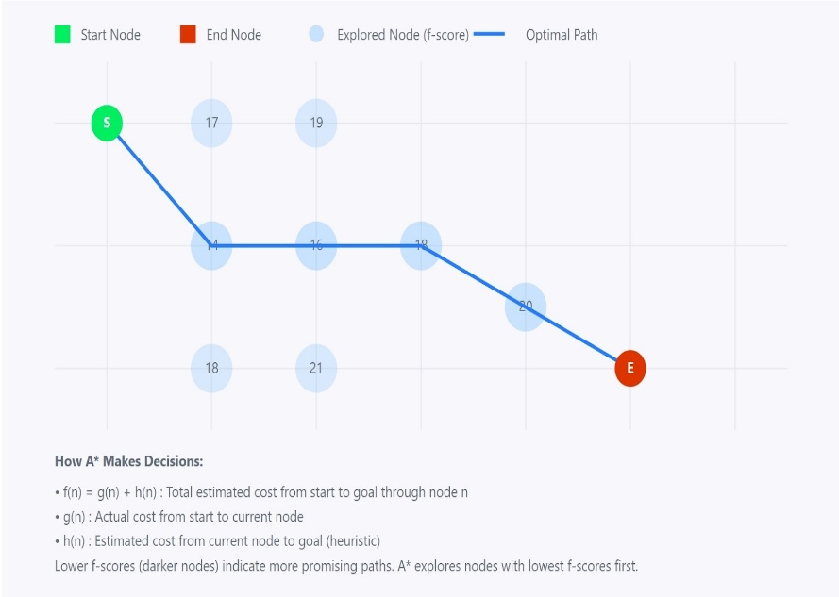

**A* algorithm**

**3. Identified Gaps in Existing Research :**

Even though route optimization has been extensively studied, the following gaps remain:

**🚧 1. Lack of Real-Time Dynamic Routing :**

📌 **Problem**: Most existing models focus on static route optimization, assuming fixed road conditions.  
📌 **Gap**: **Limited research on dynamically adjusting routes based on live traffic, roadblocks, and weather conditions.**  
📌 **Example**: Delivery companies need real-time adjustments for delays due to traffic congestion or accidents.

**🚧 2. Multi-Modal Route Optimization is Underdeveloped :**

📌 **Problem**: Most studies focus on single transport modes (cars, trucks, or public transport).  
📌 **Gap**: **Limited research on integrating multiple transport modes (buses, bicycles) into one optimized route.**  
📌 **Example**: A traveler using a combination of metro and cab for a daily commute needs a unified optimized route.

**🚧 3. Environmental & Fuel Efficiency Not Prioritized :**

📌 **Problem**: Algorithms optimize for shortest distance or fastest route, but rarely consider fuel efficiency or environmental impact.  
📌 **Gap**: **Limited studies on optimizing routes to reduce fuel consumption and carbon footprint.**  
📌 **Example**: Logistics companies need eco-friendly routes that balance fuel costs and delivery time.

**🚧 4. AI-Based Personalized Route Optimization is Limited**

📌 **Problem**: Most models use general parameters for all users.  
📌 **Gap**: **Minimal research on personalized route optimization based on user behavior, preferences, and past routes.**  
📌 **Example**: A taxi service that learns a driver's preferred routes and optimizes accordingly.

🚧 **5. Single Source, Multiple Destination Optimization is Complex :**

📌 **Problem**: Existing algorithms often struggle with optimizing multiple destination routes efficiently.  
📌 **Gap**: **Limited research on efficient algorithms that handle multiple destinations from a single source while minimizing total travel time and cost.**  
📌 **Example**: A courier service that needs to deliver multiple packages from a warehouse to different locations with optimal fuel and time management.

🚧 **6. Time-Window Constraints in Route Optimization :**

📌 **Problem**: Some deliveries or transport routes require specific time windows, which are not always considered in optimization models.  
📌 **Gap**: **Limited research on incorporating strict delivery or pickup time constraints while still optimizing the route.**  
📌 **Example**: Food delivery services like Swiggy/Zomato need to deliver within 30 minutes, making time-sensitive routing crucial.

🚧 **7. Traffic & Weather-Adaptive Routing Still Needs More Precision:**

📌 **Problem**: While some studies focus on traffic-based route optimization, they do not factor in **unexpected events like weather changes, road closures, or accidents dynamically**.  
📌 **Gap**: **Need for advanced AI/ML models that adjust routes dynamically based on real-time external conditions.**  
📌 **Example**: A transportation fleet should automatically reroute based on sudden storms, flooding, or accidents.

**🚧 8. Multiple Source, Single Destination Optimization :**

📌 **Problem**: Existing models mainly focus on single-source routing, but real-world scenarios often require multiple starting points converging to one destination.

📌 **Gap**: Limited research on efficiently optimizing routes from multiple sources while minimizing time, cost, and distance.

📌 **Example**:

* **Ride-Sharing (Uber, Lyft)** → Multiple pickups to a single drop-off (e.g., airport).
* **Supply Chain** → Deliveries from multiple warehouses to a retail hub.
* **Emergency Services** → Ambulances from different locations reaching one hospital.

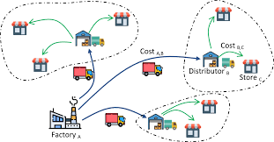

Multiple Source Single Destination

 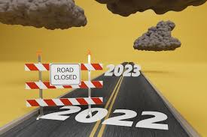

AI-Based Personalized Route Traffic & Weather-Adaptive Routing



Time-Window Constraints in Route Optimization

**4. Scope for Future Research :**

To bridge the existing gaps in route optimization, future research should focus on the following key areas:

✅ **Smart Route Adjustment in Real-Time :**

AI can help change routes instantly based on **live traffic, accidents, weather, and roadblocks**. This will improve **faster deliveries, emergency services, and daily travel**.

✅ **Using Different Transport Modes Together :**

A system that **combines cars, buses, metro, and bicycles** to give the best and most **affordable travel options** for users.

✅ **Eco-Friendly and Fuel-Saving Routes :**

AI can help find the best routes that **save fuel and reduce pollution** while still being **fast and efficient** for transport and delivery companies.

✅ **Routing in Remote & Unmapped Areas :**

AI-based maps can **predict and suggest routes** in places where **GPS data is unavailable**, helping **rural transport, emergency services, and deliveries**.

✅ **Personalized Route Suggestions :**

AI can **learn a person’s travel habits** and suggest the **best routes** based on **past preferences, shortcuts, and favorite roads** for taxis, deliveries, and commuters.

✅ **Better Multi-Stop Route Planning :**

New AI models can **optimize trips with multiple stops**, improving efficiency for **couriers, ride-sharing (Uber, Lyft), and supply chains**.

✅ **Routes That Adapt to Time & Weather :**

Smart AI can **re-route vehicles** when there are **storms, floods, or traffic jams**, helping services like **food delivery, logistics, and emergency response**.

Would you like a more **detailed explanation** of any specific point? 🚀

**5. References :**

**Dijkstra’s Algorithm**

* **Wikipedia**: [Dijkstra's Algorithm](https://en.wikipedia.org/wiki/Dijkstra%27s_algorithm)
* **GeeksforGeeks**: [Dijkstra’s Algorithm Explanation](https://www.geeksforgeeks.org/dijkstras-shortest-path-algorithm-greedy-algo-7/)

***A* Algorithm***

* **Wikipedia**: [A* Search Algorithm](https://en.wikipedia.org/wiki/A*_search_algorithm)
* **Red Blob Games**: [Introduction to A* Algorithm](https://www.redblobgames.com/pathfinding/a-star/introduction.html)

**Genetic Algorithm (GA)**

* **Towards Data Science**: [Introduction to Genetic Algorithms](https://towardsdatascience.com/introduction-to-genetic-algorithms-including-example-code-e396e98d8bf3)
* **Google OR-Tools**: [Vehicle Routing with Genetic Algorithms](https://developers.google.com/optimization/routing/vrp)

**Ant Colony Optimization (ACO)**

**Towards Data Science**: [Ant Colony Optimization Explained](https://towardsdatascience.com/ant-colony-optimization-in-python-4b7b6c1a0a0e)

**Neural Networks**

**Wikipedia**: [Artificial Neural Network](https://en.wikipedia.org/wiki/Artificial_neural_network)

**Reinforcement Learning (RL)**

* **OpenAI Gym**: [Reinforcement Learning Toolkit](https://www.gymlibrary.dev/)

**Google Maps API**

* **Google Maps Platform**: [Google Maps API Documentation](https://developers.google.com/maps/documentation)
* **Google Maps Directions API**: [Route Optimization with Google Maps](https://developers.google.com/maps/documentation/directions/overview)

**OpenStreetMap (OSM)**

* **OSRM (Open Source Routing Machine)**: [OSRM Documentation](http://project-osrm.org/)
* **Leaflet.js**: [Interactive Maps with OpenStreetMap](https://leafletjs.com/)
* **Dynamic and Predictive Routing:**

NextBillion.ai - Trends in Route Optimization .

Link : <https://www.mdpi.com/2071-1050/15/22/16128>

* **Multi-Modal Route Optimization:**  
  NextBillion.ai - Multi-Modal Transportation .

Link : <https://www.mdpi.com/2071-1050/15/22/16128>

* **Eco-Friendly & Fuel-Efficient Routing:**  
  MDPI - Green Vehicle Routing .

Link: <https://www.mdpi.com/2071-1050/15/22/16128>

* **AI-Based Personalized Route Optimization:**  
  [arXiv - AI in Route Recommendation](https://arxiv.org/html/2403.00284v2) .

Link: <https://arxiv.org/abs/2403.00284>

* **Time-Window Constraints in Routing:**  
  MDPI - Vehicle Routing with Time Windows

Link: <https://www.mdpi.com/2071-1050/15/15/12004>