**NLP on IMDB movie ratings using deep learning**

This project concentrates on classifying the movie ratings as “Best”, “good” or “bad” using NLP and Deep learning techniques. Text is the raw data available and we need to train the model using NLP techniques. As model has to remember previous review comments which are useful, I’m including LSTM(Recurrent neural Networks) in this. The whole code has been built in python using keras package.

**Step 1) Load the data set**

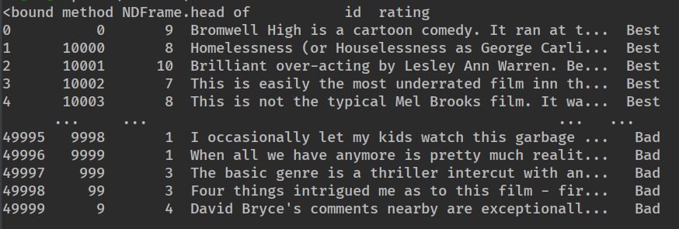

Data set contains

* Id – Unique id for each review
* Rating – Rating for that review
* Review – Review description
* Label – Defined by me as “Best” , “Good” and “Bad”.

(It was extracted from raw files and I converted it into a proper CSV for further uses).

**Step 2) Visualization**

Word count from each review

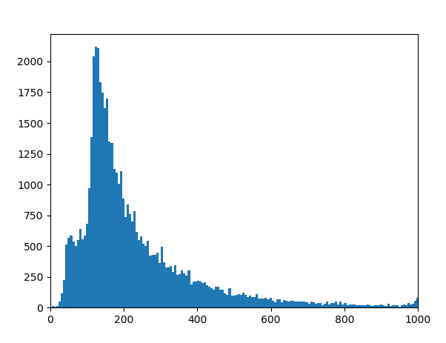

**Wordcloud for ngram words**

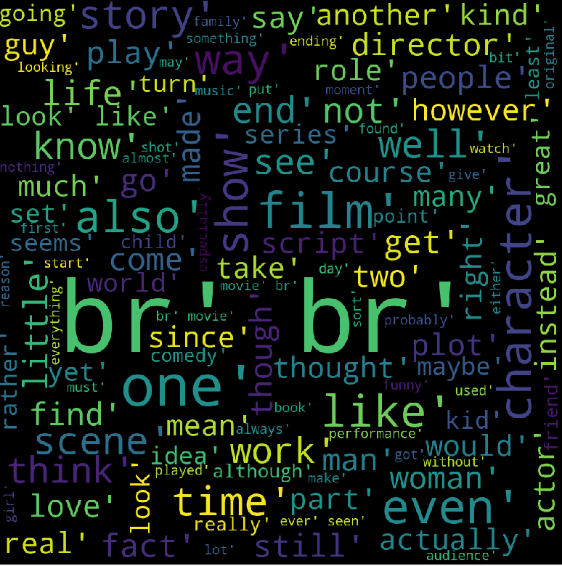

**Step 3) Building LSTM**

Model summary is

