**Exp. 2: Design a system for LPG gas burners such that, whenever it is turned on, a green LED starts blinking and if it stays on for more than 2000 ms, instead of the green LED, a red LED starts blinking.**

**Circuit Diagram:**

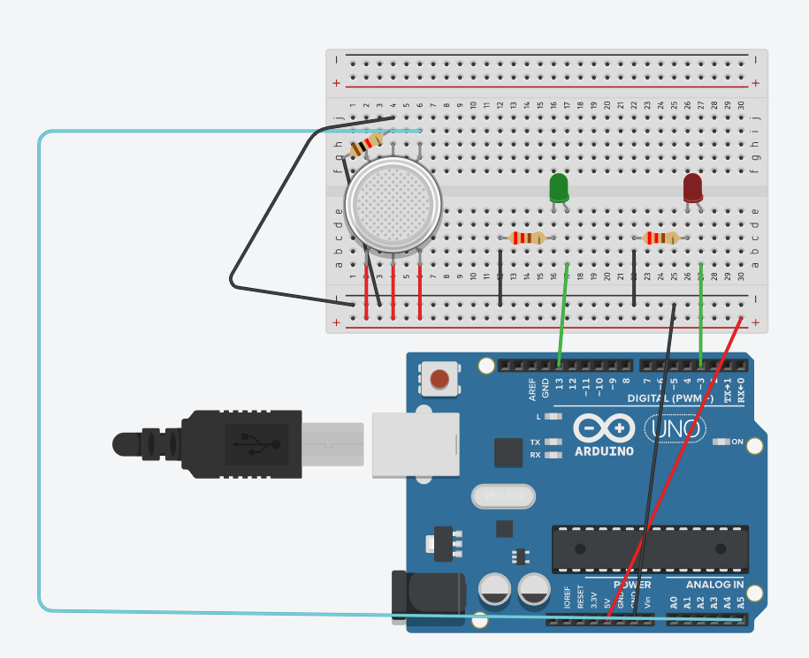

**Theory:-**

Concept Used:

* In Breadboard, the rows on top and bottom are connected in series whereas in middle the connections in columnwise.
* In arduino when Code is passed , it sends signals to LED connected in form of 0 & 1; i.e. when LED is to be switched off ‘0’ is passed else ‘1’ is passed.
* The positive part is connected to digital pins and negative part is connected to ground(GND).
* Level of smoke is detected by analog input pin.

Learning & Observations:

* I learned how to connect hardware and software.
* I learned how gas sensor can be used with an arduino.
* I observed that the specific LEDs light up at specific times.

Problems & Troubleshooting:

* There was problem while uploading code to Arduino , as the port selected was incorrect hence, to solve it. I change the port.
* Some LEDs was not glowing , so I had to replace it.
* The LEDs were not glowing as expected due to some error in code, so the code was edited.
* The gas sensor was not detecting the smoke, so I had to change the code a little bit.

Precautions:

* Arduino Board should be kept at dry place.
* Correct Board/Port is to be selected.
* All connections should be tight.
* The positive side of LED should be connected to digital pin and negative to ground.
* Resistor of appropriate value should be used.
* Input pins should be selected according to the use.

Learning Outcomes:

* How to make proper connection using LEDs and wires.
* Understand the logic how to use gas sensor in an appropriate manner.