FrontEnd Internship at LongShot AI

Tech Assignment

By – Jamal Mydeen

App link:- <https://jamal-meowgpt.vercel.app/>

Email – [jamalmohideen971@gmail.com](mailto:jamalmohideen971@gmail.com)

Phone Number - +91 9004013777

1.Introduction

As mentioned in the email, I have successfully completed my assignment. I developed an AI chat application using ReactJS and hosted it on Vercel, naming it MeowGPT. The application can be accessed through the following link:- <https://jamal-meowgpt.vercel.app/>. I incorporated Material UI icons and Lucide for fancy icons, while using SCSS for styling. The application's UI draws inspiration from ChatGPT and is designed to be responsive.

Cache Storage is employed for various functionalities, including adding new chats, deleting existing ones, and updating content within chats. Additionally, I seamlessly integrated LongShot APIs with my app to facilitate AI-powered conversations.

2.My Experience

The deadline was in two days and i encountered some issues with the API connection, receiving a 'Too Many Requests' error in the development then i utilized multiple email accounts.

Although I considered integrating authentications and storing the chats in a backend database, I was unable to do so due to the limited time duration. I focused on completing the UI on day 1 and implemented the functionalities on day 2.

3.OpenAI Integration

For AI integration, I utilized LongShot-AI's APIs and obtained my API request key. Subsequently, I included the API request key in the Authorization section of my request header. The response was in the form of a string, 'text.' I promptly forwarded the new prompt message to the main chat for the user's seamless experience and added it to the cache storage.

4.WorkFlow

Initially Whenever The App is opened for the time , A new chat will be opened in which I have provided some sample prompt which user can proceed , or simply they can type Their Prompt in the Input . After That when the user enters the Submit button the API function is called and the response AI-chat is received .

The API - <https://docs.longshot.ai/api-reference/endpoint/InstructPrompt> is called and simple Javascript Fetch API is used . After receiving the response , The UI animation is carried out for new chat . The animation is similar to ChatGPT’s Animation . The user can delete Their Chats by clicking The Trash Button which is which is assigned to each Chats in the sidebar section . The chats are stored in Cache storage , and can be retrived at any time the user wants . If the User try to use the AI so many Time then Some Error popup will be shown.

5.Result

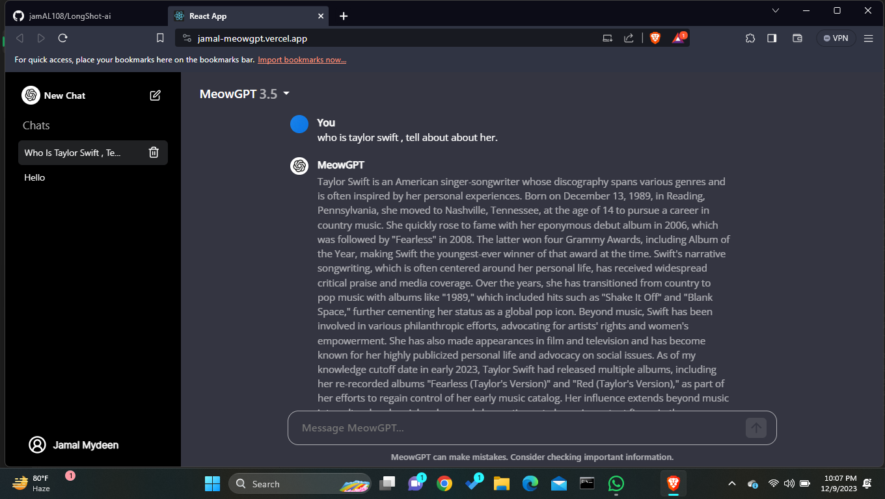

4.1 Home page for MeowGPT

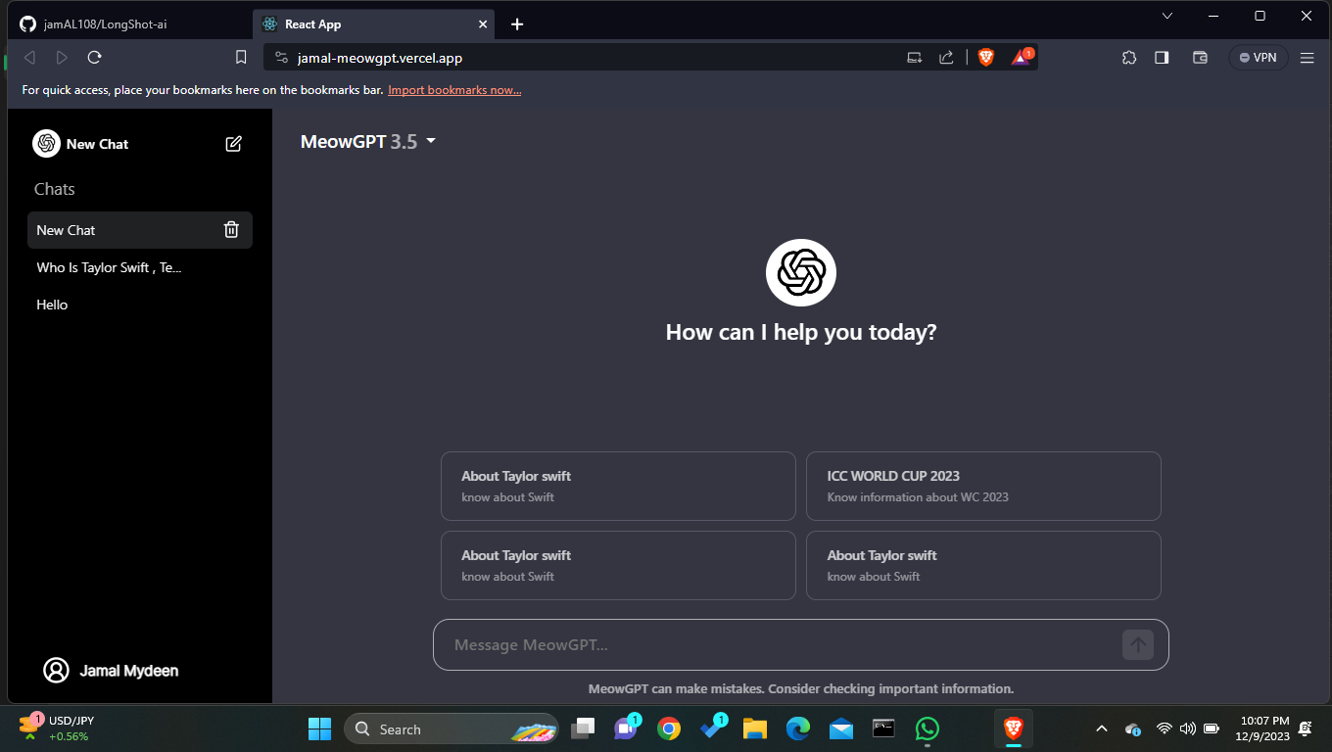

4.2 Adding new chat page .

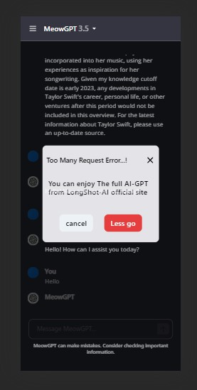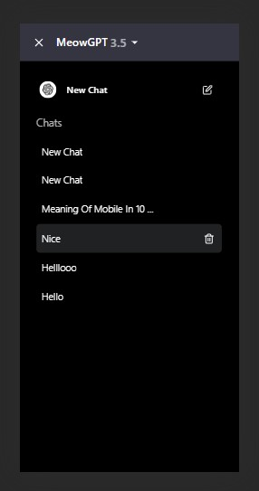

Pic - 1 If in the case the app recieves the `Too manyrequest` error then there will be the POPup message Stating the Error .

Pic - 2 The Sidebar for Mobile responsive Page.

6.Conclusion

In conclusion, the completion of this internship assignment has been a fulfilling journey marked by the development of the MeowGPT AI chat application using ReactJS and I hope so You liked my Work . Thank You so much.