## 

## 

Author: Sivan Bershan, Date: 06/13/2025

Intern: Rahul, work period: 06/15/25 - 08/31/25

**Introduction**

iMouse (<https://imouse.info/>) is a Monitoring Platform for lab mice that, based on 3-4 cameras, enables remote observance of mice and through machine learning on top of these images, allows counting and finding the duration of certain behaviors.

Both these functionalities have been implemented in V1. That means we produce video material on 5 clients, we have trained a model on 3 base behaviors that are currently used for auto-annotation.

The image below shows how the cameras are attached to the sides of the cage. The data is then processed on edge devices and sent to a server that hosts iMouseHub (at the customer’s site), our monitoring platform. This platform allows observation, video access, zoning, limited alerting and further functionality.

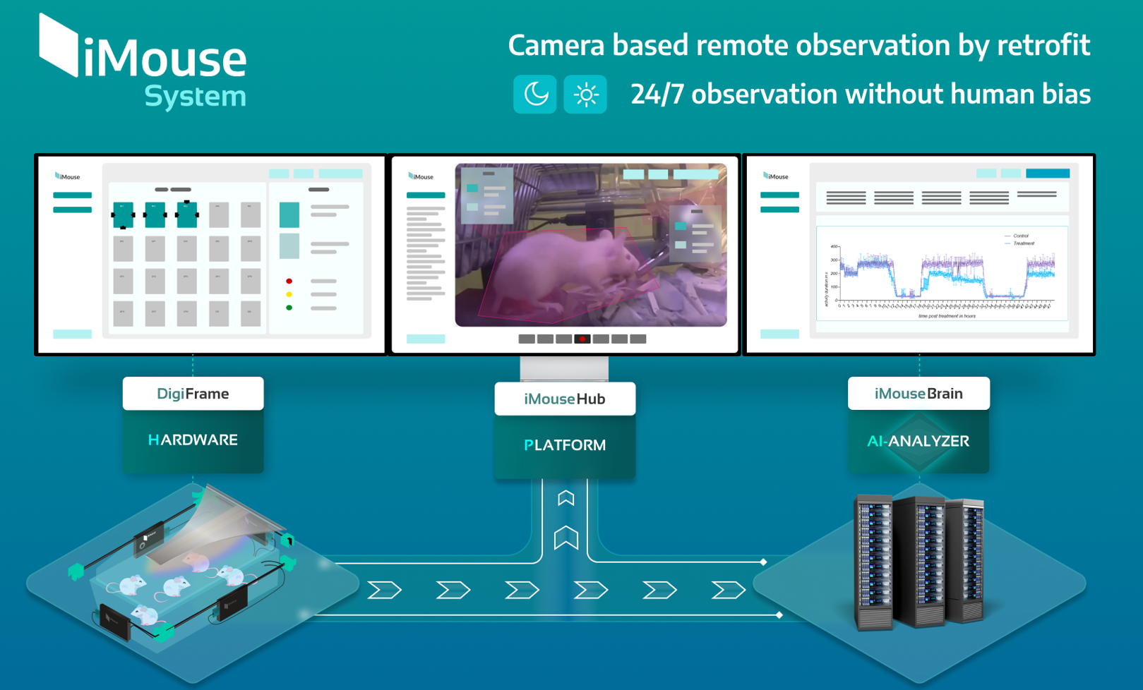

The customer tags behaviors of interest and these tagged videos are transferred to another server that hosts iMouseBrain, which consists of a computer vision annotation tool as well as an analyzer, which is basically python software to a) preprocess video data, b) train and build a model, c) postprocess data and d) output annotated video and reports on behaviors by either Mouse, Cage, or Group.

This data is then transferred back to the customer site and integrated in their backup. The models are trained across customers and provided to all customers that participated in generating the images.

The internship project consists of creating logic in the monitoring platform iMouseHub that allows us to use zones and other logic in a meaningful way.

Use cases are:

* A client wants to be alerted, when a mouse is longer than 10 minutes away from the litter. → Litter absence
* A client wants to be alerted, when a mouse moves too much on the day before she’s bound to give birth. → pre-birth movement patterns (too much is not good, because mouse isn’t preparing), postpartum: mouse should start to move, but not for long phases, post-litter movement patterns (72h after birth, the mouse should be moving 2km a day roughly)
* Automatic zones around drinking, eating, house → that means we draw a zone around the house, then perform object detection based on this zone and move the bounding box, once the house moves
* House is accessed and left alerts → this can be done already

The internship project consists of creating alerts in iMouseHub that cover the above named use cases and in addition many others that may be helpful.

These alerts should base on the videos transmitted directly from the client site and they should be implemented that the customer receives an alert on their phone (via zm ninja and / or per email)

**→ please insert your list of complete use cases here, so we can prioritize**

1. Litter absence longer than 10 minutes
2. Drinking station inactivity or overuse
3. Pre-birth movement spike (day before due)
4. Early postpartum long continuous movement episodes
5. Post-litter activity deviation vs baseline (proxy now, distance later)
6. House moved or rotated beyond tolerance

Deliverables are:

* Video documentation on how to create alerts in iMouseHub
* Video documentation on how analysis works in iMouseHub
* Written report for final end-to-end documentation
* Alerts implemented and tested in iMousehHub
* Analysis reports
* Code checked into github, if necessary

Prerequisites:

* Access to Zoneminder - HH
  + <http://10.0.2.2/>

Project Plan: this phase started on 6/15 and supposed to be completed by 7/1 - **please hand in deliverables asap**

Phase 1 - week 1-2: Problem Understanding and Action Plan

* Please check that your access works
* Familiarize yourself with the alerting function in zoneminder (iMouseHub). This is an open source software and you can find many videos on youtube. Please document the 3 best videos in here:
* Develop a plan of action that covers the named use cases and make at least 15 more suggestions.
* Present your findings to the team and decide together which ones are worth implementing and with what efforts (Here I need your estimates)
* Deliverables:
  + 3 links to the best zoneminder videos
  + List of use cases to be inserted above
  + Presentation was delivered

Phase 2 - week 3-5: Implementation. This phase started on 7/1 and was supposed to be completed by 7/15 - we’re significantly delayed, as today is 8/11

* Implement all discussed alerts
  + **Are all technical issues resolved now?**
* Video document how these alerts work
* Present to the team
* Also allow for some time here so that we can present to the client and get their feedback.
* Discussion on other use cases and what needs to be improved
* Document the newly defined requirements from the discussion here:
* Deliverables:
  + Python code
  + 5 minute video on how alerts work in iMouseHub and what the different options are, and a few remarks on the implementation in python.

Phase 3 - week 6-7: Refinement This phase started on 7/16 and was supposed to be completed by 7/30 - we’re significantly delayed, as today is 8/11 and this phase has not even started

* Implement the suggested new alerts and improvements
* Understand how the alerts can be reported on.
* Present to the team with a focus on how to implement analysis based on alerts.

Phase 4 - week 8-10: ~~Report implementation~~

* ~~Implement Alerts reporting~~
* ~~Document the entire process from adding an alert to analysis on a written document no longer than 5 pages long excluding images. Use graphs and images to show what the customer benefit is in your opinion.~~
* ~~Present report and alert analysis to the team.~~
* Discussion with CTO on how to roll out alerts for every new client (Ansible)