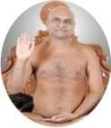
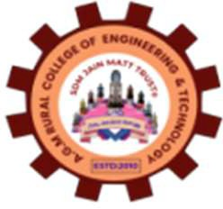
S.D.M Jainmatt Trust®
A. G. M RURAL COLLEGE OF ENGINEERING AND TECHNOLOGY, VARUR
Navagrahteerth, NH-4 Road, Varur -581 207, Dist. Dharwad, Karnataka
(APPROVED BY AICTE, NEW DELHI, AFFILIATED TO VTU, BELAGAVI AND RECOGNIZED BY STATE GOVT.
Accredited by NAAC with B⁺⁺ )
Phone: 0836-2312071, Fax: 0836-2312061, E-mail:principal@agmrcet.ac.in, Web: www.agmrcet.ac.in

Department of Basic Science and Humanities

CERTIFICATE

Certified that the Interdisciplinary Project (IBPRJ258) work entitled “SOLAR MOBILE CHARGER”, is carried out by Mr. Dadesab Maktumsab Attar, Mr. Rahul Ashok Bedre, Mr. Mohammed S Topinkatti, Mr. Jagadish M Halleppanavar, Mr. Karthik Madar,
Mr. Mohammad R Rahutar are bonafied students of Department of Basic Science & Humanities, A. G. M. Rural College of Engineering and Technology, Varur, in partial fulfillment for the award of Bachelor of Engineering in Dept. Name of the Visvesvaraya Technological University, Belagavi, during the academic year 2025-26. It is certified that all correction/suggestions indicated have been incorporated in the report and has been approved as it satisfies the academic requirements in respect to project prescribed for the said degree.

Guide | HOD | Principal
Dr. Sumana Achar | Dr. Mahesh Bannur | Dr. Sandeep Kyatanavar
Associate Professor | Associate Professor | Professor, Dept. Of Electronics
Dept. of Electronice and | Dept of Basic | and Communication Enginnering
Communication Enginnering,  AGMRCET,Varur | Science and Humanities  AGMRCET,Varur | AGMRCET,Varur

Name of Examiners Signature with Date
1.

2.

