Safety, Reliability, Quality and Standards (SQRS) Committee

Background and Purpose
The SQRS committee was formed in 2019 as a focus point for issues related to safety at first, expanding later to related questions of quality, reliability and standards in 2021. Its purpose is to provide support for applicants and entrepreneurs, and beyond them the communities they serve, on these issues.

Key Duties of the Committee
- Promote local safety culture in the ISV projects under development.
- Provide guidance to ISV entrepreneurs in the areas of electrical safety, electrical reliability, quality and electrical standards.
- Support aspects of project application and reporting under the committee’s purview.
- Promote technical training and presentations at ISV-related events.
- Develop support material in these areas to help volunteers and others.

Recent and Ongoing Initiatives
- Questions added to project application and reporting (2021-2022).
- Development of support material leveraging the ISV repository.
- Support for safety and standards activities at IEEE events, such as keynotes, tutorials and panel sessions at PowerAfrica, workshop in Latin America, etc.

Contact Information
Bruno Lequesne : 1-262-777-0226, blequesne@outlook.com

Why an SQRS Committee for ISV?

Why safety?
Electrical accidents are relatively rare, compared to other types of accidents (falls, cuts, etc.), but are proportionally more deadly. Introducing electricity, or developing electricity in a specific region, is a wonderful thing, transforming lives for the better. This is also a great opportunity to raise awareness around safety issues, and share some simple precautions to take around electricity, as well as around any machinery.
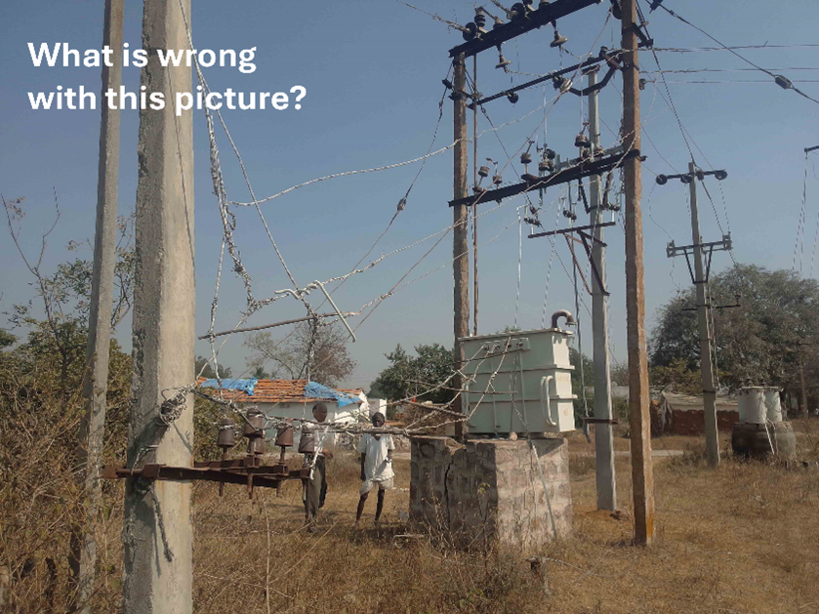
Example of poor quality, failing equipment and the danger it represents (Photo credit: C. Satish)

Why reliability?
Poor quality equipment can doom the best thought-out and executed project. Early failure will lead to disappointment among customers, necessitate unscheduled and possibly costly repairs, and distract a project from an otherwise great growth trajectory. Thinking through quality issues early on and assuring products meet specifications can go a long way in ensuring success.

Why quality?
Quality ensures reliability and safety, and as such is an important component of project development and implementation. It is important to ensure good quality in design basis notes, engineering drawings, construction methodology, purchase-order terms and conditions, contract conditions including good definition of deliverables, guaranteed performance parameters, warranties offered, etc.

Why standards?
ISVx operates in parts of the world where standards are sometimes not well established, and if they are, not well enforced. As a result, imported equipment is designed on varying standards. Furthermore, the standards may not be well adapted to a location for which they were not developed. While standard development per se is beyond the reach of ISVx projects, awareness of their importance and help with developing them where possible is critical.
These four topics are interrelated: Poor quality equipment may fail, resulting in possible short circuits and safety issues, etc. All of them can result in wasted efforts or worse. This committee’s role is to gather information around these topics and raise awareness among entrepreneurs, their customers, and society at large. Ultimately, information better tailored to the SmartVillage audience will be developed by this committee. The group is also working hand in hand with academics and where appropriate government and standard bodies to foster the education of engineers well versed in these topics, and capable of developing proper resources for their countries.
The committee is always looking for volunteers. We have teams for Africa, Latin America, South Asia and China dedicated to this topic in their respective regions, all looking to grow this activity with motivated volunteers.

