Restaurant Project Overview
PROJECT LINK - https://github.com/rahulbhassy/Restaurant

Tools and Technology Used

SQL Server as Source Database and acts as Source for PowerBI Consumption
I used SQL Server with PySpark because they work well together. SQL Server provides stable, structured storage for restaurant data, while PySpark handles heavy processing—pulling data, cleaning it, transforming it, and writing results back efficiently.
SQL Server keeps data consistent, and PySpark offers the speed and scalability needed for analytics.
Although SQL Server isn’t a real-time sink, PySpark’s micro-batch approach supports near-real-time updates. SQL Server also integrates smoothly with Power BI, making dashboard creation simple and allowing easy comparison across outlets. Overall, this setup provides a stable backend, accurate reporting, and a scalable structure for expanding analytics features.

Pyspark + Python + SQL + Pycharm
I used PySpark, Python, SQL, and PyCharm together because this combination makes it easy to work with SQL Server as the source or any database. PySpark handles large-scale processing, Python gives flexibility for business logic and OOPS, SQL helps in extracting and shaping the data from SQL Server, and PyCharm provides a clean environment to develop everything in one place.
This stack allows fast data processing, smooth integration with SQL Server through JDBC, and a development workflow that’s easy to maintain and extend. It keeps the entire pipeline efficient, organized, and scalable, which fits the needs of a multi-restaurant analytics project.

Delta Lake + Parquet as Storage (Data Warehousing)

Delta Lake is ideal for big data because it adds ACID transactions, versioning, schema enforcement, time-travel, and efficient upserts/deletes on top of Parquet, making data reliable and easy to manage. With PySpark, processing becomes faster through parallel joins, aggregations, and transformations.
Delta Lake also provides optimizations like file compaction, Z-ordering, and data skipping, improving query speed, while MERGE, caching, and versioning give better control and adaptive query executions and optimisations with spark.
Parquet is used for lightweight incremental loads—storing raw or newly arrived batches before merging into Delta.
In short: Parquet for fast incremental loading, Delta Lake for stable, optimized analytics storage.

Prefect as Orchestration Tool

I used Prefect because it’s an open-source orchestrator similar to Airflow but much easier to set up and use. It lets me build pipelines in pure Python without Airflow’s heavy scheduling and DAG overhead.
Prefect offers a simpler developer experience, lighter infrastructure, and no need for a webserver, scheduler, or metadata database. It manages retries, logging, and dependencies with minimal configuration.
In short, Prefect provides Airflow-like orchestration, scheduling, and monitoring with a more modern, Python-friendly, and low-maintenance workflow, which suited the project’s time constraints.
If time isn’t a constraint, I’d go with Airflow. It’s more mature, widely used in enterprises, and has a stronger scheduling and governance setup. The ecosystem is bigger, and it handles complex, long-term, multi-team pipelines really well. Prefect is easier and more flexible, but Airflow gives you the stability and enterprise-level features needed for large-scale projects.

PowerBI for reporting
I chose Power BI for reporting because it connects easily to SQL Server, Delta Lake and modern data platforms like databricks , Azure Data Lake , AWS S3 and handles large datasets well, and lets me build interactive dashboards quickly. The tool is simple to use, has strong data modeling features, and supports DAX, which makes KPI calculations flexible.
Power BI also updates reports automatically, works well with real-time or near-real-time data, and provides clean visuals that are easy for business users to understand. Overall, it’s a good fit because it’s fast to build with, reliable for analytics, and ideal for sharing insights across the team.

RESTAURANT PROJECT STRUCTURE
Restaurant Analytics Platform – Project Overview
This repository contains a complete Restaurant Analytics Platform built using PySpark, Delta Lake, SQL Server, and Power BI. The solution is designed for a multi-outlet restaurant chain, enabling real-time insights into sales, kitchen performance, and inventory management.
Architecture Overview
The system follows a layered medallion architecture:
• Source Layer – SQL Server
• Raw Layer – Delta Lake raw data
• Enrich Layer – Cleaned analytics data
• Power BI Layer – Modeled tables pushed back into SQL Server
Core Components
1. Data Generation (Resturant/DataGenerator/)
• Generates synthetic data for all dimension and fact tables.
• Includes data_generator.py, data_ingester.py, schema.py.

2. Source Fact Processing (Resturant/SourceFact/)
• Ingests and validates source data. Supports Full load and incremental loads.
• Performs mandatory column checks, type casting, anomaly detection.
• Loads Delta tables into the Raw Layer.

3. Fact Enrichment (Resturant/EnrichFact/)
• Converts raw facts into analytics-ready enrich tables.
• Implements Factory Pattern via Harmonizer. ( The project uses a Factory Pattern through the Harmonizer class to automatically decide which enrichment logic to run based on the table being processed. Instead of writing multiple if/else checks, the Harmonizer looks at the table name and chooses the correct class—like FactSalesEnricher, FactKitchenEnricher, or FactStockEnricher. This keeps the pipeline clean, easy to extend, and more organized. When a new fact table is added, you just create a new enricher and register it—no pipeline code needs to change.)
• Adds KPIs, exploded line-items, and operational metrics.
The enrichment framework also supports people-level and outlet-level analytics.
- enrich_people focuses on building enhanced customer- and chef-related attributes such as loyalty indicators, visit frequency, cooking performance patterns, and preference trends.
- enrich_outlet generates outlet-level KPIs including operational efficiency, peak-hour patterns, sales mix ratios, kitchen load indicators, and stock health summaries.
Both enrichment modules follow the same design standards used in fact enrichment—clean transformations, derived KPIs, configuration-driven rules, and Delta-based incremental processing.
5. Power BI Refresh (Resturant/PowerBIRefresh/)
• Pushes enriched data to SQL Server for reporting.
• Includes Prefect orchestration.
6. Shared Infrastructure (Shared/)
IMP NOTE: The shared module was developed for my personal project uber_project that I have mentioned in my resume , developed few months back , The idea was to create a reusable framework that can fit any data engineering project on an onpremise system, customized based on my understanding and ease of use. I reused this framework for the Restaurant project.
• The Shared module is the infra backbone of the entire platform. It contains all the common infrastructure pieces that every pipeline—SourceFact, EnrichFact, PowerBIRefresh, and even other domains—relies on.
It includes:
- Unified Spark session management
Centralized utilities to create the right type of Spark session, whether it’s for JDBC reads, heavy transformations, or spatial processing.
- Standardized Data Lake I/O
DataLakeIO ensures all pipelines follow a consistent folder structure and naming convention across raw, enrich, system, and dev/prod layers.
- Reliable data loading and writing utilities
DataLoader and DataWriter handle CSV, Parquet, Delta, JSON, GeoJSON, and JDBC operations with consistent settings, logging, and error handling.
- Centralized configuration and credentials
All environment settings, JDBC details, and shared paths are maintained in one place to avoid duplication and keep pipelines clean.
- Delta Lake optimization tools
Automated VACUUM, OPTIMIZE, and Z-Ordering routines help maintain performance and manage storage efficiently.
Overall, the Shared module plays a key structural role—promoting consistency, reducing repeated code, and making the platform easier to manage, scale, and extend.
Data Model
Follows a star schema with 5 dimensions and 3 fact tables, plus a flattened fact_sales_items table.
7. Prefect Orchestration
The project is built around a clear, layered pipeline structure that moves data smoothly from raw ingestion to analytics-ready outputs. Each layer has a specific role, and together they form a reliable, maintainable, and scalable data engineering workflow.
1. Raw Layer Pipeline
. The Raw Layer captures data exactly as it arrives—without heavy transformation—so that the original source files remain preserved and traceable.
2. Enrich Layer Pipeline
the Enrich Layer transforms it into meaningful, structured information.
This is where cleaning, joining, validation, and business logic come together.
3. ETL Orchestration & Scheduling
To keep everything running smoothly, the project uses Python-based orchestration tools such as Prefect (and optionally Dask).
These flows coordinate when each pipeline runs, what parameters it uses, and which tables need processing.
4. Delta Table Management
The system also includes maintenance routines for Delta tables to keep storage fast and healthy.
Through DeltaLakeOps, tasks like OPTIMIZE, VACUUM, and schema updates ensure long-term performance and consistency across the data lake.
Key Design Patterns
• Factory Pattern for enrichment
• Configuration-driven processing
• Incremental loading with timestamp-based deltas
• Abstracted data lake layer management

POWERBI REPORTS
Outlet Overview
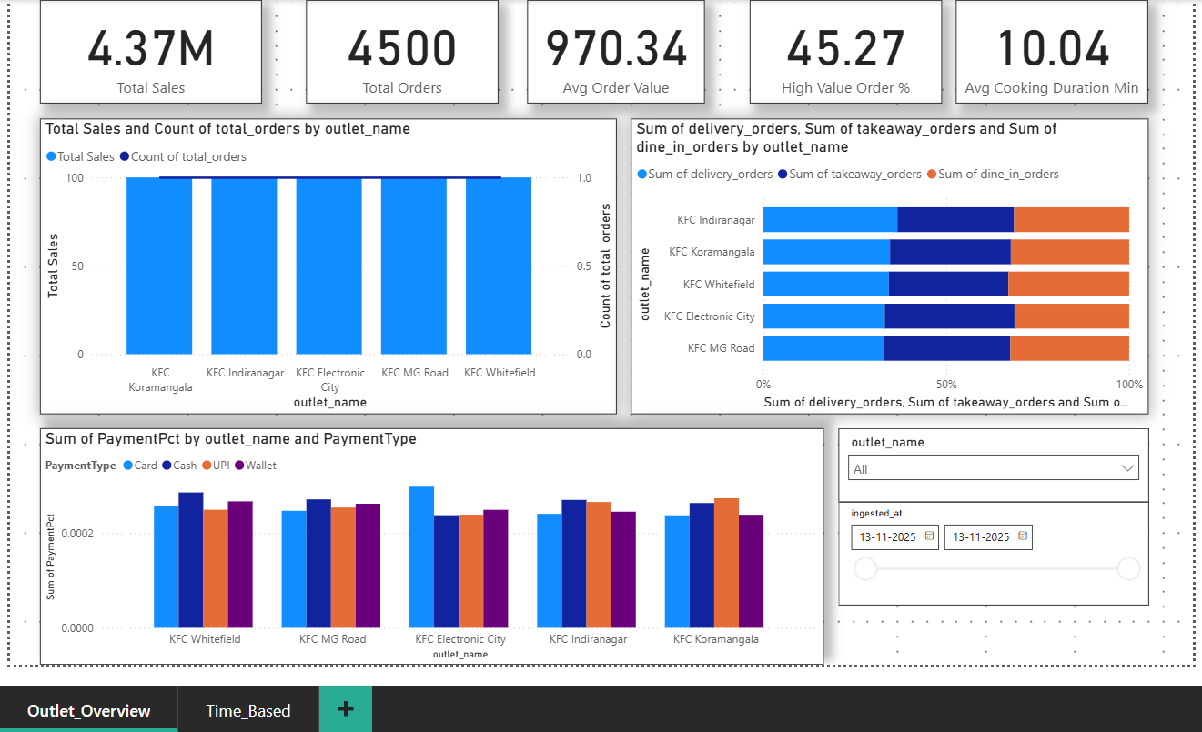
Outlet Time & Daily Metrics
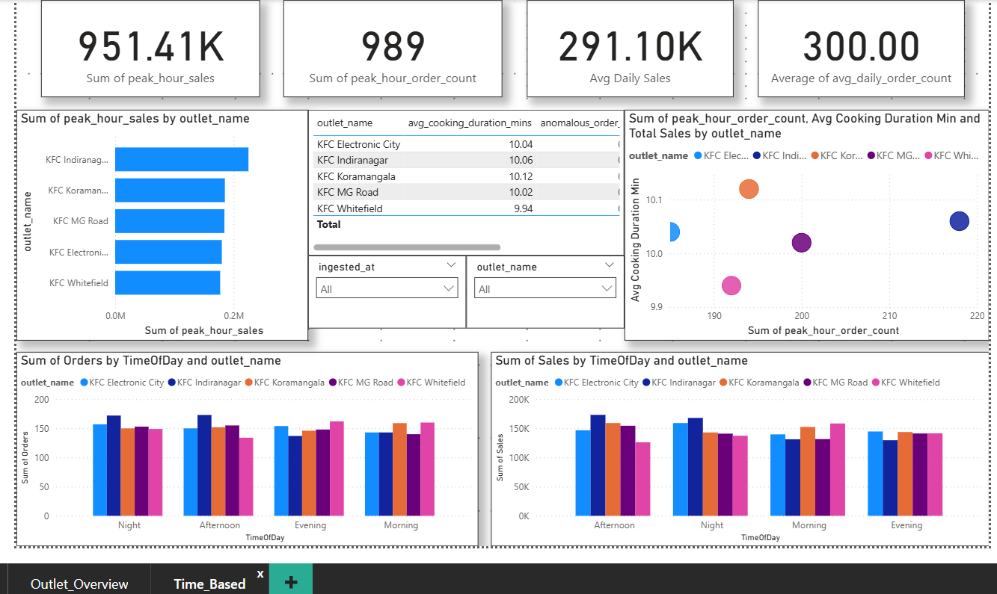
Outlet Stock
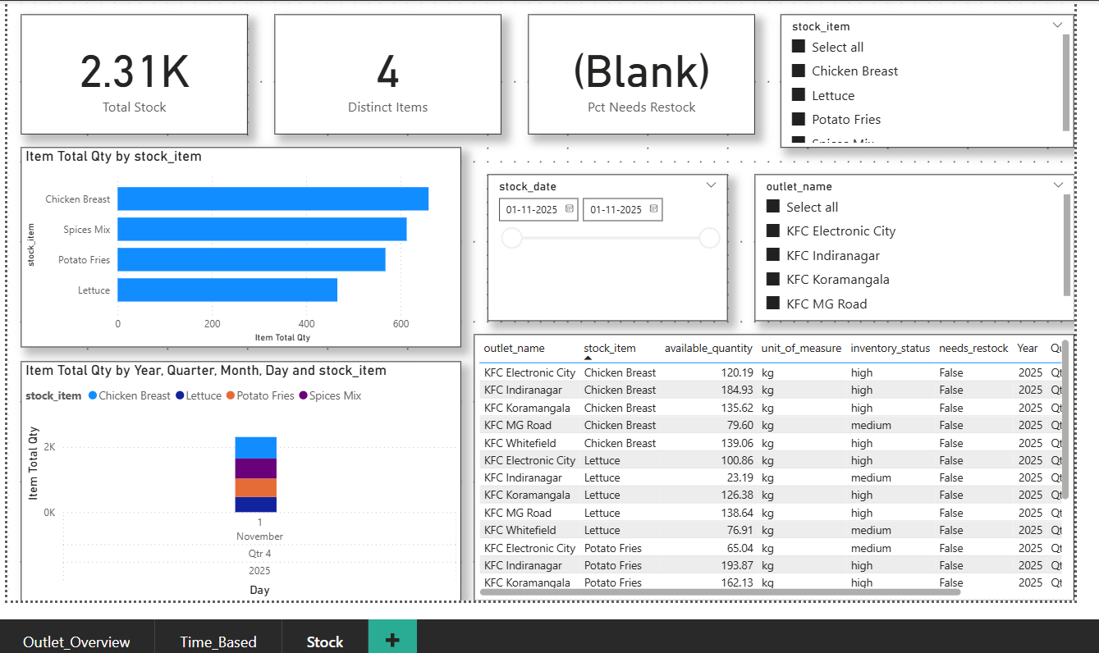
Customer Metrics
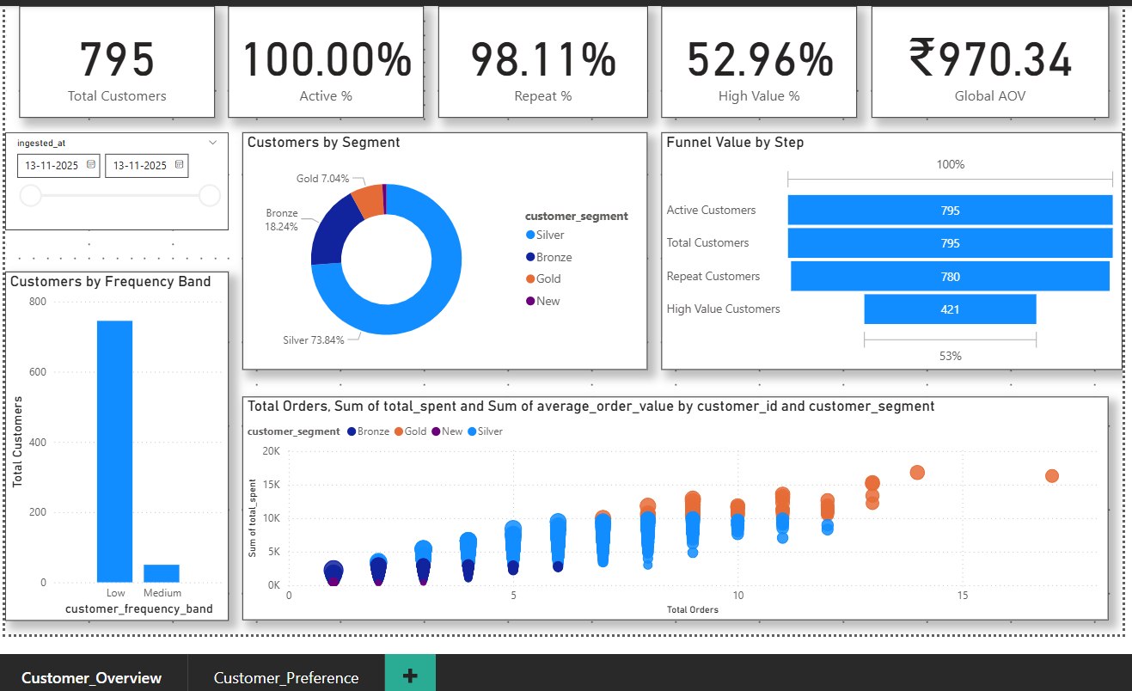
Customer Preference
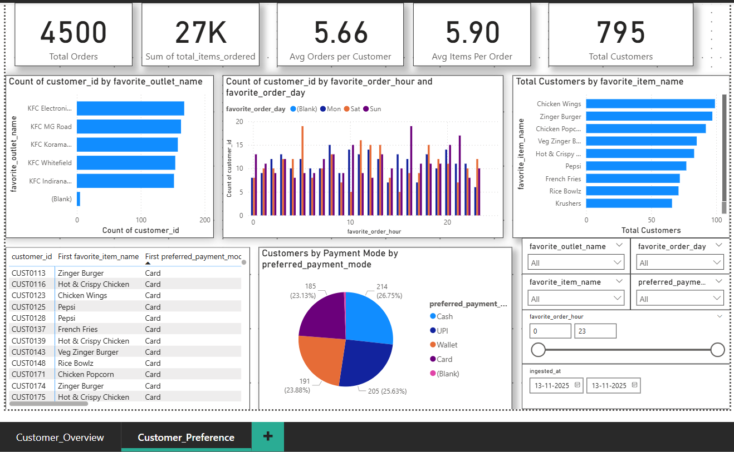

FUTURE PLANS AND IMPROVEMENTS
1. Implement Incremental Processing for enrich layer fact tables and advanced schema and data quality checks for enrich layer tables .
2. Implement SCD Type 2 for tables like customer , customer_preference , chef_performance , outlet_performance . SCD Type 2 keeps track of history enabling us to identify changing patterns of preference , performance etc..
3. Performance Tuning
(A)Enabling partitioning and pulling data in batches using pyspark and jdbc connections to improve performance and load data faster.
(B)Partitioning the Source tables based on date which will enable faster incremental processing by the enrich layer pipelines .
(C)Bucketing/Clustering Source data based on aggregations and filtering performed by enrich layer tables like customer , preferences , performance etc..
(D)Zordering the enrich layer tables based on downstream query patterns for faster data loads.
(E)Analysing and finding the small tables / dataframes that can be Broadcasted / cached while processing , this will significantly improve data processing by reducing shuffles.
4. Development of Balancing Checks which runs for each table after each table is processed. This will enable us to ensure that there is no data loss and maintain data consistency and integrity .
On a high level – get the counts of source and target tables and compare It . Ideally it should be same . SQL Query to get the counts will be based on aggregations and transformations performed on that table.
5. Implement a cloud-based or on-prem real-time streaming solution using PySpark Structured Streaming or Delta Live Tables in Databricks. This will allow the system to handle live data from multiple restaurants, process it instantly, and update dashboards without delays. Using these streaming frameworks will make the pipeline more scalable, reliable, and easier to manage as data volume grows.
Delta Live Tables in Databricks automates pipeline management—handling quality checks, incremental processing, and data reliability with almost no manual effort and can be used for both batch streaming and real time streaming.
6. Powerbi Reports for fact tables , chef or staff performance and creation of drilldown Reports and detailed reports taking into consideration about the relationships between tables.
7. Enabling on demand refreshes of reports in powerbi using powerbi pipeline.

