# Deep Learning:

Deep learning is a type of machine learning that mimics the neuron of the neural networks present in the human brain. Computer Vision Deep learning models are trained on a set of images a.k.a training data, to solve a task. These deep learning models are mainly used in the field of Computer Vision which allows a computer to see and visualize like a human would.

Deep learning models can be visualized as a set of points each of which makes a decision based on the inputs to the node. This sort of network is similar to the biological nervous system, with each node acting as a neuron within a larger network.

Thus, deep learning models are a class of artificial neural networks. Deep learning algorithms learn progressively about the image as it goes through each neural network layer. Early layers learn how to detect low-level features like edges, and subsequent layers combine features from earlier layers into a more holistic and complete representation.

## How deep learning differs from traditional machine learning

Unlike more traditional methods of machine learning techniques, deep learning classifiers are trained through feature learning rather than task-specific algorithms. What this means is that the machine will learn patterns in the images that it is presented with rather than requiring the human operator to define the patterns that the machine should look for in the image. The feature learning technique is used every day in how we teach a child to recognize different objects.

Feature learning is a method of traditional Machine Learning, where we use lots of features and connect all those to a basic feature.

Feature learning have the freedom to be done using supervised or unsupervised type learning.

In the case of supervised feature learning, the neural network is trained using labeled input data like supervised neural networks and multilayer perceptron.

Whereas in the case of unsupervised feature learning, neural network uses unlabeled data like dictionary learning, independent component analysis, matrix factorization, it works by looking for recurring patterns.

For example, to teach a child how to identify a dog among various animals, the teacher would provide many examples of dog images, its behavior and allow the child to understand the differences between the the duo. This is feature learning at work.

The major distinguishing factor of deep learning compared to more traditional methods is the ability of the performance of the classifiers to large scaled with increased in quantities of data.

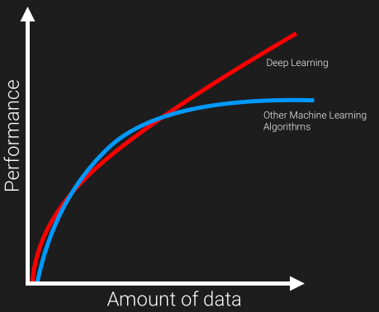

Older machine learning algorithms typically plateau in performance after it reaches a threshold of training data. Deep learning is one-of-a-kind algorithm whose performance continues to improve as more the data fed, the more the classifier is trained on resulting in outperforming more than the traditional models/ algorithm.

The execution time is comparatively more for deep learning , as it needed to be trained with lots of data. The major drawback of this ability to scale with additional training data is a need for trusted data that can be used to train the model. While the world is generating exponentially more data every year, the majority of this data is unstructured, and therefore currently unusable.

## So, what happens in Deep Learning?

The software learns, in a very realistic sense, to recognize patterns in digital representations of images, sounds, censor data and other data. We are pre-training data, in order to classify or predict and build a train/training set and test set(we know the result). And on prediction obtaining a optimal point such that our prediction gives a satisfying result.

The neurons are based out in different level and made to make their prediction at each level and most-optimal predictions, and then use the data in order to give a best-fit outcome. It is considered as true intelligence on machine.

## FAQs on Deep Learning

**What Deep Learning can do?**

1. It can also prescribe medicine used in medication.
2. Computer vision and pattern recognition
3. Robotics — Deep Learning systems have been taught to play games and even made to taught WIN games.
4. Facial recognition
5. Precision agriculture
6. Fashion technology
7. Autonomous vehicles
8. Drone and 3D mapping
9. Post estimation in Sports analytics & Retail markets
10. Security & Surveillance
11. Satellite imagery
12. Audio / Voice recognition
13. Restoring sound in videos
14. Text OCR on documents, Predicting the result of legal case a team of researchers from British and America builded a algorithm by feeding with few examples and factual information, that was able predict a court’s decision.
15. Chatbots for sales & marketing

The applications of Deep Learning and about its potential to solve real-world problems are limitless.