# **Introduction**:

Python is a widely used general-purpose, high level programming language. It was initially designed by Guido van Rossum in 1991 and developed by Python Software Foundation. It was mainly developed for emphasis on code readability, and its syntax allows programmers to express concepts in fewer lines of code.

Python is a programming language that lets you work quickly and integrate systems more efficiently.

There are two major Python versions- Python 2 and Python 3. Both are quite different.

1. Scripting language(interrupted) features from Perl & Shell script.
2. Object oriented concept from C++.
3. Function programming from C, without having Class you can call function.
4. Syntax borrow from C & ABC language.
5. Free Ware and Open Source.
6. High level programming language(Machine level) memory and space management by internally.
7. Platform Independent -> write once and run anywhere.
8. Portability->Migrating easily->python program any manchine.
9. Dynamically Typed->no need to declare variable type, require only variable name- dynamically typed by internally.
10. **Both ->Procedural and Object Oriented language.**
11. Extensible->already existing program -> native language support.
12. Embedded-> we can use python program in any other language.
13. Python is not suitable for large scale enterprise application.

## Where we can use python:

1. Desktop application.
2. Networking application.
3. Games
4. Data Analysis
5. Data Science with python
6. Machine Learning
7. Artificial Intelligence (AI) application
8. IOT application

## Flavors for python(Standard):

1. Cpython
2. Jython or JPython(work with Java language)
3. IronPython(work with C# language)
4. Pypy -> JIT(just in time)-> performance improvement.
5. Ruby python->(for ruby language)
6. Anaconda Python-> Large values of data processing.
7. Stackless - > (Python for Concurrency-> multithreading)

## Identifiers (variable, class, method names):

1. Rules to defined identifiers in python-> alphabet sysmbos(support Uper case and Lower case)
2. Digits( from 0 to 9), Underscore( _ ) , special char not support($@# etc).
3. ( _ ) single underscore 🡺 private (start with single underscore) ex. _a, _b
4. (__) double underscore 🡺 strongly private (start with single underscore).
5. ( __main__ ) start and end with double underscore 🡺 language specified identifier defined by python.
6. TOTAL and total both are different identifier.
7. No length limit to defined identifiers ( aaaaaaaaaaaaaaaaaaa…..n)
8. 33 reserved words.(raise,assert if ,for. Etc)
9. **Long type is not there in python-3 until python-2 was there.**
10. **In python everything is Object. Like – init,float,bool,str,list,set etc**.
11. Any number which is start with – 0b or 0B ( zero and small or capital B) are called Binary format .

Example: a=0b1111 🡺values is 15

a=0B1111🡺15

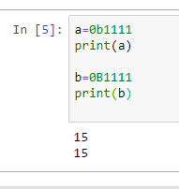

1. True + True = 2

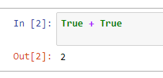

1. True + False = 1 (note🡺 true=1 and false= 0)

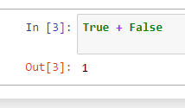

1. Second line 3 single or double quotes- Multiple line string literals

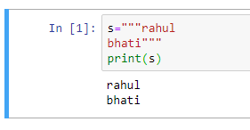

1. Positive and Negative index is possible in python. Means positive index is for Forward and negative index is for Backward, indexing moving from both direction.

