What is design pattern:
In software engineering, a Design Pattern is a tried-and-tested solution to a common problem that occurs during software design. Think of them as blueprints or templates that you can customize to solve a specific architectural challenge in your code.
Design patterns in Java refer to structured approaches involving objects and classes that aim to solve recurring design issues within specific contexts. These patterns offer reusable, general solutions to common problems encountered in software development, representing established best practices. By utilizing design patterns, developers can communicate more effectively about their approaches to problem-solving, fostering collaboration and consistency in their code.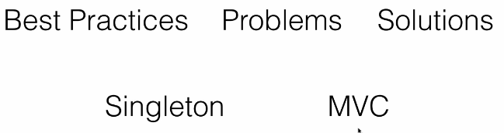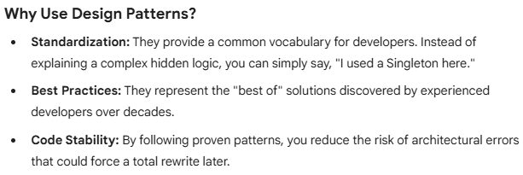 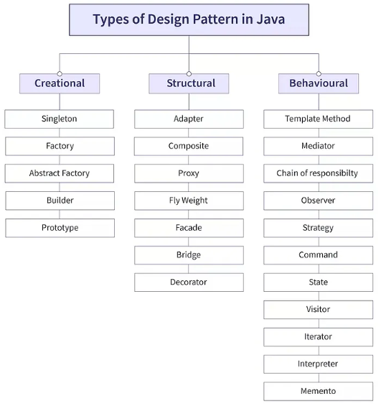

Creational Design Patterns:
Creational design patterns software engineering mein wo patterns hote hain jo object creation mechanisms (object banane ke tareeke) se deal karte hain.
Creational design patterns provide various object creation mechanisms, which increase flexibility and reuse of existing code.

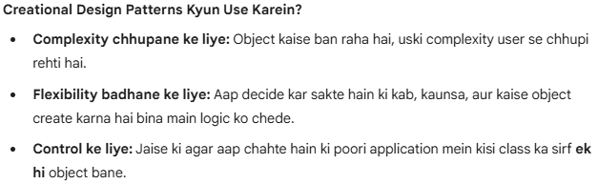
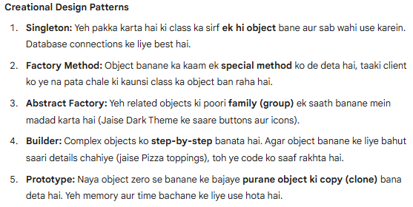
1. Singleton Pattern:
Iska maqsad ye ensure karna hota hai ki ek class ka poori application mein sirf ek hi instance (object) ho. Ye aksar Database connection ya Loggers ke liye use hota hai.
Singleton is a creational design pattern that lets you ensure that a class has only one instance, while providing a global access point to this instance. 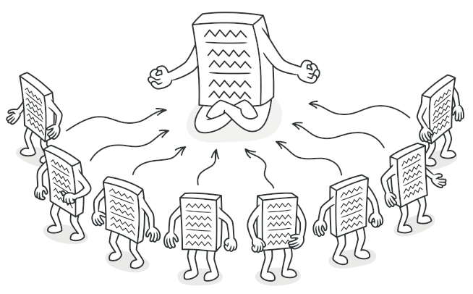
The Singleton class declares the static method getInstance that returns the same instance of its own class.
The Singleton’s constructor should be hidden from the client code. Calling the getInstance method should be the only way of getting the Singleton object.
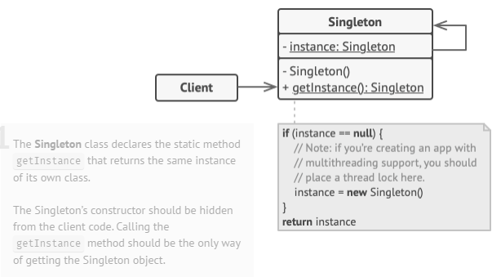
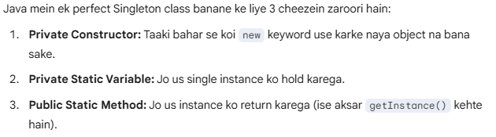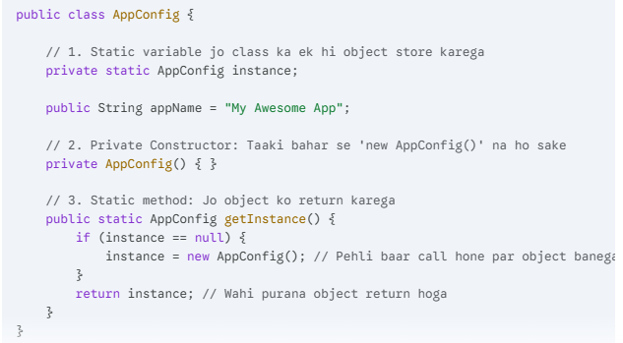

2. Factory Method Pattern:
Factory Method Pattern ek aisa creational design pattern hai jo ek interface ya class banata hai objects create karne ke liye, lekin sub-classes ko allow karta hai ki wo decide karein ki kis class ka object instantiate (banana) hai.
Iska sabse bada fayda ye hai ki aapka main code (client code) specific classes se "tightly coupled" nahi hota.
Factory Method is a creational design pattern that provides an interface for creating objects in a superclass, but allows subclasses to alter the type of objects that will be created. 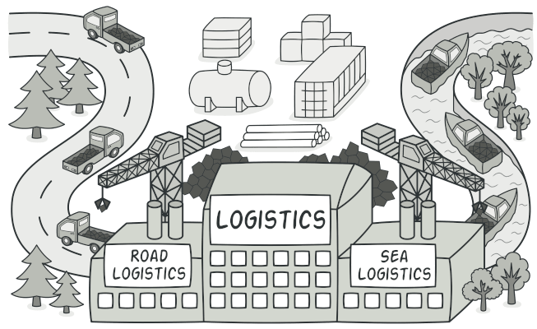
Factory Method ka Simple Example: Shape Factory:
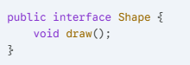
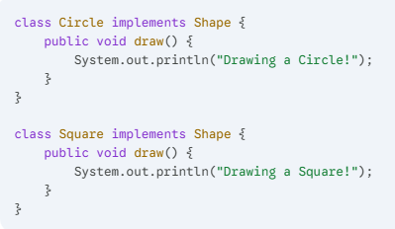
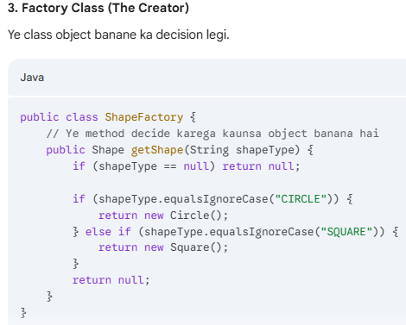
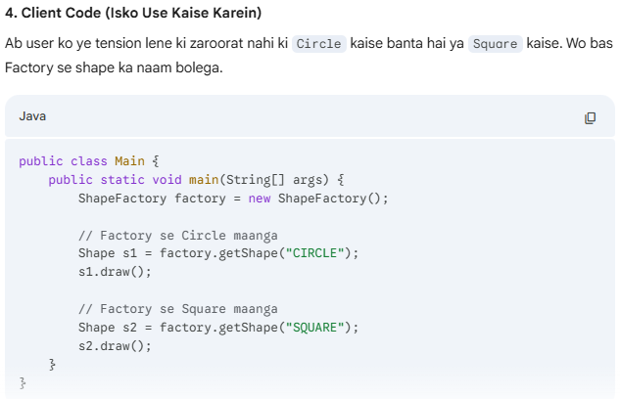
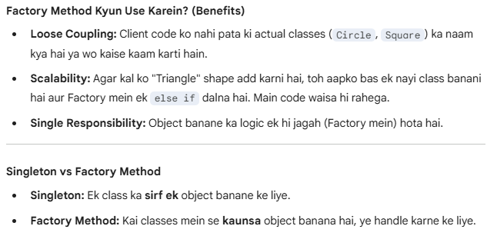

3. Abstract Factory Pattern:
Abstract Factory Pattern ko "Factory of Factories" bhi kaha jata hai.
Jab aapke paas bahut saare related objects hote hain aur aap unhe unki "families" ke hisaab se banana chahte hain, tab Abstract Factory ka use hota hai.
The Abstract Factory Pattern is a creational design pattern that allows you to produce families of related objects without specifying their concrete classes.
Think of it as a "factory of factories." It provides a way to encapsulate a group of individual factories that have a common theme.
Abstract Factory ek "Factory of Factories" hai.
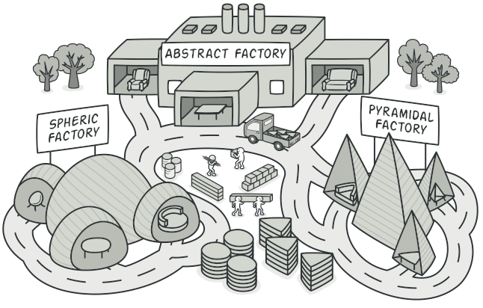
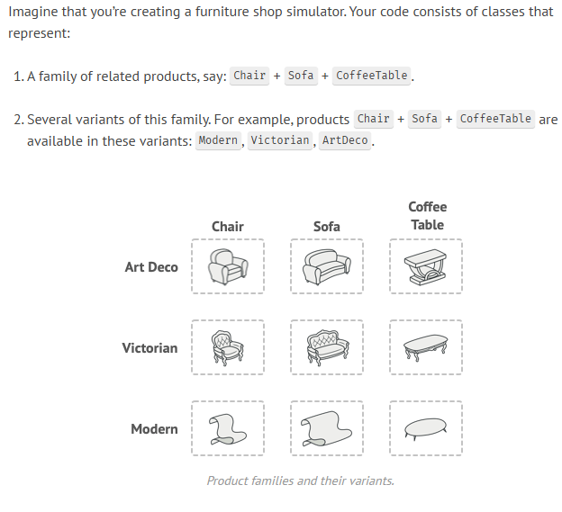
Bilkul, wahi Furniture wala example detail mein dekhte hain. Is pattern ka asli maza tab aata hai jab aapke paas multiple product categories (Chair, Sofa, Table) aur multiple styles (Modern, Victorian, Rustic) honge.
Ye example Abstract Factory Pattern ko perfectly justify karta hai kyunki yahan "Consistency" sabse zyada zaroori hai.
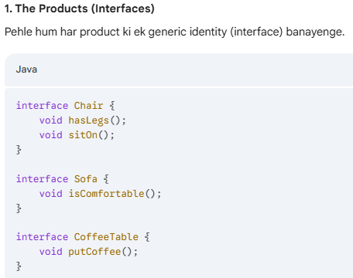
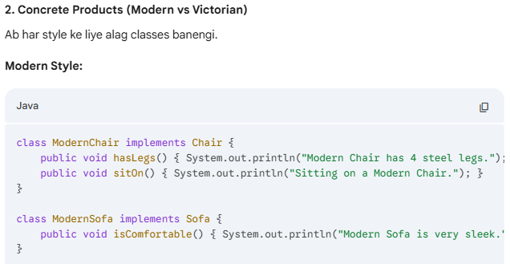
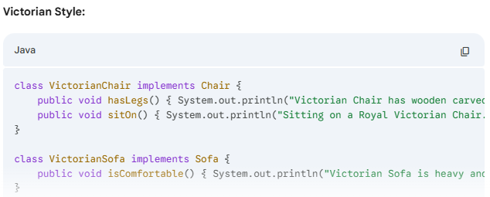
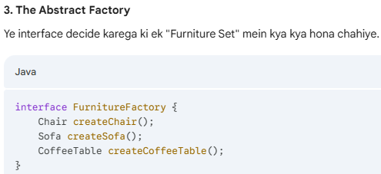
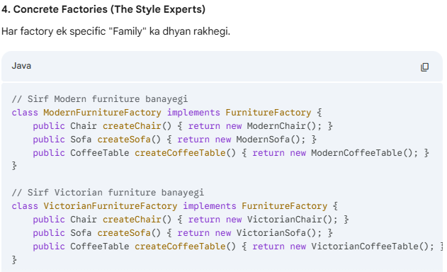
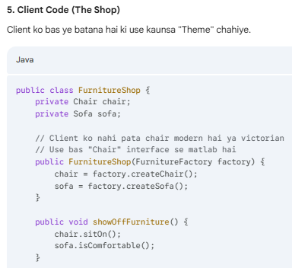
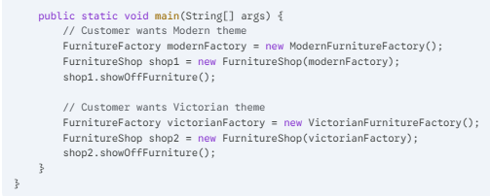

4. Builder Pattern:
Jab ek object bahut complex hota hai aur usse banane ke liye bahut saare steps chahiye hote hain, tab Builder pattern ka use hota hai. Ye step-by-step object construction mein help karta hai.
Builder Pattern Kya Hai
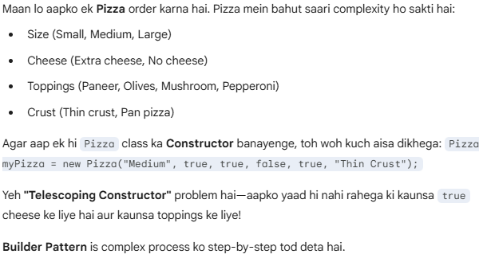
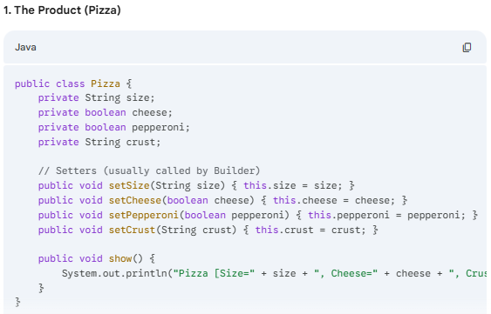
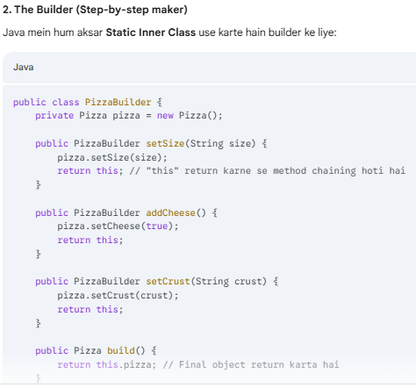
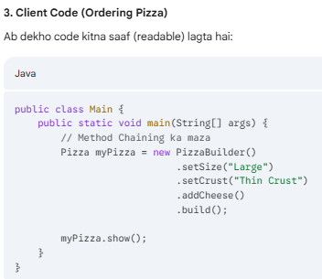

5. Prototype Pattern:
Agar ek object banana bahut "expensive" (memory ya time consuming) hai, toh hum naya object banane ki jagah purane object ki copy (clone) bana lete hain.
Maan lo aapke paas ek aisa object hai jise create karne mein bahut mehnat lagti hai—shayad woh database se heavy data fetch karta hai ya koi complex calculation karta hai.
Ab agar aapko bilkul waisa hi ek aur object chahiye, toh aap fir se wahi heavy process follow nahi karna chahenge. Prototype Pattern kehta hai: "Naya object scratch se banane ke bajaye, purane object ki Copy (Clone) bana lo."
Isse hum "Object Cloning" bhi kehte hain.
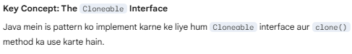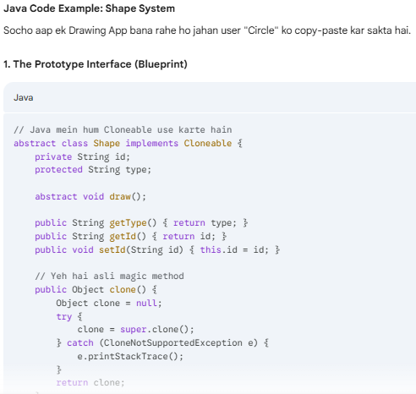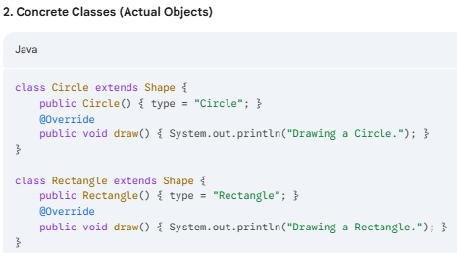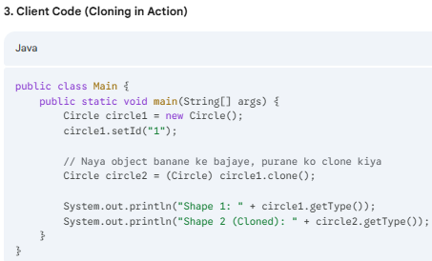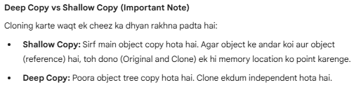

Structural Design Patterns:
Structural design patterns explain how to assemble objects and classes into larger structures, while keeping these structures flexible and efficient.
Structural Design Patterns ka main focus is baat par hota hai ki kaise classes aur objects ko aapas mein joda jaye (assemble kiya jaye) taaki ek bada aur flexible structure ban sake.
Agar Creational patterns "object banane" ke baare mein hain, toh Structural patterns "objects ke rishte" (relationships) ko manage karne ke baare mein hain. Inka maqsad ye hota hai ki agar system ka ek hissa change ho, toh poora structure disturb na ho.
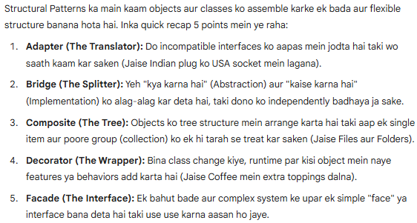
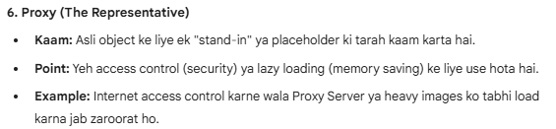

Adapter Pattern:
Adapter is a structural design pattern that allows objects with incompatible interfaces to collaborate.
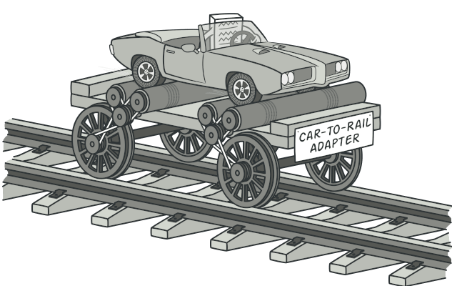
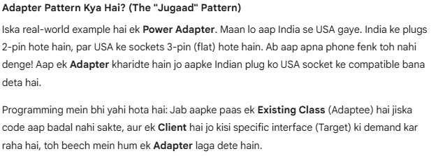
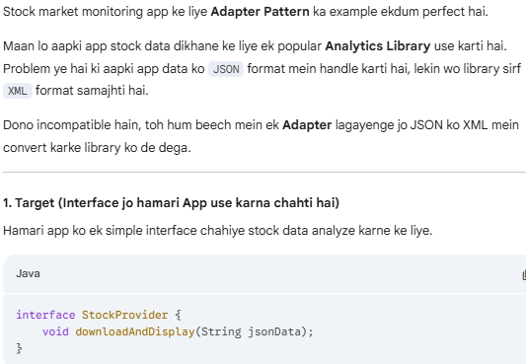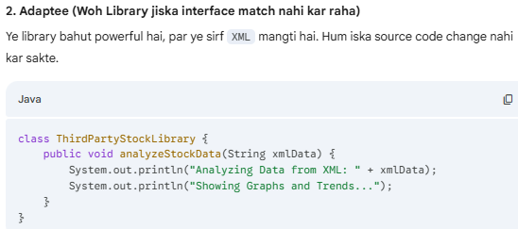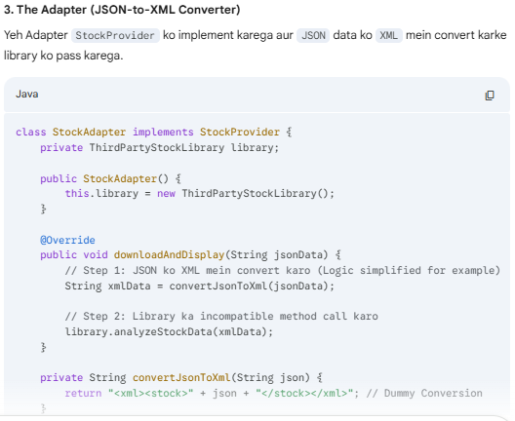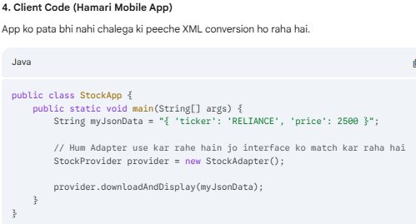

2. Facade Pattern:
Facade is a structural design pattern that provides a simplified interface to a library, a framework, or any other complex set of classes.
Example: Jab aap Amazon par "Place Order" button dabate hain, toh peeche Inventory, Payment, aur Shipping jaise 10 complex systems kaam karte hain, lekin aapke liye sirf ek button (Facade) hota hai.
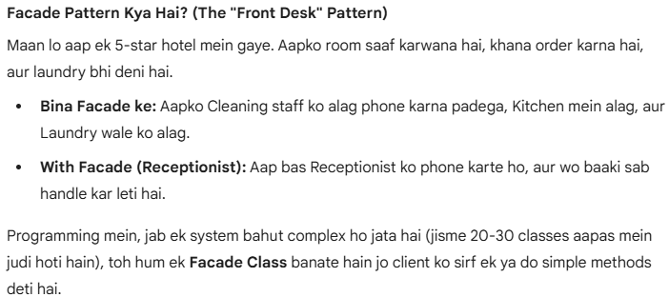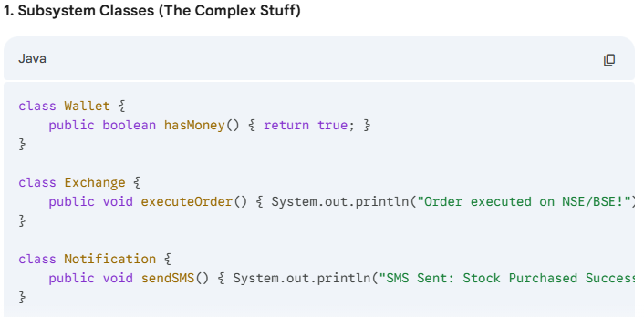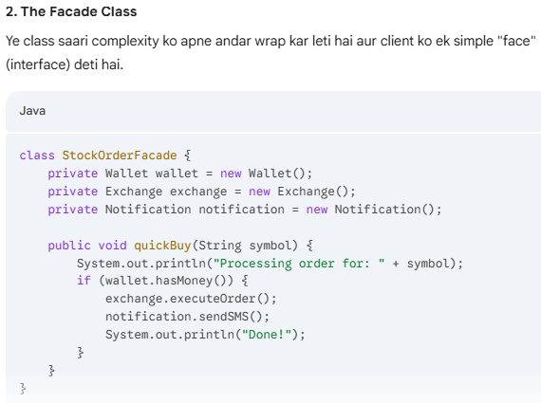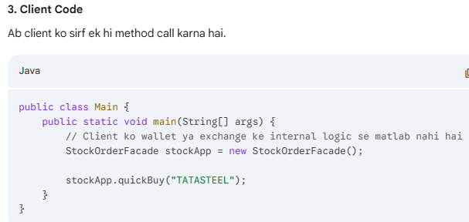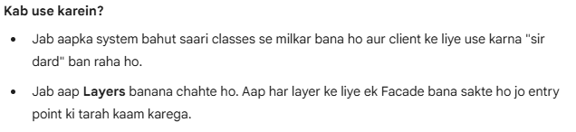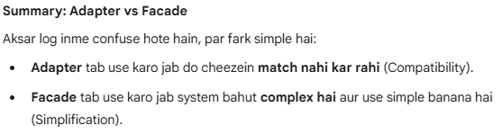

3. Decorator Pattern:
Decorator is a structural design pattern that lets you attach new behaviors to objects by placing these objects inside special wrapper objects that contain the behaviors.
Ab aate hain Decorator Pattern par. Yeh pattern tab kaam aata hai jab aap kisi object ki functionality ko dynamically (runtime par) badhana chahte ho, bina uski original class ko chhede (modify kiye).
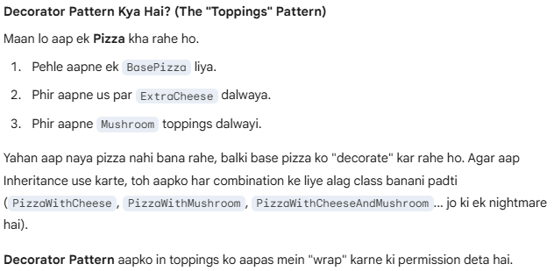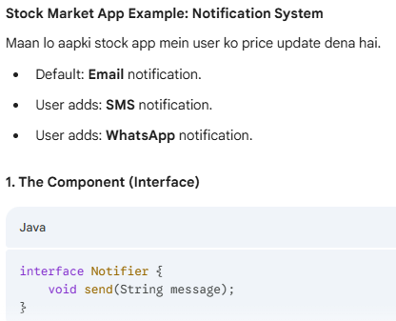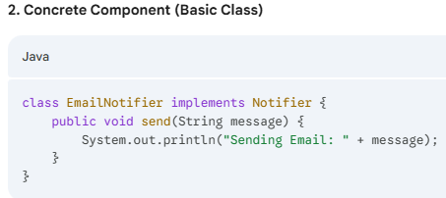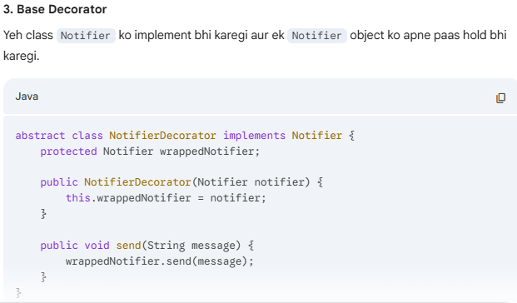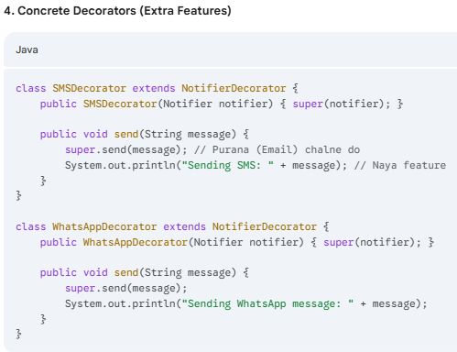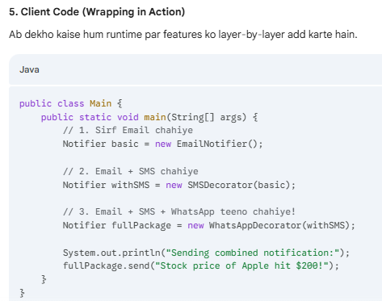

4. Proxy Pattern:
Proxy is a structural design pattern that lets you provide a substitute or placeholder for another object. A proxy controls access to the original object, allowing you to perform something either before or after the request gets through to the original object.
Proxy Pattern ek aisa Structural Design Pattern hai jo ek "placeholder" ya "representative" object provide karta hai.
Simple words mein: Proxy ek Security Guard ya Middleman ki tarah kaam karta hai. Jab aap kisi asli object ko direct access nahi dena chahte, toh aap beech mein Proxy laga dete hain.
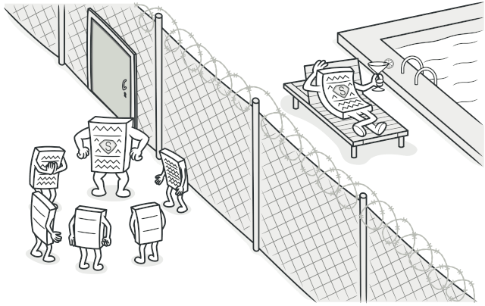
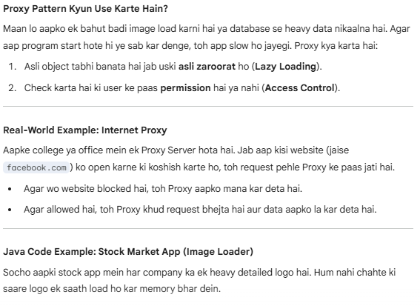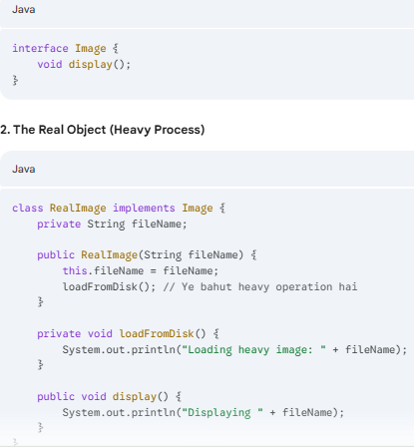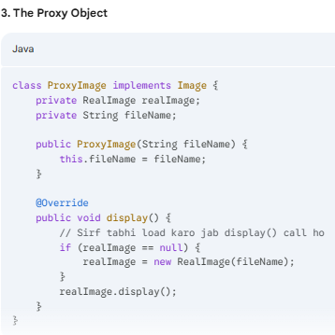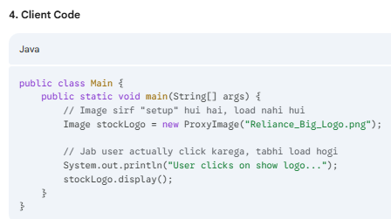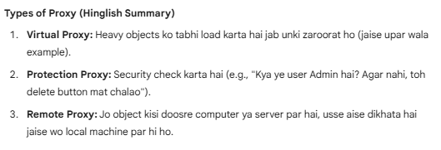
Why would you want to control access to an object? Here is an example: you have a massive object that consumes a vast amount of system resources. You need it from time to time, but not always.

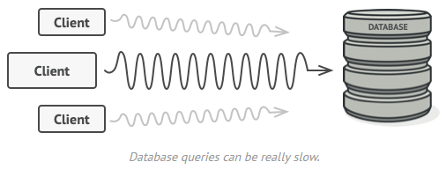
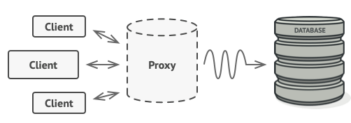

5. Composite Pattern:
Composite is a structural design pattern that lets you compose objects into tree structures and then work with these structures as if they were individual objects.
Composite Pattern ek aisa Structural Design Pattern hai jo aapko objects ko tree structure mein organize karne ki permission deta hai taki aap poore structure ko (chahe wo ek single object ho ya group of objects) ek hi tarah se treat kar sakein.
Simple word mein: Jab aapka "Part" (Single item) aur "Whole" (Collection) dono ka behavior same ho, tab hum Composite Pattern use karte hain.
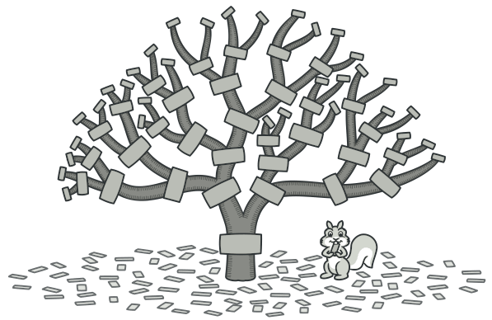
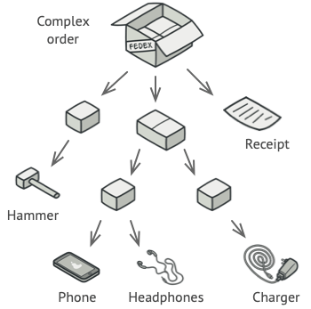
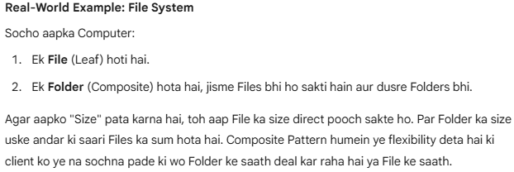
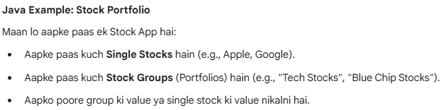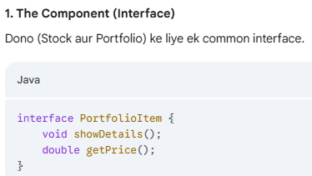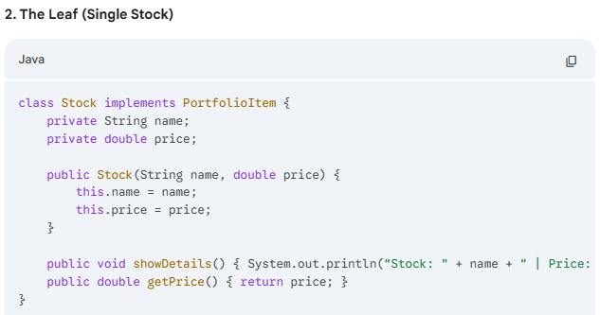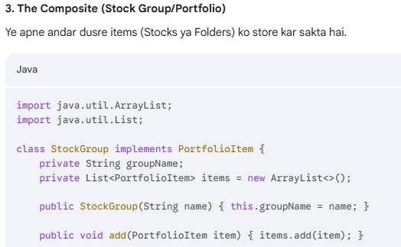
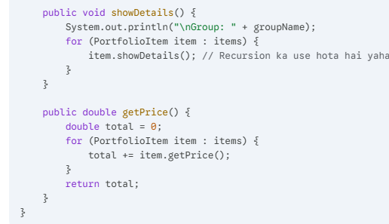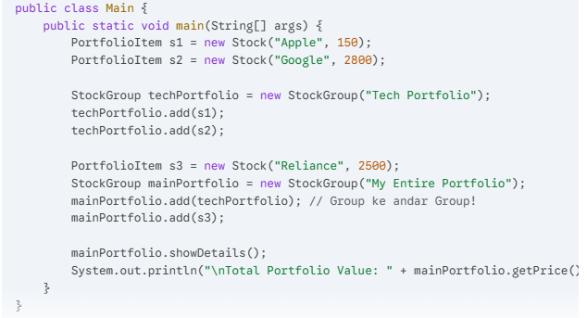

6. Bridge Pattern:
Bridge is a structural design pattern that lets you split a large class or a set of closely related classes into two separate hierarchies—abstraction and implementation—which can be developed independently of each other.
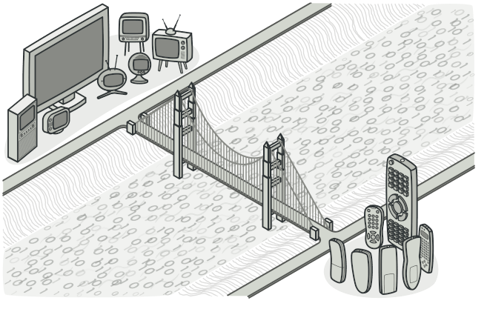
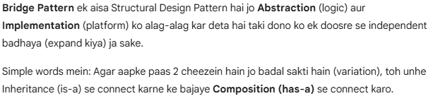
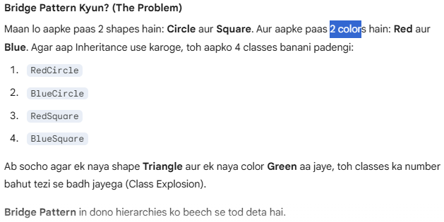
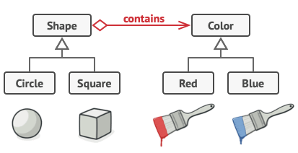
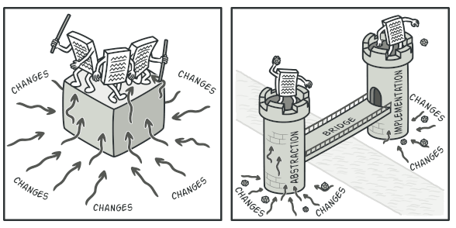
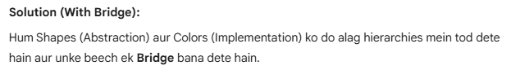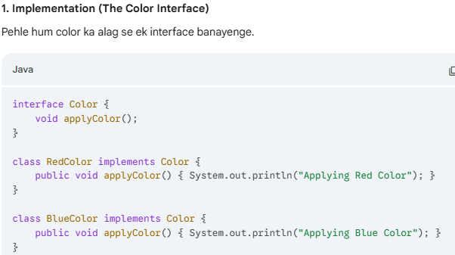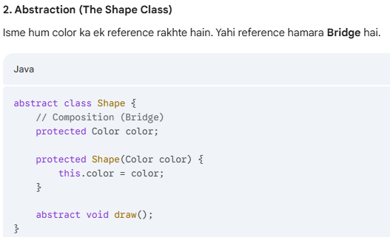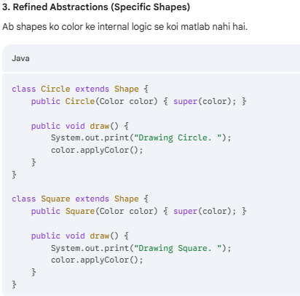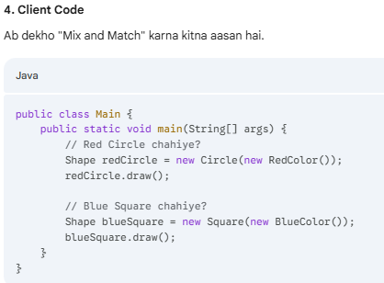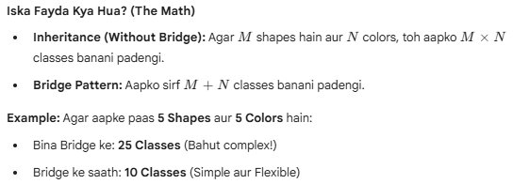

Behavioral Design Patterns:
Behavioral design patterns are concerned with algorithms and the assignment of responsibilities between objects.
Yeh patterns is baate par focus karte hain ki objects aapas mein baat (communication) kaise karte hain aur unki responsibilities kaise divide hoti hain.

1. Observer Pattern:
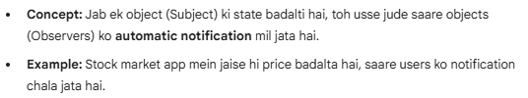

2. Strategy Pattern:
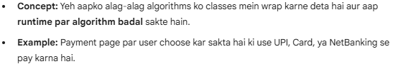

3. Command Pattern:
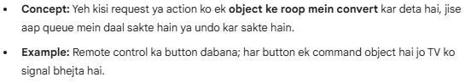

4. State Pattern:
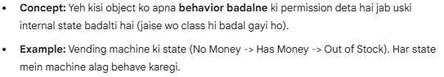

5. Iterator Pattern:
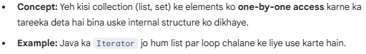

6. Template Method Pattern:
