Steps to create a keystore from Command line

Create command:
Keytool –gemkeypair –alias testkey –keyalg RSA –keypass testkey –keystore servermap.jks

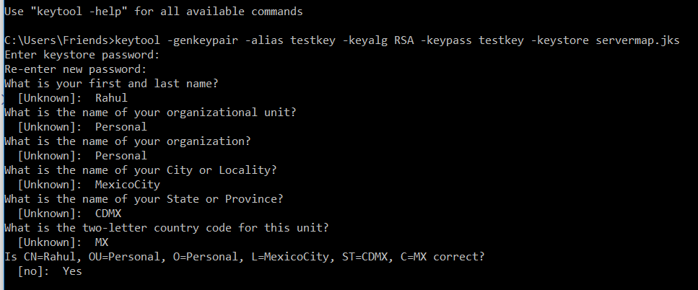

Display command:
Keytool –v –list –keystore servermap.jks
