YEAR: 2026

bLINKIT ANALYTICS PROJECT

SQL-Based Business Analysis Report

Prepared By:
Rahul Chowdhury

Tools Used:
• PostgreSQL
• Excel

Project Focus:
• Sales & Revenue Analysis
• Delivery Performance Analysis
• Customer Satisfaction Analysis
• Inventory Management Analysis
• Marketing & Promotional Analysis

Index:
- Blinkit Business Analytics Project

- Project Overview

- Dataset Overview

- Business Questions

- Analysis & Findings

- Recommendations

- SQL Concepts Used

- Conclusion

Project Overview:
The aim of this project is to analyse Blinkit's sales performance, delivery efficiency, inventory management, customer satisfaction, demand patterns, and promotional strategies using SQL. Through data-driven analysis, the project identifies key business trends, operational challenges, and opportunities for improvement, and provides recommendations to support better decision-making and business growth.

Dataset Overview:
Dataset Name: Blinkit Dataset
Total Records: 13,000
Unique Products: 12,617

Key Attributes:
• Product Name
• Category
• City
• Sold Quantity
• Final Price
• Profit Margin %
• Delivery Time
• Customer Rating
• Offer Type
• Shelf Life
• Reorder Level
• Stock
• Demand Index

Tools Used:
• PostgreSQL
• Excel (for validation and visualization)

Business Questions:

Sales & Revenue
- Which products contribute the most to overall sales volume and revenue?
SQL Query:
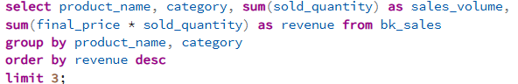

Output:
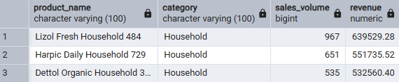

Key Findings:
• The top revenue-generating products were predominantly from the Household category, indicating strong customer demand for household essentials.
• The concentration of multiple Household products among the highest-performing items suggests that the category is a major contributor to overall sales volume and revenue within the dataset.
Business Recommendation:
- Analyse the characteristics of top-performing Household products and expand the product portfolio with similar items to capitalize on existing customer demand.
- Ensure consistent stock availability of high-revenue products, as stock-outs in these items could have a significant impact on overall revenue generation.
- Consider bundling complementary household products and cross-selling related items to increase average order value.

- Within the highest-revenue category, which products are the top revenue contributors?
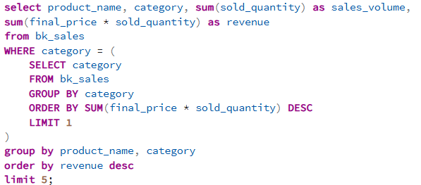
SQL Query:

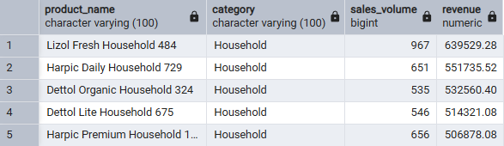
Output:

Key Findings:
- The Household category emerged as the highest revenue-generating category within the dataset.
- Household cleaning products dominated the top-performing products by revenue, indicating strong and consistent consumer demand for essential household items.
- Brands such as Lizol, Harpic, and Dettol appeared repeatedly among the highest-revenue products, suggesting that established brands may play a significant role in driving sales performance.
Business Recommendation:
- Conduct further analysis to determine the factors driving the success of top-performing products, including brand reputation, pricing strategy, promotional offers, product availability, and shelf life.
- Use these insights to identify opportunities for expanding the product portfolio with similar high-demand products and optimizing inventory planning.

Delivery
- How does average delivery time vary across cities?
SQL Query:

Output:
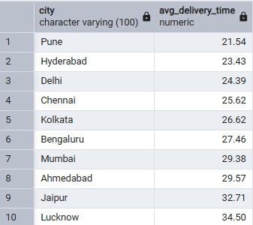
Key Findings:
- The average delivery for all the cities is different from one another
- Average delivery times varied across cities, indicating differences in delivery efficiency and operational performance.
- Pune has the lowest average delivery time, while Lucknow has the highest.
Business Recommendation:
- Investigate the operational factors contributing to Pune's low delivery times, such as inventory availability, traffic conditions, delivery distance, and logistics efficiency.
- Apply successful practices from high-performing cities to slower-performing locations such as Lucknow to improve delivery speed, customer experience, and overall operational efficiency.
- Continuously monitor city-level delivery performance to identify bottlenecks and maintain service quality.

- How do the highest-revenue categories compare in terms of profitability, delivery performance, and customer satisfaction?
SQL Query:
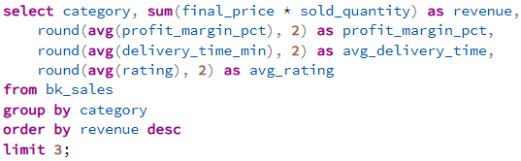
Output:
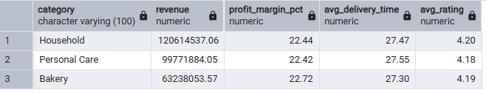
Key Findings:
- Household, Personal Care, and Bakery emerged as the top revenue-generating categories within the dataset.
- Household generated the highest revenue, significantly outperforming the other categories.
- Despite substantial differences in revenue, all three categories exhibited remarkably similar average profit margins, delivery times, and customer ratings.
- The results suggest that factors other than profit margin, delivery performance, and customer satisfaction may be contributing to the higher revenue generated by the Household category.
Business Recommendation:
- Conduct further analysis to identify the factors driving the superior revenue performance of the Household category, including product assortment, pricing strategy, promotional effectiveness, stock availability, and demand patterns.
- Revenue performance should be evaluated alongside profitability metrics to identify categories that generate sustainable business value rather than simply high sales volume.
- Investigate why the Household category generates substantially higher revenue while maintaining a profit margin similar to other top-performing categories. Identifying cost drivers, pricing strategies, discounting practices, and operational inefficiencies may reveal opportunities to improve profitability without compromising sales performance.

Customer
- How do customer ratings vary among the most heavily discounted products?
SQL Query:
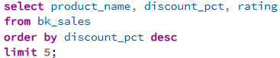
Output:
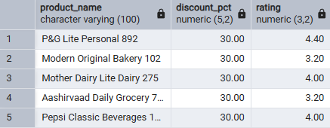
Key Findings:
- Even among products offering the highest discount (30%), customer ratings varied considerably.
- The results suggest that discounts alone do not guarantee higher customer satisfaction.
- Other factors such as product quality, brand reputation, availability, and perceived value may have a greater influence on customer ratings than discounts alone.
Business Recommendation:
- Promotional discounts should not be used as the sole strategy for improving customer satisfaction, as highly discounted products still exhibit varying customer ratings.
- Conduct further analysis of product quality, brand perception, customer reviews, and product availability to identify the factors most strongly influencing customer ratings.
- Focus on improving the overall customer experience in addition to offering discounts, as customer satisfaction appears to depend on multiple factors beyond price reductions.
- What relationship exists between delivery performance and customer satisfaction?
SQL Query:
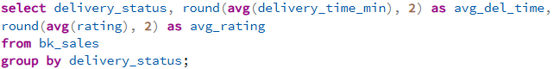

Output:
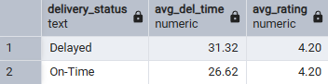

Key Findings:
- Delayed deliveries exhibited substantially higher average delivery times than On-Time deliveries.
- Despite the difference in delivery times, both delivery groups maintained nearly identical average customer ratings.
- The results suggest that delivery speed alone may not be the primary factor influencing customer ratings within this dataset.
Business Recommendation:
- Avoid evaluating customer satisfaction solely through delivery speed, as delayed and On-Time deliveries received similar average ratings.
- Conduct additional analysis to identify the factors most strongly influencing customer satisfaction, including product quality, pricing, brand reputation, packaging, and product availability.
- Maintain efficient delivery operations while also monitoring broader customer experience metrics to better understand rating behaviour.

Inventory
- What is the shelf-life profile of organic products, and which products are most susceptible to early expiration?
SQL Query:
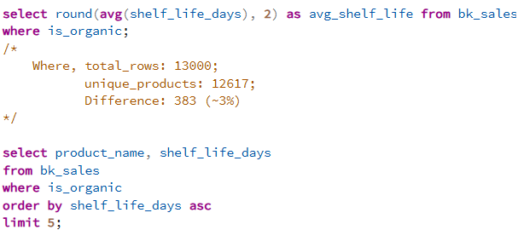

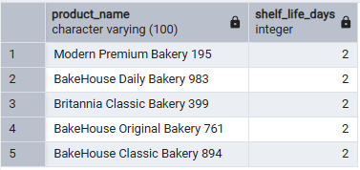
Output:

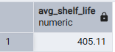

Key Findings:
- Organic products in the dataset have an average shelf life of approximately 405 days.
- Despite the relatively long average shelf life, certain organic products exhibit significantly shorter shelf lives and may be more vulnerable to spoilage.
- The presence of short-lived products alongside long-lived products highlights the need for differentiated inventory management strategies within the organic product segment.
Business Recommendation:
- Closely monitor inventory levels for organic products with shorter shelf lives to reduce the risk of expiration and product wastage.
- Implement category-specific replenishment strategies rather than applying a uniform inventory policy across all organic products.
- Prioritize demand forecasting for highly perishable organic products to maintain product freshness while minimizing excess stock.
- Does shelf life appear to influence inventory reordering requirements?
SQL Query:
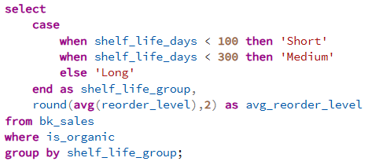
Output:
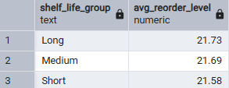
Key Findings:
- Products with short, medium, and long shelf lives exhibited very similar average reorder levels.
- The results suggest that shelf life alone does not appear to be a significant factor influencing inventory replenishment decisions within this dataset.
- Other factors, such as product demand, sales volume, stock availability, or inventory policies, may have a stronger influence on reorder levels.
Business Recommendation:
- Inventory replenishment strategies should not rely solely on product shelf life, as no clear relationship was observed between shelf life and reorder levels.
- Further analysis should be conducted to evaluate the impact of demand, sales volume, stock levels, and product popularity on inventory replenishment requirements.
- Consider incorporating multiple inventory metrics when determining reorder thresholds to improve stock management and reduce the risk of stock-outs or excess inventory.

Marketing
- How do demand levels and stock availability vary across cities?
SQL Query:
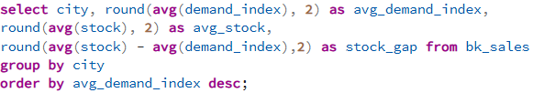
Output:
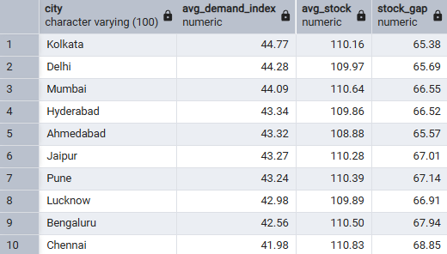
Key Findings:
- Demand levels and stock availability varied across cities, indicating differences in local market conditions and inventory requirements.
- Some cities exhibited higher demand indices while maintaining relatively similar stock levels, suggesting that inventory allocation may not always be directly proportional to demand.
- The stock gap metric highlights cities where inventory levels may require closer monitoring to ensure that customer demand can be met efficiently.
Business Recommendations:
- Regularly review inventory allocation across cities to ensure stock levels are aligned with local demand patterns.
- Prioritize inventory planning in cities with higher demand indices to reduce the risk of stock-outs and lost sales opportunities.
- Monitor stock gaps and demand trends continuously to improve forecasting accuracy and optimize inventory distribution.

10. How do promotional offers impact sales volume and revenue generation?
SQL Query:
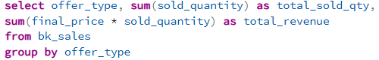
Output:
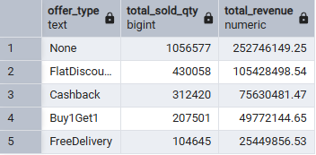
Key Findings:
- Products without promotional offers generated the highest sales volume and revenue within the dataset.
- Among promotional strategies, Flat Discount and Cashback offers were associated with stronger sales performance than Buy1Get1 and Free Delivery offers.
- The results suggest that promotional offers alone may not be the primary driver of sales, as products without offers still outperformed promoted products.
Business Recommendations:
- Evaluate promotional campaigns based on incremental sales and profitability rather than assuming that discounts automatically increase revenue.
- Further investigate product demand, brand strength, pricing, and customer preferences to determine why non-promotional products achieved the highest sales performance.
- Focus promotional efforts on products and categories where discounts or incentives demonstrate measurable business value rather than applying offers uniformly across all products.

SQL Concepts Used:
• Data Definition Language (DDL)
- CREATE TABLE
- DROP TABLE
• Data Import
- COPY command
• Data Retrieval
- SELECT
- WHERE
- ORDER BY
- LIMIT
• Aggregation Functions
- SUM()
- AVG()
- ROUND()
• Grouping & Filtering
- GROUP BY
- HAVING
• Conditional Logic
- CASE WHEN
• Subqueries
- Nested SELECT statements
• Basic Business Analytics
- Revenue Analysis
- Inventory Analysis
- Customer Rating Analysis
- Delivery Performance Analysis
- Demand & Stock Analysis

Conclusion:
This project demonstrated how SQL can be used to transform raw business data into meaningful insights. Through the analysis of Blinkit's sales performance, delivery efficiency, inventory management, customer satisfaction, demand patterns, and promotional strategies, several key trends and opportunities were identified.
The analysis revealed that Household products were the primary revenue drivers, delivery performance varied across cities, customer ratings were influenced by factors beyond discounts and delivery speed, and inventory decisions appeared to be affected by multiple variables rather than shelf life alone. Additionally, products without promotional offers generated higher sales and revenue than promoted products within this dataset, highlighting the importance of evaluating performance from multiple perspectives.
Overall, this project strengthened practical SQL skills while demonstrating the process of converting business questions into data-driven findings and actionable recommendations.

