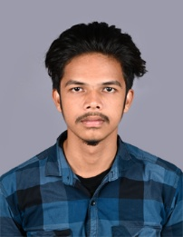

**RAHUL C T**

**Indira Nagar(east) – 2nd Street**

**Sulur, Coimbatore - 641402**

# Cell : 8072360944 E-m[ail :vprtamil@gmail.com](mailto:vprtamil@gmail.com),

# [rahul04cbe@gmail.com](mailto:rahul04cbe@gmail.com)

**Educational Qualification:**

* BCA

RVS College of Arts and Science(Autonomous)

Sulur,Coimbatore - 641402

Year of passing : April 2024

First : 79%

* 12 th standard

GHSS, kuttalam

Percentage : 77%

* 10 th standard

New Star Matriculation School, kuttalam

Percentage : 79%

# Skill Set

Java, javascript

# Courses Completed

* Completed a online course on “ Java Certification course” in skillup by simplilearn.
* Completed a online course on ” Java programming” in GreatLearning Academy .
* Completed a online course on ” OOPS in Java” in GreatLearning Academy .
* Completed the online course on “Python Fundamentals for Beginners” in GreatLearning Academy.

# Personal Details :

Name : RAHUL C T

Gender : Male

Date of Birth : 04/05/2004

Nationality : Indian Languages known : Tamil , English

The above details are true to the best of my knowledge

Thanking You

Yours Faithfully,

# [RAHUL C T]