**Alumni Directory**

Submitted in partial fulfillment of the requirements of the degree

## BACHELOR OF ENGINEERING IN INFORMATION TECHNOLOGY

By

|  |  |
| --- | --- |
| **Prabhit Chaugule – 20101A0031**  **Rahul Chougule - 20101A0055** |  |
|  |  |
|  |  |

Supervisor

**Prof. Rohit Bharve**



**Department of Information Technology Vidyalankar Institute of Technology**

**Vidyalankar Educational Campus,**

**Wadala(E), Mumbai - 400 037 University of Mumbai (AY 2021-22)**

# CERTIFICATE

This is to certify that the Mini Project entitled **“Alumni Directory ”** is a bonafide work of Prabhit Chaugule – 20101A0031, Rahul Chougule - 20101A0055 submitted to the University of Mumbai in partial fulfillment of the requirement for the award of the degree of **“Bachelor of Engineering”** in **“Information Technology” .**

##### Prof. Rohit Bharve

Supervisor

##### Dr. Vipul Dalal Dr. S. A. Patekar

Head of Department Principal

# Mini Project Approval

This Mini Project entitled “Alumni directory” by Prabhit Chaugule – 20101A0031, Rahul Chougule - 20101A0055 is approved for the degree of **Bachelor of Engineering in Information Technology.**

#### Examiners

**1………………………………………**

(Internal Examiner Name & Sign)

##### 2…………………………………………

(External Examiner name & Sign)

Date: 14/12/2021

Place: Wadala, Mumbai

# Contents

Abstract ii

Acknowledgments iii

List of Abbreviations iv

List of Figures v

List of Tables vi

List of Symbols vii

1. Introduction 1
   1. Introduction
   2. Motivation
   3. Problem Statement & Objectives
   4. Organization of the Report

##### Literature Survey 11

* 1. Survey of Existing/Similar System
  2. Limitation Existing/Similar system or research gap
  3. Mini Project Contribution

##### 3 Proposed System 18

* 1. Introduction
  2. Architecture/ Framework
  3. Algorithm and Process Design
  4. Details of Hardware & Software
  5. Experiment and Results
  6. Conclusion and Future work

##### 4 References 32

**II. ABSTRACT**

Using our website user can book tickets of the event they want. They can cancel their booking at any time. Admin can post out movie tickets and charge a price on tickets. This system is an auditorium management software projects. It includes all the features and functions needed to efficiently manage an auditorium. It includes an administrator account which is used to handle/control all the system functionality. The system keeps track of auditorium status and advance bookings. The system keeps records of auditorium bookings along with associated event details and customer contacts in a well maintained database. The administrator can easily check the auditorium bookings and timings in the system gui.

##### III. ACKNOWLEDGEMENTS:

I would like to thank our Head of the department Dr Vipul Dalal Sir and our mentor Prof. Rohit Bharve, who helped in completion of our project.

On the occasion of presenting our Capstone project report, we thank our respectful teachers, fellow mates who have given their valuable contribution which has made our project possible. Then I would like to thank my parents and friends who have helped us with their valuable suggestions and guidance which has been helpful in various phases of the completion of the project. I am making this project not only for marks but it will also increase my knowledge. I have no valuable words to express my thanks, but my heart is still full of the favors received from every person.

1. Prabhit Chaugule - 20101A0031
2. Rahul Chougule - 20101A0055

##### IV LIST OF ABBREVIATIONS:

Table 1

|  |  |
| --- | --- |
| UI | User Interface |
| PVM | Python Virtual Machine |

##### V LIST OF FIGURES:

|  |  |  |
| --- | --- | --- |
| **SR**  **No** | **Figure Name** | **Page No** |
| 1 | Block Diagram | 15 |
| 2 | ER Diagram | 16 |
| 3 | Sign UP Page | 19 |
| 4 | Sign In Page | 20 |
| 5 | Home Page | 21 |
| 6 | Event Details Page | 22 |
| 7 | Seat Selection Page | 23 |

**Chapter 1 INTRODUCTION**

This auditorium management website includes all the features and functions needed to efficiently manage an auditorium. It includes an administrator account which is used to handle/control all the system functionality. The system keeps track of auditorium status and advance bookings. The system keeps records of auditorium bookings along with associated event details and customer contacts in a well maintained database. The administrator can easily check the auditorium bookings and timings in the system GUI. The system also notifies when new event timing draws near.

##### Motivation

Their was a demand for online auditorium booking system, where people can access the website and buy their event ticket. Also a lot of thanks to our project guide to inspire us to do this project. Many people want the uniqueness and GUI on their expectations. User also demand of new and unique features like booking cancel.

* 1. **Problem Statement and Objectives**

Users can book ticket of movie they want. Some of the feature of our project are:

* **Admin login and admin dashboard:** It has admin login who is has the authority of the system and he is responsible for approving and disapproving the users request for auditorium booking. Admin can add and delete notifications and updates in the system.
* **User Registration:** There is user registration form available where new users can create their account by providing required information to the system.
* **Booking System:** User can request for the booking for a particular date. Subsequently the system will generate the total cost incurred for the expected days.
* **Approving/Disapproving Request:** The booking requests are directly sent to admin account by the system. Admin can view all the requests along with respective user details and therefore make decisions for approving or disapproving the requests.
* **Email Notification:** The system will inform the respective customers through an email about their status of booking request whether approved or disapproved. Also it mails user their respective receipts.

##### OBJECTIVES:

##### Our website will provide booking online movie tickets services.

##### To keep user highly interactive.

##### To satisfy user demand and solve their problems.

## Organization of Report

Chapter 1 gives introduction about the Mini Project and highlights the motivation behind choice of this Mini Project.

Chapter 2 gives us idea about Existing/Similar systems their limitations and the contribution of this Mini Project to the Society

Chapter 3 tells us the architecture and framework of the project, it also tells us about the algorithm and the Result of the project and what can we add to it in the future.

### Chapter 2

**LITERATURE SURVEY**

* 1. **Survey of Existing/Similar System**

We took a serve of many existing and similar system and we found that they were lacking in some of the features and Gui like:

1) Bookmyshow.

2) Kayak.

##### Limitation Existing/Similar system or research gap

1) **Bookmyshow**:

1. Harder to set setting like Gui and others.
2. Background music noise.
3. Bugs

2) **Kayak**:

1. Unable to find login button
2. Random popups

The limitations in the above mentioned systems are fixed and stabilized in our website which user will not face any issue.

**Advantages:**

* The system is useful as it calculates an exact cost for requested number of days.
* It is convenient for user as he do not have to actually visit the place.
* This system is effective and saves time and cost of the users.
* Easy registration.

**Disadvantages:**

* It reduces employment as the human efforts are being automated by this system.

##### Mini Project Contribution

Our team has contributed on this project to meet user demand. Also each and every member of team have contributed equally.

### Chapter 3

##### PROPOSED SYSTEM

* 1. **INTRODUCTION**

This auditorium management website includes all the features and functions needed to efficiently manage an auditorium. It includes an administrator account which is used to handle/control all the system functionality. The system keeps track of auditorium status and advance bookings. The system keeps records of auditorium bookings along with associated event details and customer contacts in a well maintained database. The administrator can easily check the auditorium bookings and timings in the system GUI. The system also notifies when new event timing draws near.

##### ARCHITECTURE/FRAMEWORK

##### The following figure shows the architectural block diagram of the implemented system.

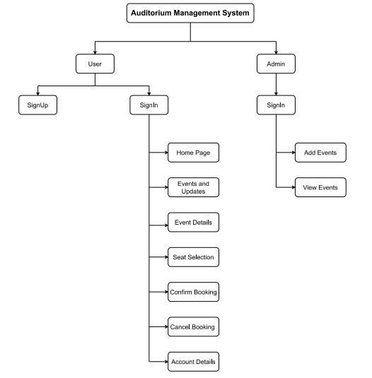

* + - ­­

Figure No: 3.1 Block Diagram

Block Diagram­­­ is divided in two sections:

**User**:

•Users can create Account.

•User can book Tickets.

•Users can cancel Booked Tickets.

**Admin**:

•Admin can Add events.

•Admin can modify details of added events.

##### ALGORITHM AND PROCESS DESIGN

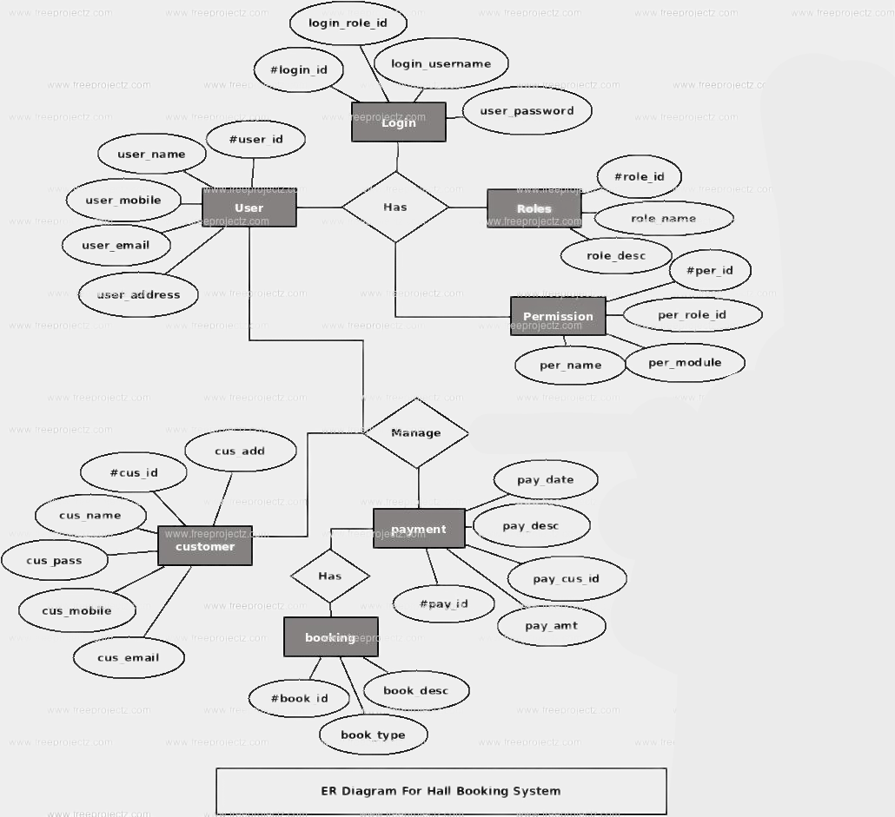Following is an ER diagram for the design of the database for the implemented system.

Figure No: 3.2 ER Diagram

##### There are three distinct components

* + - 1. **Client application-**

This is the front end where our clients communicate with the framework. Its fundamental work is to complete distinctive client orders and get data from the database.

* + - 1. **Database Server-**

It focusses on productively dealing with the assets, for example, various tables in which the information is available. The admin's essential occupation is to deal with the information tables ideally among different Users who simultaneously demand same asset

* + - 1. **Network for connecting the first two components-**

A network and communication software, in other terms, jdbc connections, drivers, libraries, etc. are used to transport the data between the User and the server.

##### DETAILS OF HARDWARE AND SOFTWARE

Developing the system environment calls for the requirement of hardware and software. The hardware and software requirements in our project are-

**Hardware requirements-**

* Basic computer system
* Processor – i3
* Ram- 4Gb
* HDD – 256GB

**Software requirements-**

* Apache NetBeans 8.2
* phpMyAdmin 5.0.3
* jdk 8.0.261
* mysql-connector-java-8.0.22

##### EXPERIMENT AND RESULTS

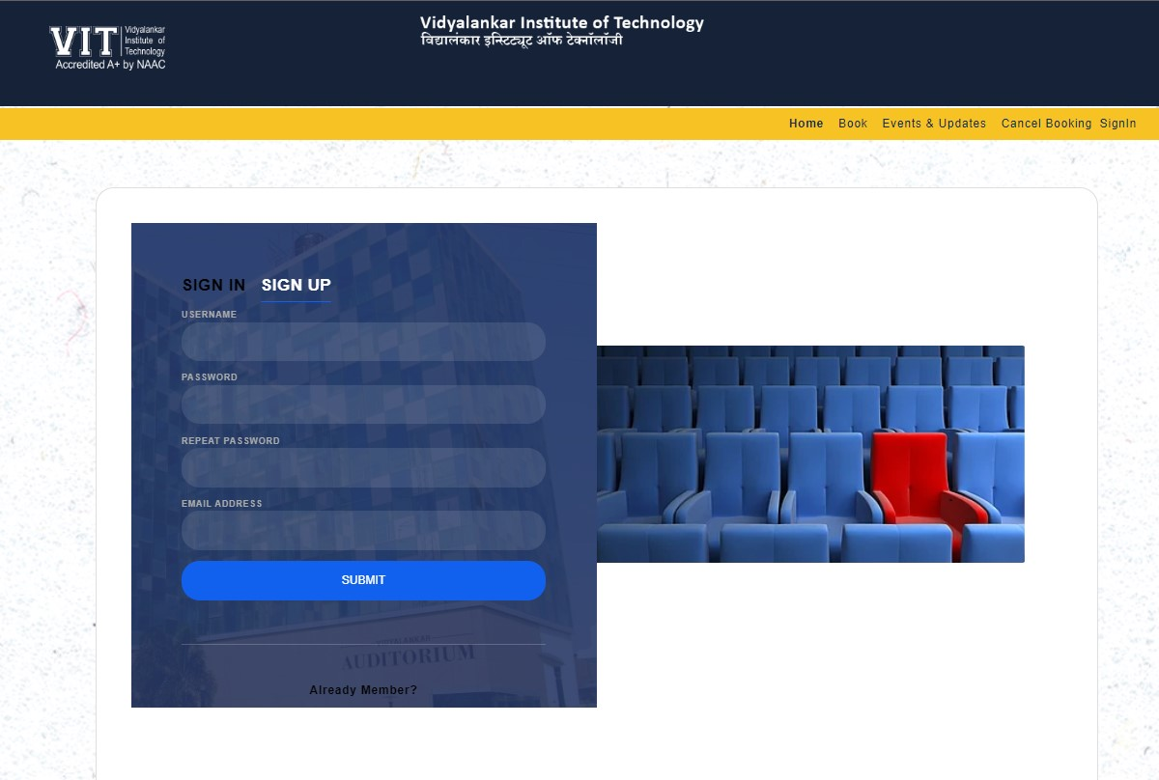

Figure No: 3.3 **SignUp Page**

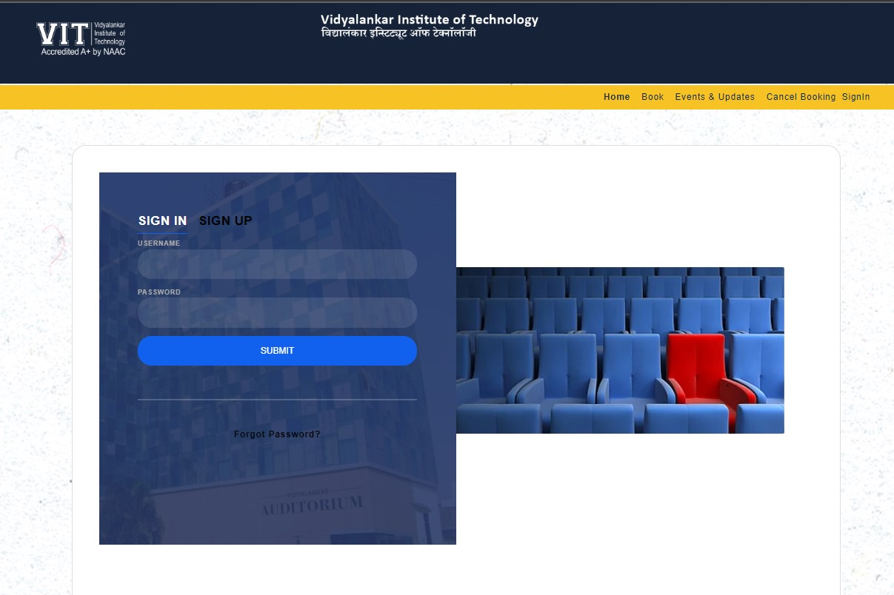

Figure No: 3.4 SignIn Page

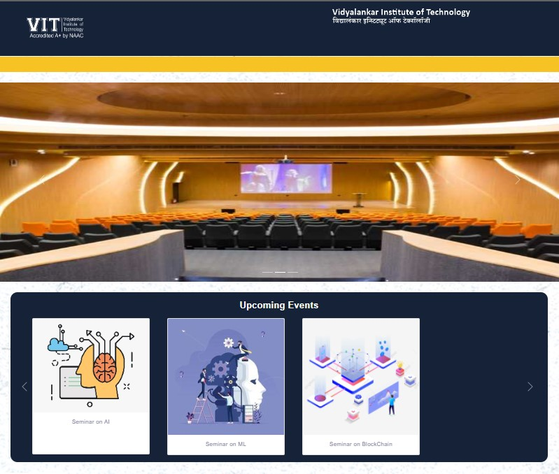 Figure No: 3.5 Home Page

Figure No: 3.6 Event Details Pa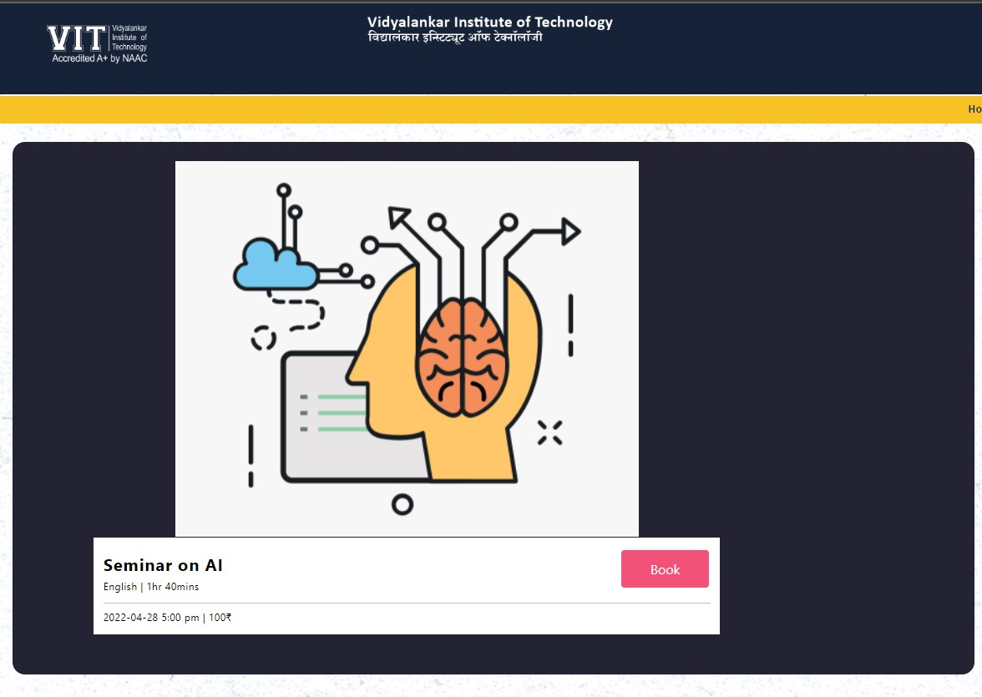ge

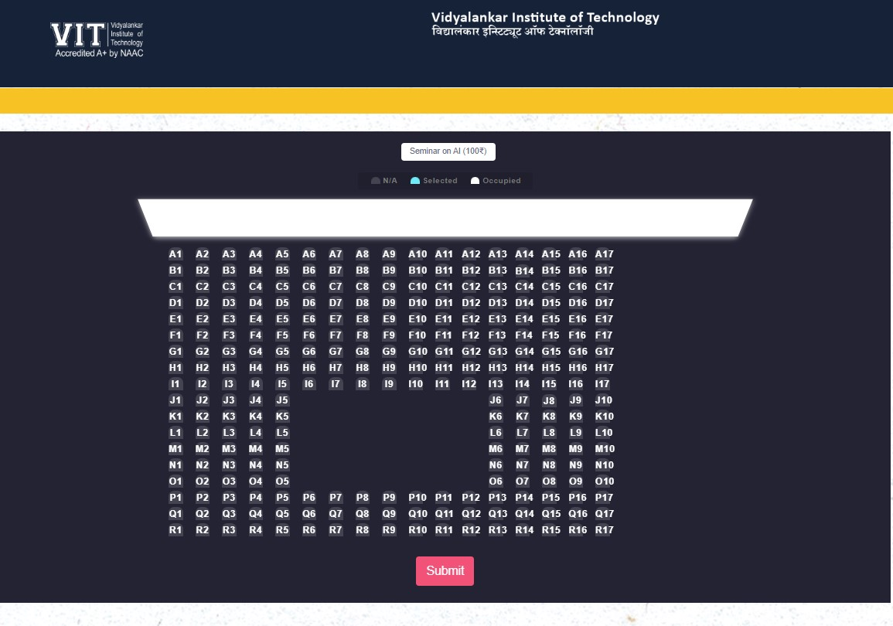 Figure No: 3.7 Seat Selection Page

##### CONCLUSION AND FUTUREWORK

Online auditorium booking system is very important for college/university. This proposed system is a python based application that provides facility for maintaining a central repository of the project. Admins will help the organization in reducing their data collection cost and time. It will increase the number of contact-able alumni.

**REFERENCES**

[1] “PythonConcept” <https://www.javatpoint.com/python-tutorial/>

[2] <http://www.w3schools.com>

[3] <https://www.freeprojectz.com/php-projects-projects/hall-booking-system>

[4] <https://1000projects.org/online-auditorium-booking-management-application.html>

Chapter 6

Our GitHub Repository Link:

<https://github.com/rahulch07/Auditorim-Management-System.git>