CIVICRESOLVE
ONLINE COMPLAINT REGISTRATION &
MUNICIPAL GRIEVANCE RESOLUTION PORTAL
PROJECT REPORT AND TECHNICAL DOCUMENTATION
Full-Stack Web Development Internship
SkillWallet SmartBridge
TECHNOLOGY STACK
MongoDB Atlas • Express.js • React • Node.js
Repository: https://github.com/rahulchate18/CivicResolve
Demonstration video:
https://drive.google.com/file/d/1krFIVeCz5jVzi2uFZ4pLrluTms4N6seV/view
Prepared for internship project review

DOCUMENT INFORMATION
Item | Details
Project title | CivicResolve — Online Complaint Registration & Municipal Grievance Resolution Portal
Project category | Full-stack web application / internship project
Internship context | SkillWallet SmartBridge
Technology | MongoDB, Express.js, React, Node.js (MERN)
Source repository | https://github.com/rahulchate18/CivicResolve
Demo video | https://drive.google.com/file/d/1krFIVeCz5jVzi2uFZ4pLrluTms4N6seV/view
Document status | Expanded report draft; screenshots and final test output should be verified before submission

REPORT GUIDE
This report follows the broad structure of the supplied SpeakEase sample: introduction, scenario-based case study, system requirements, architecture and MVC, project setup, development structure, data models, workflow, screenshots, testing, and conclusion. CivicResolve-specific descriptions are used; features not confirmed as implemented are identified as conditional or verification items.
- 1. Introduction and background
- 2. Problem statement, objectives and scope
- 3. Scenario-based case study
- 4. System requirements
- 5. Technology stack and technical architecture
- 6. MVC pattern
- 7. Functional modules and user roles
- 8. Data model and ER diagram
- 9. Application workflow and sequence diagram
- 10. Project structure and setup
- 11. Backend development
- 12. Frontend development
- 13. Security and validation
- 14. Testing and verification
- 15. Output screenshots and demo evidence
- 16. Limitations and future enhancements
- 17. Conclusion and references

1. INTRODUCTION
CivicResolve is a web-based complaint registration and grievance-resolution portal designed to bring citizens and complaint-handling staff into a shared digital workflow. A citizen can create a complaint, retain its tracking identifier, and review the available status information. Authorized officers can process complaints and update their status according to the permissions implemented by the application.
The project is built with the MERN stack. React provides the browser-based user interface; Node.js and Express.js provide server-side request handling and REST endpoints; MongoDB stores application records; and Mongoose defines the document schemas and database operations. The backend is separated into routes, controllers, models, validators, authentication/authorization middleware, and centralized error handling.

1.1 Purpose of the project
The purpose is to demonstrate how a modern full-stack web application can organize a complaint lifecycle, from initial submission to review and resolution, while applying authentication, role-based access, input validation, and maintainable application structure.

1.2 Intended audience
- Citizens who need to submit and follow up on civic issues.
- Officers or agents who review and process assigned complaints.
- Administrators who oversee the operations exposed by their authorized dashboard.
- Developers and evaluators reviewing the project's design, implementation, and testing approach.

1.3 Project boundary
CivicResolve is documented as an academic/internship application. This report does not claim official integration with a municipal authority, production service-level guarantees, or deployment-scale performance testing. Only workflows available in the final running build should be demonstrated as completed features.

2. PROBLEM STATEMENT, OBJECTIVES AND SCOPE

2.1 Problem statement
When civic complaints are managed through disconnected channels or manually, it can be difficult to maintain a consistent record of the issue, identify its current status, determine who is responsible for processing it, and communicate progress to the person who reported it. Staff may also need a consistent method for reviewing and prioritizing incoming complaints.
CivicResolve addresses this problem by centralizing complaint details and status information in a web application. It provides a common record for the citizen-facing and staff-facing parts of the workflow.

2.2 Objectives
- Provide user registration and login.
- Allow a citizen to submit complaint details through a structured form.
- Generate a unique tracking identifier in the format CMP-YYYYMMDD-XXXXXX.
- Store complaint category, priority, current status, contact details, attachments and status history as supported by the model.
- Support role-aware access for citizens, officers/agents and administrators.
- Support complaint-related messages and feedback models where connected to the active UI/API.
- Use server-side validation, JWT authentication, role authorization and centralized error handling.
- Keep the code organized so that routes, controllers, models and middleware can be maintained and tested separately.

2.3 Scope
Included in the documented design | Not claimed without further verification
Account authentication and protected API patterns | Official municipal or government-system integration
Complaint records and tracking identifier | Guaranteed resolution deadlines or service-level agreements
Role-aware officer/administrator workflows | Production uptime or large-scale performance benchmarks
Data models for users, complaints, agents, feedback and messages | Any screen or function not present in the final build
Validation, error handling and automated tests | Formal third-party security certification

3. SCENARIO-BASED CASE STUDY

3.1 Background
A city resident notices a civic issue such as damaged street lighting, a road defect, or a sanitation concern. The resident wants a reliable way to register the issue and return later to see whether the complaint has been reviewed.

3.2 Illustrative user persona
Attribute | Illustrative detail
Name | Ananya Shah (fictional persona)
Role | Citizen / resident
Goal | Register a civic issue and follow its progress
Challenges | Uncertainty about whether a complaint was received; difficulty keeping reference details; limited visibility into status
Expected outcome | A recorded complaint, a tracking identifier and accessible status information

3.3 The challenge
- The citizen needs a structured form rather than an informal message.
- The complaint needs a persistent identifier so it can be found later.
- Staff need a record with enough information to review the issue.
- Status changes should be reflected in the application so the citizen can check progress.

3.4 How CivicResolve addresses the scenario
- The citizen opens the application and signs in or registers.
- The citizen enters the complaint title, description, category, priority and required contact information.
- The frontend submits the request to the backend API.
- The backend validates the input, applies relevant access checks, creates the complaint record and generates a tracking ID.
- The citizen receives a response and can use the dashboard or available complaint view to check the record.
- An authorized officer reviews the complaint and updates the status as the case progresses.
- After a resolution, feedback may be submitted if that workflow is available in the current build.
Scenario note: This is an illustrative use case, not a record of a real complaint or a guarantee that every step is enabled in every deployment.

4. SYSTEM REQUIREMENTS

4.1 Software requirements
Software / tool | Purpose
Windows 10/11, macOS or Linux | Operating system for development and execution
Node.js | JavaScript runtime for the backend and tooling
npm | Dependency installation and project scripts
React + Vite | Frontend UI development and local development server
Express.js | HTTP routing and backend API framework
MongoDB Atlas or configured MongoDB | Document database for application records
Mongoose | Schema modeling and database access
Modern browser (Chrome / Edge / Firefox) | Run and test the web interface
Git and GitHub | Version control and source repository
Code editor such as VS Code | Project editing and debugging

4.2 Hardware requirements
Component | Practical development recommendation
Processor | Modern multi-core CPU capable of running a browser and Node.js processes
Memory | 8 GB RAM as a practical baseline; 16 GB improves multitasking
Storage | Enough free disk space for source files, npm dependencies, logs and screenshots
Network | Internet access for package installation, GitHub and remote database access

These hardware values are practical recommendations, not formal benchmark results. Actual requirements depend on the development environment and workload.

4.3 User requirements
- Users need a modern browser and an active network connection to access a deployed instance.
- A user must authenticate before accessing protected functions.
- A user should only see or modify resources allowed by the role and ownership checks in the active implementation.
- The server must have its required environment variables configured privately.

5. TECHNOLOGY STACK AND TECHNICAL ARCHITECTURE

5.1 Technology stack
Technology | Layer | Role
React | Presentation | Builds interactive pages, forms and dashboards.
Vite | Frontend tooling | Runs the development server and builds frontend assets.
Node.js | Runtime | Executes server-side JavaScript.
Express.js | API / routing | Defines REST endpoints and request-processing pipeline.
Mongoose | Data access | Defines schemas and performs MongoDB operations.
MongoDB Atlas | Persistence | Stores user, complaint and related application documents.
JWT | Authentication | Carries signed authentication claims for protected requests.
Validation middleware | Request quality | Checks request payloads before business logic executes.
Git / GitHub | Version control | Tracks and hosts source code.

5.2 Technical architecture diagram
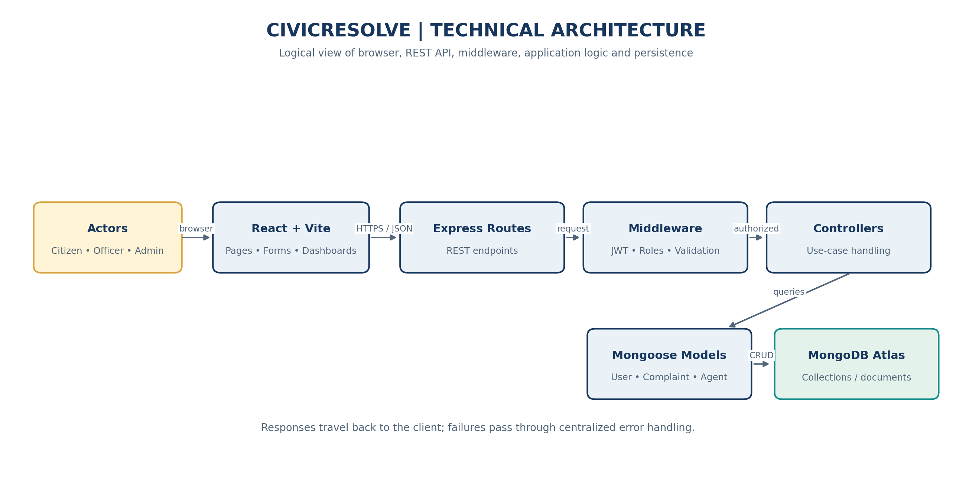
Figure 1. High-level technical architecture of CivicResolve.

5.3 Architecture layers
Layer | Responsibility | Typical processing
Presentation layer | User interaction | Render forms, dashboards, complaint status and feedback.
API / routing layer | Map HTTP requests | Receive GET/POST/PUT/PATCH/DELETE requests and route them.
Middleware layer | Cross-cutting checks | Authenticate JWT, authorize roles, validate payloads, handle errors.
Controller layer | Coordinate use cases | Read request values, call relevant model operations, return status and JSON.
Model / data layer | Data structure and persistence | Mongoose schemas and queries backed by MongoDB collections.

5.4 Typical request and response
- The browser gathers user input and sends an HTTP request to the API.
- Express matches the request to a route and executes the applicable middleware.
- Authentication and authorization checks run where required; validators reject invalid data.
- The controller coordinates the operation and calls the relevant Mongoose model.
- MongoDB stores or retrieves the document, and the controller builds the response.
- The API returns JSON and an HTTP status; the frontend updates the view or presents an error.

5.5 Architecture benefits
- Separation of concerns makes responsibilities easier to locate.
- Reusable middleware avoids repeating authentication and validation logic in every handler.
- A model layer provides a consistent interface for reading and writing documents.
- A REST API allows the frontend and backend to be developed and tested independently.
- The structure supports incremental extension while preserving existing behavior.

6. MVC PATTERN
Model–View–Controller (MVC) is a design pattern that separates data handling, user-facing presentation and request coordination. CivicResolve uses an MVC-like separation across the MERN application. The mapping below is conceptual: React provides the browser View, Express controllers coordinate API operations, and Mongoose models manage persistence. Express routes and middleware support the controller layer.
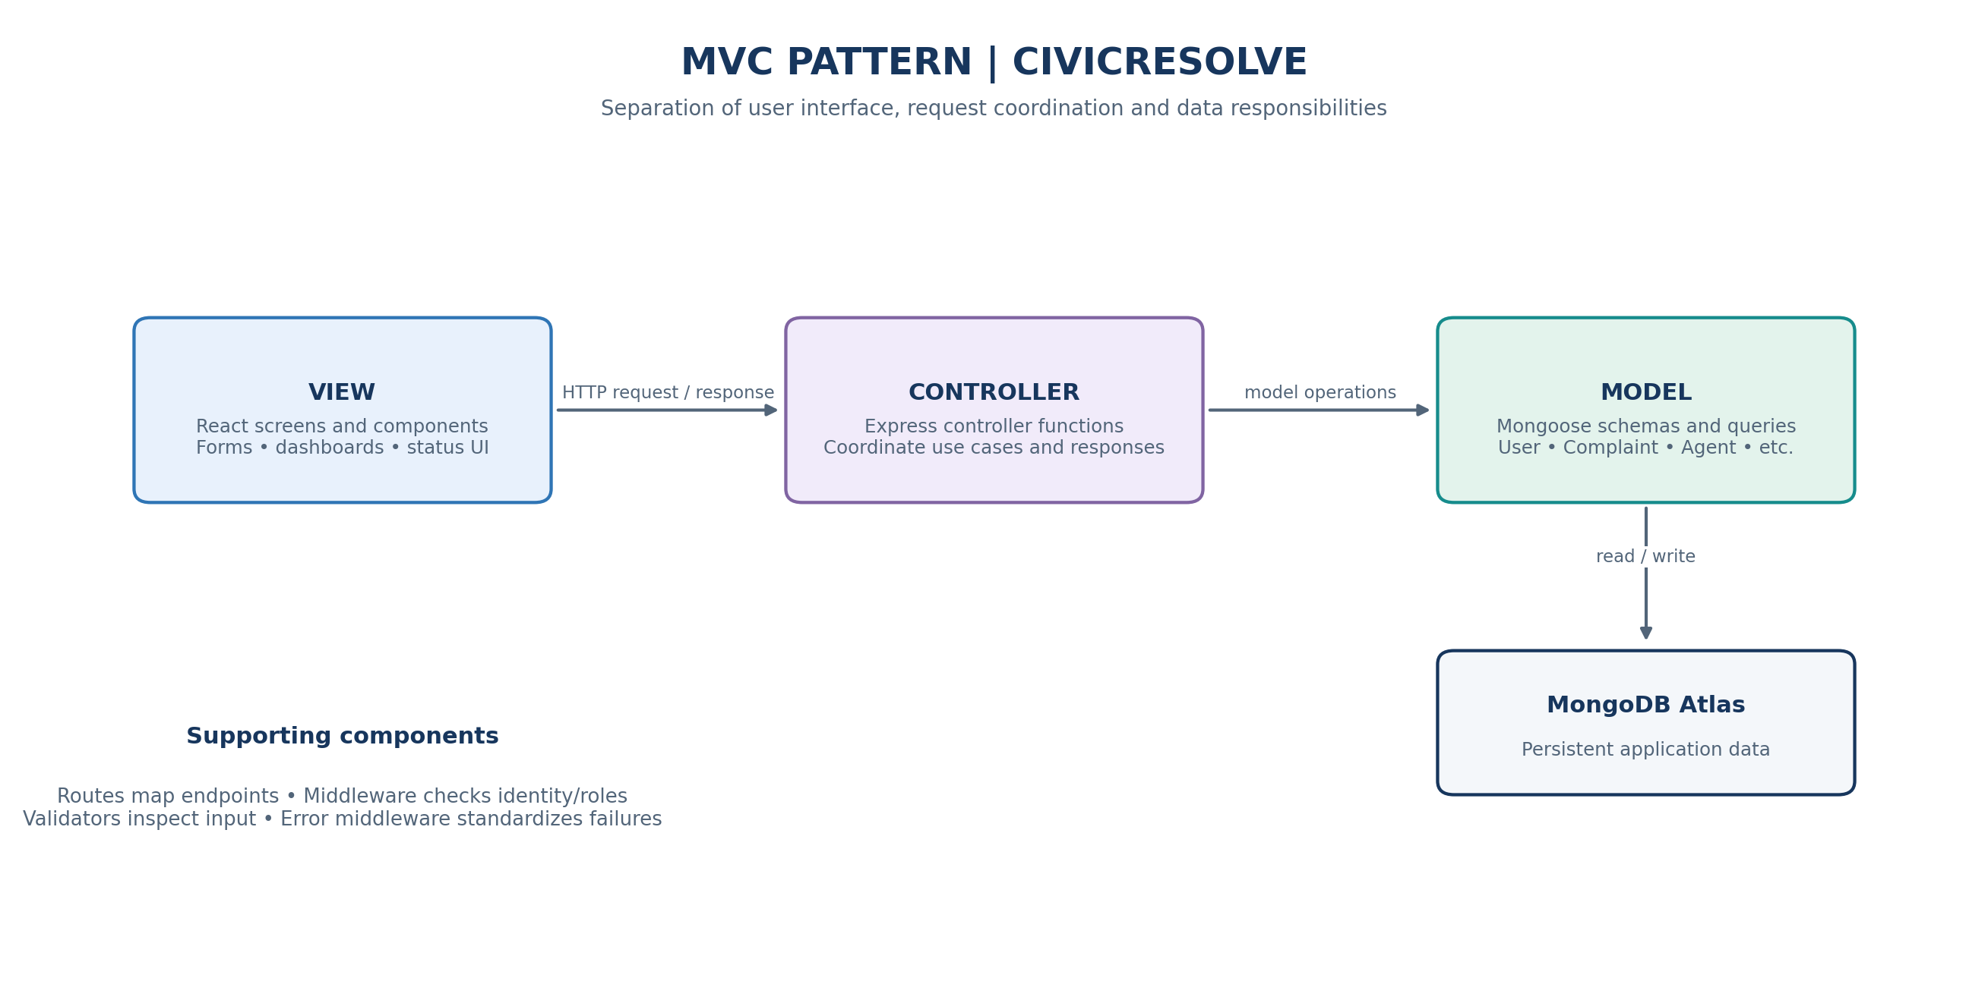
Figure 2. MVC pattern mapped to the CivicResolve stack.
MVC component | CivicResolve mapping | Detailed responsibility
Model | User, Complaint, Agent, Feedback and Message Mongoose models | Define document fields, constraints, defaults, enums and database operations.
View | React pages, forms and reusable UI components | Display complaint lists and details; collect user input; show status and errors.
Controller | Express controller functions | Coordinate requests, apply use-case logic, invoke models and return API responses.
Routing support | Express route modules | Connect URL + HTTP method to the appropriate middleware/controller.
Middleware support | JWT auth, role authorization, validators, error middleware | Apply cross-cutting checks and standardize failure responses.

6.1 Model layer
The Model layer represents application data and exposes operations to read or update it. The Complaint model contains a generated tracking ID, complaint text, category, priority, status, citizen contact information, attachments and status history. The User, Agent, Feedback and Message models represent the other major parts of the complaint domain.

6.2 Controller layer
A controller receives a request after the route and applicable middleware have processed it. It reads validated request data, coordinates the operation, interacts with one or more models, and returns an HTTP status and response body. Controllers should not expose database credentials or internal stack traces to clients.

6.3 View layer
The React frontend acts as the View. It presents inputs and results, sends API requests, and renders loading, success and error states. The frontend should not be treated as the final security boundary; server-side authentication and authorization remain necessary.

6.4 Advantages in CivicResolve
- Maintainability: changes can be localized to the relevant layer.
- Testability: model validation, controller behavior and middleware can be tested independently.
- Extensibility: new complaint-related modules can follow existing route/controller/model conventions.
- Collaboration: frontend and backend work can proceed against a stable API contract.
- Security: shared middleware centralizes access checks and request validation.

7. FUNCTIONAL MODULES AND USER ROLES

7.1 Citizen module
- Register and log in using the supported authentication flow.
- Create a complaint with the fields required by the application.
- View complaint information and its tracking identifier where exposed by the interface.
- Review available status updates and history.
- Use messaging or feedback features if enabled in the final UI and API.

7.2 Officer / Agent module
- Access only the complaint views and actions permitted to the signed-in role.
- Review complaint description, category, priority and current status.
- Update complaint status through authorized operations.
- Use supported complaint-related communication features.
- Agent records include department, specialization, approval status, availability and workload-related fields.

7.3 Administrator module
- Access administrator views exposed by the application.
- Review management information available in the current build.
- Perform only the actions granted by server-side authorization rules.
- Avoid assuming that every user-management function exists unless it can be demonstrated.

7.4 Complaint tracking module
A complaint tracking identifier is generated in the pattern CMP-YYYYMMDD-XXXXXX. The Complaint model also includes status and a status-history audit trail, which help represent how the complaint changes over time.

7.5 Messaging and feedback models
Message and Feedback models are present in the described backend model set. The report treats their user-facing workflows as conditional: verify the actual UI routes and permissions in the final build before claiming them as end-to-end features.

8. DATA MODEL AND ER DIAGRAM
MongoDB is a document database rather than a relational database. The following ER-style diagram is a conceptual view of the main domain entities. The exact reference fields, embedded subdocuments and cardinalities must be checked against the current Mongoose schemas before treating the figure as a physical database specification.
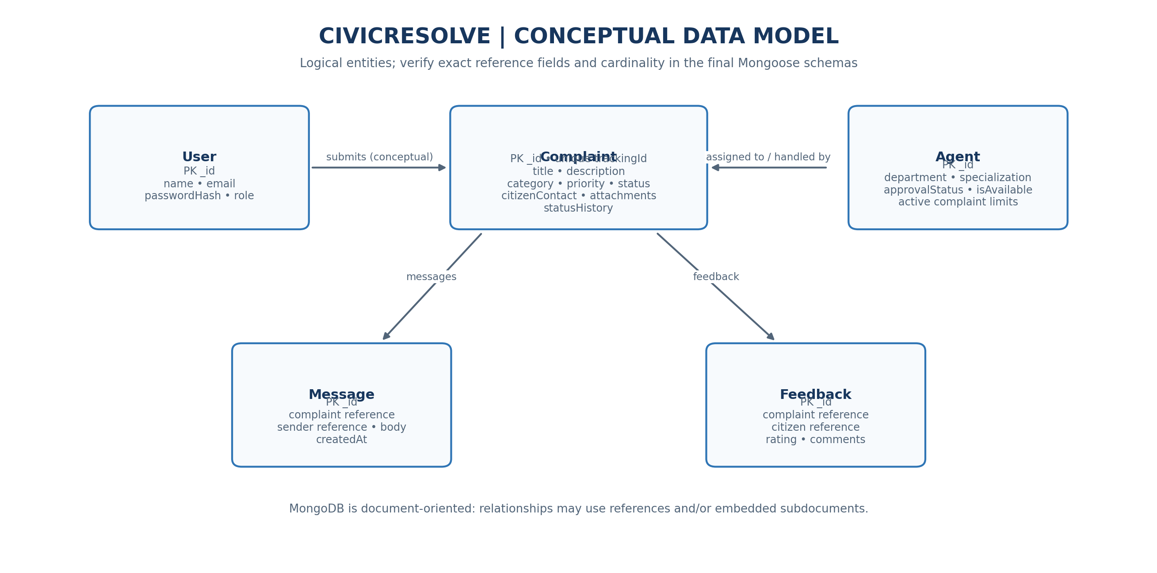
Figure 3. Conceptual entity relationship diagram for the main CivicResolve models.
Model | Purpose | Known data / fields
User | User identity and access role | Name, email, password hash and role (exact field names should be verified in schema).
Complaint | Core grievance record | Tracking ID, title, description, category, priority, status, citizen contact, attachments, status history.
Agent | Officer/agent profile and capacity | Department, specialization, approvalStatus, isAvailable, maxActiveComplaints, activeComplaintsCount.
Feedback | Feedback related to complaint handling | Feedback information associated with a complaint; confirm exact fields in schema.
Message | Complaint-related communication | Message records associated with a conversation/complaint; confirm exact fields and references.

8.1 Complaint entity — key fields
Field / group | Purpose
trackingId | Human-readable identifier, generated in CMP-YYYYMMDD-XXXXXX format.
title and description | Summarize the civic issue and provide details for review.
category | Classifies the type of complaint using supported values.
priority | Represents the urgency classification using supported values.
status | Represents the current stage in the complaint lifecycle.
citizenContact | Subdocument for contact details, as defined by the schema.
attachments | Stores attachment metadata or references, depending on implementation.
statusHistory | Audit-trail entries that record status changes and associated metadata.

8.2 Agent entity — key fields
Agent records include approvalStatus (PENDING, APPROVED, REJECTED), department, specialization, isAvailable, maxActiveComplaints and activeComplaintsCount. These fields can support assignment and workload control where the corresponding application logic is implemented.

8.3 Data integrity considerations
- Tracking identifiers should be unique and generated consistently.
- Enumerated fields should reject unsupported category, priority and status values.
- Required fields should be validated before persistence.
- Access to complaint documents should respect role and ownership rules.
- Status-history entries should be written alongside successful status changes to preserve traceability.

9. APPLICATION WORKFLOW

9.1 User flow diagram
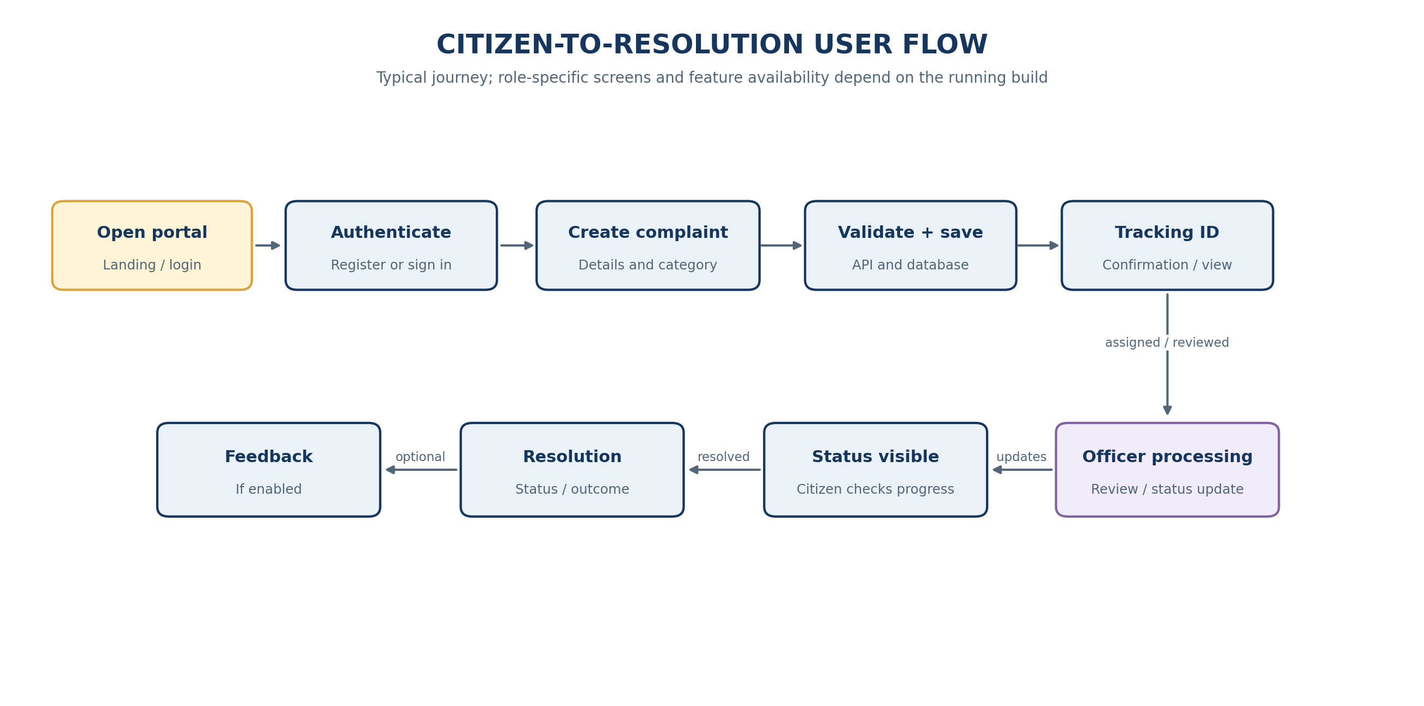
Figure 4. Typical citizen-to-resolution workflow.

9.2 Complaint creation sequence diagram
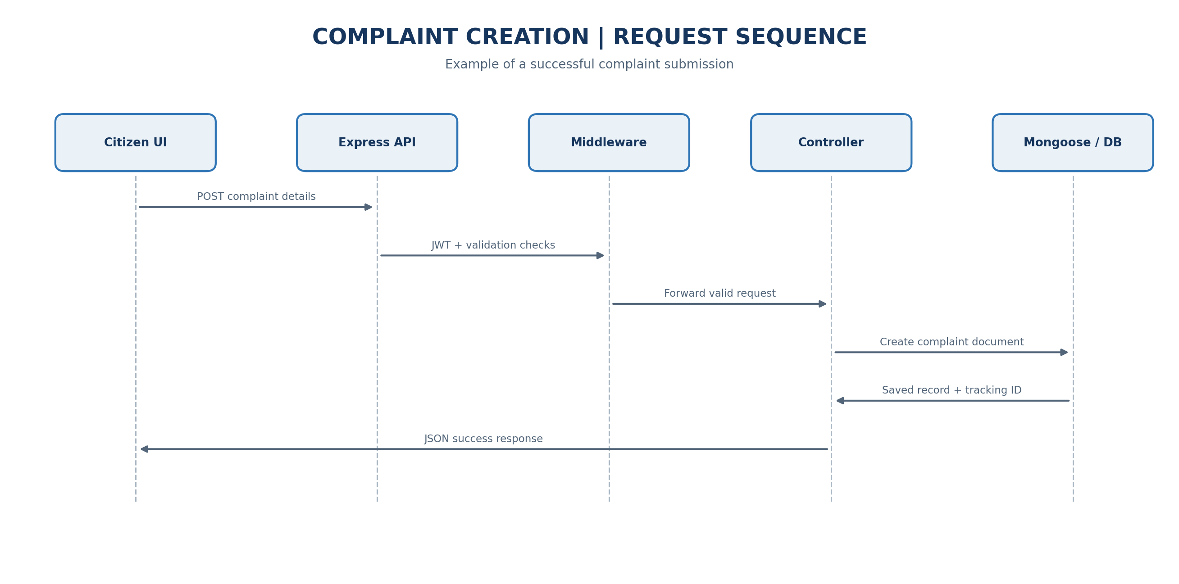
Figure 5. Example request sequence for creating a complaint.

9.3 Detailed complaint lifecycle
- Access: a user opens the application and signs in or registers.
- Submission: the citizen completes the complaint form with required details.
- Validation: the server checks payload shape and required fields; protected routes check identity and permissions.
- Creation: the controller coordinates the model operation and the server generates a tracking identifier.
- Persistence: MongoDB stores the complaint document and related fields.
- Confirmation: the API returns the created record or a safe confirmation response.
- Review: an authorized officer reviews the complaint and updates its status as allowed.
- Follow-up: the citizen checks the current status and available history.
- Closure and feedback: the case is marked resolved through the supported workflow; feedback can be recorded if enabled.

9.4 Exception and alternate flows
Condition | Expected handling
Missing or invalid fields | Validator rejects the request and returns a client error.
No/invalid authentication token | Protected route denies the request.
Insufficient role permissions | Authorization middleware denies the restricted action.
Complaint not found | Controller returns an appropriate not-found response.
Database/provider failure | Centralized error handling returns a safe error response.
Duplicate tracking ID or persistence conflict | Handle the persistence error safely and avoid reporting a false success.

10. PROJECT STRUCTURE AND SETUP

10.1 Logical project structure
The following structure reflects the known backend organization. Exact frontend folder names and additional files may differ in the current repository; confirm them from the checked-out source.
CivicResolve/
├── client/ or frontend/ # React + Vite user interface
│ ├── src/
│ │ ├── components/ # Reusable interface components
│ │ ├── pages/ # Application screens
│ │ ├── context/ # Shared client state, if used
│ │ ├── services/ or api/ # HTTP client and API calls
│ │ └── main.jsx / main.tsx
│ ├── package.json
│ └── .env.example
├── server/
│ ├── config/ # Database / runtime configuration
│ ├── models/ # User, Complaint, Agent, Feedback, Message
│ ├── controllers/ # Request and business-operation handlers
│ ├── routes/ # Express endpoint definitions
│ ├── middleware/ # Auth, authorization, validation, errors
│ ├── validators/ # Request validation rules
│ ├── tests/ # Automated tests
│ ├── server.js
│ ├── package.json
│ └── .env.example
├── documentation/
└── .gitignore

10.2 Prerequisites
- Install a supported Node.js release and npm.
- Clone the repository from https://github.com/rahulchate18/CivicResolve.
- Have access to the configured MongoDB Atlas project or another supported MongoDB instance.
- Use the repository's environment example files to identify required variables.

10.3 Backend setup
- Open PowerShell and change to the repository folder.
cd C:\Users\rahul\online-complaint-registration
cd server
npm install

- Create a local .env file using server/.env.example as a guide. Enter the actual database URI and JWT secret locally; do not put secrets in the report or GitHub.
- Start the server using the development/start script defined in server/package.json.
- Confirm the terminal indicates that the API is listening and the database connection succeeds.

10.4 Frontend setup
# Open a second PowerShell terminal
cd C:\Users\rahul\online-complaint-registration
# Enter the actual frontend directory (client or frontend)
npm install
npm run dev

The project has previously run with the backend at http://localhost:5000 and the frontend at http://localhost:5174. Treat these as previously observed development URLs, not guarantees; use the ports printed by the current terminal.

10.5 Environment and repository safety
- Never commit real .env files, database credentials, JWT secrets, or user passwords.
- Commit sanitized .env.example files only.
- Keep database access limited to the necessary users and network sources.
- Review git status before committing generated reports, screenshots or build files.

11. BACKEND DEVELOPMENT

11.1 Express server
The backend entry point starts the Express application, configures middleware and routes, connects to the database, and listens on the configured port. A health-check route was previously verified at the root endpoint; confirm its current response before using it as evidence.

11.2 Routes and controllers
Routes declare the API surface and map each HTTP method/path to middleware and a controller. Controllers coordinate authentication, complaint, agent, feedback and message operations that are present in the source. The authentication route set includes registration and login endpoints at /api/auth/register and /api/auth/login.

11.3 Authentication and authorization
JWT-based middleware verifies access tokens for protected endpoints. Authorization middleware checks whether the authenticated role is permitted to perform an operation. For endpoints that operate on user-specific resources, ownership must be checked by the server rather than trusted from client-supplied IDs.

11.4 Validation and centralized error handling
Dedicated validators check supported request payloads. Validation errors and unexpected exceptions are passed through centralized error handling so that clients receive consistent status codes and safe messages.

11.5 Complaint tracking identifier
The Complaint model uses a tracking ID pattern CMP-YYYYMMDD-XXXXXX. The identifier should be verified in the created response and database record during manual testing. If identifiers are generated randomly, uniqueness handling should be retained so that a collision does not silently overwrite a record.

11.6 Automated tests
The development history recorded 25 backend tests passing with zero failures. This is a historical result only. Run the current test command after the final code changes and replace it with the actual latest output in the submitted report.
cd server
npm test

12. FRONTEND DEVELOPMENT

12.1 React application
The React frontend provides the user-facing layer. It collects form input, calls the backend API, renders results, and communicates loading, validation and error states. Vite supports local development and production asset building.

12.2 Suggested component responsibilities
Frontend area | Responsibility
Authentication screens | Collect credentials and present authentication feedback.
Citizen dashboard | Present the citizen's complaint records where implemented.
Complaint form | Collect required complaint fields and display field errors.
Complaint details / tracking | Show tracking ID, status and status history where available.
Officer workspace | Expose complaint review and status update actions allowed for that role.
Admin dashboard | Present management functions that are actually implemented.
API client | Centralize requests, base URL, token handling and response parsing.
Shared UI components | Reusable inputs, cards, badges, dialogs, tables and feedback messages.

12.3 Frontend request handling
- Validate obvious input errors in the UI for a better user experience.
- Send requests to the API and display a loading state where appropriate.
- Render the server's validation or authorization error in a safe, understandable way.
- Update the relevant page after a successful response.
- Do not treat client-side validation as a replacement for server validation.

12.4 Responsive design and usability
The interface should remain readable on typical desktop and mobile widths, use clear labels for forms, distinguish status states, and give visible confirmation after important actions. Evaluate these points using the actual running application and screenshots rather than relying on this report alone.

13. SECURITY AND VALIDATION
Control | Purpose / verification
JWT authentication | Reject missing, invalid or expired tokens on protected routes.
Role authorization | Prevent citizens and other roles from invoking privileged operations.
Ownership checks | Prevent access to another user's records unless explicitly permitted.
Input validation | Reject malformed, missing or unsupported fields before writes.
Password handling | Store password hashes; never store or display plaintext passwords.
Centralized error handling | Return safe messages without leaking stack traces or secrets.
Environment variables | Keep credentials and signing secrets out of source control.
Database permissions | Use least-privilege credentials and secure network access.
Transport security | Use HTTPS for public deployment and configure CORS deliberately.
Abuse controls | Consider rate limiting, request size limits and audit logging before production.

Security controls should be confirmed against the current code and deployment configuration. This report is not a penetration-test certificate.

14. TESTING AND VERIFICATION

14.1 Automated testing
The available project history records an automated test suite with 25 tests passing and zero failures. The result should be rerun after the final submitted changes; do not present the historical count as a newly verified result.

14.2 Manual verification matrix
Test ID | Scenario | Expected result | Result to record
TC-01 | Register with valid details | Account created or success response | Pass / Fail
TC-02 | Register with invalid/missing fields | Validation response; no invalid record | Pass / Fail
TC-03 | Login with valid credentials | Authentication succeeds and token/session is issued | Pass / Fail
TC-04 | Login with invalid credentials | Safe authentication failure | Pass / Fail
TC-05 | Call protected route without token | Request is denied | Pass / Fail
TC-06 | Use a role without permission | Restricted action is denied | Pass / Fail
TC-07 | Create complaint | Complaint is persisted and tracking ID returned | Pass / Fail
TC-08 | Inspect status history | Relevant history is visible/updated as designed | Pass / Fail
TC-09 | Update complaint status as authorized officer | Updated status is persisted and returned | Pass / Fail
TC-10 | Use nonexistent complaint ID | Appropriate not-found response | Pass / Fail
TC-11 | Database unavailable | Safe error; no false success | Pass / Fail
TC-12 | Feedback/message flow | Feature works if included in the active build | Pass / Fail / N.A.

14.3 Final verification record
Field | Complete before submission
Verification date | ____________________________________________
Git commit / version tested | ____________________________________________
Backend test command | ____________________________________________
Automated test result | ____________________________________________
Manual end-to-end result | ____________________________________________
Known defects / limitations | ____________________________________________

15. OUTPUT SCREENSHOTS AND DEMONSTRATION EVIDENCE
This section is intentionally organized like a project-report evidence section. Replace each placeholder with a genuine screenshot from the running CivicResolve application. Do not submit diagram illustrations as if they were application screenshots. Use fictional/demo records and hide personal or secret information.

15.1 Landing page / login
Capture the actual entry page or login screen.
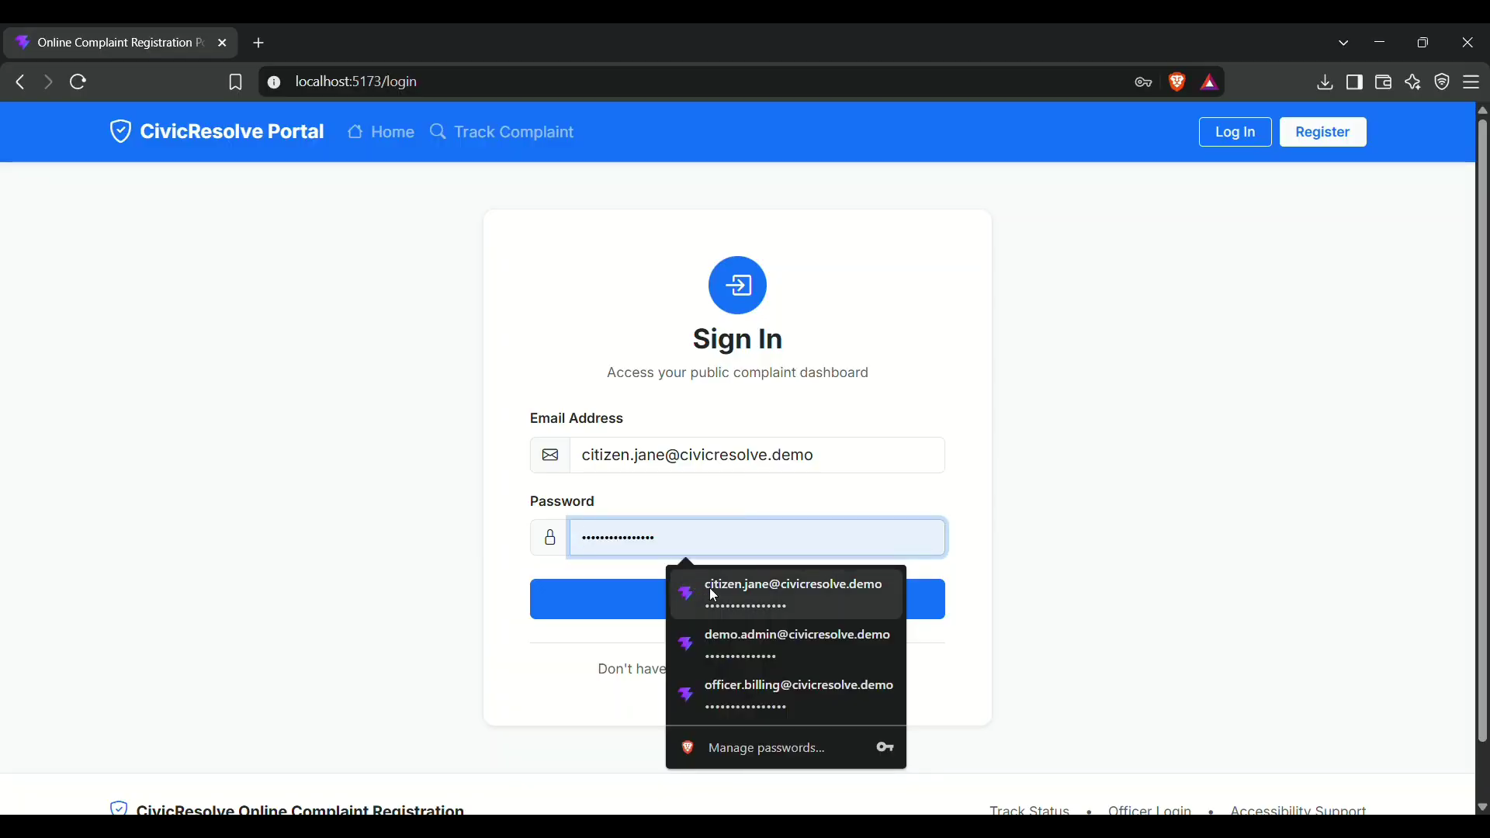

15.2 Registration screen
Show the supported registration fields and validation feedback.
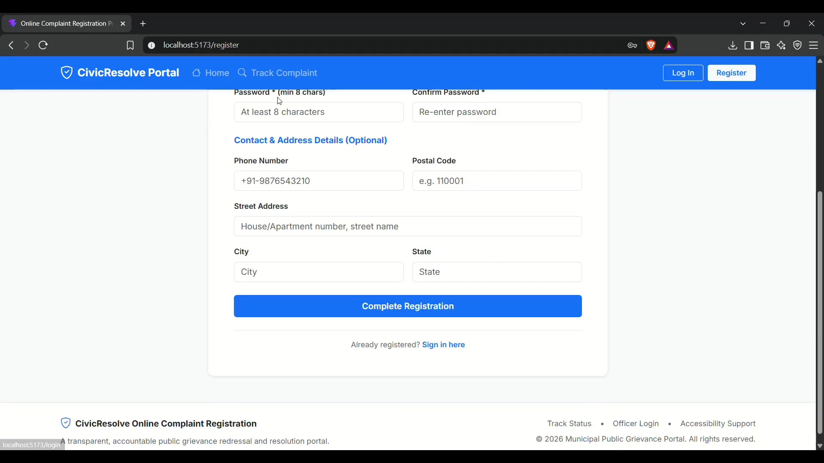

15.3 Citizen dashboard
Show the signed-in citizen's complaint list or home view.
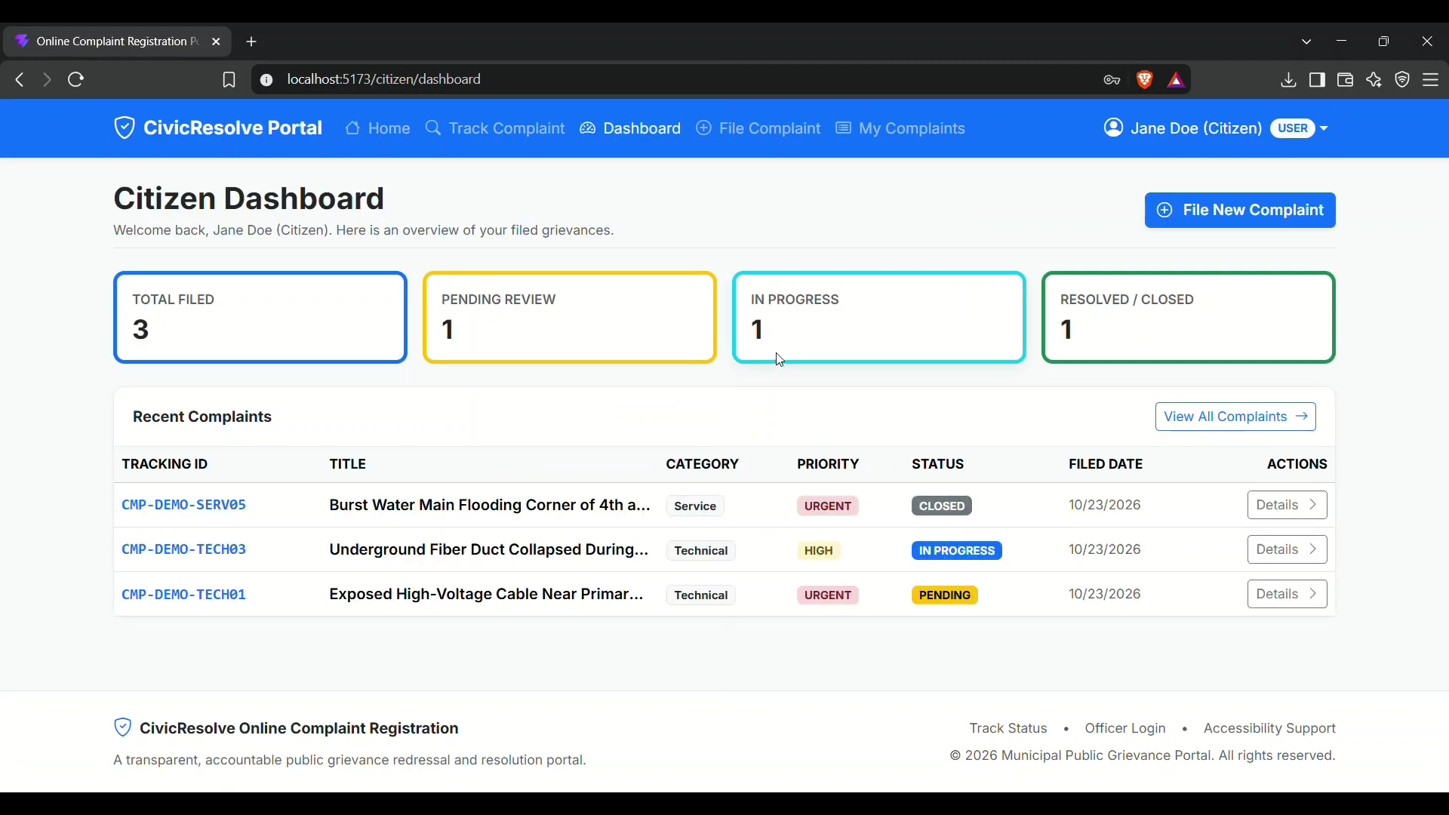

15.4 Complaint submission
Show the complaint form and a successful submission/confirmation.
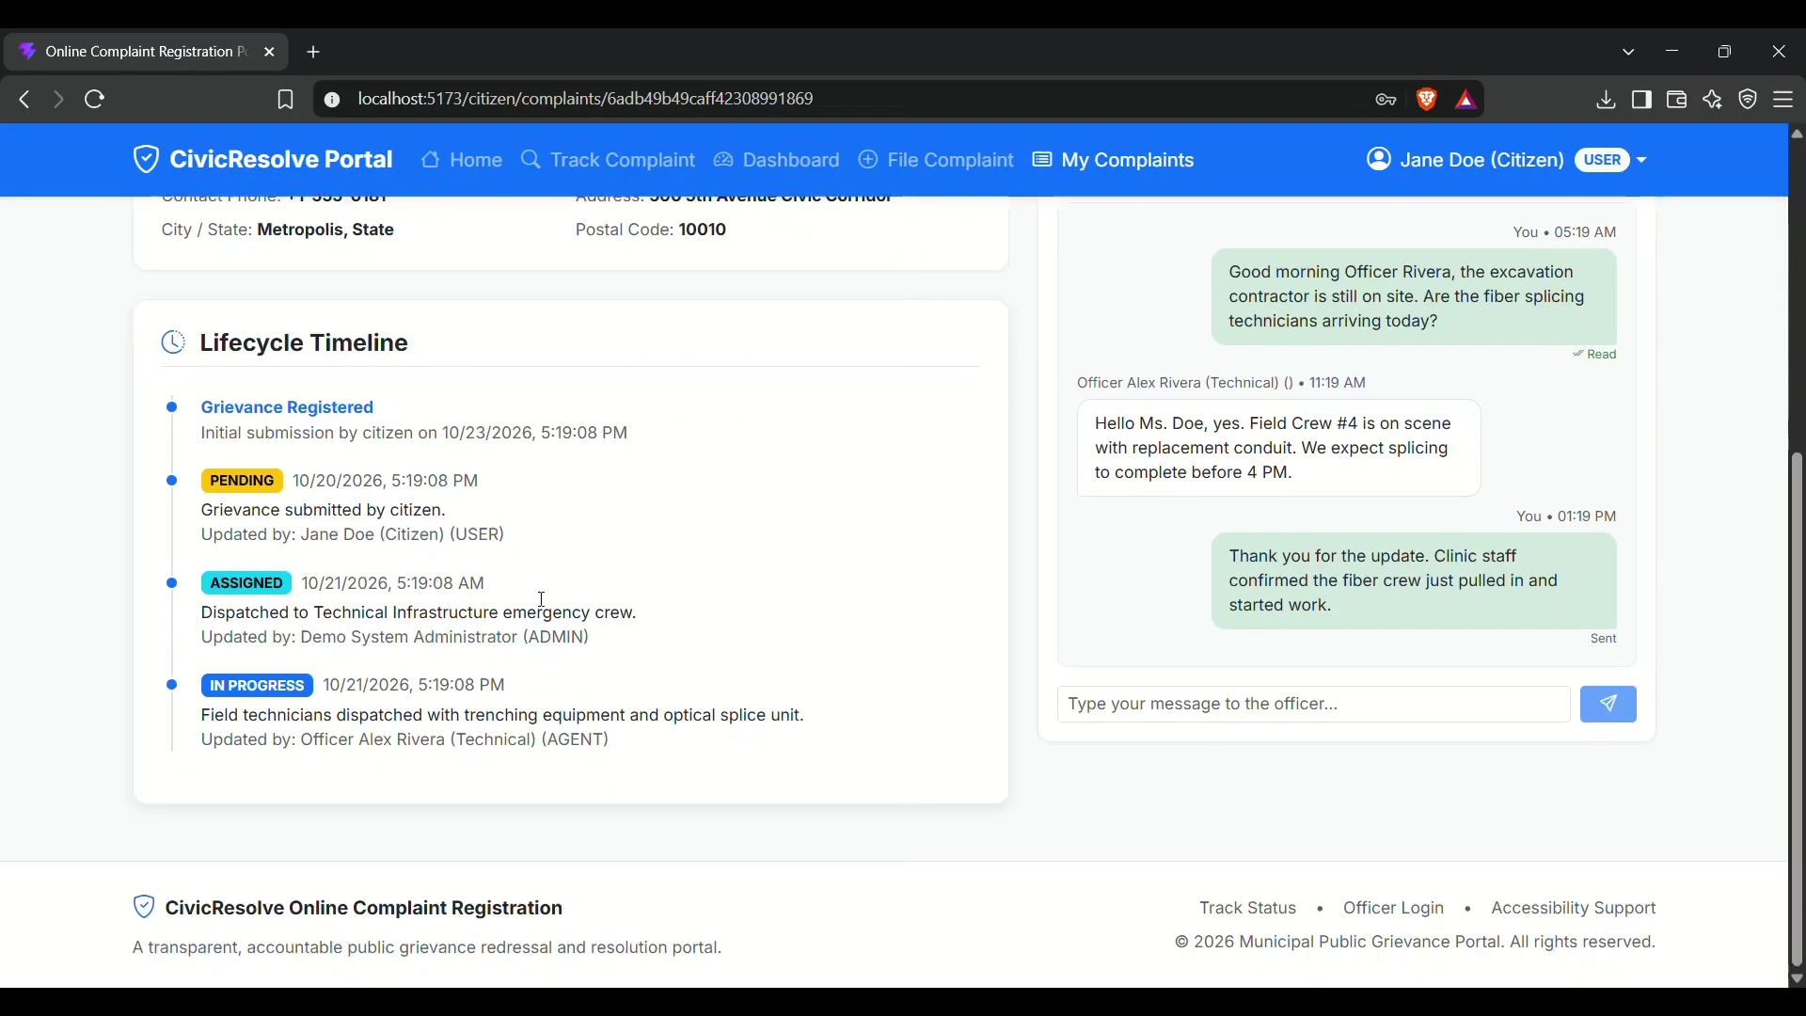

15.5 Tracking ID and complaint details
Show the generated tracking identifier and current status.
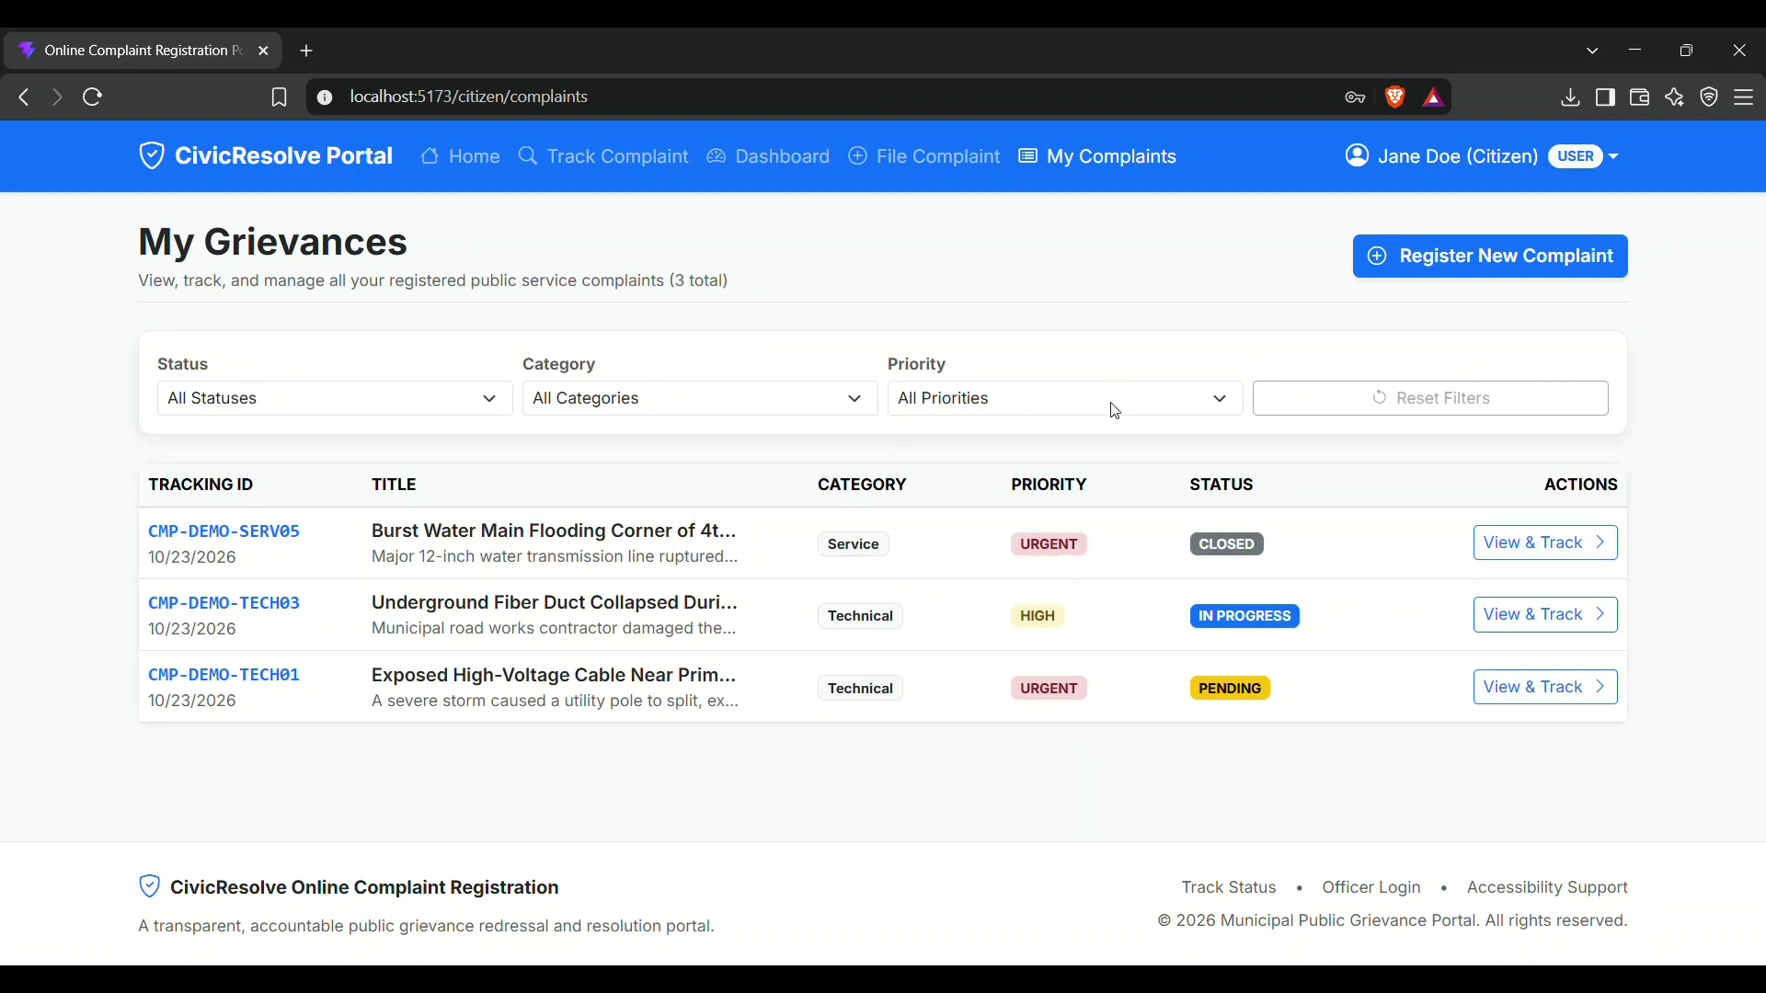

15.6 Technical officer workflow
Show the officer's permitted complaint review or status update.
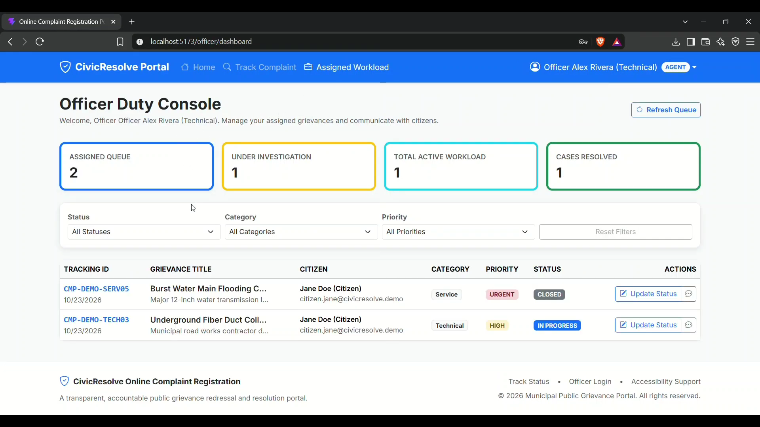

15.7 Billing officer workflow
Show the billing role's permitted view/action if present in the current demo.
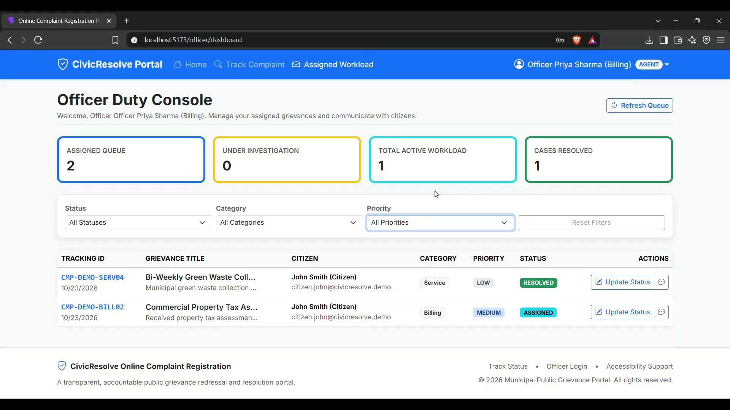

15.8 Administrator dashboard
Show the administrative view and implemented management features.

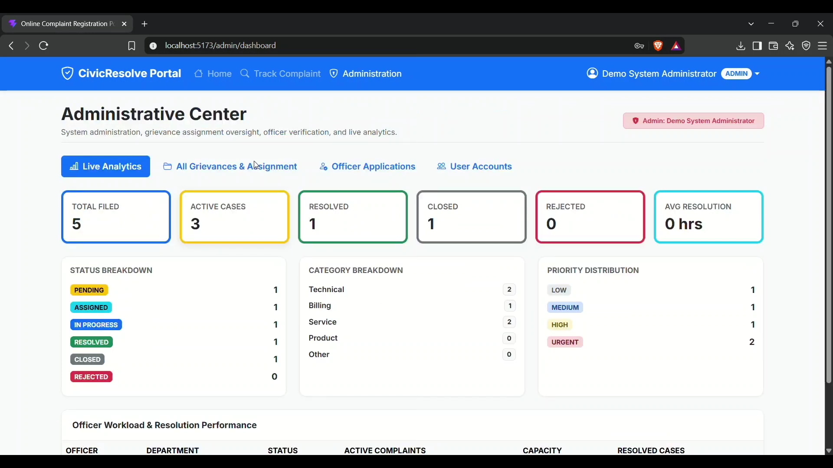15.9 Message / feedback
Show complaint-related messages or feedback if enabled.
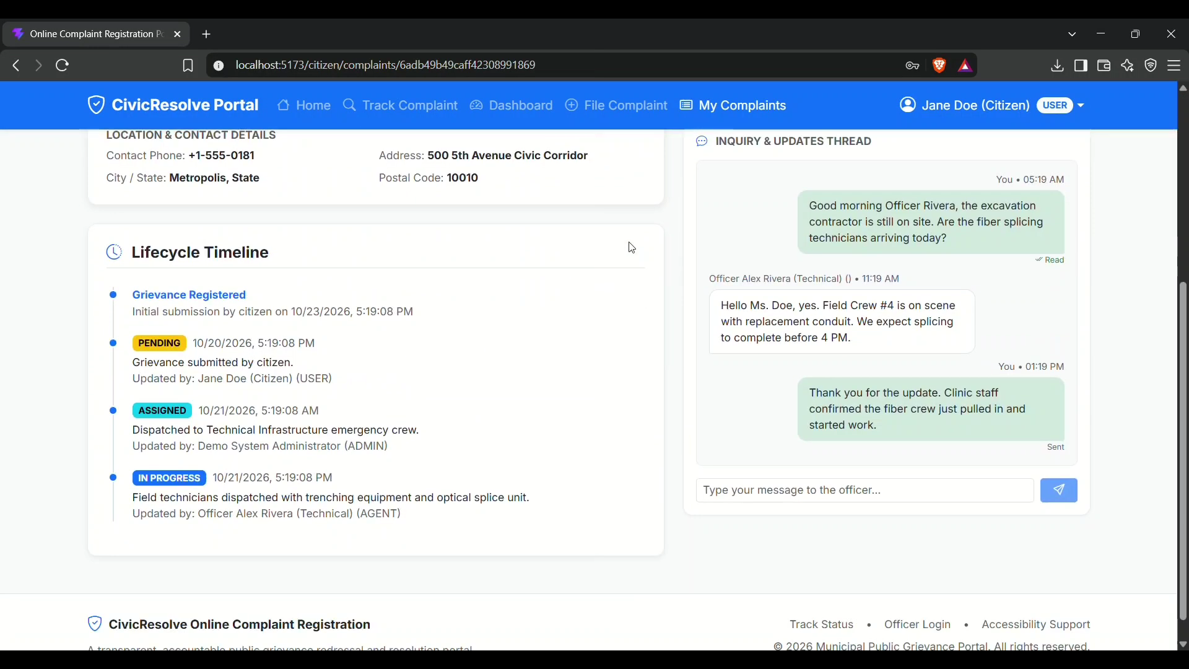

15.10 Test output
Capture the latest automated test run and ensure the output corresponds to the submitted code.
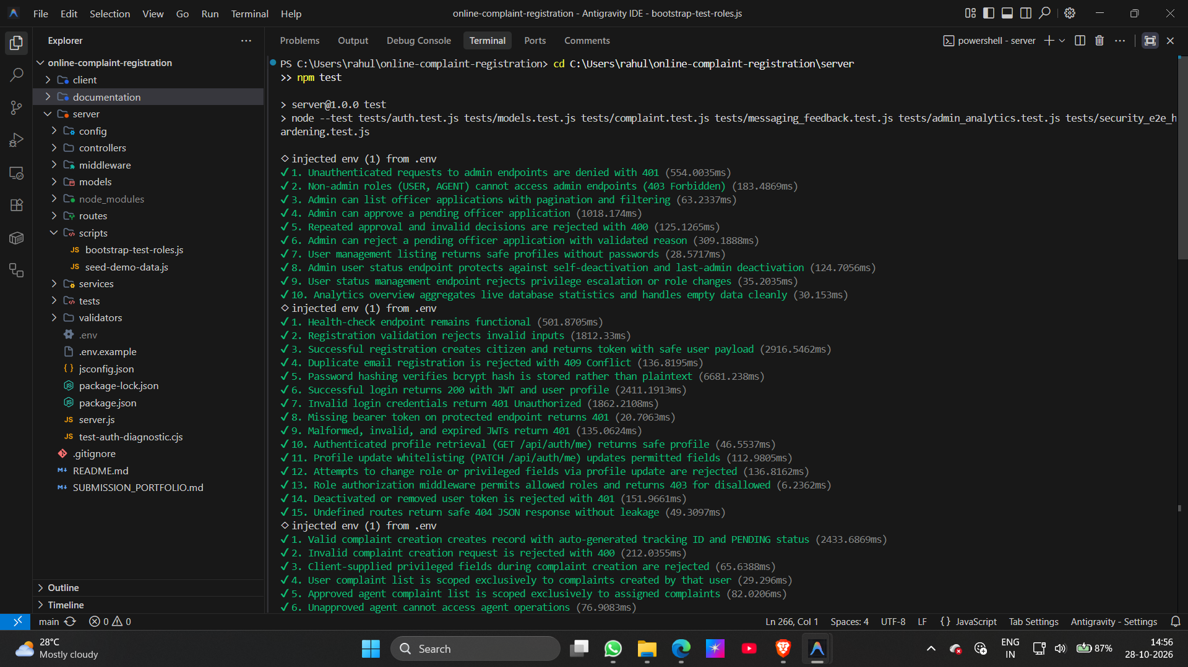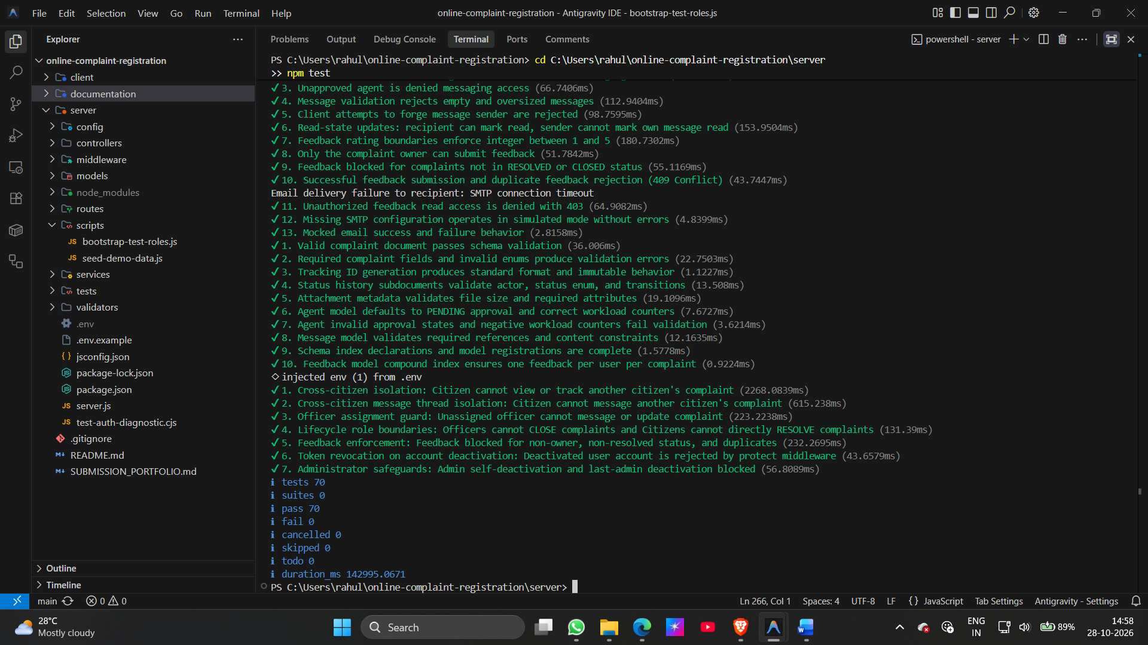

15.11 Demonstration video
Project demo video link supplied by the project owner:
https://drive.google.com/file/d/1krFIVeCz5jVzi2uFZ4pLrluTms4N6seV/view
Before submission, open the link in a private/incognito browser or another account to confirm that the evaluator has permission to view it.

16. LIMITATIONS AND FUTURE ENHANCEMENTS

16.1 Current limitations to state accurately
- The project is an academic/internship implementation and is not claimed to be officially integrated with a municipal authority.
- Production deployment, uptime, load performance and large-scale security have not been established by this report.
- Some modules represented in the model layer may require additional verification to confirm full end-to-end UI support.
- The ER diagram is conceptual and should be checked against the final Mongoose schemas.
- Screenshots and final test results must be updated from the submitted build.

16.2 Future enhancements
- Email/SMS notifications for complaint submission, assignment and status changes.
- Location capture and ward/department routing based on civic geography.
- SLA timers, escalation rules and workload dashboards.
- Analytics for complaint categories, processing time and resolution trends.
- Secure attachment storage, file type validation and malware scanning if uploads are enabled.
- Accessibility and localization review.
- Automated browser-based end-to-end tests for citizen and officer journeys.
- Production deployment monitoring, rate limiting, audit logs and formal security review.

17. CONCLUSION
CivicResolve demonstrates the design of a full-stack complaint-registration and grievance-management application using MongoDB, Express.js, React and Node.js. The system's logical architecture separates the browser interface, API routing, request middleware, controller operations and persistence. Its main domain models represent users, complaints, agents, messages and feedback, while the complaint record includes a tracking identifier and status-history information.
The MVC mapping, conceptual ER diagram, user-flow diagram and request-sequence diagram provide a visual overview of the system. Authentication, role-based authorization, request validation and centralized error handling are important safeguards in the backend design. For a final academic or internship submission, the report should be paired with genuine application screenshots, current test output and a verified demonstration link.

REFERENCES
- CivicResolve source repository: https://github.com/rahulchate18/CivicResolve
- Project model, controller, route, middleware and validator files in the repository.
- Official React documentation: https://react.dev/
- Official Node.js documentation: https://nodejs.org/docs/
- Official Express documentation: https://expressjs.com/
- Official MongoDB documentation: https://www.mongodb.com/docs/
- Mongoose documentation: https://mongoosejs.com/docs/
- Demonstration video supplied by the project owner: https://drive.google.com/file/d/1krFIVeCz5jVzi2uFZ4pLrluTms4N6seV/view

