NYC Water Consumption & Billing Analysis Report (2013–2025)
Analysts: Rahul & Kiran
Course: Big Data Analytics

Executive Summary
Over the past several years, New York City has seen a sharp increase in complaints about water and sewer bills. Residents, public facilities, and NYCHA developments have reported bills that appear inconsistent with their actual water use. To understand what is driving these irregularities, we analyzed more than twelve years of data (2013–May 2025) from the NYC Open Data Water Consumption & Cost dataset.
After cleaning the original 66,433-row dataset down to 14,589 usable records, we evaluated trends through descriptive, diagnostic, predictive, and prescriptive analytics. Across every stage of analysis, one pattern emerged clearly: consumption alone cannot explain most of the variation in charges.
Our regression analysis (R² = 0.38) reveals that estimated bills add an average of $588.83 per bill and contribute to $23 million+ in billing anomalies. Manhattan shows the highest costs per HCF, and extreme variation in billing cycles (some exceeding 800 days) further inflates charges. Fixing meter accuracy, standardizing billing practices, and implementing anomaly review processes will restore fairness and transparency to NYC's water billing system.

A. Background / Overview
The City of New York is facing a noticeable increase in water billing concerns, with many customers reporting bills that do not match their usage patterns. These inconsistencies undermine confidence in the billing system and hinder operational planning. According to the dataset insights, total annual charges have fluctuated, estimated bills have risen in recent years, and the highest single bill reached $157,910.56. These figures underscore the need for a systematic investigation into root causes.

B. Role & Motivation
As NYC data analysts, our role was to investigate the drivers behind billing irregularities and determine where the city can improve consistency. The motivation is practical: improving audits, reducing misbilling, recovering revenue lost to anomalies, and strengthening future policy decisions. This work directly supports operational fairness and efficient resource planning for NYC.

C. Main Question, Dataset, and Hypotheses
What factors influence water bills, and where can NYC improve consistency?

Dataset Used:
NYC Open Data – Water Consumption & Cost (2013–2025) Includes: consumption, charges, borough, rate class, days, and anomaly indicators
https://data.cityofnewyork.us/Housing-Development/Water-Consumption-And-Cost-2013-May-2025-/66be-66yr/about_data

Why This Dataset Is Appropriate:
It includes every variable directly relevant to determining how charges are calculated and whether they align with actual water use.

Hypotheses
Consumption does not fully explain charges.
- Estimated reads and long billing cycles contribute to billing variance.
- Anomalies may represent recoverable overcharges.
- Borough and rate class likely influence cost differences.
D. Data Preparation Process
Started with 66,433 records from NYC Open Data (2013-May 2025). Removed 48,925 blank, repeated, or corrupted rows and 2,917 zero-value entries (zero days, sewer-only charges, etc.). Standardized all numeric fields by removing dollar signs and commas, fixed invalid dates, and verified billing cycles for consistency. Final dataset contained 14,589 clean records ready for regression analysis. Note: 2025 data only extend through May.
# Appendix Item 1

E. Methodology & Analysis
Our analysis included descriptive, diagnostic, predictive, and prescriptive techniques, following course requirements.

1. Regression Analysis
The regression model included consumption, borough, and estimated status as predictors of total charges.
Key results (full output in # Appendix Item 5):
- R² ≈ 0.38 – meaning consumption and other variables explain only 38% of charge variation.
- Estimated bills add approx. $588 to a bill on average.
- Consumption has a statistically significant but moderate effect on charges.
These results confirm that bill amounts are influenced heavily by non-consumption factors, supporting Hypothesis 1.
# Appendix Item 2

Main measures
# | Measure | What It Shows
1 | Avg Rate per HCF | Effective cost per unit of water
2 | Expected Charges | Predicted "normal" bill amount based on usage, cycle length, borough & meter status (regression model)
3 | Anomaly Amount | Actual bill minus Expected bill (positive = likely overcharged)
4 | Total Anomaly Amount | Sum of all positive anomalies = potential savings
5 | % Estimated Bills | Percentage of bills not based on actual meter reads

Descriptive Analysis
We computed core measures such as total charges by year, average rate per HCF, proportion of estimated bills, average consumption per bill, and highest single bill amounts. These results highlighted noticeable year-to-year fluctuation in charges and a rise in estimated billing.
(Visual summary in # Appendix Item 3.)

3. Diagnostic Analysis
We examined anomaly totals, high-anomaly meters, borough-level patterns, and estimated-bill frequencies. A total anomaly amount exceeding $23 million indicates substantial misbilling potential.
(See # Appendix Item 4.)

4. Predictive Analysis
We examined trends over time for total consumption and total charges, along with projections for future years. While consumption trends downward gradually, forecasted future charges trend upward, which supports the conclusion that structural inconsistencies exist.
(See # Appendix Item 5.)

5. Prescriptive Analysis
Using anomaly counts, billing-day irregularities, and high-rate meters, we identified priority areas where management action could improve fairness and reduce financial waste.
(See # Appendix Item 6.)

F. Key Findings
- Consumption does not fully explain charges; inconsistencies exist throughout the billing structure.
- Estimated reads are a major contributor to inflated and variable bills.
- More than $23 million in anomaly amounts represents recoverable revenue.
- Borough-level disparities are substantial, with Manhattan showing the highest cost per HCF.
- Some developments have extremely long billing cycles, which distorts monthly and annual billing consistency.
Recommendations
- Improve Meter Reliability & Reduce Estimated Reads
- Reduce reliance on estimates
- Improve data quality for billing and forecasting
- Deploy AMR/Smart Meters if needed
- Create a Monthly Anomaly Review Dashboard
- Monitor flagged meters
- Automatically escalate high-anomaly cases
- Recover misbilled revenue proactively
- Standardize Borough Billing Policies
- Reduce cost/HCF disparities
- Ensure equal treatment across developments
- Identify boroughs with chronic data quality issues (e.g., Bronx)

Conclusion
NYC’s billing irregularities are driven by data quality problems, estimated bills, and structural inconsistencies in the billing system. Strengthening meter reliability, standardizing policies, and institutionalizing anomaly review practices will significantly improve fairness and rebuild trust in NYC’s water billing system.

# Appendix Item 1
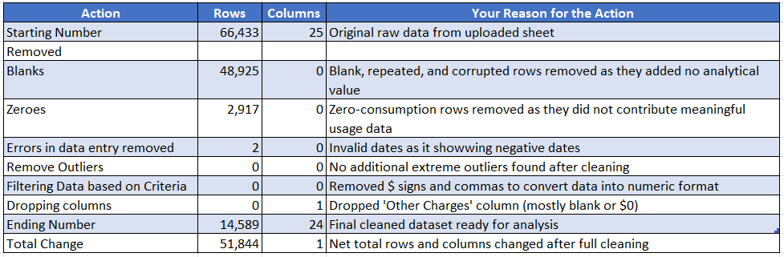

# Appendix Item 2
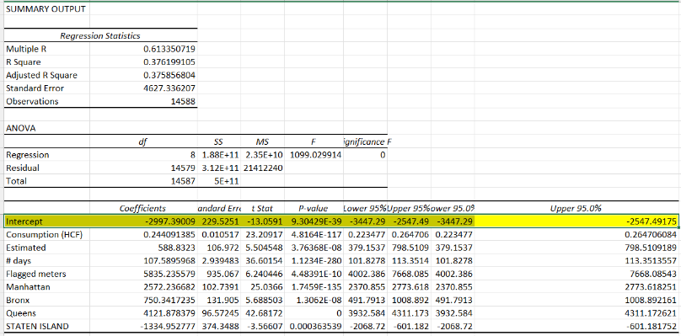

# Appendix 3
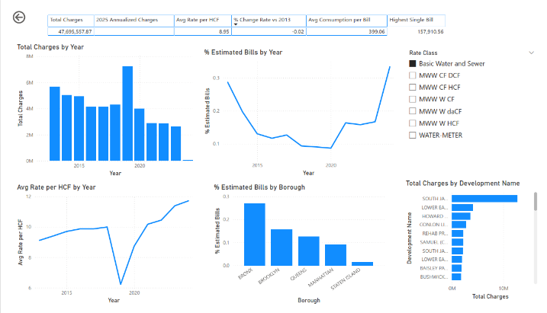

# Appendix 4 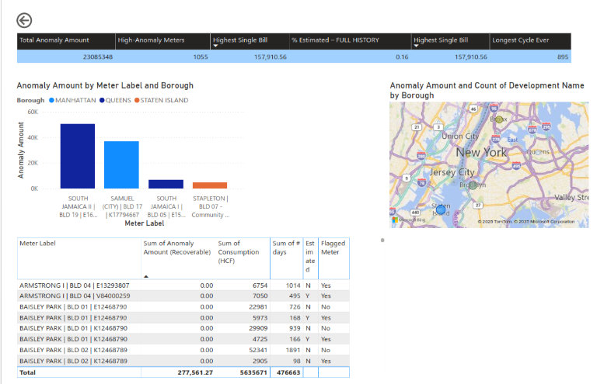

# Appendix 5
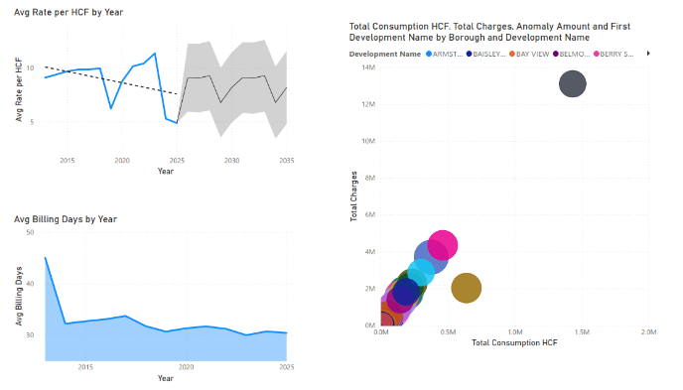

# Appendix 6
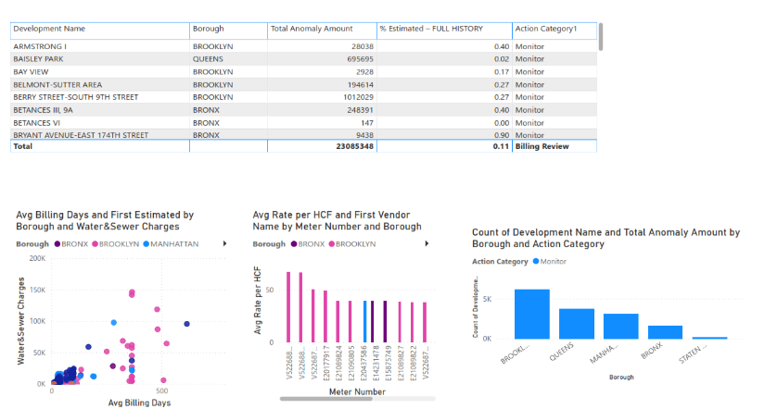

# Appendix 7
