**Assignment 1**

**Object Oriented Programming**

**Name: Rahul Chowdhury**

**Sapid: ############**

**Roll No.: R##########49**

**Batch: ##**

**Domain: Wine Shop Inventory Management System Using Java**

**###Application Design:**

**## Introduction**

**The Wine Shop Inventory Management System is a Java program that allows the management of alcoholic beverage items within a wine shop. It provides functionality to add new items, track the quantity and types of alcoholic beverages, sell items, count the total number of items in stock, and display the current inventory.**

**## Features**

**1. **Add Items**: This feature allows the user to add new alcoholic beverage items to the inventory. The user can specify the item's name, type of alcohol (Whiskey, Wine, Gin, Vodka, Rum, or Beer), price, quantity, and subtype (if applicable).**

**2. **Count Items**: This feature provides the total count of items in the inventory, considering all types of alcoholic beverages.**

**3. **Sell Items**: Users can sell alcoholic beverage items by specifying the item name and the quantity to be sold. If the requested quantity is available in the inventory, the program processes the sale and provides information about the sold items and the total revenue generated.**

**4. **Display All Items**: This feature displays the current inventory of alcoholic beverages, categorized by their types (e.g., Whiskeys, Wines, Gins, Vodkas, Rums, Beers). It shows details such as the name, type, price, and quantity of each item.**

**5. **User-Friendly Menu**: The program presents a user-friendly menu to guide users through the available options, making it easy to navigate and interact with the system.**

**Code**

**###Package Using in the Project:**

package myPackage ;

*// Base class for alcoholic beverages stores the name price and quantity for all types*

public class Alcohol {

    private String name;

    private double price;

    private int quantity;

*// Constructor for base class*

    public Alcohol(String name, double price, int quantity) {

*this*.name = name;

*this*.price = price;

*this*.quantity = quantity;

    }

*//Method for returning the Name of the Braverage*

    public String getName() {

        return name;

    }

*//Method for returning the Price of the Braverag*

    public double getPrice() {

        return price;

    }

*//Method for returning the Quantity lefr in stock  of the Braverage*

    public int getQuantity() {

        return quantity;

    }

*//Method for adding Braverages in existing Stock*

    public void addQuantity(int amount) {

        quantity += amount;

    }

*//Method for checking whether the Braverage is available for sell or not*

    public boolean sell(int amount) {

        if (amount <= quantity) {

            quantity -= amount;

            return true;

        }

        return false;

    }

}

**##Package Structure: The above package holds the Alcohol class which is the Base class for all type of Alcohols**

**###Main Menu Driven Code for Managing the Inventory:**

import java.io.IOException;

import java.util.ArrayList;

import java.util.List;

import java.util.Scanner;

import myPackage.Alcohol;

*// Whiskey class, derived from Alcohol*

class Whiskey extends Alcohol {

    private String type;

    public Whiskey(String name, double price, int quantity, String type) {

*super*(name, price, quantity);

*this*.type = type;

    }

    public String getType() {

        return type;

    }

}

*// Wine class, derived from Alcohol*

class Wine extends Alcohol {

    private String type;

    public Wine(String name, double price, int quantity, String type) {

*super*(name, price, quantity);

*this*.type = type;

    }

    public String getType() {

        return type;

    }

}

*// Gin class, derived from Alcohol*

class Gin extends Alcohol {

    public Gin(String name, double price, int quantity) {

*super*(name, price, quantity);

    }

    public String getType() {

        return "Gin";

    }

}

*// Vodka class, derived from Alcohol*

class Vodka extends Alcohol {

    public Vodka(String name, double price, int quantity) {

*super*(name, price, quantity);

    }

    public String getType() {

        return "Vodka";

    }

}

*// Rum class, derived from Alcohol*

class Rum extends Alcohol {

    public Rum(String name, double price, int quantity) {

*super*(name, price, quantity);

    }

    public String getType() {

        return "Rum";

    }

}

*// Beer class, derived from Alcohol*

class Beer extends Alcohol {

    public Beer(String name, double price, int quantity) {

*super*(name, price, quantity);

    }

    public String getType() {

        return "Beer";

    }

}

*//The WineShop class managing all the menu*

class WineShop {

    private List<Whiskey> whiskeys = new ArrayList<>(); *//ArrayList for containing Whiskeys*

    private List<Wine> wines = new ArrayList<>();       *//ArrayList for containing Wines*

    private List<Gin> gins = new ArrayList<>();         *//ArrayList for containing Gins*

    private List<Vodka> vodkas = new ArrayList<>();     *//ArrayList for containing Vodkas*

    private List<Rum> rums = new ArrayList<>();         *//ArrayList for containing Rum*

    private List<Beer> beers = new ArrayList<>();       *//ArrayList for containing Beer*

    public void addItem(String name, double price, int quantity, String alcoholType, String subtype){

*//If the item is Whiskey store it in Arraylist Whiskey*

        if (alcoholType.equals("Whiskey")) {

            if (subtype.equals("Malted") || subtype.equals("Scotch")) {

                whiskeys.add(new Whiskey(name, price, quantity, subtype));

            }

            else {

                System.out.println("Invalid Whiskey subtype: " + subtype + ". Item not added.");

            }

        }

*//If the item is Wine store it in Arraylist Wine*

        else if (alcoholType.equals("Wine")) {

            if (subtype.equals("Red Wine") || subtype.equals("White Wine")) {

                wines.add(new Wine(name, price, quantity, subtype));

            }

            else{

                System.out.println("Invalid Wine subtype: " + subtype + ". Item not added.");

            }

        }

*//If the item is Gin store it in Arraylist Gin*

        else if (alcoholType.equals("Gin")) {

            gins.add(new Gin(name, price, quantity));

        }

*//If the item is Vodka store it in Arraylist Vodkas*

        else if (alcoholType.equals("Vodka")) {

            vodkas.add(new Vodka(name, price, quantity));

        }

*//If the item is Rum store it in Arraylist Rum*

        else if (alcoholType.equals("Rum")) {

            rums.add(new Rum(name, price, quantity));

        }

*//If the item is Beer store it in Arraylist Beer*

        else if (alcoholType.equals("Beer")) {

            beers.add(new Beer(name, price, quantity));

        }

*//If the input type of alcohol not matched*

        else {

            System.out.println("Invalid type of alcohol: " + alcoholType + ". Item not added.");

        }

    }

*//countItems() function returns the total number of Items Present In the Inventory At that Time*

    public int countItems() {

        return whiskeys.size() + wines.size() + gins.size() + vodkas.size() + rums.size() + beers.size();

    }

*//SellItem Method is used for Selling the item and modify the inventory*

    public void sellItem(String name, int amount) {

        for (Whiskey whiskey : whiskeys) {  *//For Selling Whiskeys*

            if (whiskey.getName().equals(name)) {

*//If the Item is Available*

                if (whiskey.sell(amount)) {

                    System.out.println("Sold " + amount + " " + name + " for $" + whiskey.getPrice() * amount);

                }

*//If the item is not available*

                else {

                    System.out.println("Insufficient quantity of " + name + " in stock.");

                }

                return;

            }

        }

        for (Wine wine : wines) {   *//For Selling Wines*

            if (wine.getName().equals(name)) {

                if (wine.sell(amount)) {

                    System.out.println("Sold " + amount + " " + name + " for $" + wine.getPrice() * amount);

                }

                else {

                    System.out.println("Insufficient quantity of " + name + " in stock.");

                }

                return;

            }

        }

        for (Gin gin : gins) {    *//For selling Gins*

            if (gin.getName().equals(name)) {

                if (gin.sell(amount)) {

                    System.out.println("Sold " + amount + " " + name + " for $" + gin.getPrice() * amount);

                }

                else {

                    System.out.println("Insufficient quantity of " + name + " in stock.");

                }

                return;

            }

        }

        for (Vodka vodka : vodkas) {  *//For selling Vodkas*

            if (vodka.getName().equals(name)) {

                if (vodka.sell(amount)) {

                    System.out.println("Sold " + amount + " " + name + " for $" + vodka.getPrice() * amount);

                }

                else {

                    System.out.println("Insufficient quantity of " + name + " in stock.");

                }

                return;

            }

        }

        for (Rum rum : rums) {   *//For Selling Rums*

            if (rum.getName().equals(name)) {

                if (rum.sell(amount)) {

                    System.out.println("Sold " + amount + " " + name + " for $" + rum.getPrice() * amount);

                }

                else {

                    System.out.println("Insufficient quantity of " + name + " in stock.");

                }

                return;

            }

        }

        for (Beer beer : beers) {   *//For Selling Beers*

            if (beer.getName().equals(name)) {

                if (beer.sell(amount)) {

                    System.out.println("Sold " + amount + " " + name + " for $" + beer.getPrice() * amount);

                }

                else {

                    System.out.println("Insufficient quantity of " + name + " in stock.");

                }

                return;

            }

        }

        System.out.println("Item not found: " + name);

    }

*//The displayItems() Method Display The Full Inventory*

    public void displayItems() {

        System.out.println("Wine Shop Inventory:\n");

*//Each Loops travers the ArrayLists and Prints Stock with Details*

        System.out.println("Whiskeys:\n");

        for (Whiskey whiskey : whiskeys) {

            System.out.println("Name: " + whiskey.getName() + "| Type: " + whiskey.getType()

                    + "| Price: $" + whiskey.getPrice() + "| Quantity: " + whiskey.getQuantity());

        }

        System.out.println("\nWines:\n");

        for (Wine wine : wines) {

            System.out.println("Name: " + wine.getName() + "| Type: " + wine.getType()

                    + "| Price: $" + wine.getPrice() + "| Quantity: " + wine.getQuantity());

        }

        System.out.println("\nGins:\n");

        for (Gin gin : gins) {

            System.out.println("Name: " + gin.getName() + "| Type: " + gin.getType()

                    + "| Price: $" + gin.getPrice() + "| Quantity: " + gin.getQuantity());

        }

        System.out.println("\nVodkas:\n");

        for (Vodka vodka : vodkas) {

            System.out.println("Name: " + vodka.getName() + "| Type: " + vodka.getType()

                    + "| Price: $" + vodka.getPrice() + "| Quantity: " + vodka.getQuantity());

        }

        System.out.println("\nRums:\n");

        for (Rum rum : rums) {

            System.out.println("Name: " + rum.getName() + "| Type: " + rum.getType()

                    + "| Price: $" + rum.getPrice() + "| Quantity: " + rum.getQuantity());

        }

        System.out.println("\nBeers:\n");

        for (Beer beer : beers) {

            System.out.println("Name: " + beer.getName() + "| Type: " + beer.getType()

                    + "| Price: $" + beer.getPrice() + "| Quantity: " + beer.getQuantity());

        }

    }

}

public class WineShopApp {

    public static void main(String[] args) throws IOException{ *//If any input error Occurs it throws an IO Exception*

        WineShop shop = new WineShop();

        Scanner scanner = new Scanner(System.in);

        int choice;

        Display();  *//Display The Welcome Massage*

        do {       *//Options Available in the Inventory Menu*

            System.out.println("\nMenu:\n");

            System.out.println("1. Add Items\n");

            System.out.println("2. Count Items\n");

            System.out.println("3. Sell Items\n");

            System.out.println("4. Display All Items\n");

            System.out.println("5. Quit\n");

            System.out.print("Enter your choice: ");

            choice = scanner.nextInt();

            System.out.println("\n");

            switch (choice) {

*//Case 1 for Adding Items In Inventory*

                case 1: {

                    String name, alcoholType, subtype;

                    double price;

                    int quantity;

                    System.out.print("Enter item name: ");

                    scanner.nextLine();

                    name = scanner.nextLine();

                    System.out.print("Enter type of alcohol (Whiskey/Wine/Gin/Vodka/Rum/Beer): ");

                    alcoholType = scanner.next();

*//If SubType of the Alcohol Available*

                    if (alcoholType.equals("Whiskey")) {

                        System.out.print("Enter subtype (Malted/Scotch): ");

                        subtype = scanner.next();

                    }

                    else if (alcoholType.equals("Wine")) {

                        System.out.print("Enter subtype (Red Wine/White Wine): ");

                        scanner.nextLine();

                        subtype = scanner.nextLine();

                    } else {

                        subtype = "";

                    }

                    System.out.print("Enter item price: ");

                    price = scanner.nextDouble();

                    System.out.print("Enter item quantity: ");

                    quantity = scanner.nextInt();

                    shop.addItem(name, price, quantity, alcoholType, subtype);

                    break;

                }

*//Case 2 for Count Total Items*

                case 2: {

                    int count = shop.countItems();

                    System.out.println("Total items in stock: " + count);

                    break;

                }

*//Case 3 for Selling Items and Update the inventory*

                case 3: {

                    String name;

                    int amount;

                    System.out.print("Enter item name to sell: ");

                    scanner.nextLine();

                    name = scanner.nextLine();

                    System.out.print("Enter quantity to sell: ");

                    amount = scanner.nextInt();

                    shop.sellItem(name, amount);

                    break;

                }

*//Case 4 for Display The Full Inventory*

                case 4: {

                    shop.displayItems();

                    break;

                }

*//Case 5 for Exit*

                case 5:

                    System.out.println("Exiting program.\n\n");

                    break;

*//Default Input gives the chosies again*

                default:

                    System.out.println("Invalid choice. Please try again.");

            }

        } while (choice != 5);  *//The While loop continues until 5 is pressed for exit*

        scanner.close();

    }

    private static void Display() {

        System.out.println("######################################################");

        System.out.println("#############     Rahul's Wine Store     #############");

        System.out.println("######################################################");

        System.out.println("#     Whiskey   Vodka   Rum   Wine   Gin   Beers     #");

        System.out.println("######################################################");

    }

}

**## Usage**

**1. **Add Items**:**

**- To add a new item, select option 1 from the main menu.**

**- Enter the item's name, type of alcohol, subtype (if applicable), price, and quantity.**

**- The program will validate the input and add the item to the inventory if it meets the criteria.**

**2. **Count Items**:**

**- To count the total number of items in stock, select option 2 from the main menu.**

**- The program will display the total item count.**

**3. **Sell Items**:**

**- To sell items, select option 3 from the main menu.**

**- Enter the name of the item to be sold and the quantity to sell.**

**- The program will check if the requested quantity is available in stock and process the sale if possible, providing information about the sale and revenue generated.**

**4. **Display All Items**:**

**- To view the current inventory, select option 4 from the main menu.**

**- The program will display a categorized list of alcoholic beverage items, including their names, types, prices, and quantities.**

**5. **Exit**:**

**- To exit the program, select option 5 from the main menu.**

**## Code Structure**

**The program is structured using object-oriented principles and includes the following classes:**

**- AlcoholicBeverage: A base class for alcoholic beverages, containing common attributes and methods.**

**- Derived classes for specific types of alcoholic beverages, such as Whiskey, Wine, Gin, Vodka, Rum, and Beer.**

**- WineShop: A class that manages the wine shop's inventory and provides methods for adding items, counting items, selling items, and displaying the inventory.**

**- <ArrayList> is used for all type of beverages to store Inventory data in a dynamic sized Array**

**- Also for loop , for-each loop ,Switch stratements and a infinite while loop are used in the project**

**- Exception Handling is used to handle IO exceptions in Main method**

**-Java Package are used -> The myPackage Contains base class for all Alcohol type**

**## How to Run**

**1. Compile the program.**

**2. Run the compiled executable.**

**3. Follow the on-screen menu prompts to interact with the program.**

**##Some Output Example of the Program**

**#Menu**

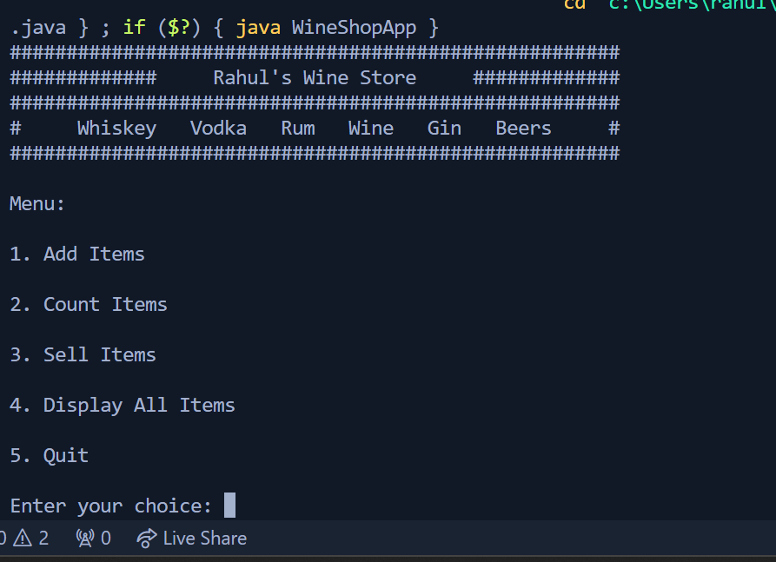

**#Add Items**

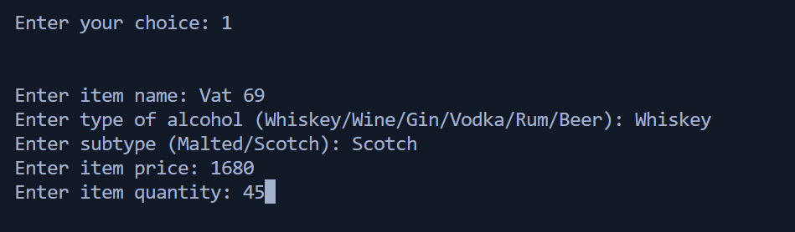

**#Count Items**

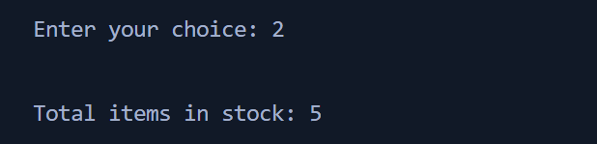

**#Display All Items**

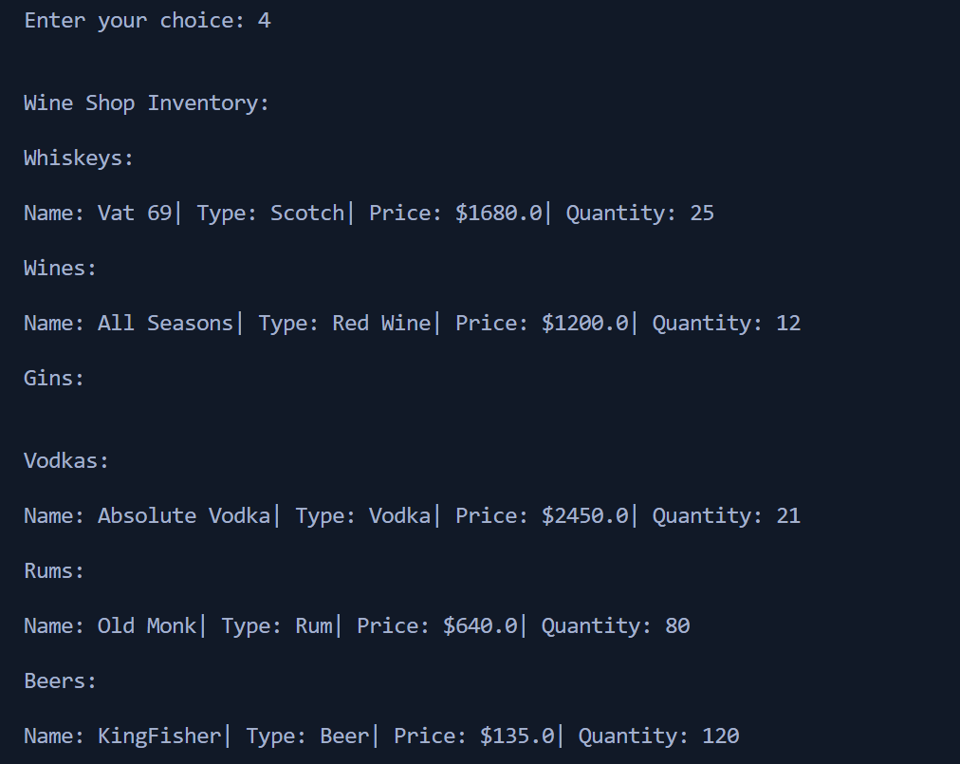

**#Sell Items**

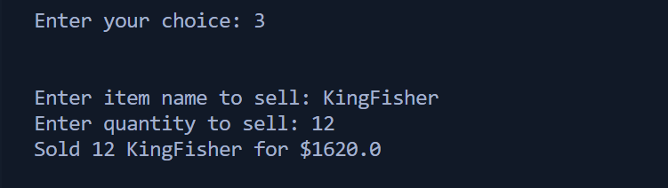

**#Inventory Update After Selling**

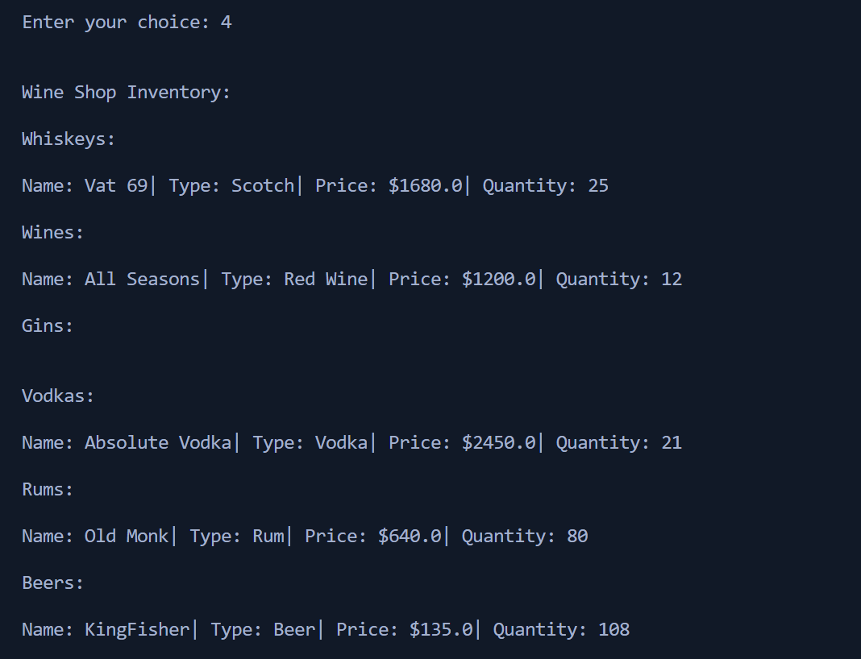

**#Exiting Program**

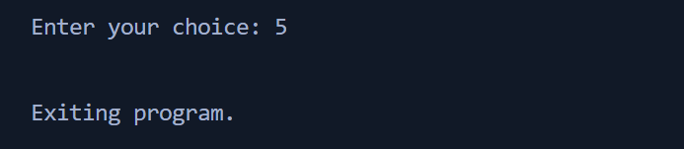

## Conclusion

The Wine Shop Inventory Management System is a useful tool for managing and tracking alcoholic beverage items within a wine shop. It simplifies tasks such as adding new items, monitoring inventory levels, selling items, and displaying the current stock. This program can be extended and customized to meet the needs of a real-world wine shop or similar business.

**End**