Midterm Mastery (Part I) - Submission Report

Step I: Sharing Results from Homework 6
I posted my Homework 6 observations and analysis in Piazza under the SharingHomework6 thread and referenced my original results. My key finding was that bounded per-request work (exactly 100 product checks) keeps latency controlled at moderate load, and horizontal scaling solves throughput pressure more effectively than relying on vertical-only tuning.
My measured HW6 highlights:
- Baseline single-task test (5 users, 2 minutes): 5,915 requests, 42.5 RPS, avg 79.5 ms, p95 83 ms, 0% failures.
- Single-task stress test (150 users): 256,128 requests, 1,273.8 RPS, avg 87.89 ms, p95 160 ms, p99 220 ms, 0% failures.
- Scaled-service test (autoscaling active): 552,209 requests, 1,450.5 RPS, avg 80.76 ms, p95 92 ms, p99 170 ms, 0% failures.
- Observed autoscaling transition: desired/running/pending moved 2/2/0 -> 4/2/2 -> 4/3/1 -> 4/4/0.
- Resilience test: one ECS task was stopped during active load, traffic continued, and service returned to steady healthy state.

Step II: What I Found Valuable So Far
The most valuable part of this course has been learning how decisions connect across API design, deployment, observability, and resilience. At first these topics felt separate; through assignments, they now feel like one engineering loop: design, deploy, measure, adapt, and verify.

1) API Contracts and Modular Thinking
Working from contract-first definitions improved how I think about service boundaries and change safety. Stable interfaces reduce coupling, which makes teams faster and debugging more local. This connected strongly with the Parnas reading: decomposition quality drives long-term maintainability.

2) Infrastructure as Code and Repeatability
Terraform changed my workflow from click-based setup to reproducible infrastructure. Desired-state configuration improved consistency, collaboration, and teardown hygiene. I learned that if another engineer cannot reproduce the same environment from commands, the setup is not production-grade.

3) Load Testing as a Design Tool
Locust became a design instrument rather than a final checkbox. By varying users, spawn rates, and duration, I could observe where throughput stabilized, where latency tails increased, and when scaling policy decisions actually changed service behavior.

4) CPU vs Memory Bottlenecks
Homework 6 made bottleneck classification practical. Because products were preloaded in memory, memory remained comparatively steady while CPU absorbed most request pressure. That evidence justified scaling decisions better than speculative code micro-optimization.

5) Horizontal Scaling and Resilience
The most important systems insight was that horizontal scaling improves both capacity and fault tolerance. With ALB + ECS autoscaling, the system handled heavy load with stable success rate and continued serving traffic when one task was stopped during runtime.

6) Observability and Decision Quality
CloudWatch metrics, target health, and ECS events turned performance decisions into evidence-based reasoning. Correlating request behavior (Locust) with service behavior (CPU, memory, desired/running counts) gave clearer explanations and better tuning confidence.
Overall, the most valuable outcome so far is a stronger systems-level mental model. I now connect contract-first API thinking, reproducible infrastructure, empirical load testing, autoscaling strategy, and resilience validation as one end-to-end engineering process.

Diagram A: HW6 Horizontal Scaling Flow
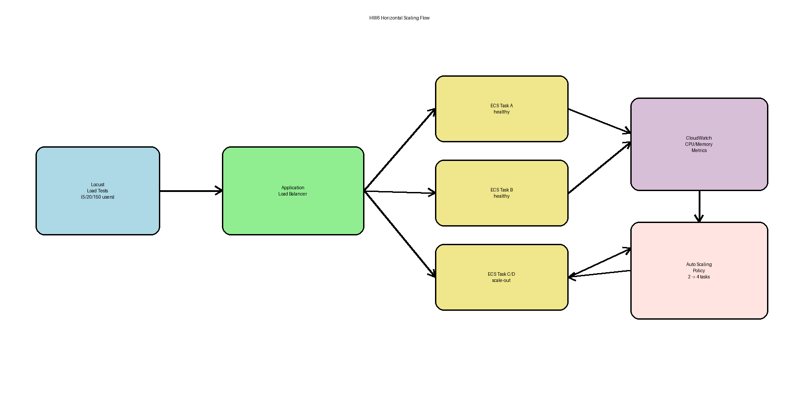
Figure A. Request flow from load generator to ALB, ECS tasks, CloudWatch, and autoscaling feedback.

Diagram B: Course Learning Map
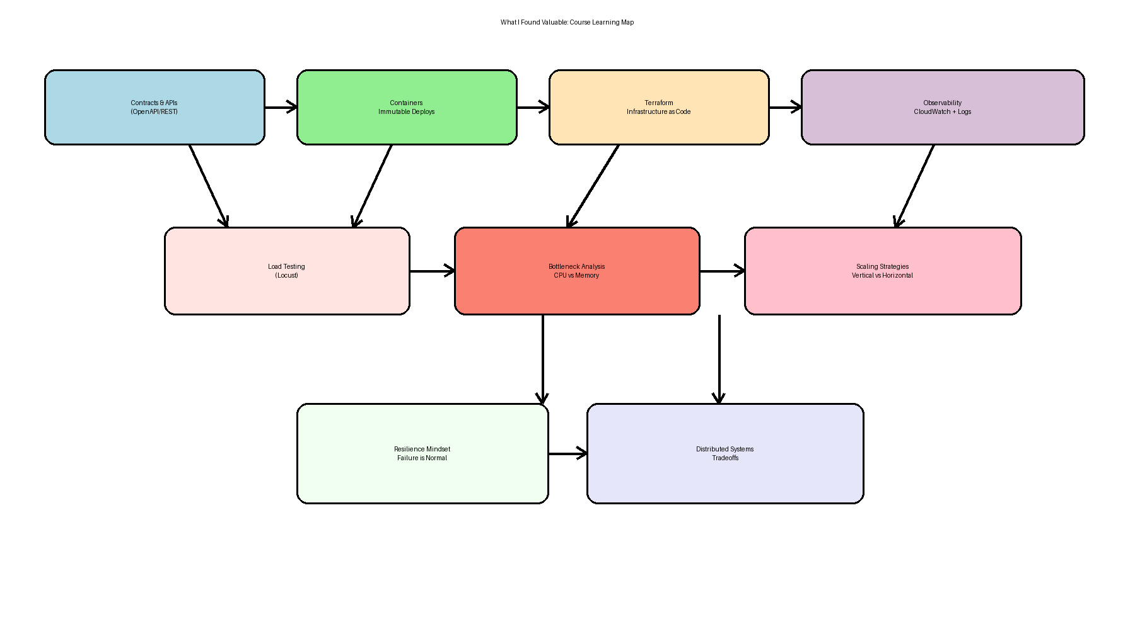Figure B. Mental model linking APIs, deployment, observability, load testing, bottleneck analysis, scaling, and resilience.

